Dr. Molly Bright

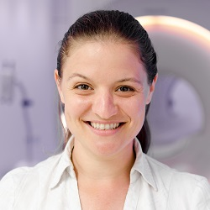
Assistant Professor of Biomedical Engineering
Assistant Professor of Physical Therapy and Human Movement Sciences
Northwestern University
https://www.brightlab.northwestern.edu
https://scholar.google.com/citations?hl=en&user=Weu-NwQAAAAJ

Our research uses advanced imaging techniques to assess the interaction of neural activity and vascular physiology in healthy brains and neurological disease. This involves the design and implementation of tools to stimulate or monitor human physiology during MRI scanning, and the development of specialized MRI acquisition methods to characterize neurovascular function. In combination with bespoke signal processing pipelines developed in our lab, we aim to produce robust quantitative imaging biomarkers for studying Multiple Sclerosis, fatigue, migraine, stroke, dementia, spinal cord injury, and the response of individual patients to personalized therapeutic interventions. This work is in collaboration with Physical Therapy and Human Movement Sciences, Neurology, Radiology, the Center for Translational Imaging, and the Northwestern University Interdepartmental Neuroscience program.

Talk: 9:30-10:20am, March 17, 2021
Weldon School of Biomedical Engineering, Purdue University

Title: Adding vascular insight to the fMRI experiment

Register in advance for this webinar:
https://purdue-edu.zoom.us/webinar/register/WN_amfh7E_PRte5FOglIc3MOw
Dr. Manus Donahue
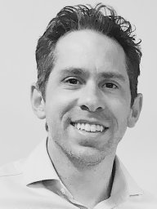
Professor of Radiology and Radiological Sciences, Neurology and Psychiatry and Behavioral Sciences
Director, Center for Imaging and Biomarker Development
Vanderbilt University Institute of Imaging Science

https://www.vumc.org/donahue-lab/home
https://scholar.google.com/citations?user=gcwqa54AAAAJ&hl=en&oi=ao
Manus was trained at Duke University (BS: Physics; BA: Philosophy), Johns Hopkins University (PhD: Biophysics), and the University of Oxford (post-doc: Neurology). He joined the Johns Hopkins faculty in 2009 and in 2010 moved to Vanderbilt University Medical Center, where he is currently a Professor of Neurology, Psychiatry and Behavioral Sciences, and Radiology and Radiological Sciences. His work is focused on using new imaging and computational approaches to characterize tissue function in health and disease. Over the past six years, he has been the Principal Investigator of five NIH-funded studies in which these approaches have been applied in patients with atherosclerotic cerebrovascular disease, moyamoya disease and syndrome, and lymphatic disorders to evaluate emerging therapies. He is a member of the FDA-established Brain panel to determine endpoints in clinical trials of patients with sickle cell disease, ad hoc member of several NIH study sections, Vice Chair of the Vanderbilt Human Subjects Protections Committee (HS2), editorial board member of the Journal of Cerebral Blood Flow and Metabolism, CEO of biosight, LLC, and youth soccer coach in the Harpeth Valley Youth Soccer Association.
Talk: 9:30-10:20am, April 7, 2021
Weldon School of Biomedical Engineering, Purdue University
Title: neuroimaging to improve care in cerebrovascular disease
Register in advance for this webinar:
https://purdue-edu.zoom.us/webinar/register/WN__117OuYYT_qryNdPLxnvkg

Dr. Amy Janes

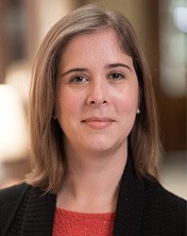
Director, Functional Integration of Addiction Research Laboratory

Associate Professor of Psychiatry, Harvard Medical School
https://janeslab.mclean.harvard.edu/people/
https://scholar.google.com/citations?hl=en&user=Hrb3KQ4AAAAJ

Amy C. Janes, PhD, directs the Functional Integration of Addiction Research Laboratory at the McLean Imaging Center. While she began her research career studying addiction in preclinical models, her current NIH-funded research uses clinical neuroimaging to clarify how individual differences in brain function, chemistry, and structure influence drug use and relapse. She also uses these tools to clarify links between drug use and psychopathology, with the goal of using neuroscience to inform personalized treatment development.

Dr. Janes directs the clinical-basic training track of the NIDA T32 Post-Doctoral Training Program, and she holds a joint appointment with Suffolk University to provide research training to pre-doctoral candidates attaining degrees in clinical psychology.

Talk: 9:30-10:20am, April 21, 2021
Weldon School of Biomedical Engineering, Purdue University
Title: individual differences in nicotine dependence
Register in advance for this webinar:
https://purdue-edu.zoom.us/webinar/register/WN_VTiCn9TPQea_v2-B-ERbAw

Dr. David C. Zhu
PROFESSOR, RADIOLOGY, PSYCHOLOGY
Michigan State University
https://www.egr.msu.edu/people/profile/zhuda
https://www.ncbi.nlm.nih.gov/sites/myncbi/david.zhu.1/bibliography/51860946/public/?sort=date&direction=ascending
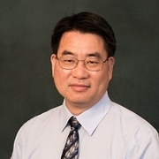
I joined GE Healthcare in 2000 after I completed my PhD. I worked on various MR methodology developments, including fast spin echo imaging and fast volumetric imaging. I also participated in the development of the new EXCITE MR system. I decided to return to academic research in late 2002. I joined the Brain Research Imaging Center at the University of Chicago as an MRI physicist. I continued my research in MR imaging techniques, specifically, spiral imaging for functional MRI (fMRI) applications, T1 mapping of the brain and the quantification of cerebrospinal fluid dynamics for the study of hydrocephalus. I also expanded my interest to fMRI applications. I joined the faculty at Michigan State University in 2005. With other faculty members, we developed the Cognitive Imaging Research Center, and I have been supporting its growth in a role of an MRI physicist and the lead of the support team. I have been collaborating with clinical experts to develop MRI techniques to detect and characterize plaques at the carotid artery, with chemists on MR molecular imaging, and with psychologists and neuroscientists to apply fMRI and other neuroimaging methods to study visual cognition, attention, memory, language processing, social cognition, concussion, normal aging and Alzheimer's disease. Currently, I am leading the Imaging Core of an NIH funded clinical trial aimed to reduce the risks of Alzheimer's disease.
Talk: 9:30-10:20am, April 28, 2021
Weldon School of Biomedical Engineering, Purdue University
(Title will be sent out later)
Register in advance for this webinar:
https://purdue-edu.zoom.us/webinar/register/WN_jdLgaSVLTA2_u8O3hxpWjw

