|  |
| --- |
| Sample Document |

Author Name

*Authors affiliation, fluid@power*

**Abstract**.

This is a sample input file. Comparing it with the output it generates can show you how to produce a simple document of your own. The paper should not be more than 15 pages.

**Keywords**. Keynote lecture, technical presentation, social events.

# Introduction

Purdue’s Maha Fluid Power Research Center invites you to participate to the 2026 International Maha Fluid Power Conference. The conference will be held at Purdue University from September 8th to 10th. The goal of the conference is to network, exchange ideas, and present the recent research trends in fluid power and motion control technologies. The conference will include technical presentations, keynote lectures, and social events.

# Submission Guideline

The organizers will welcome technical contributions from academia and industry on all topics related to fluid power and motion control systems, such as novel fluid power components and systems, solutions for system electrification, condition monitoring, noise and vibration, soft robotics, alternative prime movers, tribology and fluid, pneumatics, etc.

Peer reviewed paper contributions will be published SCOPUS indexed and published open access. In addition, a selection of paper will be published open-access online in International Journal of Fluid Power. A best paper award will be selected among all peer-reviewed full papers.

* Notification of Abstract Acceptance (Dec 31, 2025)
* Paper Submission (Mar 15, 2026)
* Final Paper Submission (Jun 15, 2026)

# 2024 Maha Fluid Power Conference

For the first time in the history of Maha events, there will be an exposition area to display latest component and off-road vehicles with latest actuation technologies.

## Exposition

The exhibit will take place at the Purdue Memorial mall, next to the main conference venue (Stewart Center). Each space will have an approx. size of 20 ft x 20 ft.

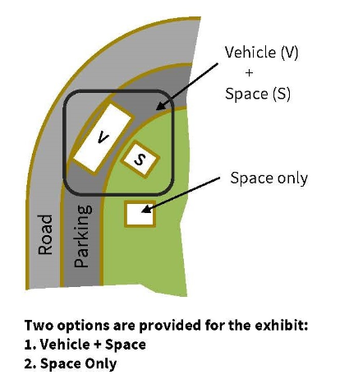

Figure 2.1. Exposition space options

## Power Consumption of conference

In general, energy efficiency of a conference is related to:

|  |  |
| --- | --- |
| $$η_{conferece}=\frac{n_{conversation}}{n_{coffee consumed}}$$ | (2.1) |

# References

[1] L. Shang, et. al., ‘Frequency domain analysis of coffee consumption in conference conversations, 2026 International Maha Fluid Power Conference., West Lafayette, 2026.