ROAD TO THE
NATIONAL REGISTER

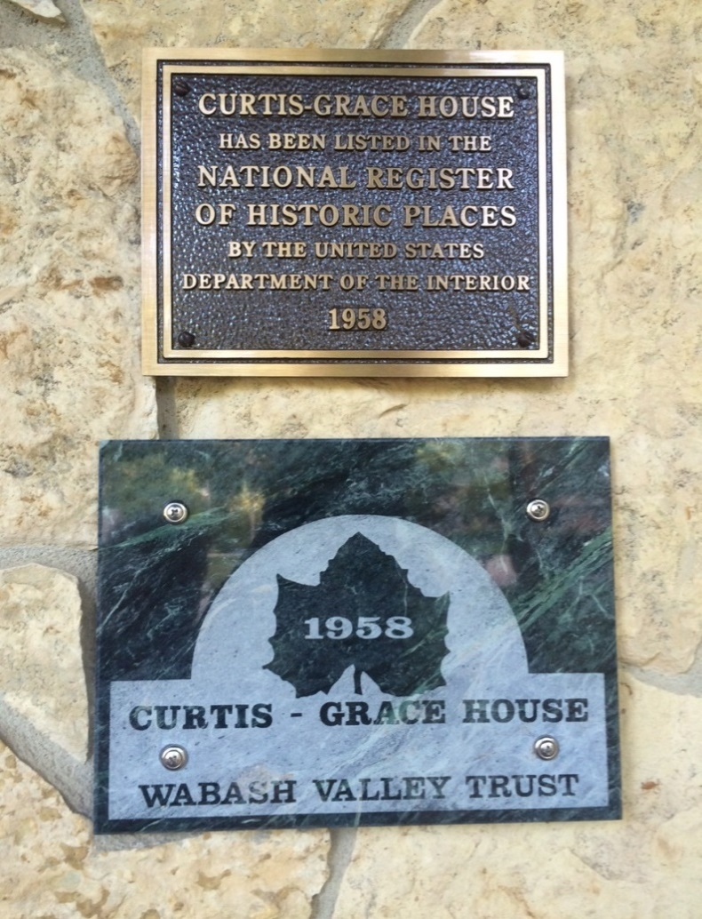

RICHARD E. GRACE
CONNIE F. GRACE

ROAD TO THE NATIONAL REGISTER

Richard E. Grace and Connie F. Grace

Kindle and iPhone Edition, Amazon eBook (2015)

Review

From Long Island, New York to Long Beach, California there is an ongoing movement to restore and preserve historic architecture: Victorian, Italianate, Prairie, Ranch, Mid-century Modern and many more styles. America’s most outstanding properties are listed in the National Register of Historic Places (NRHP). These properties are our architectural heritage.

Road to the National Register details a love affair with a single property: a Mid-century American Modern house built in 1958. The authors purchased this property from an estate sale in 1980. For thirty-five years they have been the stewards who restored and maintained the original design of this mid-century classic to the closest millimeter.

Their house was designed by a young Professor of Architecture at the University of Illinois, Urbana, Robert J. Smith. His vision and imagination were rooted in principles set out earlier by Mies van der Rohe (glass window walls), Frank Lloyd Wright (symbiotic relationship between indoors and outdoors) and Joseph Eichler (post-and-beam construction). Smith’s unique floor plans and building materials captured the hearts of young adults in post-WW II America. The Curtis-Grace house is one of Smith’s extraordinary early designs.

Dick and Connie Grace are the authors who prepared the nomination for listing the Curtis-Grace house in the National Register of Historic Places.

They also authored this book as a guide for others. If you have a significant and outstanding property, you will learn, firsthand, what steps will help you achieve NRHP listing: Eligibility, Significance, Integrity and Age. Our unique, complete and approved Registration Form will guide your way. Enjoy the Road to the National Register!

____________
R. E. Grace and C. F. Grace, Road to the National Register, Kindle e-Book,
Amazon.com, 2015

Media Contact: Winter
Dr. Richard E. Grace 765.463.5271 (Home) January 1 – March 30
2175 Tecumseh Park Lane 765.496.7384 (Office) 3155 Gulf of Mexico Dr.
West Lafayette, IN 47906 765.494.1204 (FAX) Longboat Key, FL 34228
dandcgrace@aol.com regrace@purdue.edu 941.383.3791 Unit 230

GraceRoad2016

