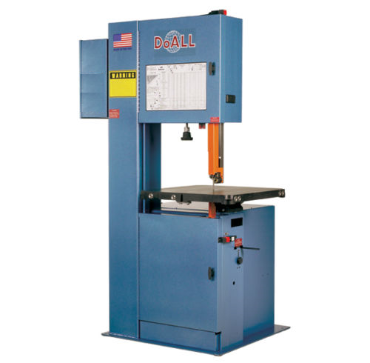
Blade Guard
Blade
Vertical Band Saw
Blade Guard Adjustment Wheel
Controls

Safety: Safety glasses
No loose clothing, hair, or jewelry
Purpose: Rough cut stock to smaller size
Materials: Standard steels, aluminums, plastics, and woods
NO composites or hardened steel

Operational Procedures
- Ensure proper PPE and clothing.
- Double check work area for free space, warning signs, etc.
- Adjust blade guard.
- Ask a TA to supervise you.
- Turn on machine and check speeds.
- Adjust speed if necessary. (If changing gears the machine MUST be turned OFF!)
- CAREFULLY cut part!
- Turn off machine with E-stop button.
- Clean area thoroughly. Should look better than you found it.

