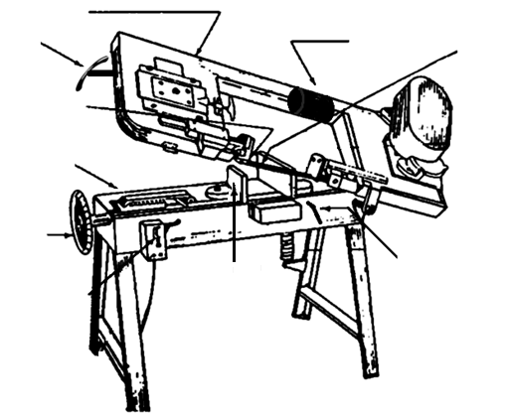
Controls
Vise Adjustment Wheel
Blade Guides
Head
Blade
Droplock
Vise
Auto stop
Lowering Handle
Weight
Drop Saw

Safety: Safety glasses
No loose clothing, hair, or jewelry
Purpose: Rough cut stock to smaller size
Materials: Standard steels, aluminums, plastics, and woods
NO composites or hardened steel

Operational Procedures
- Ensure proper PPE and clothing.
- Double check work area for free space, warning signs, etc.
- Slide weight to motor/hinge side of bandsaw.
- Gently lower head to line up part with blade.
- Clamp part into vise.
- Adjust blade guides.
- Ensure coolant knob is correctly adjusted.
- Ask a TA to supervise you.
- Turn on machine and check speeds.
- Adjust speed if necessary.
- Cut part.
- Clean area thoroughly. Should look better than you found it.

