ME 576 Lab Assignment Session 8

This week's laboratory experiment involves programming of PLCs. Generate PLC programs for two examples covered in the class: i) drilling operation and ii) conveyor line with bin bags.

For the first case, the following functions need to be added. After drilling is completed (lower limit switch E7 is touched), there will be 2 seconds dwelling time before the drill begins to retract. Also, when the drill arm finishes retracting (upper limit switch E8 is touched), the spindle motor must stop. Assume that the spindle motor is in operation only while the output to A1 is high.

In both cases, make the PLC programs more comprehensive by adding more functions to make the operations more robust.

Generate a truth table for each case and verify the table with the simulation results on the PLC. The report must include ladder diagrams, truth tables and programs. Use the following input and output memories:
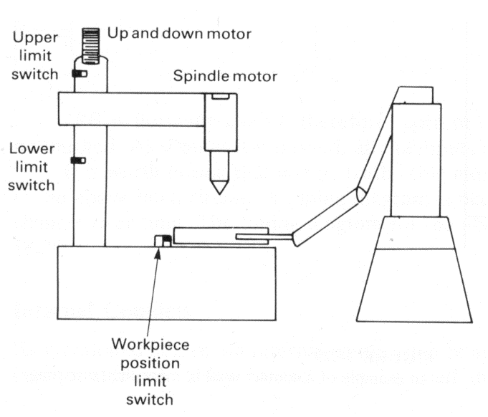
A2(up), A3(down)
Problem 1:

E7 Lower Limit Switch 1
A1
E8 Lower Limit Switch 2
E9 Lower Limit Switch 3
EA Lower Limit Switch 4
EA
A0 Part Loading
A1 Spindle Motor
A2 Up Motor
A3 Down Motor
A4 Part Unloading
E7
A0
part loading
A4
part
unloading

Problem 2:
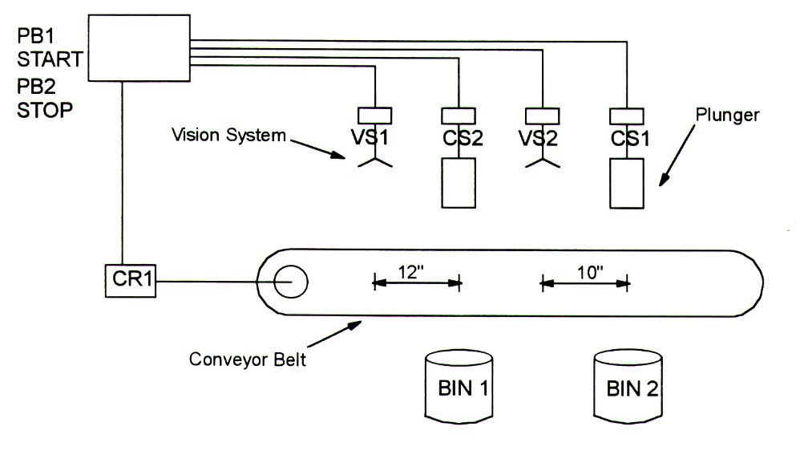
E0 Start (PB1)
E1 Stop (PB2)
E2 Visual System VS1
E3 Visual System VS2
E4 Bin 1 Overfill Sensor
E5 Bin 2 Overfill Sensor
A0 Conveyor Motor
A0 Plunger CS1
A1 Plunger CS2

Note: The following operators are helpful for this lab assignment:

CAL
IEC Operator: Calling a function block or a program
Use CAL in IL to call up a function block instance. The variables that will serve as the input variables are placed in parentheses right after the name of the function block instance.
Example:
Calling up the instance Inst from a function block where input variables Par1 and Par2 are 0 and TRUE respectively.
CAL INST(PAR1 := 0, PAR2 := TRUE)

TON
Timer function block, implements a turn-on delay. When the input gets TRUE, first a certain time will run through until also the output gets TRUE.
Inputs:
IN : BOOL; Rising edge starts counting up ET.
PT : TIME; Upper limit for counting up ET (delay time).
Outputs:
Q : BOOL; Gets a rising edge as soon as ET has reached the upper limit PV (delay time is over).
ET : current state of delay time.
Example in IL:
