ME 576 Laboratory Assignment Session 7

Generate PLC programs and generate the truth table to verify the results. Store the programs in a USB 2.0 flash drive and simulate them on the NUM PLC.

1)
E0

E1 E3 A0

E2

2) Write a short program to perform the following operation according to two inputs I0 and I1.

operation: 79 ⊗ 85 (Send output to AN2)

I0 (E1) 0 0 1 1
I1 (E2) 0 1 0 1

⊗ and or nand xor

3)
E0 E1

E2 A8

E3 E4
A9
E5

4) Operation: Motor control problem

Motor = (Motor + start) AND stop AND clamp1 AND clamp2

Use the following variables:

Motor: A0
Start: E1
Stop: E2
Clamp1: E3
Clamp2: E4

Procedures for simulation on NUM machine:

1 - Open the ME576 project template
Start Flexium Tools software in NUM machine. Under “Getting started”, click on “Open a project from disk”. Select “ME576PLC.project”. The template has been designed for pre-mapping of the variables to the correct addresses of the PLC numpad.

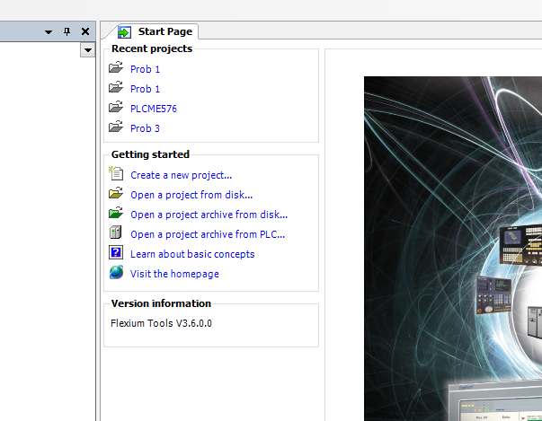

Click on Finish to accept all the default NUM project configurations

2 – Start programming in MainPRG under PLC Logic → Application

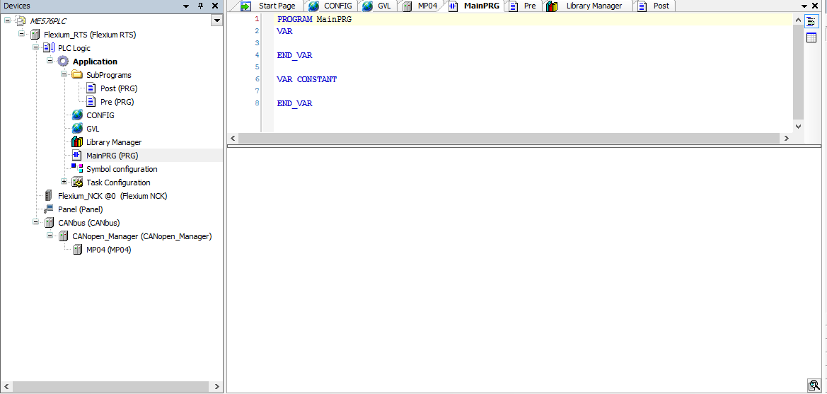

Refers to the CodeSys Manual for instructions on how to use the built in function.

3 – Convert the program from instruction list to ladder diagram to verify your code.

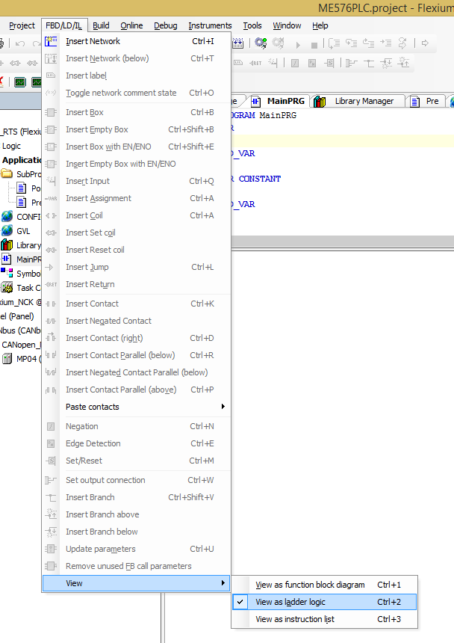

4 – Simulate the PLC program using NUM numpad buttons:

