ME 576 Laboratory Assignment Session 7

Generate PLC programs and the truth table to verify the results. Store the programs in a USB 2.0 flash drive and simulate them on the NUM PLC.

1)
E0

E1 E3 A0

E2

2) Write a short program to perform the following operation according to two inputs I0 and I1.

operation: 79  85 (Send output to AN2)

I0 (E1) 0 0 1 1
I1 (E2) 0 1 0 1

 and or nand xor

3)
E0 E1

E2 A8

E3 E4
A9
E5

4) Operation: Motor control problem

Motor = (Motor + start) AND stop AND clamp1 AND clamp2

Use the following variables:

Motor: A0
Start: E1
Stop: E2
Clamp1: E3
Clamp2: E4
Procedures for PLC simulations on NUM machine:

1 - Open the ME576 project template
Start Flexium Tools software in NUM machine. Under “Getting started”, click on “Open a project from disk”. Select “ME576PLC.project”. The variables in the template have been pre-mapped to the correct addresses of the PLC numpad.

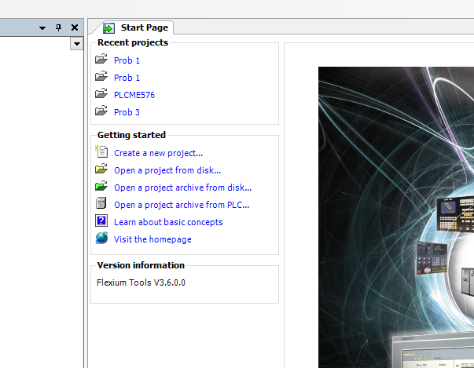

Click on Finish to accept all default NUM project configurations.

2 – Start programming in MainPRG (under PLC Logic → Application)

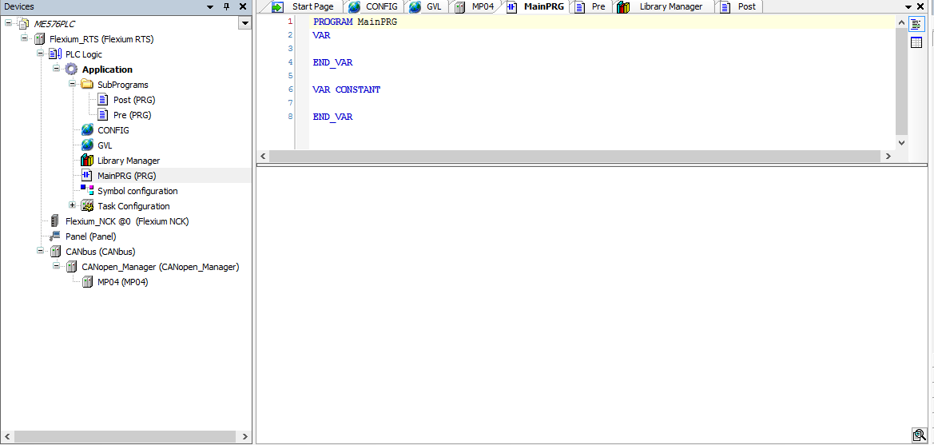

The following operators can be used for PLC programing in this lab:

Operator | Modifiers | Meaning | Example
LD | N | Loads the (negated) value of the operand into the accumulator. | LD iVar
ST | N | Stores the (negated) content of the accumulator into the operand variable. | ST iErg
S |  | Sets the operand (type BOOL) to TRUE when the content of the accumulator is TRUE. | S bVar1
R |  | Sets the operand (type BOOL) to FALSE when the content of the accumulator is TRUE . | R bVar1
AND | N,( | Bitwise AND of the accumulator and the (negated) operand | AND bVar2
OR | N,( | Bitwise OR of the accumulator and the (negated) operand | OR xVar
XOR | N,( | Bitwise exclusive OR of the accumulator and the (negated) operand | XOR N,(bVar1,bVar2)
NOT |  | Bitwise negation of the accumulator's content
ADD | ( | Addition of accumulator and operand, result is copied to the accumulator . | ADD (iVar1,iVar2)
SUB | ( | Subtraction of accumulator and operand, result is copied to the accumulator. | SUB iVar2
MUL | ( | Multiplication of accumulator and operand, result is copied to the accumulator. | MUL iVar2
DIV | ( | Division of accumulator and operand, result is copied to the accumulator. | DIV 44
GT | ( | Check if accumulator is greater than or equal to the operand, result (BOOL) is copied into the accumulator; >= | GT 23
GE | ( | Check if accumulator is greater than or equal to the operand, result (BOOL) is copied into the accumulator; >= | GE iVar2
EQ | ( | Check if accumulator is equal to the operand, result (BOOL) is copied into the accumulator; = | EQ iVar2
NE | ( | Check if accumulator is not equal to the operand, result (BOOL) is copied into the accumulator; <> | NE iVar1
LE | ( | Check if accumulator is less than or equal to the operand, result (BOOL) is copied into the accumulator; <= | LE 5
LT | ( | Check if accumulator is less than operand, result (BOOL) is copied into the accumulator; < | LT cVar1
JMP | CN | Unconditional (conditional) jump to the label | JMPN next
CAL | CN | (Conditional) call of a PROGRAM or FUNCTION_BLOCK (if accumulator is TRUE) | CAL prog1
RET |  | Early return of the POU and jump back to the calling POU | RET
RET | C | Conditional - if accumulator is TRUE, )early return of the POU and jump back to the calling POU | RETC
RET | CN | Conditional - if accumulator is FALSE )early return of the POU and jump back to the calling POU | RETCN
) |  | Evaluate deferred operation

3 – Convert the program from instruction list to ladder diagram to verify your code.

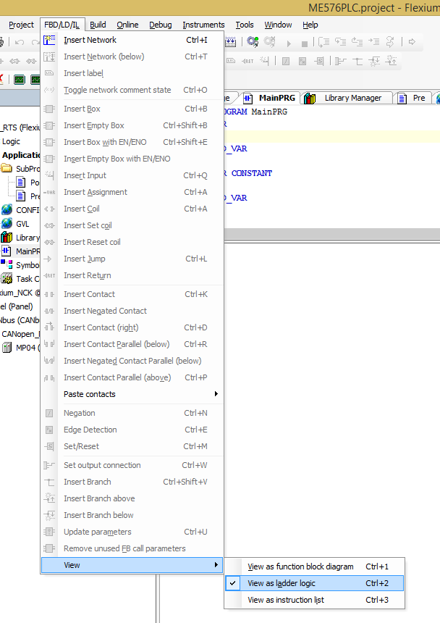

4 – Simulate PLC program using NUM numpad buttons

