Project Idea Submission – Industry

Sponsor’s/company’s Information
Name: _Starsiak osteopathic clinic___________________ Date: __09/03/2024__

Sponsor’s/company’s Liaison Contact Information
Name: __William Starsiak___________________________________________
Title: _____________________________ E-Mail: _info@starsiak.com_________
Phone: _(___)____________ Cell: _(___)_______________ Fax: _(___)___________
Address: ______3955 Eagle Creek Parkway STE A____ _____________
Street Address / P.O. Box Suite #
___Indianapolis______ ___IN__________ _46254____ ____________
City State ZIP Code Country

Project Name
Soft actuation synchronized augmenting motion generation by analyzing the heartbeat patterns

General Project Description
A device that senses respiratory rate AND beat to beat heart rate variability via the heart rate, and/or arterial constriction and relaxation using an infrared sensor on the earlobes ( either of these can be used for follow the Mayer Waves which is the most important first step), the device then introduces specific, biologically harmonious forces that match the respiratory rate initially and when the respirations entrain with the mayer waves then the force intervention matches the normal subtle motions that are synchronous with the mayer waves (there is research on this). The contacts for force application at the ribs would provide and anterio-lateral-inferior force during inspiration, and would return to neutral during expiration. This would be done at the beginning of the treatment for 3 minutes on each side, one side at a time. Then the force would begin to encourage entrainment of the breathing with the Mayer wave as sensed through HRV or infrared sensor. So if breathing was faster than Mayer wave the force would lag behind. If we can only have one more contact point to apply force in synchrony with respiration and the, continues at the end

What is the Mechanical Engineering problem you are wanting Solved?
Synchronizing a very specific force amount and vector with respiration and then mayer waves and specific subtle, inherent anatomic motions. Basically, initially augmenting respiration(like pushing a child on a swing, the augmenting deep, sublte anatomic motions synchronous with the mayer waves

Why is this problem worth solving? (Value Proposition)
The respiratory component, when done by Osteopaths every two hours to hospitalized patients with pneumonia, accelerates recovery time for pneumonia decreasing hospital stays and lowers the mortality rate from Pneumonia. The mayer wave augmentation through manual treatment by osteopaths has been effective in treating many conditions such as general stress, anxiety, insomnia, headaches, autonomic imbalance, and more

what are the most important functional requirements and specifications for this project?
Req 1: Accuracy of tracking physiologic phenomena to trigger the palpating motion. To simplify the problem for mayer wave detection, commercial heartbeat monitor that will export the waveform will be used.
Req 2: Applied forces very closely match inherent motion patterns
Req 3: Ability to track the impact of the applied forces on the mayer wave and respiration as feedback.
…
Spec 1:
Spec 2:
Spec 3:
…

What do you anticipate the students designing, analyzing, building/prototyping and testing?
Design: Utilize commercial heartbeat sensor to detect the mayer wave patterns and design a prototype actuation mechanism that can apply very small amount of forces on the certain position of the patients based on the mayer wave triggering

Analyze: Software algorithm to define, and identify the mayer wave patterns from heartbeat wave patterns will be needed (coding)

Build: Soft actuation mechanism

Test: Demonstration of synchronized action of mayer wave detection and soft actuation

What is you best estimate of the cost of the hardware, components, materials, … of the proposed prototype?
Total $1000-2000
Hardware Costs:
Component Costs:
Material Costs:
…

How much time and effort would you expect to spend on this project if you were doing it internally?
Calendar Months: Total Hours (Engineering, Shop, …):

Do you believe the project can be completed with existing technology, if not, elaborate on needed DEVELOPMENTS?
Absolutely

concerns or Other related information associated to the proposed project?
Concerns: The accurate sensing of the mayer waves, synchronizing applied forces with it, the specificity of the forces matching indwelling subtle motion patterns, the quality of the contact being comfortable (warmth and material), sensitivity to ligamentous elasticity and compliance as well as comparing them meaningfully

Other Info:

Attach any appropriate Sketches, Drawings, Standards, Data, photos, … useful in judging appropriateness and scope of proposed project.
(list of attachm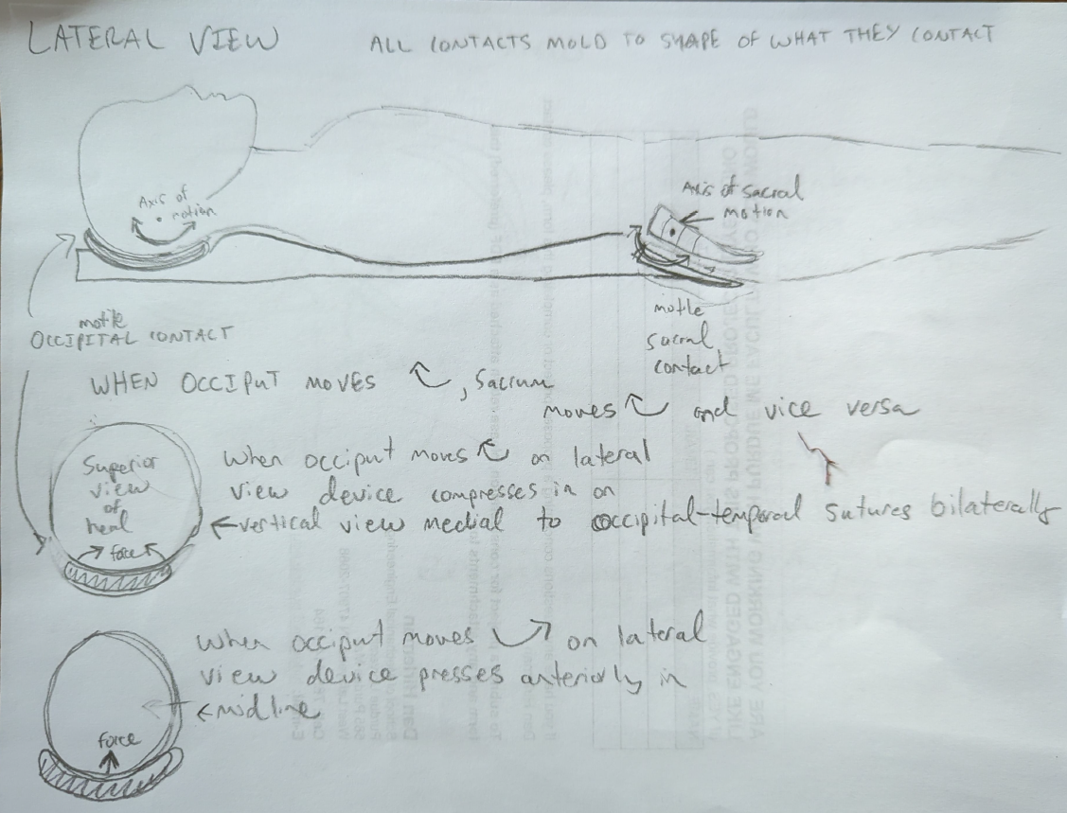ents) 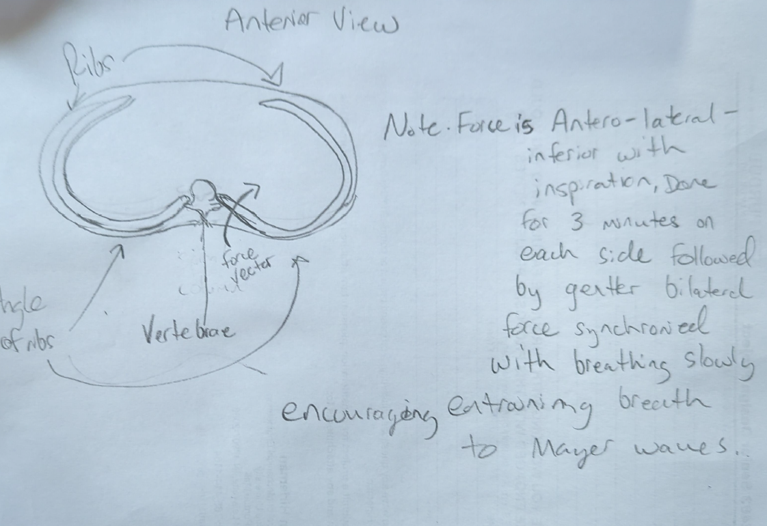

Are you working with Purdue ME Seniors who you would like on this proposed project? Yes/no (If YES, provided what information you can.)
NAME | Phone | EMAIL

Are you working with Purdue ME faculty who you would like engaged with this proposed project? Yes/no (If YES, provided what information you can.)
NAME | Phone | EMAIL

If you have any questions concerning a proposed project or completing this form please contact Professor Greg Jensen.
To submit this document for consideration, please complete the survey using either the QR code or the link below.



https://purdue.ca1.qualtrics.com/jfe/form/SV_bkCjo7jyE5Wb7ro

C. Greg Jensen, PhD
Director of Senior Design
Professor of Engineering Practice
School of Mechanical Engineering, Room 2195
Purdue University
585 Purdue Mall
West Lafayette, IN 47907-2088

Office: 765-496-0214
Cell: 801-367-6145
Fax: 765-496-1114
E-mail: jensen23@purdue.edu

