Wrap5 – Extreme Makeover, Web Site Edition
April 2006

Overview
The College of Engineering successfully launched a revamped web site in early 2006. Extensive changes to the content architecture, navigation scheme, and look-and-feel provide a fresh, user-friendly web experience.

Content Architecture
We developed a content structure and navigation scheme that is expandable and easy to understand using peer site review, internal analysis, and usability testing. All web content is organized into four sections:

- About Us – “Corporate” overview of the school or department
- Our People – Directories of Faculty, Staff, Students, Alumni, etc.
- Academics – Specifics of the school’s academic programs
- Research – Details of the school’s research initiatives

Additionally pages were created to collect information pertinent to each of our target audiences:

- Current Students
- Future Students
- Alumni & Friends
- Faculty & Staff

A recommended minimum content structure is attached. In addition to the minimum recommended structure it is suggested that you review schools at your peer institutions to identify important content that may be missing from your site. Content that you are not currently providing should be created before launching a site under Wrap5.

Migration to Wrap5
If your school opts to update their web site to Wrap5 the web team will create a development site for your school. The development site will contain the necessary structure and graphics for your school.

You will place updated versions of content from your existing site it into the new content architecture. The web team is available to answer questions during the migration. If you desire additional help student time can be purchased to assist in moving content.

Once all of the information is organized and updated in the development site the web team will work with you to launch the new site.

Working with Wrap5

Objects
Create or edit the following objects to change the appearance of pages within your site:

- sidebarLeft – This is a DTML Method or Page Template which controls what links show up within a portion of the web site. This object should define the main navigation within each of the four sections of the web site. It should contain links, one per line, without break tags. While it is possible to override the sidebarLeft at a lower level in your site, it is recommended that third level navigation be handled with the sidebarRight object.
- sidebarRight – This is a DTML Method or Page Template which controls what shows up in the right sidebar in a section of the site. This object should contain links and navigation related to the current content. Navigation within the History portion of a site should be handled using the right sidebar. It should contain headings and links one per line without breaks.
- local.css – This is a DTML Method or File which contains the style sheet for a portion of the web site.

Properties
Create or edit the following properties on folders to change the appearance of pages within your site:

- entity_title (string) – The school, department, or program name shown in the title bar and within the left side links on the school’s homepage
- show_sidebar_left (Boolean) – Turn on and off display of the left sidebar, shown by default
- show_sidebar_right (Boolean) – Turn on and off display of the right sidebar, shown by default

CSS Classes
CSS Classes can be applied to HTML you create within your site to alter the way content is displayed:

- left-photo – placed on a div tag which contains an image and a paragraph to create a left aligned photo with a caption:

<div class="left-photo">  <img src="Images/birk.jpg">  <p>Birck Nanotechnology Center</p>  </div> | 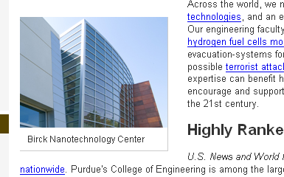

- right-photo – placed on a div tag which contains an image and a paragraph to create a right aligned photo with a caption:

<div class="right-photo">  <img src="Images/bme_building.jpg">  <p>Biomedical Engineering Building</p>  </div> | 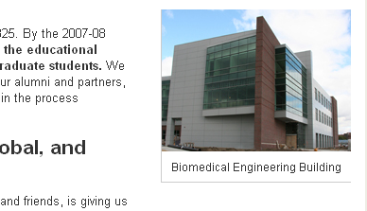

Intranet
Before Wrap5, the College of Engineering’s web site contained content targeting a mix of internal and external audiences. For example, information for Faculty submitting granting grant proposals was mixed with information for future graduate students.

In designing the new site, we decided to separate the public, marketing-oriented information from material that is directed at internal audiences. This separation allows us to present a clearer, more coherent message to the public, while making it easier for engineering faculty and staff to control who can see the information that they post.

The internally focused site is the Engineering Intranet. The intranet provides a set of tools that makes it easy to post documents and files on the web while managing access controls. Training on the Intranet will be offered in the near future.

Recommended Content Structure
- About Us
  - Home – Overview of the School
  - Meet the Head/Director/Dean
  - Administrative Structure
  - Why XXX Engineering? – Why should the world be interested in your program?
  - Diversity
  - Facilities
  - Newsroom
  - History
  - Facts and Figures
  - Giving
  - Employment
  - Contact Us
  - Visit Us
- Our People
  - Directory Listing – Alphabetical listing of Faculty and Staff
  - Faculty by Research Area
  - Administration – Listing of Upper Administration
  - Committees
  - Academic Advisors
- Academics
  - Home – Overview of Academic Programs offered by the School
  - Course Catalog
  - Undergraduate Program
  - Graduate Program
  - Financial Aid
  - Accreditation
- Research
  - Home – Overview of Research within the School
  - Research Initiatives
  - Research Areas
  - Labs & Facilities

