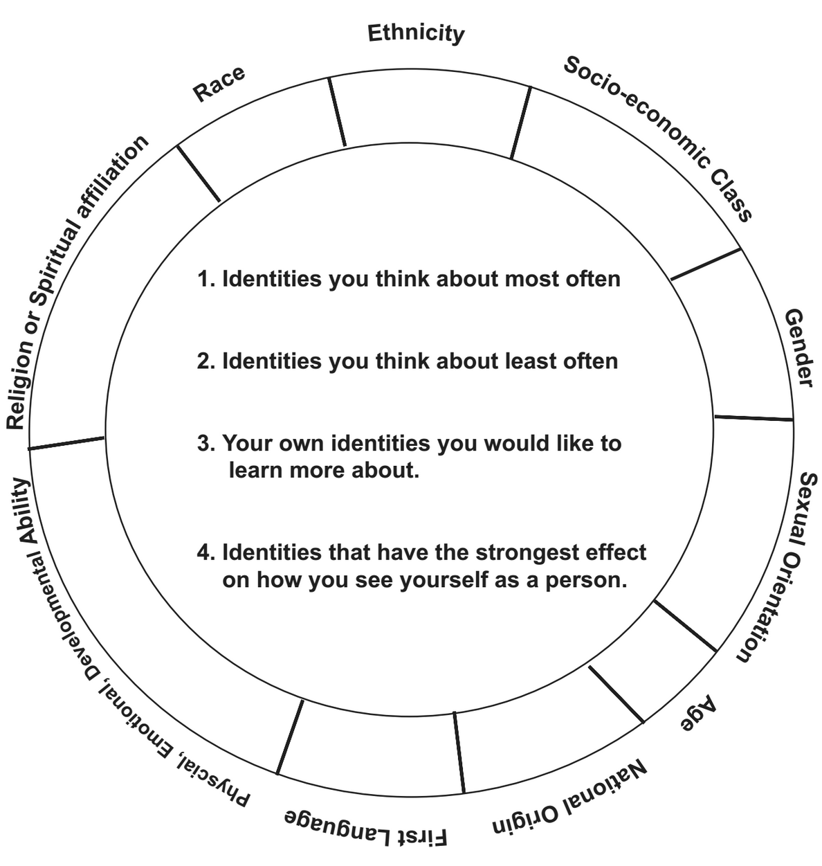

Adapted from: Zúñiga and Kachwaha (2009).“Voices of Discovery”, Intergroup Relations Center at Arizona State University.

