Purdue’s Engineer of 2020 Seed Grant Project (2008-2009 cycle)
Multidisciplinary Insights for Learning Engineering Aerospace Design (MILEAD)
Dr. Daniel DeLaurentis, Dr. Masa Okutsu, & Dr. Kathleen Howell, AAE Dr. Sean Brophy, ENE

We are currently developing a MPO (multi-player online) serious-game, virtual world version of Introduction to Aerospace Design (AAE 251), a sophomore-level engineering course offered twice a year in the School of Aeronautics and Astronautics. This project’s primary sponsor is the Purdue Discovery Learning Center. The digital delivery system intends to effectively introduce learners to the design profession of aerospace engineering, increase the authenticity of teaming, and provide a process for measuring students’ development in approaching and solving novel problems. The design process is well-tailored for a game in that learners can progressively engage in a series of “quests” (or challenges) involving collaborative design teams, research-and-design activities on specific components, and system-integration activities to bring the entire design together. We are combining current theories of learning and instruction with the principles of game design to provide a powerful new learning experience that prepares learners for future careers.
However, to make the environment rich in resources, we envision a new digital library created and shared by a network of instructors, students, departments, and industry experts via web portals and virtual worlds. The use of cyber-infrastructure would connect students directly to experts and peers to support their learning the art of design practice more effectively. The rich digital library we envision needs to be seeded with educationally appropriate resources to demonstrate its potential for intentional learning at the undergraduate engineering level. The seed grant we received from the PE 2020 effort provides the opportunity to capture and share multiple perspectives from experts (from industry and academia), leveraging our ongoing research on learning via worlds. With this grant we have developed digital content that provides “access to experts” that can be viewed during the game play for the AAE 251 students as well as a via a web portal for other student audiences (even outreach to the general public). The contributors include Professor Longuski, Professor Howell, and Dr. Okutsu (all from AAE) on spacecraft and mission design, Professor DeLaurentis (AAE) on Aircraft Design, Professor J. Mark Thom from Aviation Technology on Aircraft Engine, and series of in-game and real-world presentations by the students. Some of the digital content has already been accessed by students in AAE 251 in Spring and Fall 2009 semester in solving “quests” in aerospace design. We will evaluate the progressive refinement of learners’ ability to blend others’ ideas with their own to generate innovative conceptual designs.
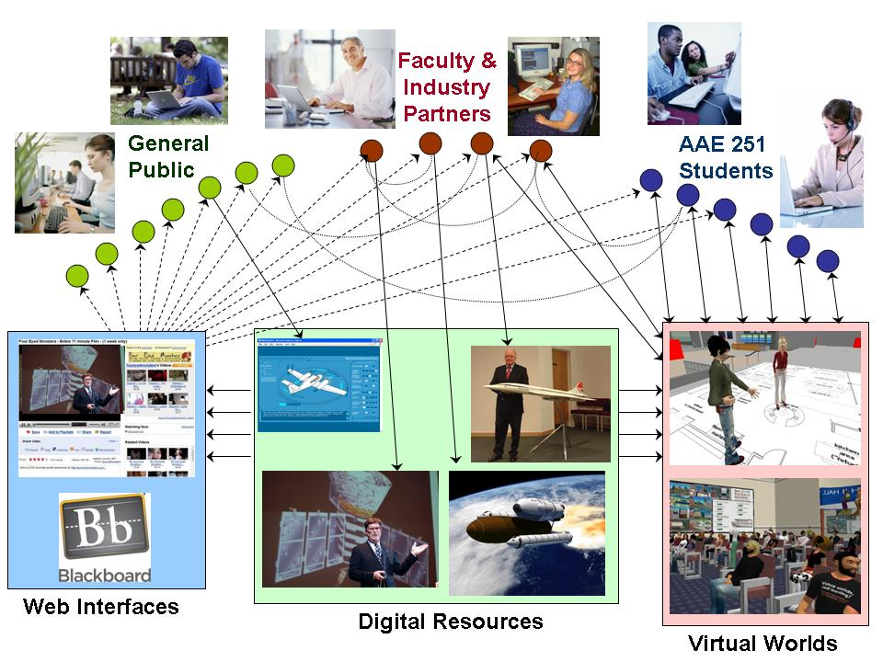
Digital resources (e.g. Video Lectures, Demonstrations, and Visualized Simulations) are developed through collaboration with faculty and industry partners. These resources are made available via the Virtual World for AAE 251 students and for the general public (including faculty, industry partners, and former, current, and future AAE 251 students). Through the Proposed Cyber-Infrastructure the Faculty and the Industry Partners Can Give Real-Time Feedback, Forming Communities Across Geographically Dispersed Locations.

