Engineering
Intranet Guide
November 2008

http://engineering.purdue.edu/Intranet
webmaster@ecn.purdue.edu

Overview
The Engineering Intranet is a collection of web sites for administrative use within the College of Engineering.

Logging In
Before you will be able to view restricted information or make updates to the Intranet sites that you administer you must log in. Every page within the Intranet contains a “My Account” box on the left below the links box. Provide your career account login and password and click the Login button.
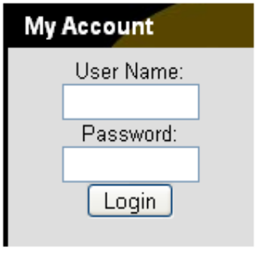
My Account Box – Logged Out
Once you have logged in the login box will change to display your fully qualified name; a logout button; and links to your personal portal, personal web site, and bookmarks.
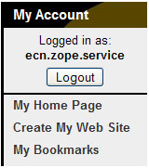
My Account Box – Logged In
You will remain logged into the Intranet until you click the logout button, close your web browser, or your session expires (a session lasts for six hours).

Accessing Admin Mode
Once you have logged into the Intranet an “Edit” link will appear in the upper right corner of sections of the web site that you are authorized to modify. Clicking the edit link will take you to an administrative screen (admin screen) for the page you are currently viewing. While on an admin screen “Edit” is replaced “View”, clicking “View” will exit the administrative screen.
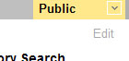
Edit Link

The Admin Screen

Breadcrumbs
Breadcrumbs show your current location within the Intranet. Clicking on an item in the breadcrumbs jumps you to the admin screen for that folder or document.
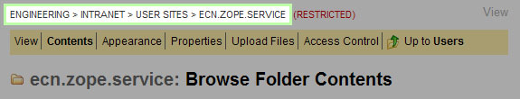
Admin Screen – Breadcrumbs

Access Identifier
The access identifier displays a summary of the access control settings for the current page. When the access identifier is green and reads “Public” everyone is able to view the current section. An access identifier that is red and reads “Restricted” is only available to those defined in that sections access controls.

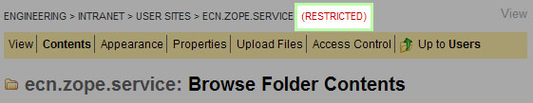
Admin Screen – Access Identifier

Options Bar
The options bar provides links to each of the admin screens for the current folder or document you are editing. The active admin screen is displayed in bold. Click on the links to view different options for the current folder or document. The options within the options bar vary depending on the type of item you are editing.
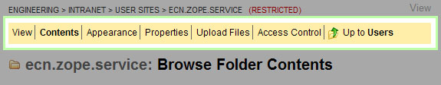
Admin Screen – Options Bar

Title
The title displays the icon and id of the item being edited along with the title of the current admin screen.
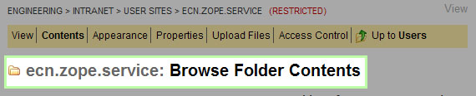
Admin Screen - Title

Workspace
The workspace displays the options for the active admin screen. These options vary greatly depending on the type of item you are editing and the active admin screen.
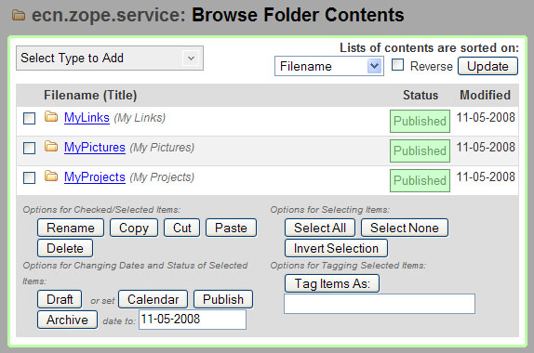
Admin Screen - Workspace

Creating your Personal Site
Once you have logged into the Intranet you can create a personal site to post your documents and files. To do this click the “Create My Web Site” link in the “My Account” box on the left side of the screen and follow the directions.
After your site is created you can return to it at anytime by logging in and clicking the “My Web Site” link in the “My Account” box.

Type: Folder
Folders hold things; they organize your documents within the Intranet in the same way that directories/folders organize your files on your personal computer.

Contents
The “Contents” admin screen lists the items located within the folder. From here you can add new content or remove exist content.

Adding new Content
In the upper left of the workspace is a grey dropdown menu titled “Select Type to Add”. Clicking on this menu brings up a list of the types of items that can be created within the Intranet.
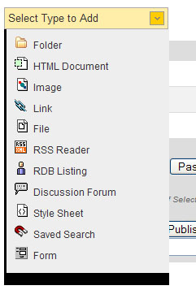
Select Type to Add Dropdown
A description of each type is available under the corresponding section within this documentation. Click on the type of item you would like to add and you are taken to the add form for that type.

Copy, Paste, and Delete
To the left of each item in the content listing is a checkbox. Checking the checkbox selects that item. After selecting one or more items several buttons are enabled below of the content listing. These buttons perform actions on the selected items. After items have been copied or cut a Paste button will also be available.
- Rename – Change the Ids of the selected items
- Copy – Copy the selected items to the Intranet Clipboard
- Cut – Cut the selected items to the Intranet Clipboard (note: items are not removed from their current folder until they are pasted into a new location)
- Delete – Remove the selected items
Three additional buttons: Select All, Select None, and Invert Selection are available to assist you in selecting the appropriate items.
- Select All – Select all of the items in the current folder
- Select None – Unselect all currently selected items
- Invert Selection – Reverse your current selection

Appearance
The “Appearance” admin screen defines what a user sees when viewing a folder. The layout a user sees is divided into four or more sections, the left sidebar, header, body, and right sidebar. The body portion can be subdivided into up to four columns. Each section can be filled with blocks of content. The default appearance for a folder is one block in the body which lists the contents of the folder.
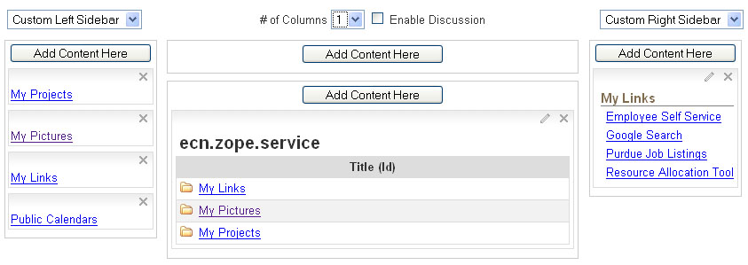
Folder Appearance

Options
Four options allow you to customize the layout of content when viewing a folder.

Folder Appearance – Options

- The left most dropdown provides two options for the left sidebar:
  - Acquire Left Sidebar – Display the links that are used in the parent folder (default)
  - Custom Left Sidebar – Create a new set of links to display in this folder (and sub folders set to acquire)
- The “# of Columns” dropdown defines how many columns of content make up the body portion of the folder’s layout.
- The “Enable Discussion” checkbox displays a simple form for discussing the content of a folder below the body. This is useful when requesting feedback on one or more documents.
- The right most dropdown provides three options for the right sidebar:
  - No Right Sidebar – Do not display a right sidebar in this folder (or sub folders set to acquire)
  - Acquire Right Sidebar – Display the items that are used in the parent folder (default)
  - Custom Right Sidebar – Create a new right sidebar to display in this folder (and sub folders set to acquire)

Adding a Block
A new block can be added to any section of the layout that is not acquired. Clicking the “Add Content Here” button within any section of the layout launches the “Select an Object” dialog. From here you can browse the content of the Intranet to find the item you would like to add to your layout.
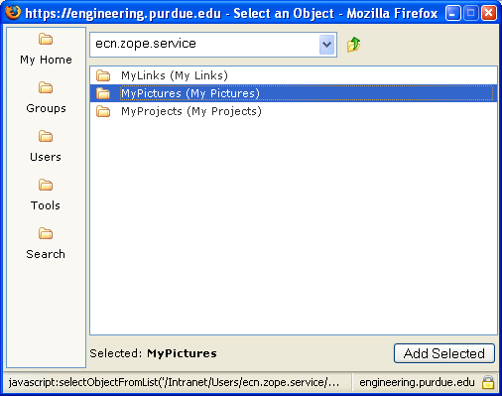
Select an Object Dialog
Select the item to add using the mouse, and then click the “Add Selected” button in the lower left corner. The folder appearance screen will refresh and the selected item will display within the section where it was added.
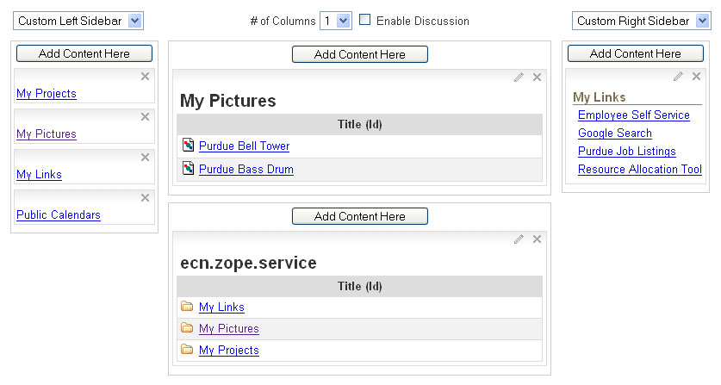
Folder Appearance – Item Added

Moving a Block
Once a block is added to the layout it can be moved within a section or placed in a different section using the mouse. Move a block by placing your mouse pointer over the gray gradient area at the top of the box, the mouse cursor will change to indicate the item is movable. You can then drag and drop the box to a new location. The target location will become highlighted with a green bar.

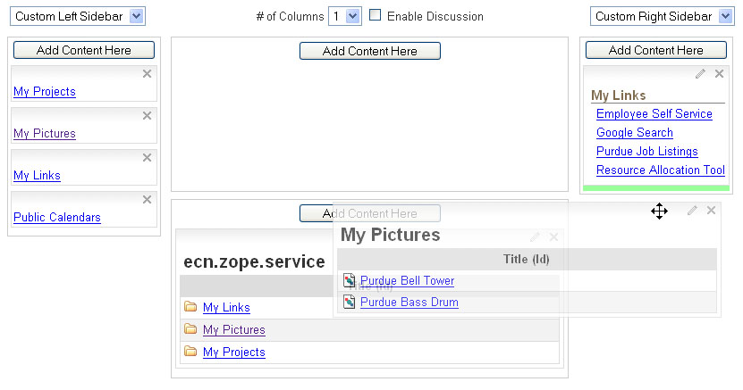
Folder Appearance – Moving a Block
After moving an item the appearance screen will refresh and display the item in the new location.

Changing a Block
The content contained in each block can be displayed in multiple ways. A folder, for example, can be displayed as: a table, a list of links, or a list of thumbnails.
To change the way a box on is displayed click on the small pencil icon in the gray bar above the box. This will launch the Appearance Settings dialog for that block.
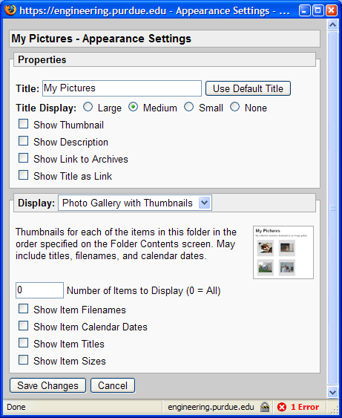
Appearance Settings Dialog

The Appearance Settings dialog lets you: set the text and size of the title for the block; turn on or off the thumbnail; turn on and off the description; and adjust how the content is displayed.
Options within the Appearance Settings Dialog vary depending on the type of object you are displaying.

Removing a Block
A block can be removed from the appearance of a folder at any time by clicking the icon in the upper right corner of the box.

Properties
The “Properties” admin screen lets you change the title, description, publication status, and thumbnail for a folder. See the section on Document Properties for a full description of each field on the properties screen.

Upload Files
It is common to need to post several files or documents to the Intranet at one time. This can be achieved from the “Upload Files” admin screen of a Folder. To access the “Upload Files” screen click the “Upload Files” link in the options bar of the folder where you would like to post your files or document.
This portion of the Intranet uses a Java Applet, as the page is loading it may present you with a few security warnings, you must answer yes to these warnings to enable the multiple file upload feature.
There are three options you can set before uploading your files:
- The “Publish Status” setting determines if newly uploaded items are immediately published or created as drafts.
- The “Replace Existing Files” determines how newly uploaded files with the same names as existing files will be handled.
- The “Upload as” setting determines what type of intranet objects are created when files are uploaded. The default option of “Files, HTML Documents, and Images” is acceptable for most uploads. The “Files only” option should be used when uploading web versions of Outlook Calendars or web versions of PowerPoint Presentations.
You must click the “Apply Options Changes” button for changes to the options to take effect.
After you have made any necessary changes to the options you can upload files by dragging the icons from your computer (desktop) and dropping them into the “File Upload” window in the workspace. (You may receive another warning stating that the server certificate is invalid, click yes to continue)
Once your files are uploaded you can view them by returning to the “Contents” admin screen.

Access Control
The “Access Control” admin screen lets you define who can view and who can edit the items within a folder. The workspace is divided into two lists: Viewers and Administrators. Viewers are able to view content within the folder. Administrators can view and edit (make changes) to the content within the folder. Each list is divided into two sections Local and Acquired.

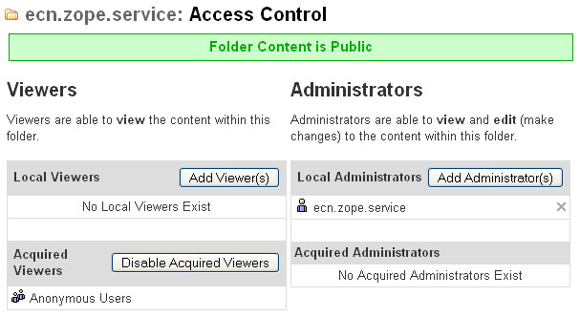
Access Control
- Local Viewers – lists the viewers added to the folder. A viewer can view the content of the folder where they are added and all sub folders. Additional Viewers are added to the list using the “Add Viewer(s)” button. Local Viewers can be removed using the icon to the right of the Viewer’s name.
- Acquired Viewers – lists the local viewers added in higher level folders. You can disable access to these viewers by clicking the “Disable Acquired Viewers” button.
- Local Administrators – lists the administrators added to the folder. An administrator can view and edit content of the folder where they are added and all sub folders, this cannot be disabled. Additional Administrators are added to the list using the “Add Administrator(s)” button. Local Administrators can be removed using the icon to the right of the Administrator’s name.
- Acquired Administrators – lists the administrators added to higher level folders. This list cannot be changed or disabled.

Adding a Viewer
Click the “Add Viewer(s)” button. This will launch the “Select a User or Group” dialog box.

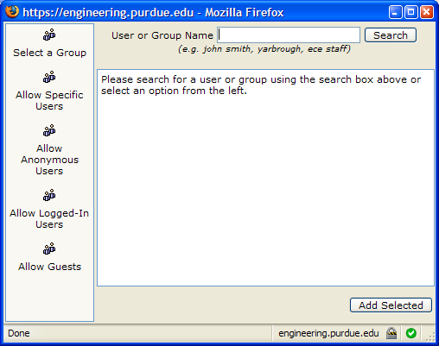
Select a User or Group Dialog
To locate a user, type a portion of the user’s name in the “User or Group Name” field and click search. A listing of available results will be displayed. Select the user you would like to add and click the “Add Selected” button in the lower right corner.
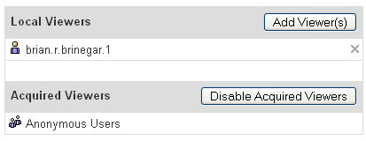
Viewers – User Added
You can remove viewers by clicking the icon to the right of their name.

Adding an Administrator
Click the “Add Administrator(s)” button. This will launch the “Select a User or Group” dialog (see “Adding a Viewer” above).

Restricting Access to a Folder
Often you will want to restrict who can view the contents of a folder. To restrict access to a folder follow these steps:
- Disable Acquired Viewers – Click the “Disable Acquired Viewers” button. This guarantees that only those viewers you specify will be able to view the content of the folder.
- Add Viewers – Use the “Add Viewer(s)” button to add those users and groups that should have access to the folder.

Opening a Folder to the Public
There may be Intranet content that should be shared without requiring users to login. This can be achieved by granting access to the “Anonymous Users” group. Click the “Add Viewer(s)” button to launch the “Select a User or Group” dialog. Click the “Grant Access to Anonymous Users” button on the right hand side. Anonymous Users will appear as a new viewer.

Access Control Groups
On the left portion of the “Select a User or Group” dialog is a button to “List Groups”. This clicking this lists several predefined groups of users. These groups are maintained by staff in various schools and administrative groups. Access granted to a group applies to everyone within that group.

Type: HTML Document
An HTML Document is document designed for the web using the Hyper Text Markup Language. Most web pages, including those on the Intranet, are made up of HTML. HTML Documents are presented to users of the Intranet with the standard graphical look-and-feel including the header, footer, and sidebars. An HTML Document can also be added to the appearance of a Folder to act as introductory text to a listing of files.
The Intranet provides an easy to use WYSIWYG (What You See Is What You Get) editor for creating HTML Documents.

Type: Image
An Image is a graphical file such as a photograph or a chart. Images can be added to the appearance of a Folder, displayed as galleries, and included in HTML Documents. When an Image is uploaded to the Intranet a thumbnail and preview image are automatically created.

Type: Link
Links provide a way to point users at web pages outside of the Intranet.

Type: File
A File is a generic Intranet object for items such as MS Word Documents, PDF Documents, Video, Audio, PowerPoint, etc.

Type: RDB Listing
A RDB Listing provides a way to list sets of people from the Engineering Resource Database.

Type: RSS Reader
An RSS Reader offers a way to pull an RSS Feed from anywhere on the web into your Intranet Site. RSS is an acronym standing for “Rich Site Summary” or “Really Simple Syndication”. Generally RSS Feeds provide news or alerts.

Type: Discussion Forum
A Discussion Forum is a place for users to exchange messages with a group. Users with access can post questions or comments. The Intranet Forums provide options to allow users to post files. Generally anyone with view access to the forum is able to post.

Type: Form
A Form is a simple to use data collection tool. A set of “fields” or questions are specified, results collected, and made available as an MS Excel Spreadsheet.

Properties
Every type that can be created within the Intranet has a basic set of common information called “Properties” the properties include the title, when an item is to be published (visible), an optional thumbnail, and a description.
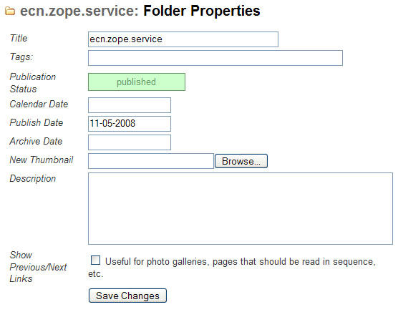
Folder Properties
- Title – Human readable identifier for the item
- Tags – Tags are key words describing an item.
- Publication Status – status of the item based on publish and archive dates (Draft, Published, or Archived)
- Calendar Date – date the item would appear on a calendar (if applicable). For example, the date of a meeting associated with meeting minutes
- Publish Date – date the item should begin appearing in listings of its container.
- Archive Date – date the item should be stop appearing in listings of its container (leave blank for items that should always be listed)
- New Thumbnail – current thumbnail associated with the folder
- Description – full text description of the item
- Show Previous/Next Links – Option allows viewers of a folder to page through the contents of the folder

