Maintaining Engineering Web Sites

An Introduction

November 2008

http://engineering.purdue.edu/
webmaster@ecn.purdue.edu

Overview of the Web

Files
A file is a named chunk of information stored on a computer. Example types of files include Word Documents, Excel Spreadsheets, PowerPoint Presentations, Digital Photographs, and Digital Music Tracks. All information stored on a computer system is stored within a file.

Web Page
A web page is a special type of file containing instructions for formatting text, images, and other content so that it can be viewed in a web browser such as Internet Explorer or Firefox.

The instructions contained within a web page are written using a language called HTML (Hypertext Markup Language). Because of this web pages are often referred to as HTML Documents.

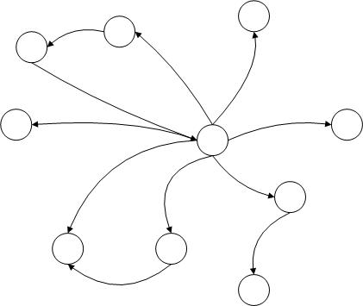
The World Wide Web (The Web)
The web is a collection of interlinked web pages and files hosted on computer systems (servers) all over the world.

Each web page or file has a unique address on the web called a Universal Resource Locator or URL.

http://engineering.purdue.edu/ECN/getting_started.html

There are two parts to every URL which you should be able to distinguish:

- Domain Name – engineering.purdue.edu
- File Path - /ECN/getting_started.html

Key Terms
- File – a named chunk of information stored on a computer
- Web Page/HTML Document – a special type of file designed to be viewed in a web browser and provide links to other web pages and files
- URL – The unique address assigned to each file on the web

Supported Template Sites

Overview
The Engineering Communications Office (ECO) and the Engineering Computer Network (ECN) support a template for the schools and departments in Engineering to use as a base for their web sites.

This template provides a standard for the look-and-feel and defines how visitors will navigate from page to page within the site. An example of the currently supported template is displayed in Figure 1.

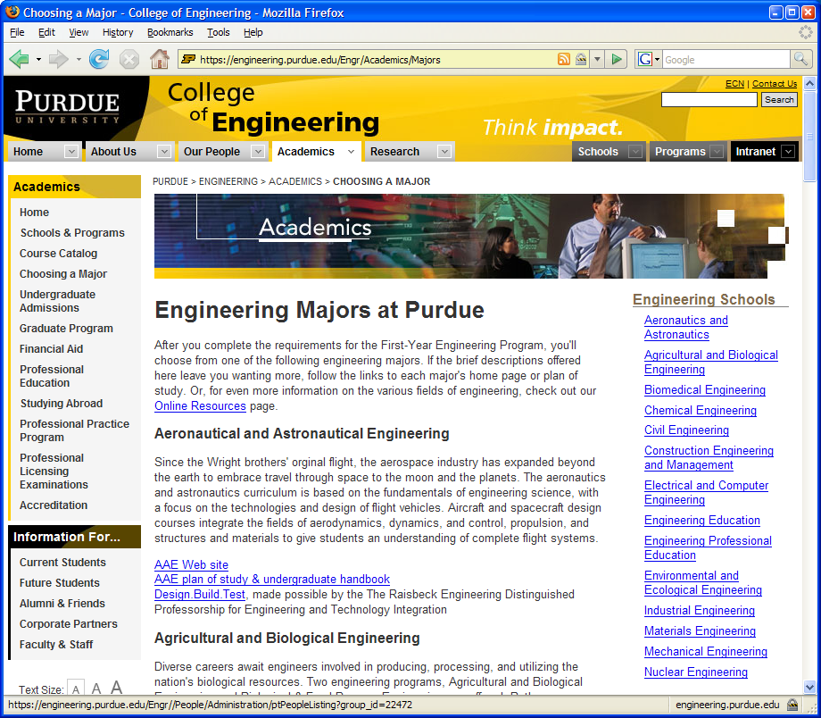
Figure 1 – Supported Template

engineering.purdue.edu
All supported template sites are hosted on the engineering.purdue.edu server and have a file path beginning with an acronym for the school. Examples are:

- http://engineering.purdue.edu/BME/ - Biomedical Engineering
- http://engineering.purdue.edu/CE/ - Civil Engineering
- http://engineering.purdue.edu/ME/ - Mechanical Engineering
- http://engineering.purdue.edu/Engr/ - College of Engineering

Navigation Elements
Navigation elements are the links which allow visitors to browse through the pages within a web site. The supported template provides three levels of navigation elements.

Primary Navigation
At the top of each page are a set of five tabs which define the major content sections within a school’s web site (Figure 2). These content sections are controlled and must remain the same across all schools using the template.

- Home – The main page of the school’s web site
- About Us – “Corporate” information about the school
- Our People – Directories of the school’s faculty, staff, and students
- Academics – Overview of the schools educational offerings
- Research – Information about the research activities

To the right of the primary navigation are tabs with links to quickly from one school or program’s site to another.



Figure 2 – Primary Navigation

Secondary Navigation
Along the left hand side of each page is the secondary navigation. The options in this navigation area change based on the section chosen in the primary navigation.

The options listed in the secondary navigation are defined by the school based on the information they wish to provide in the current section. However, links in the secondary navigation should all lead to web pages within the current section of the site.


Figure 3 – Section Navigation

Local Navigation
If a piece of content within a section is made up of multiple web pages or requires links to information outside of the current section the school can opt to include local navigation along the right hand side of the screen (Figure 4).

There is little restriction imposed on what can be done within local navigation and it may be left off completely if the school chooses to do so.



Figure 4 – Local Navigation

Maintaining a Support School Web Site

Engineering’s Web System – Zope
The College of Engineering uses a system called Zope (pronounced like soap) to manage the content within the web sites for the schools and departments. There are many interesting features Zope provides. For the purpose of this course all you need to know is that the Zope system allows you to login to your school’s web site and make changes all through your web browser.

Logging into Zope
To login to Zope, open the URL below in your web browser.

http://engineering.purdue.edu/manage_main

A login prompt will appear, login with your Purdue Career Account username and password (be sure to use only your username and not “onepurdue\username”).

A list of all of the sites hosted within Zope will appear (Figure 5). Scroll down to find your schools site and click on the school’s name.

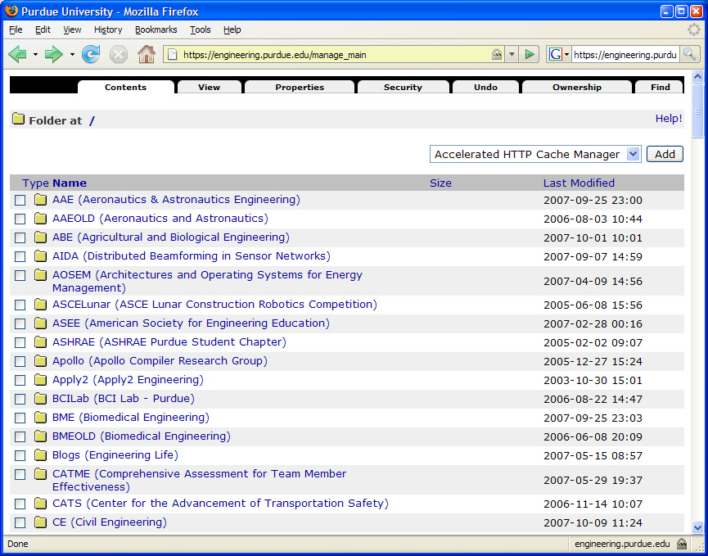
Figure 5 – Root Site Listing

It is possible to login directly to a specific site or section of a site by appending manage_main to any URL within your site. Login directly to the Environmental and Ecological Engineering web site you would open:

http://engineering.purdue.edu/EEE/manage_main

To login to the About Us section of the Environmental and Ecological Engineering web site you would open:

http://engineering.purdue.edu/EEE/AboutUs/manage_main

Browsing within Zope

Opening a Folder or Document for Editing
Once you are logged into your site you will see a list of folders and documents. This works very similar to the folders on your computer. Clicking on a folder or file will open its management page.

Backing up to a Higher Level Folder
All management pages within Zope provide a set of links called breadcrumbs (Figure 6) near the top of the page. These links provide a way to jump to folders above your current location in the folder hierarchy.

Figure 6 – Breadcrumb Links

The main folder for your school’s site, listed first in the breadcrumbs, is an acronym or abbreviation of your school’s name. Clicking on this link in the breadcrumbs will take you back to the management screen for main folder of your site.

Site Structure
Within the main folder of your site are several folders (Figure 7). The folders named: AboutUs, Academics, People, and Research correspond to the primary navigation sections within the school sites.
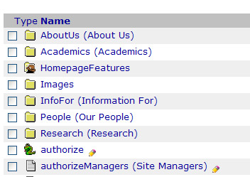

Figure 7 – Main Folder Listing

The web pages and files used within each section will generally be located within that section’s folder.

Adding a Web Page
Adding a web page is done using the following steps.

- Browse to the section where the new page should be exist
- From the drop down menu in the top right select HTML Document (Figure 8)
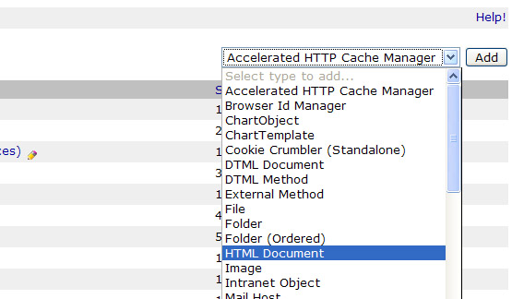
Figure 8 – Select HTML Document

- Wait for the “Add HTML Document Form” (Figure 9) to load

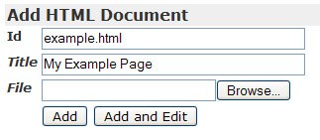
Figure 9 – Add HTML Document Form

- Enter an Id into the Id field. The Id is used to set the filename for the new web page, when choosing an Id avoid using spaces or special characters and end the filename with a .html extension. Some examples of good web page Ids are…
  - history.html
  - welcome.html
  - tuition.html
- Enter a Title into the title field. The Title is a human readable description of the new web page, it should contain spaces and proper capitalization. Some examples of good web page Titles are…
  - History of Engineering
  - Welcome to Engineering
  - Tuition Fees in Engineering

- After completing the Add HTML Document form click the Add and Edit button.
- The management screen for the new HTML Document will load

Editing an HTML Document

The Editing Interface
The screen for editing an HTML Document is modeled after Microsoft Word (Figure 10). Toolbars provide options to style text, create lists, insert links and images. For full information on using the Editing Interface visit: http://wiki.fckeditor.net/UsersGuide

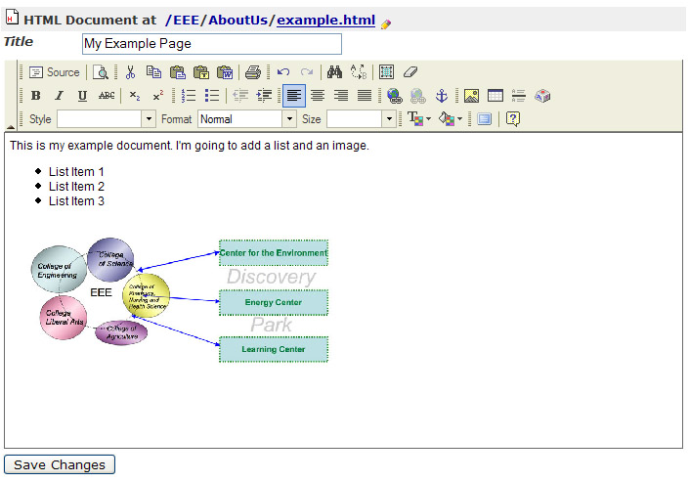
Figure 10 – Editing an HTML Document

Saving Changes
After making any changes to an HTML Document you must click the “Save Changes” button near the bottom of the screen.

Viewing the Document
Clicking the “View” tab at the top of the editing interface will take you to the public view of the newly created document (Figure 11). You will notice that the page magically acquires the look-and-feel of the rest of the site.

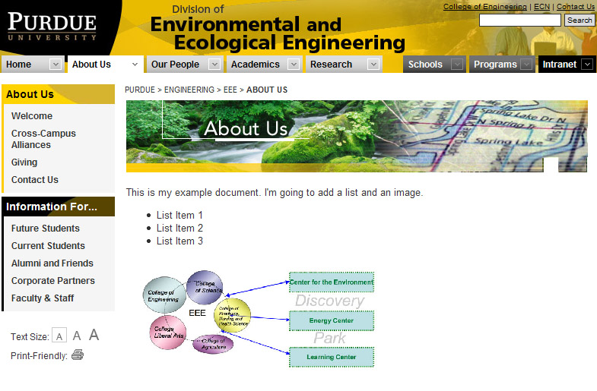
Figure 11 – Viewing an HTML Document

When viewing the document make a note of the file path (the portion of the URL after engineering.purdue.edu) in your browser’s address bar. You will need to know this to link the file into the Navigation.

Adding a Document into the Navigation
Once a document is created the last step in making it publicly available is to add a link to the document somewhere in the site’s navigation.

Adding a link to the Left Sidebar
Within each section of the four main sections of the site (AboutUs, People, Academics, and Research) exists a file called sidebarLeft. This file controls which links appear within the secondary navigation within that section.

The sidebarLeft file contains HTML code for each link in the that section’s navigation. The format of each link is:

<a href=”file_path”>Link Text</a>

Use the line above as an example when adding a new link. You will need to replace the file_path with the path you noted earlier when viewing the document. The Link Text is what visitors will see in the secondary navigation. Generally, you will use the title of the document as the link text.

Place the new link into the sidebarLeft file in the position where you would like it to appear in the menu. (Figure 12).

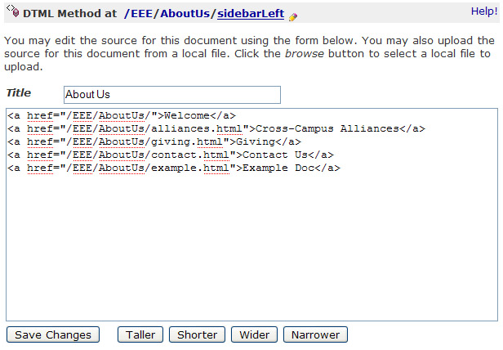

Adding a link to the Right Sidebar
If the section of your site contains local navigation a file named sidebarRight will exist on the management screen. This file can be edited in the same way as sidebarLeft.

Additional Information

Adding Other Types of Content
There are several other types of content which can be added to your site besides HTML Documents.
- Folder – Use to group content into sections
- Image – Use when uploading images or photographs. Images uploaded to the web should be in JPEG/JPG, PNG, or GIF format.
- File – Use for non-HTML content such as PDF Documents, Word Documents, PowerPoint, and Excel Files.

Suggested Naming Conventions
- Folder Id’s should begin with an uppercase character all other documents Id’s should begin with a lowercase letter
- Web Pages (HTML Documents) Id’s should include a .html extension.

File Placement
- Images and files linked within a web page should be exist in the same folder as that web page

