Site information and submission for the Nielsen Norman Group report:
“How is the information on your intranet organized?”

College of Engineering Intranet
Purdue University

Background
The engineering intranet was launched in February of 2006 as part of a major overhaul of the college web site.

The previous Purdue Engineering site was a mixture of public pages aimed at external audiences, and password-protected pages intended for various internal groups. The site’s structure reflected the college’s org chart, and each administrative office controlled a corresponding section. This made it difficult to put forward a coherent public message, since there was no central editorial authority.

Not surprisingly, the need to separate the public, marketing-driven pages from private internal communications was the driving force that led us to create an intranet. With the intranet, each administrative office has its own intranet site where it can post whatever it wants, while the public site is organized and tailored specifically for its intended audiences.

From the start, we knew that it wouldn’t be enough to move all the private information into one protected section. The existing methods for posting information were too confusing for most of the support staff, and the constant need for technical assistance added a lot of inertia to tasks that needed to be quick and simple.

In order to make a real improvement in our users’ lives, we needed an intranet that would make it very easy for them to create a simple web page, upload files and images, create links to the posted information, and control access to sections of the site.

After considering a number of off-the-shelf products, we decided it would be easier to roll our own. Commercial packages would have required a lot of work to customize and to tie into our existing authentication scheme.

By basing our intranet on the open-source application server (Zope) that our public site uses, we were able to avoid climbing the learning curve that would be associated with a new platform, and could dive right into developing the site. It also meant that we didn’t have to pay for new hardware or software.

Tools, content and organization
I think that the current state of our intranet achieves the goals we had in mind when we started. I also think that there is no single feature or element of the intranet that stands out as a “killer app” that will drive our people to use it.

Our hope is that the sum of all the intranet’s tools—the simplicity that it brings to common tasks—will be the attraction.

Since the main purpose of our intranet is to let our users publish their own information, and because we didn’t want to reinvent the multitude of other resources within Purdue’s computing universe, we settled on a relatively simple conceptual structure. Basically, everything on the Intranet falls under one of two categories: users and groups.

As our users and groups add information the structure will branch and grow deeper, but we don’t anticipate any significant elaboration of the root-level categories. Our development focus will be on improving the usability of the site and on adding new tools and content types to give the users more options to use in building their sites.

We’re moving information from the old site to the intranet in stages, so the content is currently uneven, and many of the administration sites are not actually within the intranet yet. During this transition we’re also holding training sessions for web managers, clerical staff, and others that we expect will have the greatest need to use the intranet, and who will be the first to begin filling out and maintaining its content.

A longer introduction to the Purdue Engineering Intranet is available (in a public folder within the intranet) here:

http://engineering.purdue.edu/Intranet/Groups/Committees/EWAG/Documents/IntroToIntranet.html

Navigational structure
Optional or variable items are surrounded by square brackets [ ] .

Purdue University (Purdue logo in upper left of screen links to university home page)

Engineering Intranet (text graphic in header—Engineering links to the home page of the college’s public site, Intranet links to the college administration’s intranet home page, which is the default landing page for the intranet)

Tabs (The first level items of the following outline are tabs along the bottom of the page header, and the second level items are drop-down menus on those tabs.)

- My Account (empty menu until the user logs in)
  - [ Optional list of user-defined links, specific to each logged-in user ]
  - My Portal
  - My Site
  - My Settings
- Users
  - Browse All Users
——————————
  - [ Optional list of links to other intranet user sites. The list is selected by, and specific to, each logged-in user. ]
——————————
  - [ Add [Remove] hilary.m.nelson.1 ] (This item appears if you’re logged in and browsing a user’s site, and says add or remove depending on whether or not the user is already in your optional list of favorites)
  - Edit Menu…
- Groups
  - College Administration
  - Schools & Departments
  - Offices & Programs
  - Committees
  - Centers
——————————
  - [ Optional list of links to group sites. The list is selected by, and specific to, each logged-in user. ]
——————————
  - [ Add [Remove] Group Name ] (This item appears if you’re logged in and browsing a Group site, and says add or remove depending on whether or not the group is already in your optional list of favorites)
  - Edit Menu…
- College Administration
  - College Administration
  - Dean of Engineering
  - Academic Affairs
  - Engineering Advancement
  - Financial Affairs
  - Global Engineering Programs
  - Graduate and Interdisciplinary Studies
  - Marketing and Communications
  - Research and Entrepreneurship
  - Resource Planning and Management
  - Strategic Initiatives
  - Strategic Planning and Assessment
  - Support Services
  - Undergraduate Education
- Public Sites (Right-aligned tab listing all the public school and department sites)
  - College of Engineering
  - Aeronautics and Astronautics
  - Agricultural and Biological Engineering
  - Biomedical Engineering
  - Chemical Engineering
  - Civil Engineering
  - Construction Engineering and Management
  - Electrical and Computer Engineering
  - Engineering Education
  - Engineering Professional Education
  - First-Year Engineering
  - Industrial Engineering
  - Materials Engineering
  - Mechanical Engineering
  - Nuclear Engineering
——————————
  - Cooperative Education
  - EPICS (Engineering Projects In Community Service)
  - Institute for Interdisciplinary Engineering Studies
  - Minority Engineering Program
  - Women in Engineering Program

[ Left Sidebar ] (Administrators can hide this sidebar at any given point in the site)

- Links
  - [ Variable list of links that can be redefined by users or groups at any level. By default, they are inherited from higher levels. ]
- My Account
  - [ Login form | Logged in as: user.name Logout ]
( If logged in: )
  - [ My Portal ]
  - [ My Site ]
  - [ My Settings ]

Breadcrumbs ( INTRANET > PATH > TO > CURRENT > LOCATION with each item linking back to that level )

[ Right Sidebar ] (This is an optional set of links that can be defined by administrators at any point, or hidden entirely. Unless it’s hidden or redefined locally, lower levels will inherit the sidebar from higher levels. The sidebar can contain just about anything.)

Tabs and menus



The Users and Groups tabs represent the two basic categories on the intranet.

The tab to the left of Users, My Account, is a special case of the user category, and its content is customized for the currently logged-in user.

The tab to the right of Groups, College Administration, is a special case of the group category. Because the college is the umbrella entity under which all the schools and departments exist, and because the administrative offices are the source of most of the official college content, the administration is given its own tab for quick access.

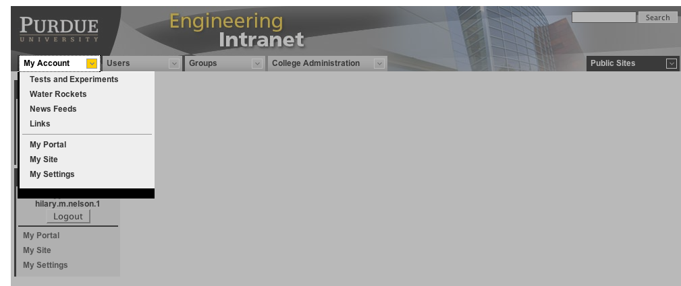

The My Account menu is empty until the user logs in. Once the site knows who the user is, the menu displays links to the user’s portal page, personal site (or a link to create one, if they haven’t yet), and preference settings.

If the user has created a personal site and has chosen to customize their left sidebar, then the My Account menu also displays those left-sidebar links so that they’re available to them at all times.

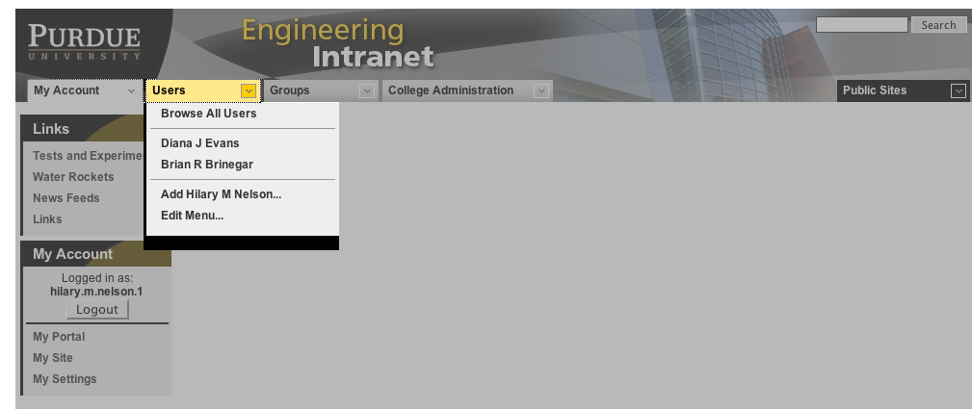

The Users menu has a link to browse the user sites on the intranet. The main page of the Users section has an alphabetical list of users broken into pages. There’s also a small search form that returns basic contact information, with links to personal intranet sites when they exist.
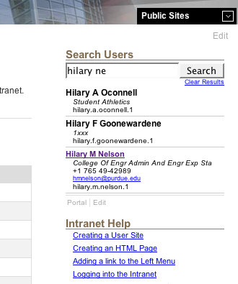
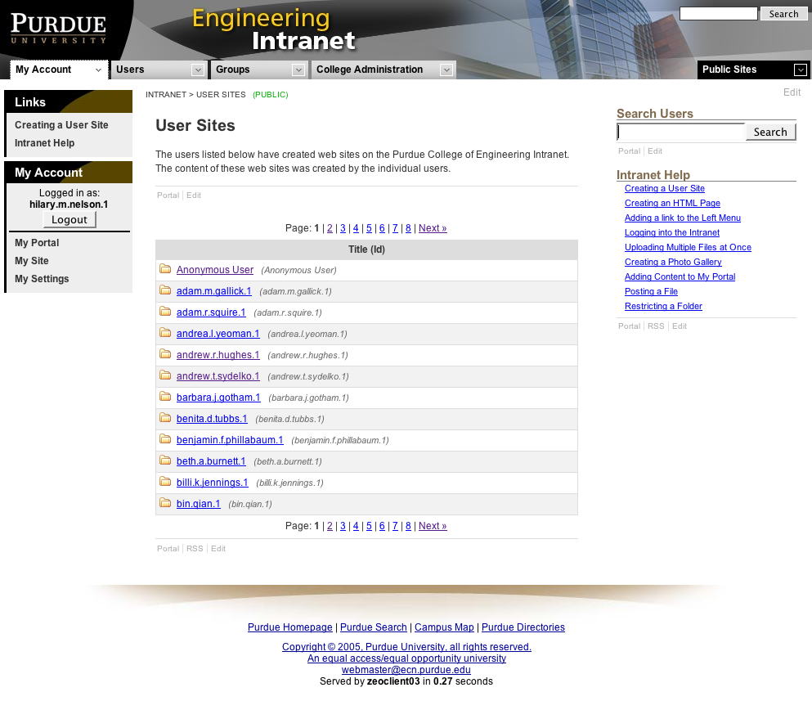
The primary purpose of the Users menu is to let logged-in users to bookmark the sites of other users. These bookmarks are stored on the server and aren’t tied to a particular computer, they are available whenever the user logs in, wherever they happen to be.

Whenever you’re on a personal intranet site, you can quickly add a bookmark for that site by going to the Users menu and selecting the “Add Jane Doe” link that you find there (where Jane Doe will be the actual user’s name).

If you decide you don’t want them on the menu anymore, go to their site and you’ll find that “Remove Jane Doe” will replace the “Add” link. Alternatively, you can choose the “Edit Menu…” link on the Users menu to jump to you’re My Settings page, where you can select multiple names to remove from the list at once.

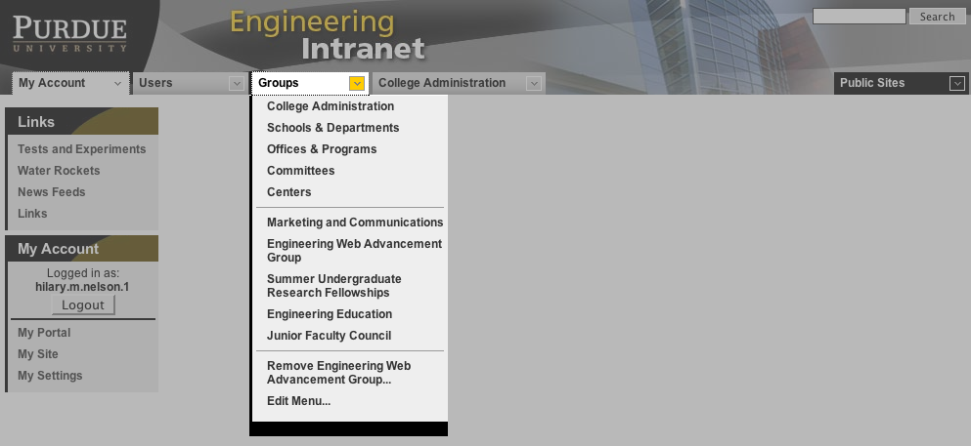

The Groups menu works just like the Users menu, except that it bookmarks sites that are designated as group sites. Group sites can be added and removed the same way that user sites are added and removed from the Users menu.

Because the group sites are organized into a hierarchy of categories, whereas users are all just lumped into one, the Groups menu includes links to the major subsets of group sites.

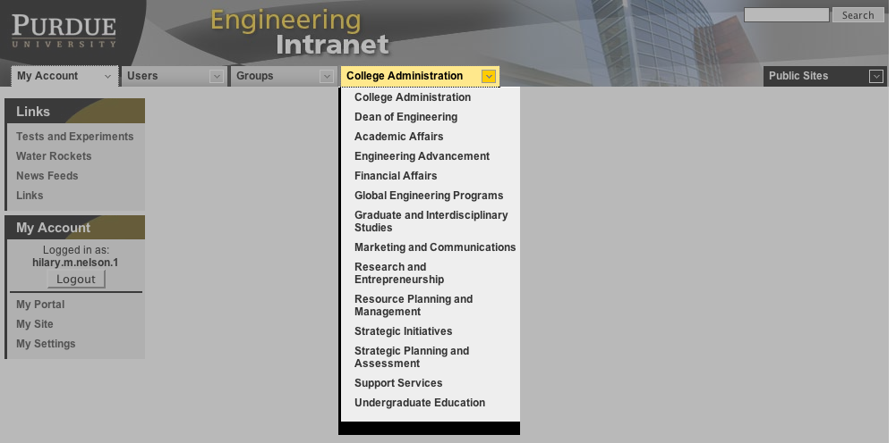

The College Administration menu is an outgrowth of the fact that the group side of our intranet has inherited the org chart structure of the old public web site. College Administration is one of the primary subsets of groups, and because of its central role in the college, the administration groups are given a prominent place in the navigation.

The usability of the intranet would probably be significantly better if the College Administration tab was replaced by a set of task- or subject-oriented links that led to sites organized around particular topics or workflows. However, given the small size of our development group, and our limited resources, such an ambitious project will have to wait. Perhaps the will to tackle the job could be mustered if the intranet succeeds in becoming a critical tool.

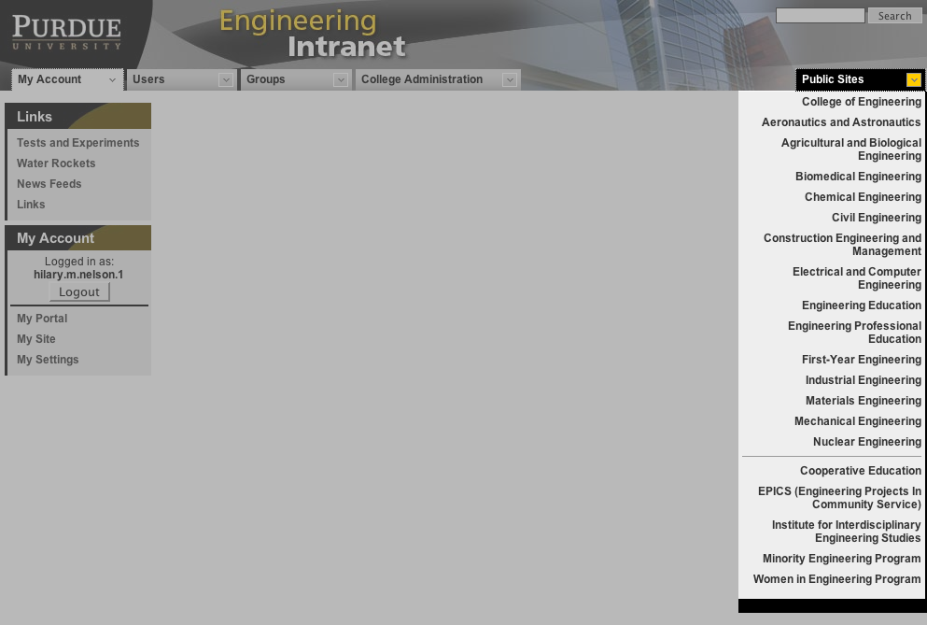

The Public Sites menu provides a way to get from the intranet to the main public sites of all the schools, programs, and departments within the College of Engineering.

Anatomy of an intranet page

When you first arrive at the intranet, you’re taken to the College Administration home page, which includes a left sidebar with links to all the college administrative offices and a login form. The body of the page has some lists of announcements, and the right sidebar has a bunch of links that replicate the links that were available on the old Dean’s site. (This page will evolve into a more rational and useful landing page as we continue the transition to the intranet.)
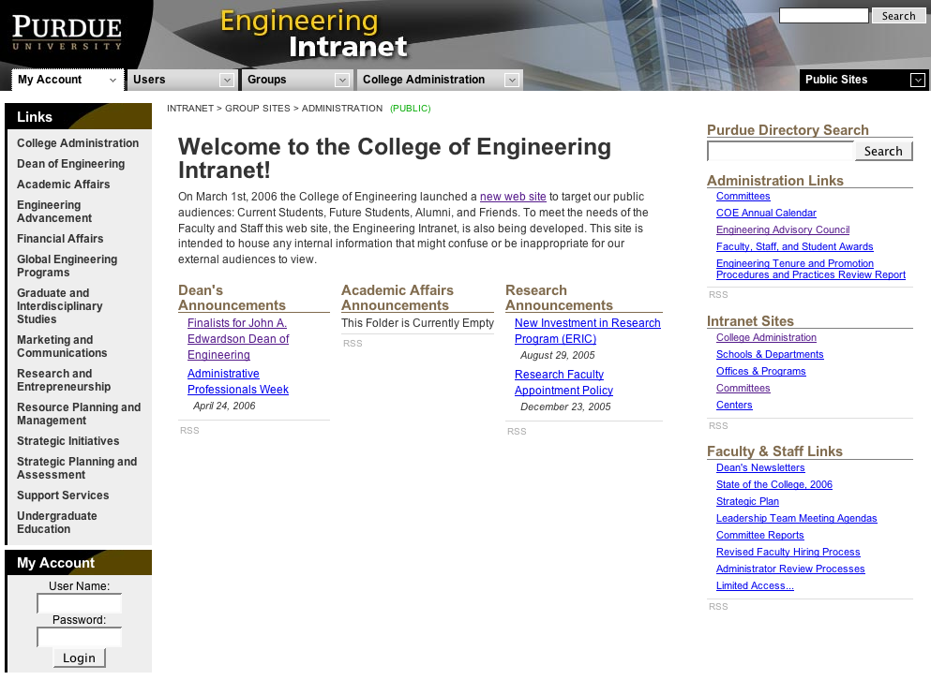

This page, like a lot of the pages on our intranet, isn’t really a page at all, in the traditional sense of an HTML or ASP file. It’s just a folder, and its default “appearance” is created by selecting files or folders from anywhere on the intranet, placing them and dragging them around the window, and selecting display options for the placed items from dialogs.

For instance, all the lists of links on the page or in the right sidebar represent folders that are found elsewhere on the intranet. The lists are generated automatically from the contents of those folders, and are updated automatically when new items are published in those folders.

This is a familiar concept for bloggers, except that instead of pulling items out of a single database based on a set of categories or keywords, we let users create any categories they like simply by grouping items together in a folder. With the potential for thousands of contributors, the task of defining a set of categories that would suit everyone’s needs would be extremely difficult, and could be too restrictive.

You can view these lists on the intranet, but you can also pull them into any RSS reader. Each list has a small “RSS” link at the bottom that will return an RSS feed of the folder’s published content. (This only works for folders that are public, and don’t have any restrictions placed on who can view them.)

Folder lists can be mixed in with other content, such as HTML documents, RSS readers (which display headlines from RSS feeds that can come from other web sites), directory listings of groups within Purdue Engineering, and so on. The title and introductory paragraph on the welcome page come from an HTML document that was added to this folder’s appearance, and that document is the only thing on the page that is actually located in this folder.

Log in to edit
To edit intranet objects, you start by logging in, using the form on the left sidebar.

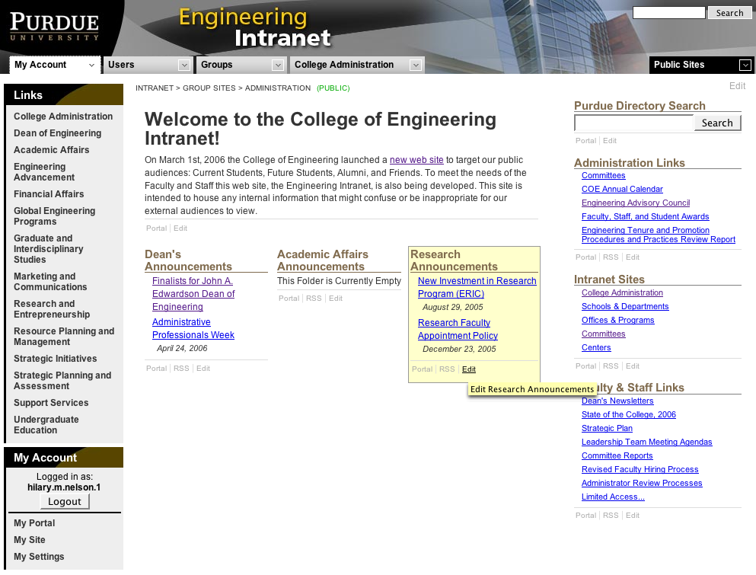
Once logged in, you’ll see small “Edit” links appear on anything that you’re allowed to modify. To edit the collection of objects that are on this page, you’d use the edit link at the upper right, below the Public Sites tab.

To edit the content of any individual block, you would use the edit link on that block. The link will take you to that object’s location, wherever it may be.

Hovering over an edit link highlights the content that you’ll be editing by turning its background a light yellow.

Example: a personal home page
I’ll use my home page to illustrate how a folder’s appearance can be customized. The title, “Hilary’s Home Page,” is from the folder itself. The subhead and brief note below it is an HTML document stored in a subfolder. The “Water Rockets” section is a subfolder, which is set to display it’s title and list the three most recent items, showing the items’ titles as links, their description property, and a thumbnail image when one exists.
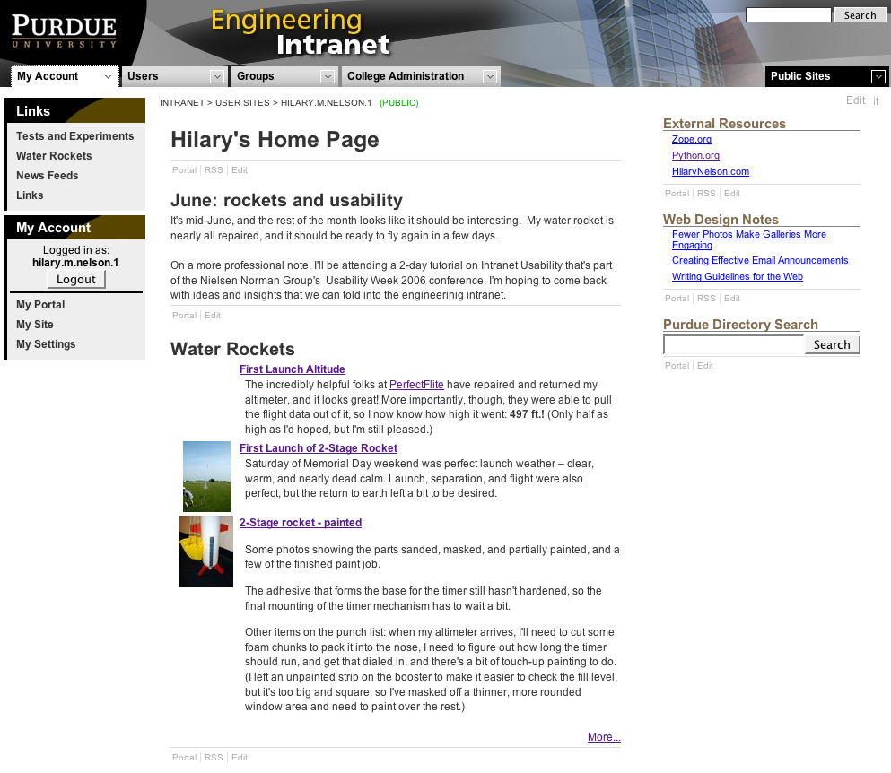

The Links on the left sidebar are links to some of the folders in my site. To add the links, I simply have to browse the server’s files in a dialog and select the folders I want.

In the right sidebar I’ve added a subfolder from my site that contains link objects that hold the URLs of sites I often visit. Below that is a folder from our Engineering Web Advancement group’s site which contains helpful articles on website management topics.

Editing the page
Clicking the edit link at the upper right takes you to the Contents view, the default management view for folders. Along the top of the page is a yellow box of links to other management screens for the object that you’re currently editing. These admin options will vary depending on the type of object, and folders have the greatest number of them. To give you an idea of how these screens work, we’ll take a quick look at the folder’s admin option screens.

Contents screen
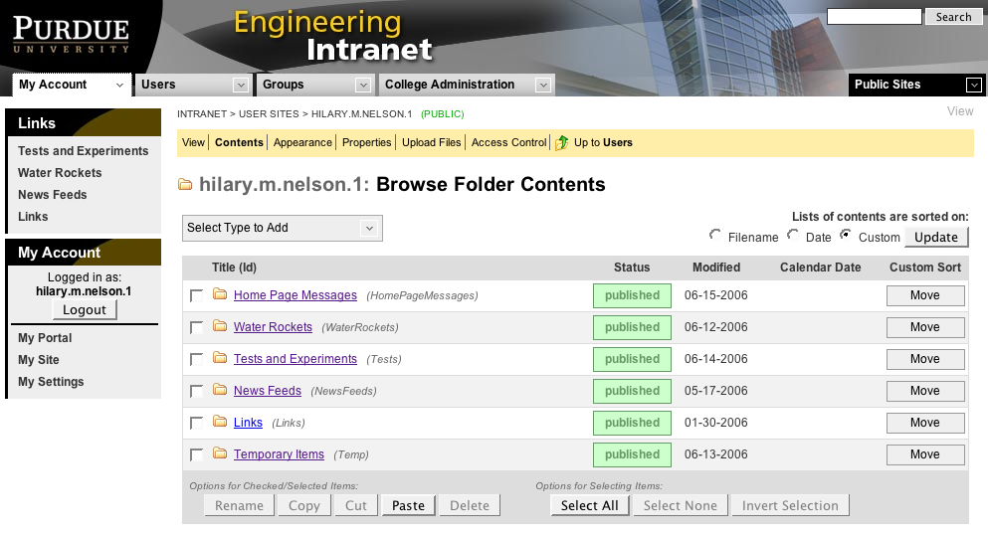
This screen lists all the files, folders, and other objects that are contained by the current folder. The list shows each object’s title (and filename), whether it’s status is draft, published or archived, when it was last modified, and a calendar date (if it has one).

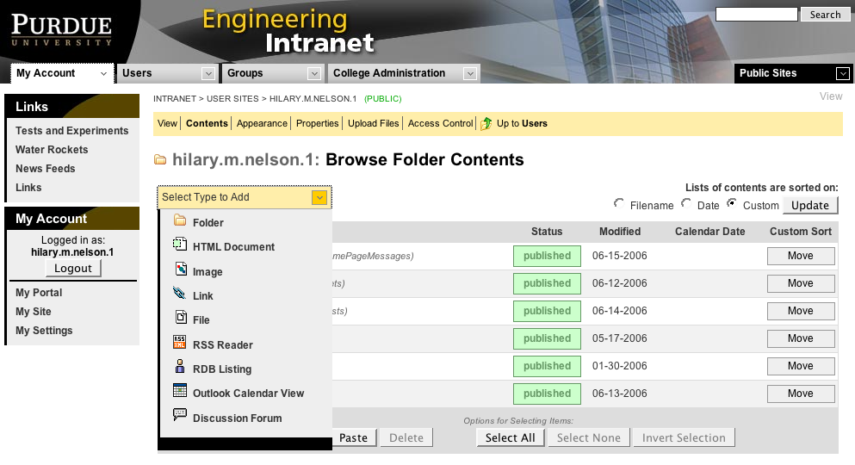
Above the list are a drop-down menu for adding new objects and radio buttons to select how the list should be sorted. If you choose the custom sorting option, buttons for moving each item up or down the list appear on the right.

Each list item also has a checkbox to the left of it. To rename, copy, cut, or delete objects, you check the ones you want to operate on, then click the appropriate button at the bottom of the list. When copying or cutting objects, they remain in their original location until you navigate to another folder and paste them.

Here’s a quick overview of the other object types that can be added to an intranet site:

- HTML Documents are created and edited in the web browser using a Java applet that lets you work either in WYSIWYG mode, or edit the raw source code.
- Images are uploaded through the browser, and will automatically generate thumbnails and medium-resolution versions.

- Links just take a URL and let you specify the title (link text).

- Files can be uploaded through the browser.

- RSS Readers retrieve RSS feeds from anywhere on the web and display a customizable list of headlines that link back to the original article.

- RDB Listings let you select any of the groups of people defined in our Resource Database to generate a page of directory listings for them. Options include pulling some people to the top of the list in a custom order, and hiding some people on the list.

- Outlook Calendar Views accept a Windows CSV file exported from MS Outlook. This calendar is then displayed on the web site as an interactive, browse-able web calendar.

- Discussion Forums let you add a message board anywhere on the intranet. They include options like whether anonymous posts should be allowed and whether or not administrators need to approve posts before they become visible.

Appearance screen
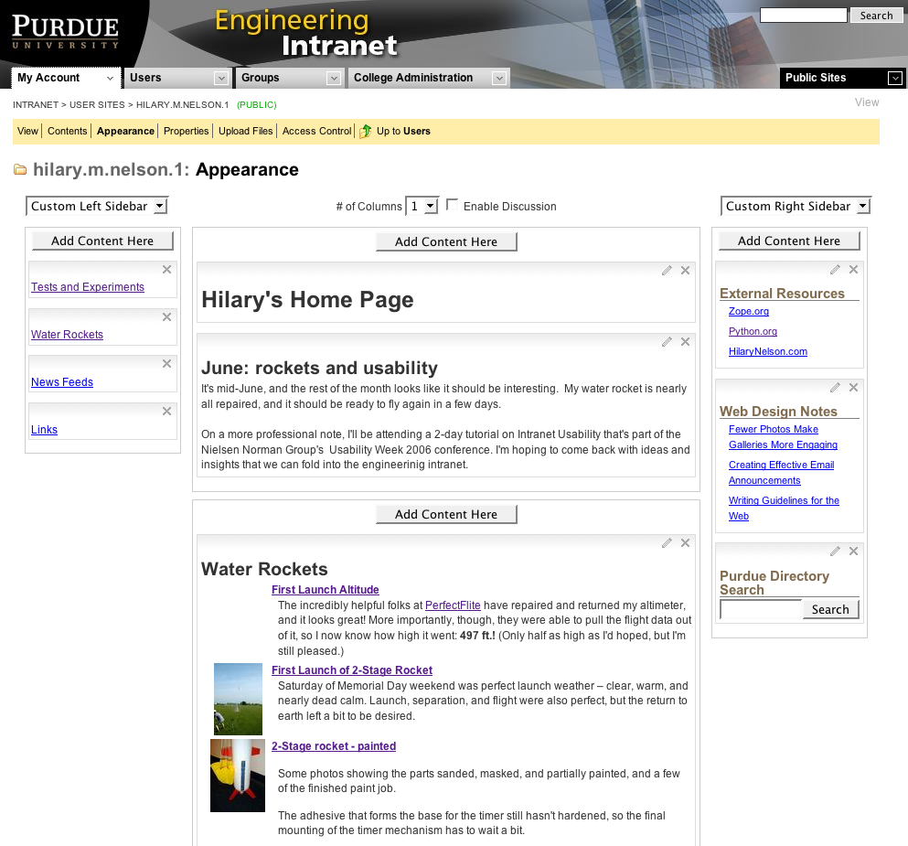
This is where you put together the default page (appearance) that you see when you arrive at a folder. The page uses Javascript and Ajax to allow your browser to function as a WYSIWYG page layout environment.

The page is laid out the same way your viewers will see it, but the blocks of content that represent each discrete object on the page are shown with light gray frames around them.

The layout is divided into the two sidebars, a header area, and a content area that can be divided into up to four columns. The sidebars can be inherited from higher levels of the site or customized for this folder and below. (Or hidden altogether, in the case of the right sidebar.)

Each area has an Add Content Here button, which will open a dialog that lets you browse the intranet to find and select objects to add to that part of the page.

The shaded bar at the top of each frame lets you drag the objects around. Objects can be freely moved between any of the parts of the page—content area, header, or sidebars. The small pencil icon opens a dialog where you can customize whatever display options are available for that object, and the X removes the object from the page.

At right are the display options for the Water Rockets content block (a folder) shown above. Here you can set the size of the title should be (or hide it), change the text of the title as it appears on this page, etc.

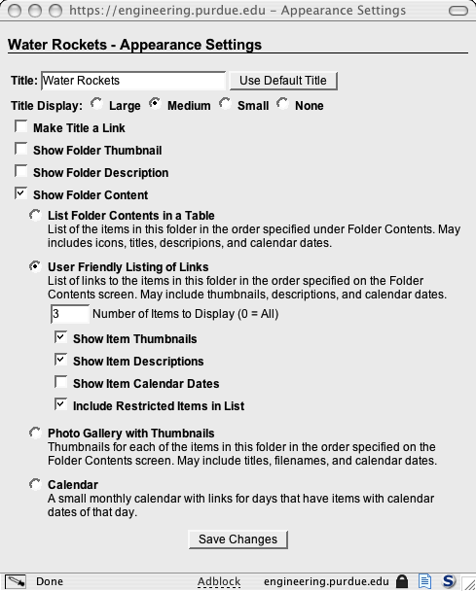
If you choose to show a list of the contents of the folder, then you get a number of choices about how they will be displayed:

- A table that lets you choose which object properties to display in each row, and lets you break up long lists into pages with previous/next links.

- A friendly (indented) list of links.

- A photo gallery, which displays thumbnails of images.

- A calendar, which draws monthly calendars with links to objects that have calendar date properties.

The display options will vary from one object type to another, and folders, again, have the greatest number of options.

With the ability to pull pieces of content from anywhere on the intranet, and given the number of choices for how those blocks are presented, it’s possible to build very complex web pages simply by clicking, dragging, and making choices on web forms—no programming required.

Properties screen
Every intranet object has a basic set of properties: title, calendar date, publish date, archive date, thumbnail image, and description. Some objects will have additional properties, which will depend on the type of object. Folders, for instance, have a checkbox that will mark them as the root folder for a group, and another that will show previous/next links to let you step through their contents.

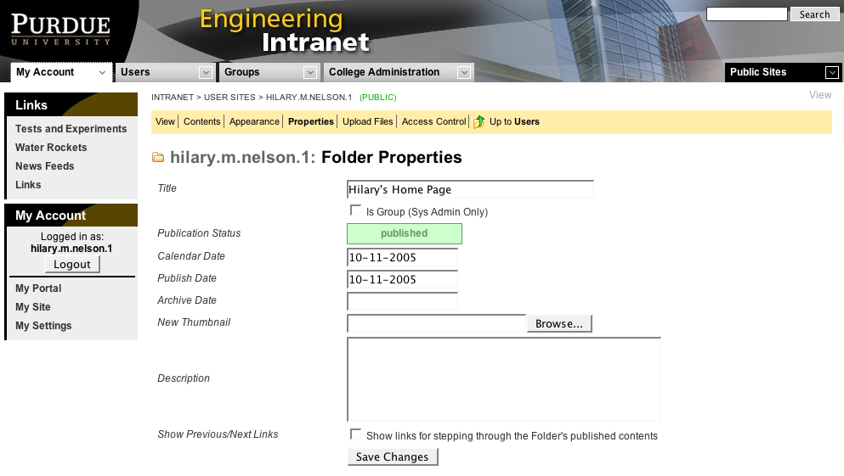
It’s these basic properties that allow every folder to create automatic lists of their published items. As soon as an item’s publish date arrives, it will appear wherever its parent folder has been placed and set to list its contents, and it will be included in the parent folder’s RSS feed. It remains there until it’s archive date arrives, or perpetually, if no archive date is set.

These dates only control whether or not the object will be listed and automatically linked. Draft, or unpublished, objects can still be viewed, but you would have to find it through the Contents screen, guess it, or be given it in some other way. For instance, you could create a folder that would list no contents because all the pages in it were not published, but it could contain a whole set of related and interlinked documents, where the links are all within the text of the pages.

The thumbnail and description properties can be used to create lists that are more informative than a simple list of titles. The Water Rockets block on my home page is a list that shows thumbnails and descriptions when they are available. The lists in the right sidebar are set to show only titles.

Upload Files screen
This page uses a Java applet to let users drag and drop groups of files or whole folders to upload them to the current folder in one batch.

This applet, and the applet we use for editing HTML documents in the browser, were acquired from third-party developers and then incorporated into our intranet. This approach has allowed us to develop a well-integrated environment with a rich feature set, without trying to reinvent the wheel for every feature.
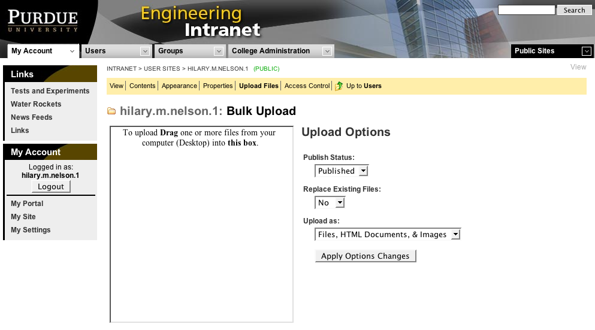

Settings to the right of the applet let you control whether the uploaded files should be published (visible in lists) immediately, whether to replace files with the same name, and whether the applet should create only file objects, or create files, HTML documents, and images, depending on the filename extensions.

While you can upload a single file from the Contents screen by using the drop-down menu, the Upload Files screen is the only way to go if you have to post more than one at a time.

Access Control screen
Security on our intranet is managed on a folder-by-folder basis. If you want to restrict access to a document or file, you need to put it in a folder, and then set the access controls for that folder. There are only two types of access available: viewer and administrator.

This is an intentionally simple security scheme. Our aim is to avoid confusing the staff who will be called on to maintain the content, and who frequently don’t have much experience with web site management.

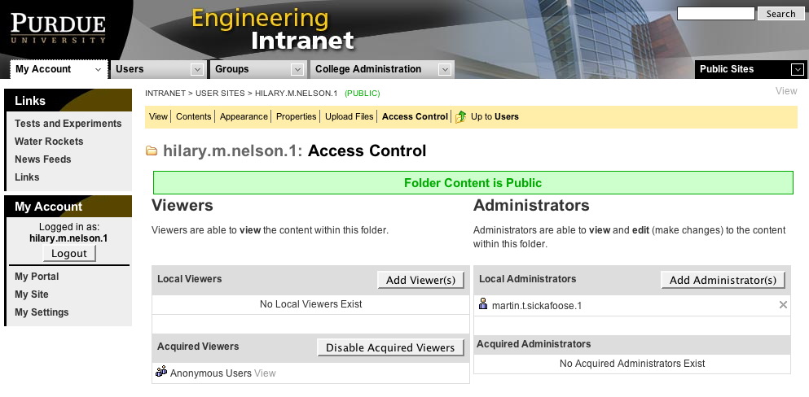
Here are the basic rules for using our access controls:

- The root of the web site is entirely public—anonymous viewers are allowed, and no login is required.

- New user sites are restricted to the user that owns them—nobody else can access them (other than an intranet super-administrator). They remain private until the user chooses to make some part of it available to specific users and groups, or to anonymous viewers.

- Group sites are the same, except access is initially restricted whoever has been designated as the group administrator.

- Other than in new user or group sites, the access controls of the parent folder will be acquired (inherited). That means that when you add a folder within your site, you don’t have to take any action to make it have the same restrictions (or lack of them) as are in effect for the parent folder. If you don’t change the access controls for any of your sub-folders, then you can change the settings for your entire site simply by editing the settings of your home folder.

- Additional (local) viewers can be added to any folder, and will then be inherited by that folder’s sub-folders

- You can disable acquired (inherited) viewers at any folder. In that case, nobody except administrators will be able to access that folder and its sub-folders unless you add local viewers.

- Administrator privileges work in exactly the same way, except that you can’t disable acquired administrators. We work on the premise that administrators will be assigned privileges at their highest level of responsibility, and it wouldn’t make sense to make you an administrator of a site, but deny you access to a sub-section of that site.

To give someone access to a folder, you click the Add Viewer(s) or Add Administrator(s) buttons. This will open a dialog window that will let you search the Purdue directory for a person or group.

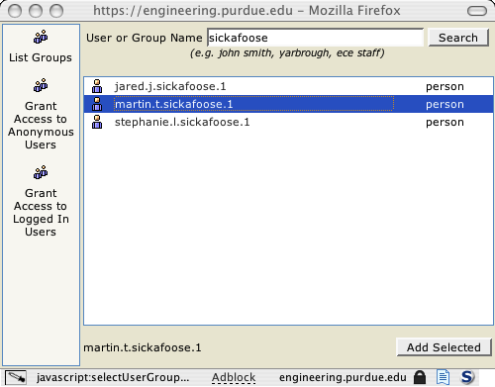
The List Groups link on the left will produce a list of all the pre-defined groups in a database. This makes it easy, for instance, to create a folder that is to be restricted to a particular office, committee, or other working group. It also simplifies maintenance of the access controls, since when the membership of the group is changed in the database, it will automatically change who can access the associated intranet resources.

The dialog also includes controls for granting access to anonymous users or to any logged-in user.

Editing other objects
Each type of intranet object has it’s own set of editing options. Some, like a link object, have only a single Edit screen with the basic properties and any object-specific properties.

An HTML document, on the other hand, has separate Properties and Edit pages. The Edit page incorporates a Java applet for WYSIWYG editing in the browser.
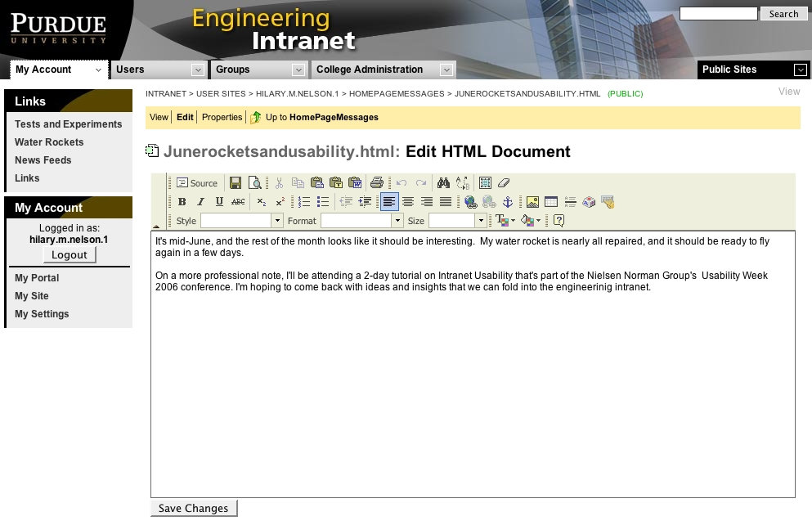
In addition to basic text formatting, the applet will let you browse the intranet for link targets and images, search and replace text in your document, and so on. You can also choose to edit the document’s source code, if you have a need to do something that the applet doesn’t support directly.

The Portal page
Along with all the features and tools designed to help our users publish information, the Purdue Engineering intranet has aspect that is intended to help users gather information for their own use.

Not surprisingly, it’s called the Portal page. (We tried to come up with something more original, but portal is a commonly accepted term for this sort of thing, and in the end we didn’t see any compelling reason to try to invent a new name for a familiar concept.)
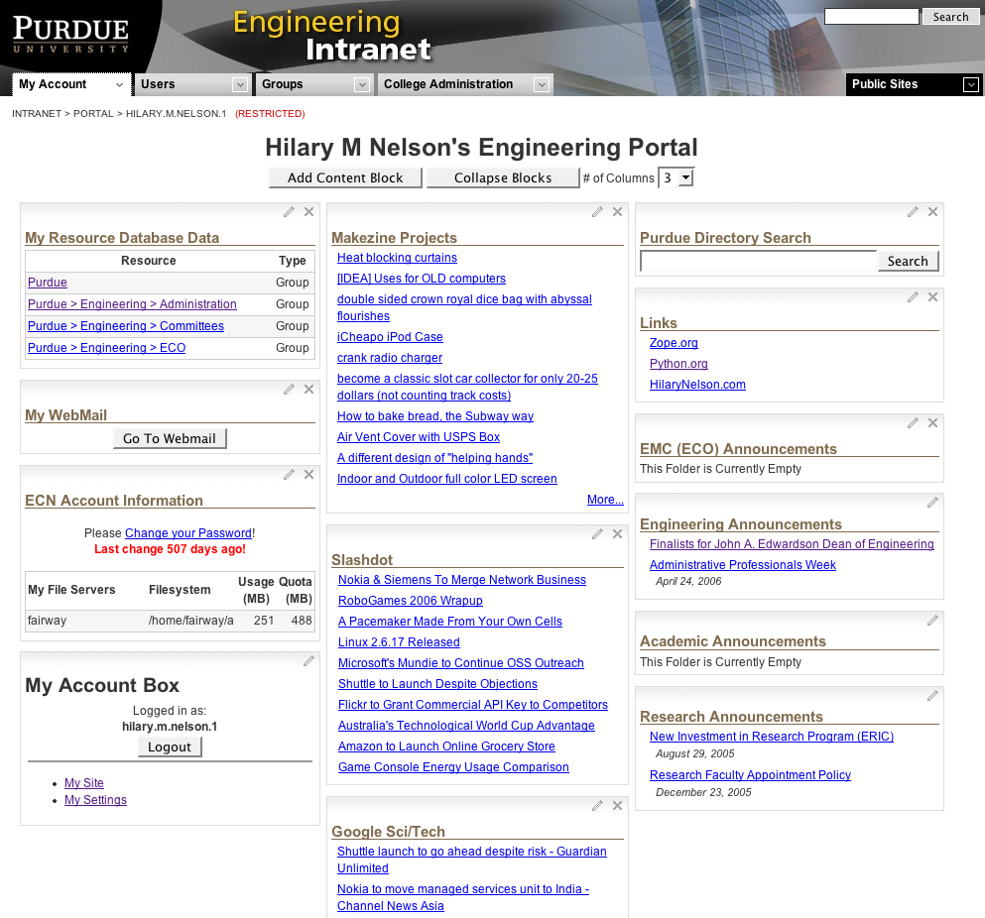

The portal can be rearranged in the same way that a folder’s appearance can, but the portal is in that mode at all times. There are no separate sidebar or header areas, but the page can be divided into as many as four columns, using the drop-down menu at the top of the page.

Content blocks are added in the same way that they are for a folder, as well. Anything you have access to on the intranet can be added to your portal page. A folder can list links to its contents, an HTML document can be displayed in its entirety, RSS readers can list headlines from news sites, and so on.

So, for instance, if you’re on a committee that has a folder where documents that need to be reviewed are posted, you could place that folder on your portal and when a new file was uploaded, you could see and jump to it the next time you visit your portal. Or, if you’re working on a project with someone, you could jointly maintain a to-do list, with it appearing on both your portals.

To make it even easier to collect material for your portal page, logged-in users see a small “Portal” link at the bottom of every block of content on the intranet. Click that link, and that object will be added to your portal. Before it’s added, you get a dialog that lets you change the title that will appear on the object when it’s appearing on your portal (so you can make it clear where it’s coming from).

The portal also offers some additional helpful widgets that make convenient connections to services and resources that aren’t directly accessible through the intranet.

Conclusion
The navigational structure of our intranet is more of a grass roots, bottom-up phenomenon than a top-down, management-driven one.

The downside of this is that the intranet doesn’t necessarily provide a clear place to go for particular tasks—you need to know something about the organization to decide where to look. I suspect that this may prove to be its greatest drawback, and we’ll probably need to make an effort to provide some clear, task-oriented navigation with a well-defined starting point before too long.

The main advantage of our intranet is that it gives our users the ability to quickly publish information. The tools it provides allow them to organize both their published information and their personal work space however they please, control who gets to see it, and reconfigure it at a moment’s notice.

Our aim is to let our users decide what is important to have on the intranet, and then help them put it there.

Prepared by:

Hilary Mark Nelson, Senior Web and Graphic Designer, hmnelson@purdue.edu

Contributors:

Brian Brinegar, Web System Developer Programmer
Martin Sickafoose, Web Development Manager
Rwitti Roy, Director/Marketing And Communications

