Replace ### with given paper number t

This document is a TEMPLATE.

If you like, please substitute your manuscript information in this document

Before you submit, please:

[ ] Update website (http://www.conftool.com/Herrick2022) with changes to author list or paper title

[ ] Check the Permission to Publish checkbox on the website

[ ] Write all author names in {Given Name} {Family Name} format

[ ] Eliminate commercialism from your paper (see Section 5.)

Author Instructions to Prepare a Manuscript for the International Refrigeration and Air Conditioning Conference at Purdue 2022

First AUTHOR¹*, Second AUTHOR²

¹Organization, Department or Equivalent,
City, State, Country
Contact Information (Phone, Fax, E-mail)

²Organization, Department or Equivalent,
City, State, Country
Contact Information (Phone, Fax, E-mail)

* Corresponding Author

ABSTRACT

The first major section of the manuscript is an abstract. The abstract should describe the contents of the paper, discuss the contribution to the field as well as present the most important results. Authors are responsible for typing accuracy and proofreading the manuscript. If accepted, the manuscript must be submitted for reproduction without being edited or retyped by the staff before printing. The manuscript must look professional and be technically correct in order to be accepted.

1. INTRODUCTION

Each manuscript should begin with an introduction that gives some background on the topic and briefly states the objective of the paper and how it relates to other works in the field. The manuscripts should report original research or technical developments and their applications. They should contain quality scientific or technical information. Manuscripts of a commercial nature will be rejected and will not be authorized for presentation. The process of acceptance or rejection of papers will be under the authority of the Conference Organizing Committee. The Organizing Committee will not be held responsible for any errors appearing in the final text. Authors assume sole responsibility for their manuscript, both for its form and its substance. Remember to check the manuscript carefully before submission. The manuscript should be submitted by only one author. Once submitted, no changes to the manuscript will be accepted.

2. HEADINGS FORMAT

The titles of the main sections have to be centered, numbered and in 12-point bold type capital letters. With the exception of the abstract, nomenclature, references, and acknowledgments section headings have to be numbered. Blank lines need to be placed above and below each main section title.

2.1 Sub-Section Headings
Sub-sections headings have to be in lower case, 11-point bold type letters. A blank line has to be placed above, but not below them.

2.1.1 Sub-sub-section headings: Sub-sub-sections should be avoided. If they are used, they should be justified left, in normal small letters, with the text beginning to the right.

3. FORMAT OF THE MANUSCRIPT

3.1 Reference Number
Place the paper ID number at the top right corner of the header in a bold type (for example, “101”); i.e., if you use this template, replace the “###” in the header of this document with the paper ID number. The paper ID number should be followed by a page number (for example, “2101, Page 1” for the first page).

3.2 Manuscript Title
Center the manuscript title with font size of 14-point bolded with a blank line below the title.

3.3 Authors
All authors should be listed by their full name with the family name appearing last, i.e., how the name is written in English (e.g., Yu Li CHO, John SMITH, Tae-yong KIM). The affiliation of the corresponding author should be given first. The affiliation and contact information of all co–authors should be listed as well. When necessary, superscripted numbers should be used to indicate which affiliation corresponds to which author. The affiliation(s) should be centered and in upper/lower case letters. The different parts of the affiliation(s) should be separated by commas, and if more than one line is necessary, the different lines should be of about the same length. For manuscripts with multiple authors, an asterisk should be used to identify the corresponding author.

3.4 Number of Pages
The entire manuscript (i.e., text, figures, tables, bibliography, etc.) must be no more than ten (10) pages long including graphs, tables and pictures. Any manuscript having excess pages will not be published.

3.5 Text Format
Times or Times New Roman font type MUST be used for any text in the document including captions, footnotes, and header information. All text has to be single spaced, black, and in 10-point type. All paragraphs must be single-spaced with a double space between each paragraph. The paragraph format is “justified”. If manuscript is prepared in the Asian format, please indicate “No Grid Lines” in Page Set Up. Asian single spacing appears as 1-1/2 spacing in Western formats. Paragraphs are not to be indented. Use single-line spacing between lines except where symbols require 1-1/2 line spaces.

3.6 Paper Size and Margins
Authors are asked to provide the manuscript in 8.5×11 inch standard U.S. letter format following the margin settings explained in this section. Hardcopy Proceedings will be made available upon request in the 8.5×11 inch standard U.S. letter format. It is imperative that authors stick to the margin settings. In order to standardize manuscript presentation, it is important that the procedures listed below be carefully followed. These instructions are also available on the web at https://engineering.purdue.edu/Herrick/about/news/Conferences/2022/Authors.

IMPORTANT: All text of the manuscript must be located within a 6.5×9 inch rectangle on an U.S. Standard Letter format page. The margins are given in Table 1. An example of the page format is given in Fig. 1. The top margin has to be set at 1 inch (2.54 cm), the left margin has to be set at 1 inch (2.54 cm), the bottom margin has to be set at 1 inch (2.54 cm), and the right margin has to be set at 1 inch (2.54 cm). The width of the text should not exceed 6.5 inch (16.5 cm) and the length of the text should not exceed 9 inch (22.87 cm).

Table 1: Page margins for manuscripts

Margin  Position | Top | Bottom | Left | Right
U.S. Standard  Letter Size | 1 inch  (2.54 cm) | 1 inch  (2.54 cm) | 1 inch  (2.54 cm) | 1 inch  (2.54 cm)
3.7 Format of Citations
Within the text of the manuscript, bibliographical sources are to be cited by giving the last name(s) of the author(s) and the year of publication. The year should always be in parentheses. The two possibilities are illustrated as follows:
Albert (1957) showed that the blend was azeotropic.
or: It was shown that the blend was azeotropic (Albert, 1957).

When there are two authors, the names of both should be cited, e.g.:
Albert and Klaus (1981) observed that the blend was azeotropic.
or: It was observed that the blend was azeotropic (Albert and Klaus, 1981).

When there are three authors or more, only the lead author of the source should be cited. The names of the other authors should be designated by et al. in italics, e.g.:
Lee et al. (1982) observed that the blend was azeotropic.
or: It was observed that the blend was azeotropic (Lee et al., 1982).

When the same author and the same year of publication are cited from more than one source, the sources should be distinguished in the text by adding the small letter "a" to the year of publication of the first source cited, "b" for the second source, and so on, e.g.,
Klaus (1980a) discovered … and further on in the text:
Klaus also pointed out (1980b) that …

3.8 Figures and Tables
Each table must be numbered (Table 1, 2, 3, etc.), with the caption centered above the table and table number in bold as shown in Table 1. Each figure must be numbered (Figure 1, 2, 3, etc.), with the caption centered below the figure and figure number in bold as shown in Figure 1. Figures and tables should be incorporated into the main body of the text. It is best to position them at the top or bottom of a page and to leave one blank line to separate them from the rest of the text. Authors should ensure that all tables and figures appear in their entirety on one page. All tables and figures must be sharp, clear, AND check that they are legible in black and white. All axis and data series must be labeled correctly. All text within the table and diagrams should be in English. The hardcopy proceedings will be black and white.

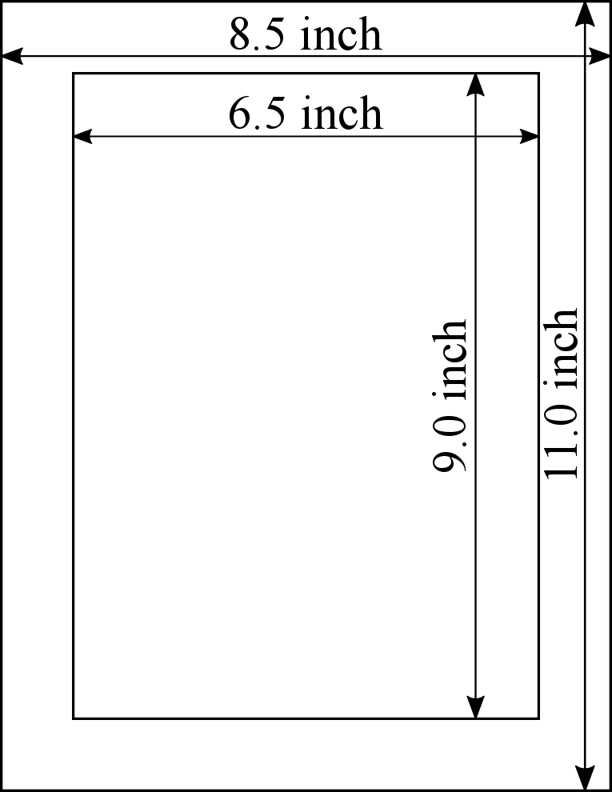
Figure 1: Text area for manuscripts (U.S. Letter format)

3.9 Format of Equations
Equations are to be centered, numbered in order (i.e., (1), (2), (3), etc.) down the right-hand side of the page and cited in the text with its number, e.g., “… as listed in equation (1)”. Use 1.5 spacing, if necessary, for equations.

Symbols used in equations should be explained directly below the equation in which they first appear or in a nomenclature section at the end of the manuscript. E.g., a method (Cheap and Fee, 1986) to estimate the cost of attending meetings is given in Equation (1). Formatting of equations has to be checked before submittal of the manuscript.

(1)

3.10 Units Format
SI units only or dual units have to be used. If dual units are used, the equivalent values in the secondary units, enclosed in parentheses, will immediately follow the original values in the primary units, i.e., SI (IP) or IP (SI).

3.11 Footer and Page Numbering
Authors are asked to include the one-line footer centered on each page of their manuscript. The footer has to be placed 0.5 inch (1.27 cm) from the bottom edge of the page for the 8.5×11 inch U.S. Standard Letter format. The required footer is included in the footer of the author template for your conference. The page number should be appended to the paper ID number in the header.

4. SUBMISSION OF MANUSCRIPT

DEADLINE: Submit your manuscripts electronically by April 4, 2022 at the online abstract and paper submission website at http://www.conftool.com/Herrick2022.

Submit manuscripts as a pdf-file that is smaller than 20 MB including an abstract, graphs and figures. We will ONLY accept electronic versions of the manuscripts.

Publication of Paper: No manuscript will be published unless the $650 registration fee is paid in full by April 1, 2020 ($750 if presenting both at IBO & Conference). If your manuscript is rejected, but you are already registered as required presenting author for the conference, the registration fee will be fully refunded.

5. COMMERCIALISM

Commercialization in the manuscript and during the oral presentation is not permitted. Manuscripts are meant to advance the general state of the art. The conferences are not a place to promote sales. If included in the manuscript, the paper will either be rejected or the commercialization will be cut out. We request, except for the first slide and author identification in the manuscript, that company names, logos and other references to proprietary equipment not be included in the manuscript, on the slides, or in the oral presentation. However, it is acceptable to describe equipment that was used in experimental tests when necessary for others to be able to reproduce the results.

6. CONCLUSIONS

Conclusions can be in paragraph form or bullet items. Remember the following:
- Do not wait until the last minute to submit your paper.
- Do not expect to get an extension for submitting your paper.
- If you do not submit your paper according to the guidelines specified in these instructions, there is NO GUARANTEE that your paper will be included in the conference proceedings.

NOMENCLATURE

The nomenclature should be located at the end of the text using the following format:
A hotel cost (US$/night)
C total cost (US$)
N number (–)

Subscript
n nights
p participants

REFERENCES

References are to be placed at the end of the manuscript in alphabetical order by the last name of the first author. All sources cited in the text have to be listed in the list of references in alphabetical order of the author's name, or of the lead author’s name (if there are several authors) at the end of the manuscript. The sources should be listed in the standard APA (American Psychological Association) style as follows:

1-Article from a periodical
Author, A. A., Author, B. B., & Author, C. C. (Year). Title of article. Title of Periodical, volume number(issue number), pages.
e.g., Herbe, L. & Lundqvist, P. (1997). CFC and HCFC refrigerants retrofits. Int. J. Refrig., 20(1), 49–54.
e.g., Cheap, I. R., Fee, W. (1986). Conference attendance on a shoestring budget. Int. J. Cost-Effective Research, 7(4), 78–93.

2-Paper published in conference proceedings
Author, A. A., Author, B. B., & Author, C. C. (Year). Title of article. In Editor, A. A., Editor, B. B., & Editor, C. C. (Eds.), Proceedings of the Title of Conference (pages). Place of publication: Name of publisher.
e.g., Forbes-Pearson, S. (1996). Uses of hydrocarbon refrigerants. In Commissions B1, B2, E1, & E2 (Eds.), Applications of Natural Refrigerants: Proceedings of the 2nd IIR-Gustav Lorentzen Conference on Natural Working Fluids, Aarhus, Denmark (439–446). Paris, France: IIF/IIR

3-Book
Author, A. A., Author, B. B., & Author, C. C. (Year of publication). Title of work: Capital letter also for subtitle. Location: Publisher. Establishments can be considered authors when they assume main responsibility for the text and their publications reflect their collective opinions or activities.
e.g., Janna, S. W. (1986). Engineering heat transfer. Boston, MA: PWS Publishers.

4-Book chapter
Author, A. A., Author, B. B., & Author, C. C. (Year of publication). Title of chapter. In A. A. Editor & B. B. Editor (Eds.), Title of book (pages of chapter). Location: Publisher.
e.g., Duminil, M. (1995). Principes de la production du froid. In D. Côme & R. Ulrich (Eds.), La chaîne du froid—Le froid au service de l'homme (33–144). Paris, France: Éditions Hermann.

Examples of APA style citations for other print and electronic sources can be found on the Purdue OWL website: https://owl.english.purdue.edu/owl/resource/560/1/.
The American Psychological Association maintains a blog where detailed instructions, commentary, and examples for citing different sources are provided: https://apastyle.apa.org/products/publication-manual-7th-edition.

Standard abbreviations for periodicals and journals can be found on Web of Science maintained by Thomson Reuters: https://images.webofknowledge.com/images/help/WOS/A_abrvjt.html

ACKNOWLEDGEMENT

An acknowledgement can be located at the end of the text to indicate the sponsor of the study presented and/or to acknowledge additional contributors to the paper.

