Flex Lab Safety Committee
  - May 1st, 2025
  - 3:30 – 4:30 pm
  - Flex B038

- Welcome
- Review of previous meeting minutes (see below)
- Urgent Business
  - Near-miss: PPE in public areas
- Old Business
  - Grad Student Safety Deputies for Flex
  - Update Door Postings
  - ISP self-inspections—Past due!
- New Business
  - Door propping – report if seen.
- Other thoughts/concerns/announcements
  - Please remember to flush eyewash stations.
  - Required PPE-Gloves, Lab coat, and Goggles.
- Adjourn

Flex Lab Safety Committee
  - March 6th, 2025
  - 3:30 – 4:30 pm
  - Flex B038

- Welcome
- Review of previous meeting minutes (see below)
- Urgent Business
  - Near-miss: Unsafe gas cylinder handling
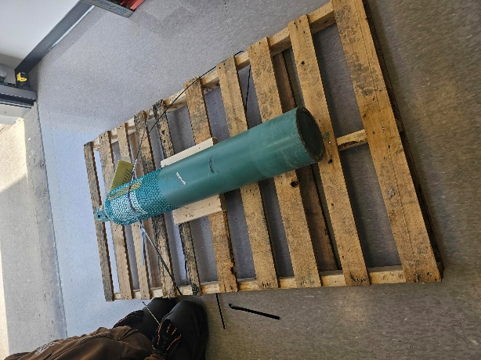
  - Waste Handling
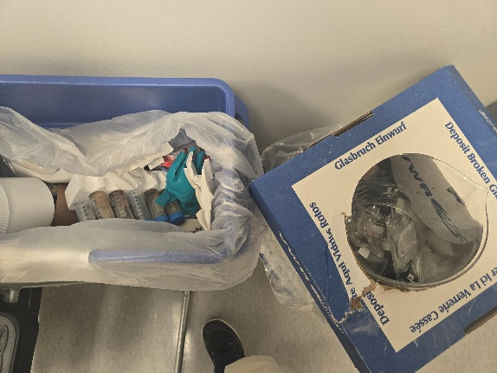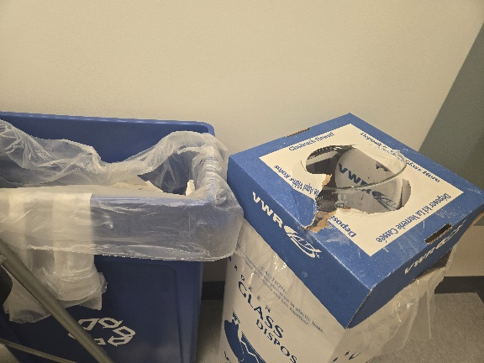

- Old Business
  - Grad Student Safety Deputies for Flex
  - Signage for elevator – Ordered?
  - Update Door Postings
- New Business
  - Unauthorized lab access
  - Upcoming ISP inspections
- Other thoughts/concerns/announcements
  - Please remember to flush eyewash stations.
  - Required PPE-Gloves, Lab coat, and Goggles.
- Adjourn

