ENGR 132 – In-Class Activity: WiFi Connection Test

Team Information
Section: Click or tap here to enter text.
Date: Click or tap here to enter text.
Team Members (Full Names):
Click or tap here to enter text.
Click or tap here to enter text.
Click or tap here to enter text.
Click or tap here to enter text.
(Optional) Team Name: Click or tap here to enter text.

Instructions
This in-class activity guides you through connecting MATLAB to an Arduino Uno R4 WiFi using a wireless network (hotspot). You will verify that MATLAB can communicate with the Arduino and control a digital output directly from the Command Window.
You will:
- Connect your Arduino Uno R4 WiFi to a hotspot using MATLAB.
- Establish a connection between MATLAB and the Arduino using a = arduino.
- Control a digital pin by sending simple commands (1 and 0) from the Command Window.
Follow these steps:
- Complete all work in MATLAB.
- Verify that your Arduino is connected to WiFi and MATLAB without errors.
- Execute the required commands in the Command Window.
- Insert a screenshot of your MATLAB Command Window showing a successful connection and execution of commands into this Word file.

Submission Instructions
Save this worksheet as a PDF and submit it to Gradescope.
- PDF file: ENGR132_ICA_WiFi_LastNames.pdf
Ensure that all team members are listed in the submission on Gradescope (if applicable) and that everyone reviews and approves the submission.

Course Resources
- Getting Started with MATLAB and Arduino Support Package
- Connect to Arduino Hardware Over WiFi
- ENGR 132 MATLAB Programming Standards page (on Brightspace)
MATLAB-Arduino Troubleshooting Guide

Required Hardware
- Arduino
  - USB Connector
- Grove LED Socket Kit
  - LED
- 9V Battery Holder
  - 9V Battery
- Grove Base Shield (Optional)
  - 4-wire F-F connector
- No Grove Base Shield
  - 4-Wire F-M split connector

Task 1: Circuit Setup
Circuit setup will vary depending on the use of the Grove Base Shield for connections. In both cases, ensure the Arduino is connected to the computer via USB for power & setup. Ensure the 9V Battery Holder is connected to the Arduino and turned ON.

With Grove Base Shield
Assemble the circuit.
- Grove Base Shield
  - Install the Base Shield on top of the Arduino.
- Grove LED Socket Kit
  - Insert a wire connector into the Grove LED Socket Kit
  - Connected to analog input D6

Without Grove Base Shield
Assemble the circuit as shown in Figure 1.
Grove LED Socket Kit
  - Insert a wire connector into the Grove LED Socket Kit
  - Connect the yellow signal (SIG) wire to pin D6.
  - Connect the red voltage (VCC) wire to the 5V pin.
  - Connect the black ground (GND) wire to any GND pin.
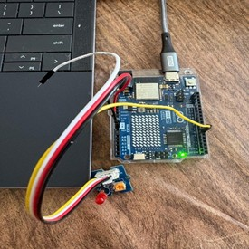
Figure 1. Grove Light Sensor connected to the A0 port on the Grove Base Shield. The A0 port corresponds to analog pin A0 on the Arduino Uno. The sensor outputs a voltage between 0–5 V that varies with light intensity. MATLAB reads this analog voltage through the Arduino’s MATLAB Support Package interface.

Task 2: WiFi Connection Setup (MATLAB + Hotspot)

General
In this task, you will connect your Arduino Uno R4 WiFi to a wireless network using a phone hotspot. This allows MATLAB to communicate with the Arduino over WiFi instead of a USB connection.
Make sure your computer and Arduino are connected to the same hotspot before continuing.
Note: A phone hotspot requires cellular data to be enabled.

Instructions
- Turn on the hotspot on your phone.
  - Note: The Arduino Uno R4 Wifi only supports 2.4 GHz frequency band. You may need to go into your device settings to change this.
- Connect your computer to the hotspot (e.g., JeannGAM), as shown in the below image.
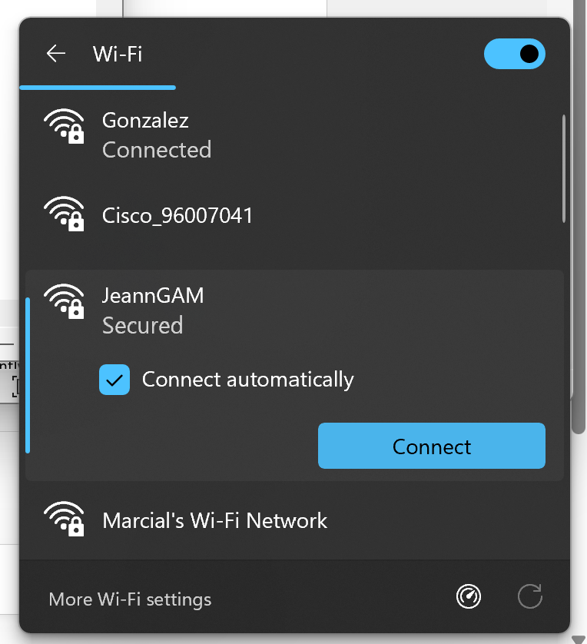
Figure 2. WiFi Connection Screen

- Open MATLAB and type the following command in the Command Window:
>> arduinosetup
  - Note: The setup window may take several seconds to open

- In the setup window:
  - Select Board: Arduino Uno R4 WiFi
  - Select Connection Type: WiFi
  - Enter your hotspot SSID and Password (SSID is the name of your hotspot, and Password is the hotspot password).

See Figure 3 below for an example of the setup window, where "JeannGAM" is the hotspot name (SSID) and "jeannetegam" is the hotspot password.

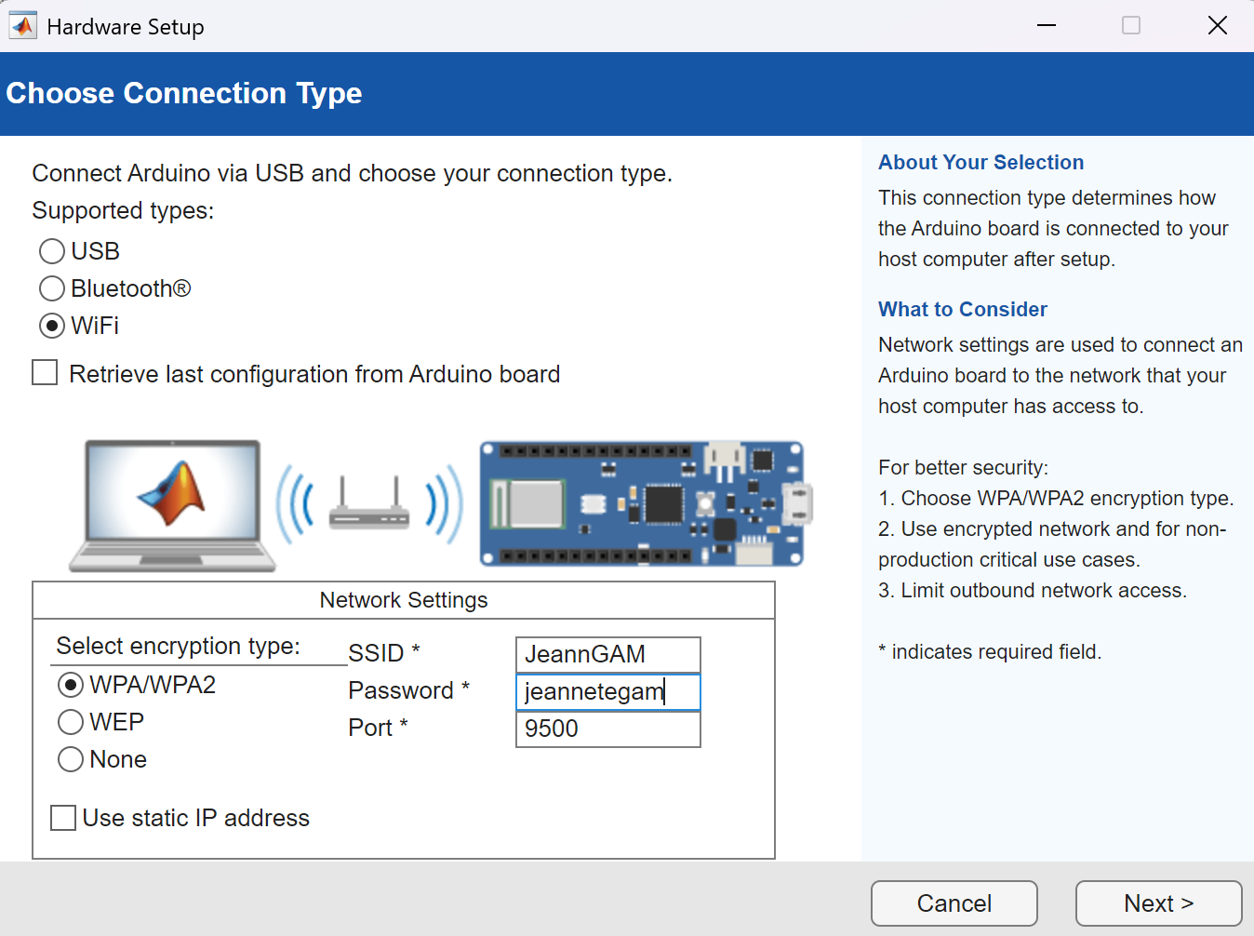
Figure 3. MATLAB Hardware Setup window showing WiFi connection settings. The SSID (JeannGAM) and Password (jeannetegam) are entered to connect the Arduino to the hotspot network.

- Select Board: Arduino Uno R4 WiFi and the correct port.
Make sure all libraries are unchecked, then click Program to upload the server to the Arduino.
Refer to Figure 4 below for an example.
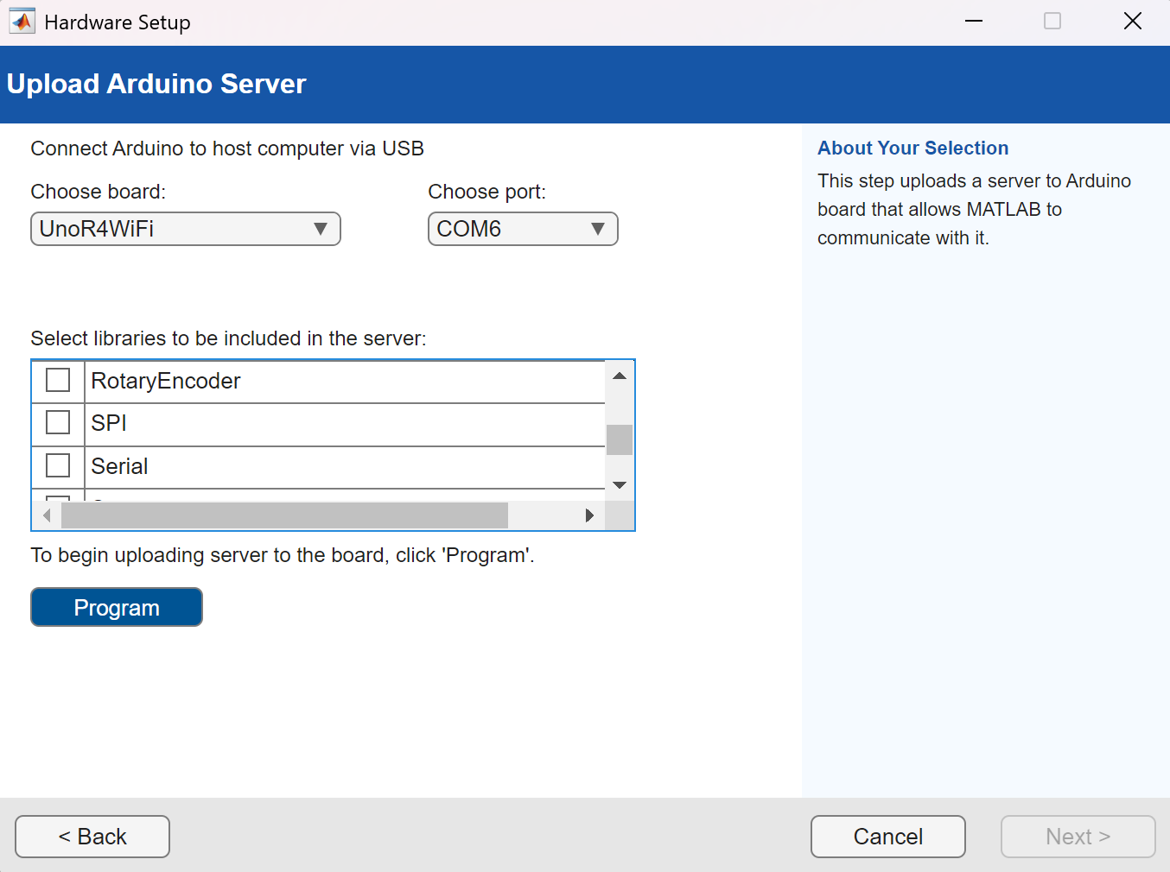
Figure 4. MATLAB Hardware Setup window showing the Arduino board (Uno R4 WiFi), port selection, and library options. All libraries are unchecked before clicking Program to upload the server.

- Click Test connection and verify that the message “Test connection successful” appears. An IP address (e.g., 172.20.10.X) will also be displayed. This IP address is unique for each Arduino and is used for communication with MATLAB. See Figure 5 below for an example.
  - If this is successful, you may click next and finish on the next page. DO NOT open the Arduino Explorer App.

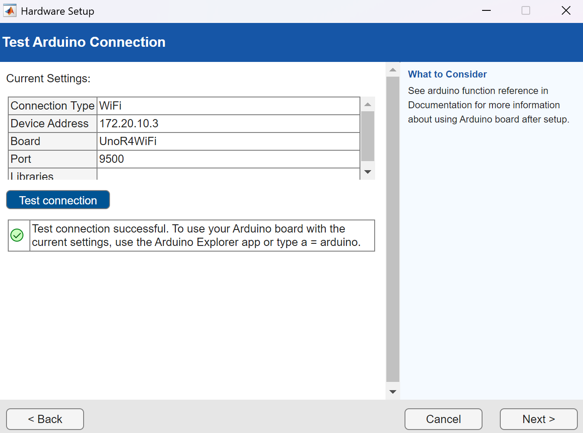
Figure 5. MATLAB Hardware Setup window showing a successful WiFi connection. The message “Test connection successful” and the displayed IP address (DeviceAddress) confirm that MATLAB can communicate with the Arduino.

- In the MATLAB Command Window, type the following command:
>> a = arduino

This command connects MATLAB to the Arduino over WiFi and displays the board properties.
Verify that the DeviceAddress (IP), board type, and available pins are displayed.
See Figure 6 below for an example.

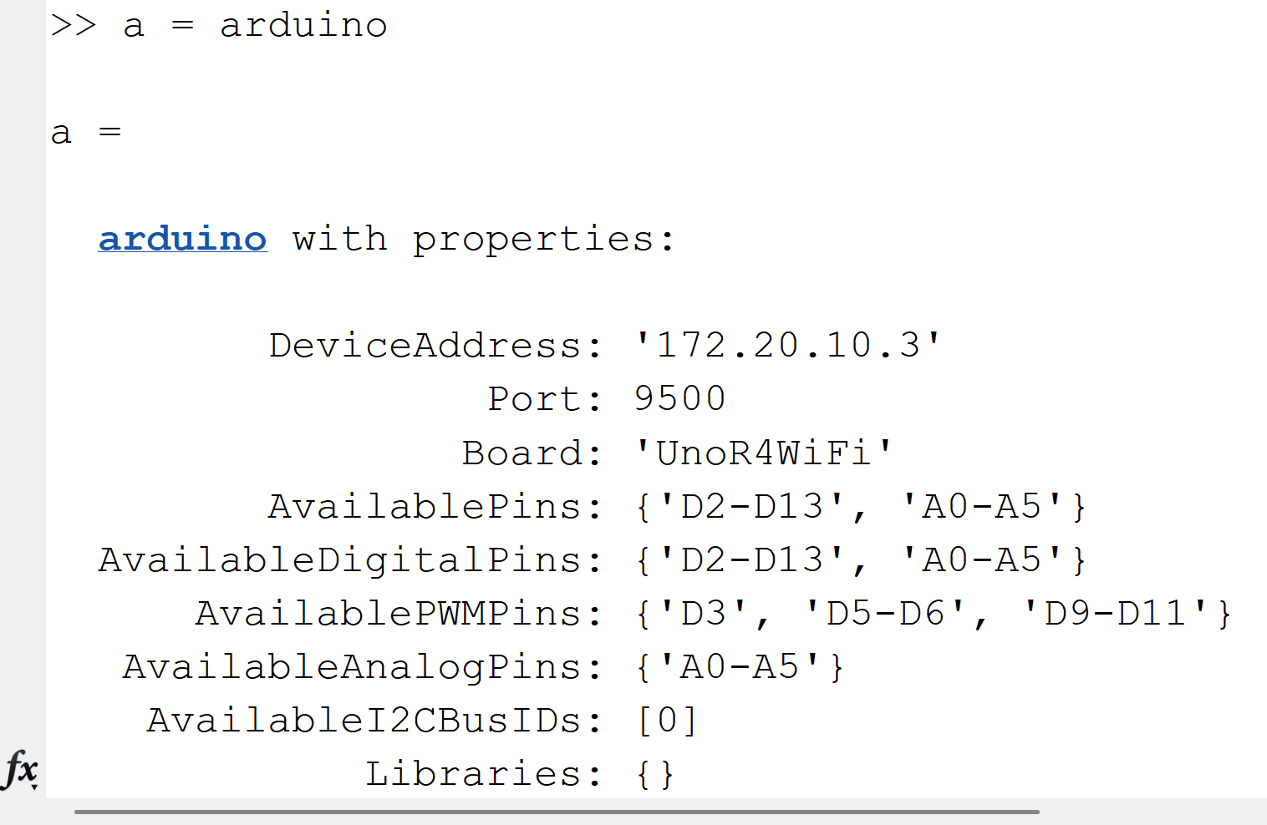
Figure 6. MATLAB Command Window showing the output of a = arduino, including the DeviceAddress (IP), board type, and available pins, confirming a successful WiFi connection between MATLAB and the Arduino
Note: Even though the Arduino is connected to WiFi, it still needs power. The 9V battery should work properly with WiFi for this activity. Otherwise, you may need to use a USB cable or phone charger to keep the Arduino powered.

- In the MATLAB Command Window, type the following commands to control the LED:

>>writeDigitalPin(a,"D6",1) %This command turns the LED ON.
>>writeDigitalPin(a,"D6",0) %This command turns the LED OFF.
Note: If the LED turns ON and OFF according to the commands, then the system is working correctly and MATLAB is successfully communicating with the Arduino over WiFi.

Proof of Completion (Deliverable)
Take a screenshot of your MATLAB Command Window showing the output of a = arduino and the command lines:
>>writeDigitalPin(a,"D6",1)
>>writeDigitalPin(a,"D6",0)

Communication Errors between the Arduino and MATLAB (WiFi)
- Check the WiFi connection.
Make sure your computer and Arduino are connected to the same hotspot network.
- Verify the hotspot is active.
Ensure your phone hotspot is turned ON and working properly.
- Reconnect in MATLAB.
If the connection fails, run:
>> clear a
>> a = arduino
- Check the Arduino power source.
Make sure the Arduino is powered using a USB cable or a stable external power source.
The 9V battery may not provide enough current for WiFi operation.
- Run the setup again if needed.
If MATLAB cannot connect, rerun: >>arduinosetup
- Restart MATLAB or reconnect the Arduino.
If issues persist, restart MATLAB or reconnect the Arduino to refresh the connection

