ENGR 132 – In-Class Activity 4: Reading Light Sensor Data and Linear Regression in MATLAB

Team Information
Section: Click or tap here to enter text.
Date: Click or tap here to enter text.
Team Members (Full Names):
- Click or tap here to enter text.
- Click or tap here to enter text.
- Click or tap here to enter text.
- Click or tap here to enter text.
(Optional) Team Name: Click or tap here to enter text.

Instructions
This in-class activity guides you through collecting real-time light intensity data using the Grove Light Sensor connected to an Arduino Uno and analyzing the data in MATLAB. You will run a provided MATLAB script to:
- Acquire voltage readings from the light sensor at different distances,
- Store and plot your measured data, and
- Create a linear regression model to analyze the relationship between distance and sensor output.
Follow these steps:
- Complete all work in MATLAB.
- Insert your circuit diagram, MATLAB code, Command Window output, and plot directly into this Word file.

Submission Instructions
- Save this worksheet as a PDF and submit it to Gradescope.
  - PDF file: ENGR132_ICA_LightSensor_LastNames.pdf
- Ensure that all team members are listed in the submission on Gradescope (if applicable) and that everyone reviews and approves the submission.

Course Resources
- Getting Started with MATLAB and Arduino Support Package
- MathWorks Example: Read Analog Sensor Data Using MATLAB – Demonstrates how to read voltage values from an Arduino in real time
- Seeed Studio Grove Light Sensor Documentation. Technical overview, pin mapping, and wiring guide for the light sensor.
- ENGR 132 MATLAB Programming Standards page (on Brightspace)
- MATLAB-Arduino Troubleshooting Guide

Required Hardware
- Arduino
  - USB Connector
- Grove Light Sensor
- Grove Base Shield (Optional)
  - 4-wire F-F connector
- No Grove Base Shield
  - 4-Wire F-M split connector
- Ruler
- Flashlight (Or device with flashlight)

Task 1: Circuit Setup
Circuit setup will vary depending on the use of the Grove Base Shield for connections. In both cases, ensure the Arduino is connected to the computer via USB.

With Grove Base Shield
Assemble the circuit as shown in Figure 1.
- Grove Base Shield
  - Install the Base Shield on top of the Arduino.
- Grove Light Sensor
  - Insert a wire connector into the Grove Light Sensor
  - Connected to analog input A0
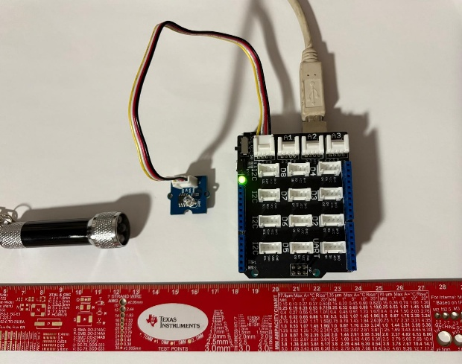
Figure 1. Grove Light Sensor connected to the A0 port on the Grove Base Shield. The A0 port corresponds to analog pin A0 on the Arduino Uno. The sensor outputs a voltage between 0–5 V that varies with light intensity. MATLAB reads this analog voltage through the Arduino’s MATLAB Support Package interface.

Without Grove Base Shield
Assemble the circuit as shown in Figure 2.
- Grove Light Sensor
  - Insert a wire connector into the Grove Light Sensor
  - Connect the yellow signal (SIG) wire to pin A0.
  - Connect the red voltage (VCC) wire to the 5V pin.
  - Connect the black ground (GND) wire to any GND pin.
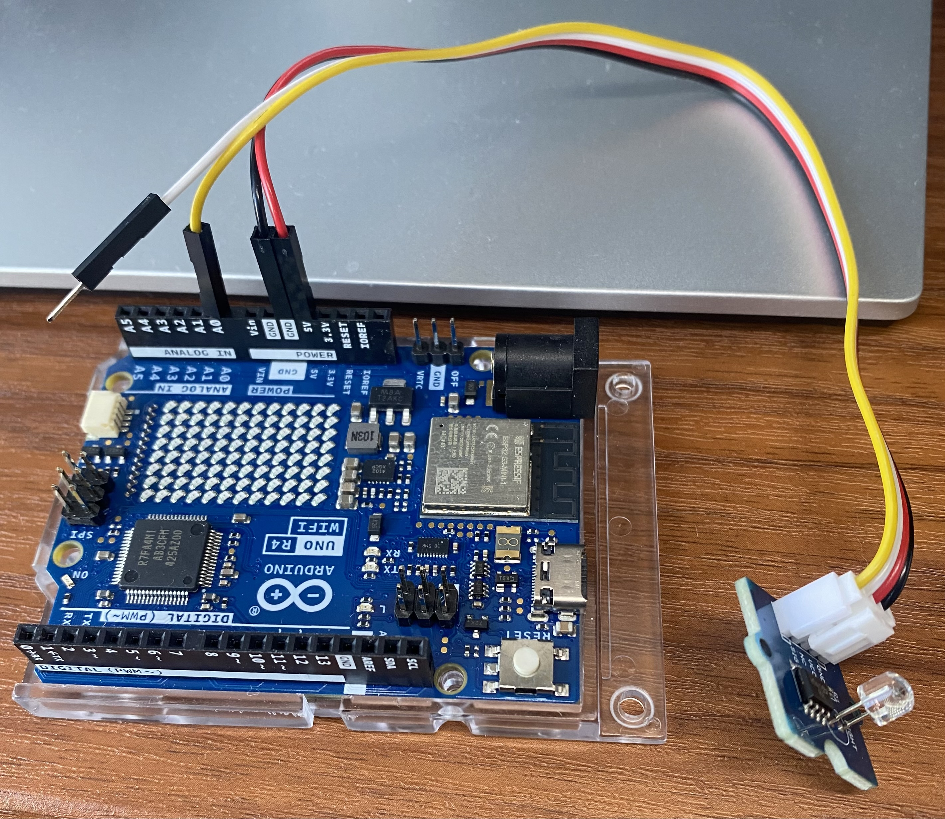
Figure 2. Grove Light Sensor connected to the A0 pin on the Arduino. The sensor outputs a voltage between 0–5 V that varies with light intensity. MATLAB reads this analog voltage through the Arduino’s MATLAB Support Package interface.

Task 2: MATLAB Script – Data Collection and Linear Regression
In this task, you will use a provided MATLAB script to collect voltage data from the Grove Light Sensor at different distances and create a linear model that relates distance (cm) to sensor voltage (V). The script uses a for loop to:
- Read the light sensor voltage at each distance using the MATLAB Arduino Support Package.
- Store the average voltage in a vector.
- Fit a linear regression model of the form
$$V=m⋅d+b$$
Equation 1: voltage (V) equals slope (m) multiplied by distance (d) plus a constant (b)
- Plot the measured data and the best-fit line.
You will:
- Make sure MATLAB can connect to the Arduino.
- Run the script to collect your data.
- Generate a plot of Distance (cm) vs. Voltage (V).
- Record the linear model and the coefficient of determination $R^{2}$.

Starter MATLAB Code (Light Sensor – Linear Regression)
Copy the code below into a new script named
ICA_LightSensor_LastNames.m
and update the author and date lines.

%% ENGR 132 - In-Class Activity: Light Sensor + Linear Regression
% Authors: _________________________
% Date: _________________________

%% 1) Connect to Arduino
clear; clc; close all;

% If you have only one Arduino connected, this is usually enough:
a = arduino();

% If needed, you can specify the COM port and board type, e.g.:
% a = arduino("COM8","Uno");

disp('Connected to Arduino.');
disp('Make sure the Grove Light Sensor is connected to A0.');

%% 2) Distances (cm) and data storage
dist_cm = [5 10 15 20 25]; % Distances in cm
N = numel(dist_cm); % Number of distances

Vmean = zeros(1, N); % Average voltage at each distance
samplesPerDist = 20; % Number of readings per distance
dt = 0.05; % Time between readings (seconds)

%% 3) Data collection loop
for k = 1:N
fprintf('\nPlace the light source at %d cm.\n', dist_cm(k));
fprintf('Press Enter when you are ready...\n');
pause; % Wait for user to press Enter

Vsamples = zeros(1, samplesPerDist);

for i = 1:samplesPerDist
Vsamples(i) = readVoltage(a,"A0"); % Read light sensor voltage
pause(dt);
end

Vmean(k) = mean(Vsamples);
fprintf('Average voltage at %d cm = %.3f V\n', dist_cm(k), Vmean(k));
end

%% 4) Linear regression: V = m*d + b
p = polyfit(dist_cm, Vmean, 1); % p(1) = m, p(2) = b
m = p(1);
b = p(2);

% Fitted line for plotting
dFit = linspace(min(dist_cm), max(dist_cm), 100);
VFit = polyval(p, dFit);

% Compute R^2
Vhat = polyval(p, dist_cm);
SSres = sum((Vmean - Vhat).^2);
SStot = sum((Vmean - mean(Vmean)).^2);
R2 = 1 - SSres/SStot;

%% 5) Plot results
figure('Name','Light Sensor vs Distance','NumberTitle','off');
plot(dist_cm, Vmean, 'o', 'MarkerSize', 8, 'LineWidth', 2); hold on;
plot(dFit, VFit, 'LineWidth', 2);
grid on;
xlabel('Distance (cm)');
ylabel('Light Sensor Voltage (V)');
title('Light Sensor Readings and Linear Fit');
legend('Measured Data','Linear Fit','Location','northeast');

%% 6) Display model and R^2
fprintf('\n================ RESULTS ================\n');
fprintf('Linear model: V = %.4f * d + %.4f\n', m, b);
fprintf('R^2 = %.4f\n', R2);
fprintf('========================================\n\n');

Task 3: Data Analysis and Interpretation
After running your MATLAB script, you should now have:
- A set of measured voltages for each distance
- A scatter plot of Distance (cm) vs. Voltage (V)
- A linear regression line
- A linear model of the form
$$V=m⋅d+b$$Equation 1: voltage (V) equals slope (m) multiplied by distance (d) plus a constant (b)

- An $R^{2}$ value
In this task, you will interpret your results and explain what they mean in the context of the experiment and the sensor’s behavior.

1. Linear Model
Your linear model relates voltage $V$ to distance $d$using the form:
$$V=m⋅d+b$$Equation 1: voltage (V) equals slope (m) multiplied by distance (d) plus a constant (b)
Write your full linear equation below, using your numerical values of m and b:

Does your linear model show that the sensor voltage increases or decreases as distance increases?
Why does this make sense physically?

2. Sensor Behavior
Look at your measured voltages for each distance:
- Did several of your readings stay close to the same value (a “flat region”)?
- Did the voltage drop noticeably at larger distances?
Explain whether your sensor showed saturation, and why this might occur with a light sensor

3. R² Value
Report your $R^{2}$
Is your $R^{2}$close to 1? Why or why not?
Discuss at least one factor that could have affected the quality of your linear fit.

4. Improving the Experiment
List two changes you could make to improve the quality of the data collected from the light sensor.

5. Prediction
Use your linear model to predict the voltage at 18 cm.
Show your calculation using your values of $m$ and $b$.

Task 4: Deliverables

1. MATLAB Script
Paste your complete MATLAB script below (Adjust size as needed)

2. Command Window Output
Paste the output showing:
- Voltage readings for each distance
- The linear model (values of m and b)
- The calculated R² value

3. Plot (Figure)
Insert your MATLAB plot showing:
- Data points (Voltage vs. Distance)
- Linear regression line
- Title, axes labels, and legend
Insert the figure below:

