Team Information
- Section: ___________________________
- Date: ___________________________

Team Members (write full names):

- ____________________________________________

- ____________________________________________

- ____________________________________________

- ____________________________________________

(Optional) Team Name: ___________________________________________

Instructions
This in-class activity guides you through collecting real-time light intensity data using the Grove Light Sensor connected to an Arduino Uno and analyzing the data in MATLAB. You will run a provided MATLAB script to:
- Acquire voltage readings from the light sensor at different distances,
- Store and plot your measured data, and
- Create a linear regression model to analyze the relationship between distance and sensor output.
Follow these steps:
- Complete all work in MATLAB.
- Insert your circuit diagram, MATLAB code, Command Window output, and plot directly into this Word file.
- Save and submit both your Word file and MATLAB script to the Brightspace In-Class Activity Drop Box.
File naming convention:
- Word file → ENGR132_ICA_LightSensor_LastNames.docx
- MATLAB script → ICA_LightSensor_LastNames.m
- MATLAB figure → ENGR132_ICA_LightSensor_LastNames.png

Relevant Course Resources:
Pre-Class Videos | - None
Course Resources | - Getting Started with MATLAB and Arduino Support Package — How to install and use the MATLAB Arduino interface.  - MathWorks Example: Read Analog Sensor Data Using MATLAB – Demonstrates how to read voltage values from an Arduino in real time  - Seeed Studio Grove Light Sensor Documentation. Technical overview, pin mapping, and wiring guide for the light sensor.  - ENGR 132 MATLAB Programming Standards page (on Brightspace)

Submission Instructions:
• Re-name your files as:
• Word file → ENGR132_ICA3_LightSensor_LastNames.docx
• MATLAB script → ICA_LightSensor_LastNames.m
• MATLAB figure → ENGR132_ICA_LightSensor_LastNames.png
- Submit all files through the designated Brightspace In-Class Activity Drop Box at https://purdue.brightspace.com/.
- Ensure that all team members are listed in the submission on Brightspace (if applicable) and that everyone reviews and approves the submission.

Task 1: Circuit Setup
  - Assemble the circuit as shown in Figure 1.
Connect the Grove Light Sensor directly to the A0 port on the Grove Base Shield attached to the Arduino Uno, as shown in the image below.
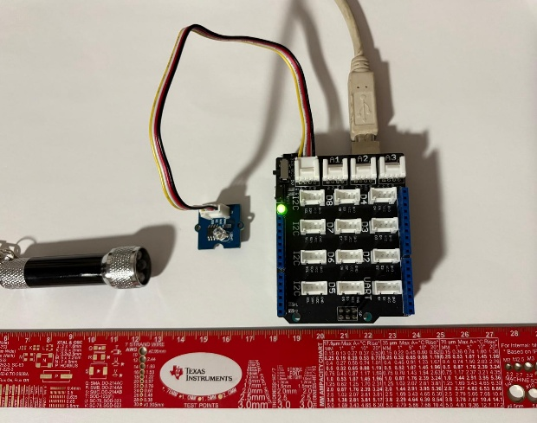

Figure 1: Grove Light Sensor connected to the A0 port on the Grove Base Shield. The A0 port corresponds to analog pin A0 on the Arduino Uno. The sensor outputs a voltage between 0–5 V that varies with light intensity. MATLAB reads this analog voltage through the Arduino’s MATLAB Support Package interface.
Ensure that:
- The Grove Base Shield is firmly seated on the Arduino.
- The Grove Light Sensor is fully inserted into the A0 port using a Grove 4-pin cable.
- The USB cable is connected to your computer before running MATLAB.
- You will use a ruler provided by the teaching team to measure the required distances.
- You may use your phone’s flashlight (or another small light source) for the experiment.

Task 2: MATLAB Script – Data Collection and Linear Regression

In this task, you will use a provided MATLAB script to collect voltage data from the Grove Light Sensor at different distances and create a linear model that relates distance (cm) to sensor voltage (V). The script uses a for loop to:
- Read the light sensor voltage at each distance using the MATLAB Arduino Support Package.
- Store the average voltage in a vector.
- Fit a linear regression model of the form
$$V=m⋅d+b$$
- Plot the measured data and the best-fit line.
You will:
- Make sure MATLAB can connect to the Arduino.
- Run the script to collect your data.
- Generate a plot of Distance (cm) vs. Voltage (V).
- Record the linear model and the coefficient of determination $R^{2}$.
Complete the steps below and paste your MATLAB code and plot into this Word file.
Starter MATLAB Code (Light Sensor – Linear Regression)
Copy the code below into a new script named
ICA_LightSensor_LastNames.m
and update the author and date lines.

%% ENGR 132 - In-Class Activity: Light Sensor + Linear Regression
% Authors: _________________________
% Date: _________________________

%% 1) Connect to Arduino
clear; clc; close all;

% If you have only one Arduino connected, this is usually enough:
a = arduino();

% If needed, you can specify the COM port and board type, e.g.:
% a = arduino("COM8","Uno");

disp('Connected to Arduino.');
disp('Make sure the Grove Light Sensor is connected to A0.');

%% 2) Distances (cm) and data storage
dist_cm = [5 10 15 20 25]; % Distances in cm
N = numel(dist_cm); % Number of distances

Vmean = zeros(1, N); % Average voltage at each distance
samplesPerDist = 20; % Number of readings per distance
dt = 0.05; % Time between readings (seconds)

%% 3) Data collection loop
for k = 1:N
fprintf('\nPlace the light source at %d cm.\n', dist_cm(k));
fprintf('Press Enter when you are ready...\n');
pause; % Wait for user to press Enter

Vsamples = zeros(1, samplesPerDist);

for i = 1:samplesPerDist
Vsamples(i) = readVoltage(a,"A0"); % Read light sensor voltage
pause(dt);
end

Vmean(k) = mean(Vsamples);
fprintf('Average voltage at %d cm = %.3f V\n', dist_cm(k), Vmean(k));
end

%% 4) Linear regression: V = m*d + b
p = polyfit(dist_cm, Vmean, 1); % p(1) = m, p(2) = b
m = p(1);
b = p(2);

% Fitted line for plotting
dFit = linspace(min(dist_cm), max(dist_cm), 100);
VFit = polyval(p, dFit);

% Compute R^2
Vhat = polyval(p, dist_cm);
SSres = sum((Vmean - Vhat).^2);
SStot = sum((Vmean - mean(Vmean)).^2);
R2 = 1 - SSres/SStot;

%% 5) Plot results
figure('Name','Light Sensor vs Distance','NumberTitle','off');
plot(dist_cm, Vmean, 'o', 'MarkerSize', 8, 'LineWidth', 2); hold on;
plot(dFit, VFit, 'LineWidth', 2);
grid on;
xlabel('Distance (cm)');
ylabel('Light Sensor Voltage (V)');
title('Light Sensor Readings and Linear Fit');
legend('Measured Data','Linear Fit','Location','northeast');

%% 6) Display model and R^2
fprintf('\n================ RESULTS ================\n');
fprintf('Linear model: V = %.4f * d + %.4f\n', m, b);
fprintf('R^2 = %.4f\n', R2);
fprintf('========================================\n\n');

Task 5: Data Analysis and Interpretation

After running your MATLAB script, you should now have:
- A set of measured voltages for each distance
- A scatter plot of Distance (cm) vs. Voltage (V)
- A linear regression line
- A linear model of the form
$$V=m⋅d+b$$
- An $R^{2}$value
In this task, you will interpret your results and explain what they mean in the context of the experiment and the sensor’s behavior.
1. Linear Model
Your linear model relates voltage $V$to distance $d$using the form:
$$V=m⋅d+b$$
Write your full linear equation below, using your numerical values of m and b:

Does your linear model show that the sensor voltage increases or decreases as distance increases?
Why does this make sense physically?
.

2. Sensor Behavior
Look at your measured voltages for each distance:
- Did several of your readings stay close to the same value (a “flat region”)?
- Did the voltage drop noticeably at larger distances?

Explain whether your sensor showed saturation, and why this might occur with a light sensor

3. R² Value
Report your $R^{2}$
Is your $R^{2}$close to 1? Why or why not?
Discuss at least one factor that could have affected the quality of your linear fit.

4. Improving the Experiment
List two changes you could make to improve the quality of the data collected from the light sensor.

5. Prediction
Use your linear model to predict the voltage at 18 cm.
Show your calculation using your values of $m$and $b$.

Task 5: Deliverables
- MATLAB Script
- Paste your complete MATLAB script:
ICA_LightSensor_LastNames.m

- Command Window Output
Paste the output showing:
- Voltage readings for each distance
- The linear model (values of m and b)
- The calculated R² value

4. Plot (Figure)
Insert your MATLAB plot showing:
- Data points (Voltage vs. Distance)
- Linear regression line
- Title, axes labels, and legend
Save the plot as:
ENGR132_ICA_LightSensor_LastNames.png
Insert the figure here:

Communication Errors between the Arduino and MATLAB:
- Check the USB connection.
Make sure your Arduino Uno R4 WiFi is firmly connected to your computer using the correct USB cable.
The green power LED on the board should turn on when connected properly.
- Verify the COM port.
In MATLAB, run: serialportlist("available")
- Use the correct port name (e.g., "COM8") in your code line: sp = serialport("COM8",115200);
- Check the baud rate.
Confirm that the baud rate in your MATLAB code (e.g., 115200) matches the baud rate defined in your Arduino sketch.
- Restart MATLAB or reconnect the USB cable.
If the connection fails or MATLAB freezes on readline, disconnect and reconnect the Arduino USB cable, then rerun your code.
- Restart your computer if issues persist.
A full restart can fix USB or COM port conflicts.

