ENGR 132 – In-Class Activity 3: Creating and Using UDFs to Read and Plot Temperature and Humidity Data

Team Information
Section: Click or tap here to enter text.
Date: Click or tap here to enter text.
Team Members (Full Names):
- Click or tap here to enter text.
- Click or tap here to enter text.
- Click or tap here to enter text.
- Click or tap here to enter text.
(Optional) Team Name: Click or tap here to enter text.

Instructions
This activity guides you through creating User-Defined Functions (UDFs) in MATLAB to read real-time temperature and humidity data from a Grove DHT22 (Temperature & Humidity Sensor Pro v1.3) sensor connected to an Arduino Uno R4 WiFi.
You will write a main MATLAB script that calls two UDFs:
- one to read and parse the sensor data, and
- one to convert the temperature from °C to °F.
Complete all work in MATLAB and insert your circuit diagram, MATLAB code, plots, and Command Window output directly into this Word file.

Submission Instructions
- Save this worksheet as a PDF and submit it to Gradescope.
  - Re-name your files as: ENGR132_ICA3_UDFs_DHT22_LastNames.pdf
- Ensure that all team members are listed in the submission on Gradescope (if applicable) and that everyone reviews and approves the submission.

Relevant Course Resources
- Getting Started with MATLAB and Arduino Support Package
- MathWorks Example: Read and Plot Temperature and Humidity Data from Arduino – Demonstrates how to read serial data from an Arduino and visualize sensor readings in real time using MATLAB.
- Seed Studio Grove Temperature & Humidity Sensor Pro (DHT22). Technical overview, pin mapping, and wiring guide.
- ENGR 132 MATLAB Programming Standards page (on Brightspace)
- MATLAB-Arduino Troubleshooting Guide

Required Hardware
- Arduino
  - USB Connector
- Grove DHT22 Temperature & Humidity Sensor
- Grove Base Shield (Optional)
  - 4-wire F-F connector
- No Grove Base Shield
  - 4-Wire F-M split connector

Task 1: Circuit Setup
Circuit setup will vary depending on the use of the Grove Base Shield for connections. In both cases, ensure the Arduino is connected to the computer via USB.

With Grove Base Shield
Assemble the circuit as shown in Figure 1.
- Grove Base Shield
  - Install the Base Shield on top of the Arduino.
- Grove DHT22 Temp & Humid Sensor
  - Insert a wire connector into the Grove DHT22 Temp & Humid Sensor.
  - Connected to digital input D2.
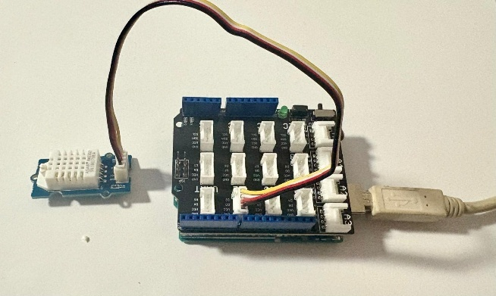
Figure 1. Grove Temperature & Humidity Sensor Pro v1.3 (DHT22) connected to the D2 port on the Grove Base Shield. The D2 port corresponds to digital pin 2 on the Arduino Uno R4 WiFi. The sensor provides two output values: ambient temperature (°C) and relative humidity (%RH), which are sent to MATLAB through the Arduino’s serial connection.

Without Grove Base Shield
Assemble the circuit as shown in Figure 2.
- Grove DHT22 Temp & Humid Sensor
  - Insert a wire connector into the Grove DHT22 Temp & Humid Sensor
  - Connect the yellow signal (SIG) wire to pin D2.
  - Connect the red voltage (VCC) wire to the 5V pin.
  - Connect the black ground (GND) wire to any GND pin.
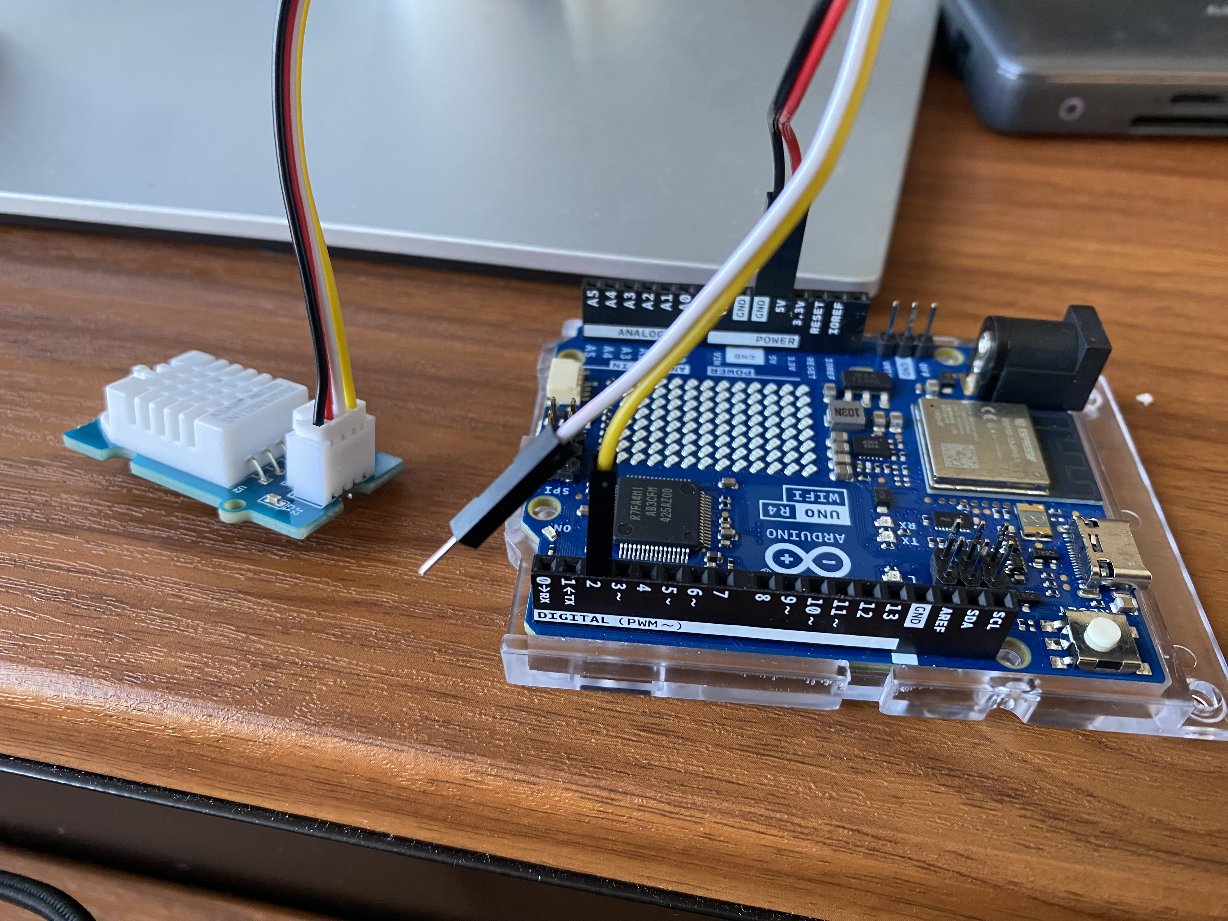
Figure 2. Grove Temperature & Humidity Sensor Pro v1.3 (DHT22) wired to the digital pin 2 on the Arduino Uno R4 WiFi.

Task 2: MATLAB Script Completion (UDFs and Real-Time Temp/Humidity Plot
In this task, you are provided with a partially completed MATLAB script that includes pseudocode comments to guide your work. Your job is to fill in the missing lines of code so that the program runs correctly and produces a real-time plot of temperature (°C) and relative humidity (%RH) read from the Grove DHT22.
You will:
- Connect to the Arduino through the serial port in MATLAB.
- Use a main script that calls two UDFs:
  - a reader function to get "T:xx.xx,H:yy.yy" from Arduino,
  - a converter function to turn °C into °F.
- Collect N readings at regular intervals.
- Print readings in the Command Window and plot temperature and humidity.
Complete the MATLAB script below by filling in the missing code sections.

function runTempMonitor()
%%%%%%%%%%%%%%%%%%%%%%%%%%%%%%%%%%%%%%%%%%%%%%%%%%%%%%%%%%%%%%%%%%%%%
% ENGR 132 - ICA 3: UDFs + DHT22 Real-Time Plot
% Authors: _________________________
% Date: ____________________________
%%%%%%%%%%%%%%%%%%%%%%%%%%%%%%%%%%%%%%%%%%%%%%%%%%%%%%%%%%%%%%%%%%%%%

%% ---------------------------------------------------------------
%% 1) Initialization / Connect to Arduino (Serial)
% Pseudocode:
% - Clear workspace and Command Window
% - Create serial object with COM and baud
% - Configure line terminator to LF
% - Wait ~2 s for Arduino to reset
clear; clc; close all;

COM = "_____"; % e.g., "COM8"
BAUD = _____; % e.g., 115200
sp = serialport(____, _____); % Create serial connection to Arduino
configureTerminator(sp, "_____"); % Defines end-of-line for serial messages
pause(___); % Waits ~2 seconds for Arduino reset

% Warm-up reading (stabilize the DHT22)
% Pseudocode:
% - Call the reader subfunction once
% - Print a short message in Command Window
firstT = 0; firstH = 0; % Initialize variables for first (warm-up) reading
[_____, _____] = readTH(sp); % Call the subfunction readTH(sp)
% outputs temperature in °C (firstT) and humidity in
% RH (firstH)

disp('Sensor ready...'); % Display message after warm-up reading

%% ---------------------------------------------------------------
%% 2) Parameters / Preallocation
% Pseudocode:
% - Choose N = number of samples
% - Create arrays for Temperature (°C), Temperature (°F), Humidity (%)
N = _____; % e.g., 10
T = zeros(1, N); % °C
F = zeros(1, N); % °F
H = zeros(1, N); % %RH

%% ---------------------------------------------------------------
%% 3) Output Header (Command Window)
% Pseudocode:
% - Print a simple table header
fprintf('-------------------------------------------\n');
fprintf(' Reading Temp (°C) Temp (°F) Humidity (%%RH)\n');
fprintf('-------------------------------------------\n');

%% ---------------------------------------------------------------
%% 4) Calculations / Acquisition Loop
% Pseudocode:
% FOR k = 1 to N
% - Call the subfunction readTH(sp)
% • Input: sp → serial object connected to Arduino
% • Outputs: tempC (°C) and hum (%RH)
% - Call the subfunction cToF(T(k))
% • Input: temperature in °C
% • Output: temperature in °F
% - Print one formatted line in the Command Window
% - Wait ~2.5 s between reads (DHT22 requirement)
for k = 1:___
[T(k), H(k)] = ___________; % Subfunction call: readTH(sp)
F(k) = ___________; % Subfunction call: cToF(T(k))
fprintf('L%02d %.2f %.2f %.2f\n', ...
k, T(k), F(k), H(k));
pause(____); % % Waits ~2.5 seconds
end

%% ---------------------------------------------------------------
%% 5) Results / Plot
% Pseudocode:
% - Use yyaxis to plot Temperature (°C) and Humidity (%)
figure('Name','DHT22 Temp/Hum','NumberTitle','off');

yyaxis left
plot(T, '-o', 'LineWidth', 1.5);
ylabel('Temperature (°C)');

yyaxis right
plot(H, '--s', 'LineWidth', 1.5);
ylabel('Humidity (%)');

xlabel('Reading Number');
title('DHT22 Readings (Arduino → MATLAB)');
legend('Temp (°C)', 'Humidity (%)', 'Location', 'best');
grid on;

%% ---------------------------------------------------------------
%% 6) Cleanup
% Pseudocode:
% - Release the serial port
clear sp;

end
Tips:
- In MATLAB, pause(2) waits 2 seconds (in Arduino, delay(2000) = 2 seconds).
- The first reading may display 0.00 — this is normal as the DHT22 stabilizes.

In the box below, paste your runTempMonitor MATLAB code. (Shrink font size as needed)

Subfunction 1 – readTH
This UDF reads a line of temperature and humidity data sent from the Arduino and returns the two numeric values.
Complete the pseudocode and fill in the missing code sections below.
function [tempC, hum] = readTH(sp)
%%%%%%%%%%%%%%%%%%%%%%%%%%%%%%%%%%%%%%%%%%%%%%%%%%%%%%%%%%%%%%%%%%%%%
% ENGR 132 - ICA 3: UDF 1 – readTH
% Authors: _________________________
% Date: ____________________________
%%%%%%%%%%%%%%%%%%%%%%%%%%%%%%%%%%%%%%%%%%%%%%%%%%%%%%%%%%%%%%%%%%%%%
% Function Purpose:
% Reads temperature (°C) and humidity (%RH) values sent by Arduino
% through the serial port. The Arduino sends a line formatted as:
% "T:24.70,H:42.30"
%
% Input:
% sp → serial object connected to the Arduino
%
% Outputs:
% tempC → temperature in degrees Celsius
% hum → relative humidity (%RH)
%%%%%%%%%%%%%%%%%%%%%%%%%%%%%%%%%%%%%%%%%%%%%%%%%%%%%%%%%%%%%%%%%%%%%

%% ---------------------------------------------------------------
%% 1) Initialization
% Pseudocode:
% - Initialize output variables
% - Send a request ('R') to Arduino to get one reading
tempC = _____; % Initialize variable for temperature
hum = _____; % Initialize variable for humidity

%% ---------------------------------------------------------------
%% 2) Calculations / Read and Extract Data
% Pseudocode:
% - Send command 'R' to Arduino
% - Read one line of text returned by Arduino
% - Extract numeric values for temperature and humidity
writeline(_____, "_____"); % Send 'R' request to Arduino
line = strtrim(readline(_____)); % Read a line of text (e.g., "T:24.70,H:42.30")

% Extract numeric values using text markers
tText = extractBetween(line, "T:", "H:"); % Text containing temperature
hText = extractAfter(line, "_____"); % Text containing humidity

%% ---------------------------------------------------------------
%% 3) Results / Assign Outputs
% Pseudocode:
% - Convert extracted text to numbers
% - Store in output variables tempC and hum
if numel(tText) >= 1
tempC = str2double(_____(1)); % Convert to numeric temperature
end
if strlength(hText) > 0
hum = str2double(_____); % Convert to numeric humidity
end
end
In the box below, paste your readTH MATLAB code. (Shrink font size as needed)

Subfunction 2 – cToF
This UDF converts a temperature value from degrees Celsius (°C) to degrees Fahrenheit (°F).
function tempF = cToF(tempC)
Complete the pseudocode and fill in the missing code sections below.
%%%%%%%%%%%%%%%%%%%%%%%%%%%%%%%%%%%%%%%%%%%%%%%%%%%%%%%%%%%%%%%%%%%%%
% ENGR 132 - ICA 3: UDF 2 – cToF
% Authors: _________________________
% Date: ____________________________
%%%%%%%%%%%%%%%%%%%%%%%%%%%%%%%%%%%%%%%%%%%%%%%%%%%%%%%%%%%%%%%%%%%%%
% Function Purpose:
% Converts temperature from degrees Celsius (°C) to degrees Fahrenheit (°F)
%
% Input:
% tempC → temperature in °C
%
% Output:
% tempF → temperature in °F
%%%%%%%%%%%%%%%%%%%%%%%%%%%%%%%%%%%%%%%%%%%%%%%%%%%%%%%%%%%%%%%%%%%%%

%% ---------------------------------------------------------------
%% 1) Initialization
% Pseudocode:
% - Declare the output variable
tempF = _____; % Initialize output variable (optional)

%% ---------------------------------------------------------------
%% 2) Calculations
% Pseudocode:
% - Apply the conversion formula °F = (°C × 9/5) + 32
tempF = (____ * __/__) + __; % Fill in the formula

%% ---------------------------------------------------------------
%% 3) Results
% Pseudocode:
% - Return the converted temperature value
% (MATLAB automatically returns the output variable)

end

In the box below, paste your cToF MATLAB code. (Shrink font size as needed)

Task 3: Command Window Output
Include a screenshot of your MATLAB Command Window showing:
- the printed header (Reading, Temp (°C), Temp (°F), Humidity (%RH)), and
- at least 5 consecutive readings (e.g., L01–L05).
Tip: If your first reading shows 0.00, that’s normal during sensor warm-up. Collect at least five valid readings after the “Sensor ready…” message.
Include a screenshot of your MATLAB Command Window Below

Task 4: Plot of Temperature and Humidity
Insert a screenshot of your MATLAB figure that displays:
- Temperature (°C) on the left axis
- Humidity (%RH) on the right axis
- labeled axes, legend, title, and grid.
Include an image of your MATLAB figure below.

