Team Information
- Section: ___________________________
- Date: ___________________________

Team Members (write full names):

- ____________________________________________

- ____________________________________________

- ____________________________________________

- ____________________________________________

(Optional) Team Name: ___________________________________________

Instructions
This in-class activity guides you through creating a MATLAB script that reads the voltage from a potentiometer connected to an Arduino and uses if/else selection structures to control an LED.
You will also generate a voltage plot to visualize how the system responds to changes in the potentiometer.
• Complete all work in MATLAB and insert your circuit diagram, MATLAB code, voltage plot, and Command Window output directly into this Word file.
• Save and submit both your Word file and MATLAB script through the designated Brightspace In-Class Activity Drop Box.
File naming convention:
- Word file → ENGR132_ICA_PotSelection_LastNames.docx
- MATLAB script → ICA132_PotSelection_LastNames.m
- MATLAB figure → ENGR132_ICA_PotSelection_LastNames.png

Relevant Course Resources:
Pre-Class Videos | - None
Course Resources | - Getting Started with MATLAB and Arduino Support Package  - MathWorks Documentation: Read Analog Voltage from a Potentiometer and Control an LED  - ENGR 132 MATLAB Programming Standards page (on Brightspace)

Submission Instructions:
• Re-name your files as:
• Word file → ENGR132_ICA_PotSelection_LastNames.docx
• MATLAB script → ICA132_PotSelection_LastNames.m
• MATLAB figure → ENGR132_ICA_PotSelection_LastNames.png
• Submit all files through the designated Brightspace In-Class Activity Drop Box at https://purdue.brightspace.com/.
• Ensure that all team members are listed in the submission on Brightspace (if applicable) and that everyone reviews and approves the submission.
Required Hardware
- Arduino R3/4
  - USB Connector
- Rotary Angle Sensor - Potentiometer
- LED Socket Kit w LED (any color)
- 2 4-Wire F-M Connectors

Task 1: Circuit Setup
  - Assemble the circuit as shown in Figure 1.
    - Potentiometer
      - Insert a wire connector into the Potentiometer.
      - Connect the yellow signal (SIG) wire to pin A0
      - Connect the red voltage (VCC) wire to the 5V pin.
      - Connect the black ground (GND) wire to any GND pin.
    - LED Socket Kit
      - Insert a wire connector into the LED Socket Kit.
      - Connect the yellow signal wire to pin D3.
      - Connect the red voltage wire to the 3.3V pin.
      - Connect the black ground wire to any GND pin.

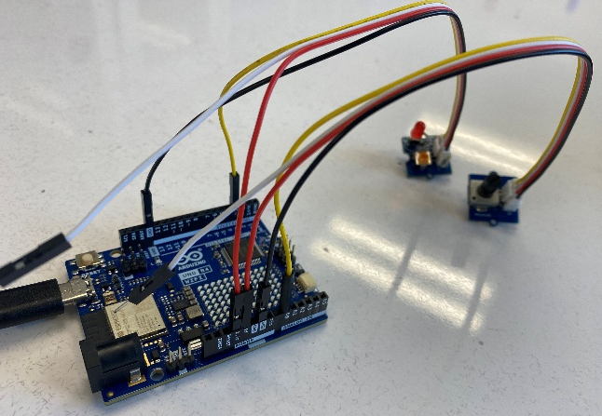

Figure 1: Potentiometer and LED connections on the Arduino Uno (A0 and D3 pins)

  - Take a picture of your setup once it is assembled and insert it below.

(Insert picture of your Arduino circuit here)

Task 2: Pseudocode

A) Write pseudocode that outlines the main steps of your MATLAB script.
Your pseudocode should show how you:

Read the potentiometer voltage from pin A0.

Use an if/else selection structure to decide whether the LED should be ON or OFF.

Display the voltage and LED status in the Command Window.

Plot the voltage readings.

Pseudocode

Task 3: Connect the Arduino from MATLAB and Test the LED

Objective:
Verify communication between MATLAB and your Arduino board, and confirm that you can control the built-in LED (pin D3).

Instructions
- Connect your Arduino to your computer using the USB cable.
- Make sure the MATLAB Support Package for Arduino Hardware is installed (Home → Add-Ons → Get Hardware Support Packages).
- Create a new MATLAB script named Connect_Test.m.
- Copy the starter code below (update the port or board type if necessary).

%% Task 3: LED Test from MATLAB
% Purpose: Verify that MATLAB can communicate with Arduino and control the LED.
% Author: [Your Name]
% Date: [Date]

clear; clc; % Removes variables from workspace & clears Command Window

% --- Connect to Arduino ---
a = arduino(); % MATLAB automatically detects the port and board

% --- LED Pin ---
ledPin = 'D3'; % Built-in LED on most Arduino Uno boards

% --- Turn LED ON ---
writeDigitalPin(a, ledPin, 1);
disp('LED ON');
pause(2); % Wait 2 seconds

% --- Turn LED OFF ---
writeDigitalPin(a, ledPin, 0);
disp('LED OFF');

% --- End of test ---
disp('Connection and LED test completed successfully.');
Deliverables
In the box below, include a screenshot of your MATLAB Command Window showing that your LED test ran successfully (no errors).
Screenshot:

Task 4: Potentiometer → LED Control Using if/else

Objective:
Use a selection structure (if/else) in MATLAB to control an LED based on the voltage read from a potentiometer.
Do not use any loops (for or while) in this task.
Instructions:
- Make sure the potentiometer is connected to A0 and the LED to D3.
- Read the potentiometer voltage once using readVoltage(a,'A0').
- Write an if/else statement that turns the LED ON when the voltage is above 2.5 V and OFF when it is 2.5 V or below.
- Run the script several times while turning the potentiometer knob to observe how the LED responds.

Copy and Complete
Copy and paste the code below into a new MATLAB script.
Save it as ICA132_PotSelection_LastNames.m, then complete the missing if/else selection structure.
%%Potentiometer and LED Control using if/else
% Purpose: Control an LED with MATLAB using a potentiometer reading

clear; clc;

% --- Connect to Arduino ---
a = arduino(); % automatically detects your board and port

% --- Define pins and threshold ---
potPin = 'A0'; % analog input from potentiometer
ledPin = 'D3'; % built-in LED
v_th = 2.5; % voltage threshold (V)

% --- Read potentiometer voltage ---
voltage = readVoltage(a, potPin);
disp(['Voltage read: ', num2str(voltage), ' V']);

% --- Selection structure (complete the blanks below) ---

% if ________________ % If the voltage is low (2.5 V or less),
% ________________ % LED should be OFF
% ________________ % Show LED OFF
% else
% writeDigitalPin(____, ledPin, 1); % LED ON
% ________________ % Show LED ON
% end

%--- Display LED status below ---
% disp( _______________________ )

\

Deliverables
In the box below, write or paste your completed MATLAB code with the finished if/else structure.

Include a screenshot of your MATLAB Command Window showing the voltage value and LED status message (“LED ON” or “LED OFF”).
Screenshot:

Task 5: Visualize the Potentiometer Reading

Objective:
Use MATLAB to create a simple plot that shows the voltage measured from the potentiometer.
This task will help you practice basic plotting commands in MATLAB.
Instructions
- Use the same script from Task 4.
- After reading the voltage, create a simple MATLAB plot that displays the measured voltage as a single point on a graph.
- Include a title, axis label, and grid in your plot.
- Run your script again while turning the potentiometer knob to see how the plotted value changes.

Deliverables
In the box below, write the MATLAB code you used to generate the plot.

Include a screenshot of your MATLAB figure showing the potentiometer voltage.

Write one or two sentences describing how the plotted voltage relates to the LED being ON or OFF.

