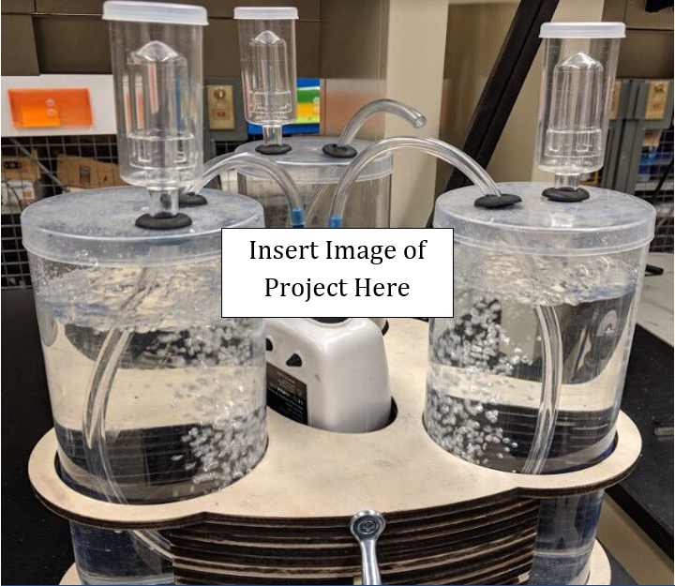
Project Name
Team Name
Midterm/Final | Semester and Year | EPICS Design Document

Contents
Section 1: Project Identification 3
Resources 3
Project Objective Statement 3
Description of the Community Partner 3
Stakeholders 3
Outcomes/Deliverables 3
User Need List 4
Expected Overall Project Timeline 4
Section 2: Specification Development 5
Resources: 5
Description of the Use Context 5
Benchmarking 5
Specification List 6
Section 3: Conceptual Design 7
Resources: 7
Concept Generation 7
Prototyping 7
Concept Convergence 7
Proposed Solution 7
Section 4: Detailed Design 8
Resources: 8
Summary of Detailed Design Process 8
Bill of Material (B.O.M) 8
Prints/Schematics/Code 8
Manufacturing and Assembly Processes 8
Risk Analysis 9
Verification 9
Validation 10
Section 5: Project Delivery 11
Resources: 11
User/Service Manual 11
Delivery Checklist 11
Customer Satisfaction Questionnaire 11
Section 6: Current Semester Record 12
Appendix A: Past Semester Records 13

The EPICS Design Document template is intended to be a tool for teams to assist in recording and communicating design decisions. Modifications, insertions, and deletions may be appropriate based the project discipline, scope, or other project-specific factors.

Section 1: Project Identification

Tutorials
- Documentation: https://tinyurl.com/EpicsDesignProcessDocument
- Video Tutorial: https://tinyurl.com/EpicsProjectIdentification

Project Objective Statement
This section should include a concise statement that address such questions as:
- Why are you doing the project (i.e. what is the motivation or need for the project?)
- How does your project fit within the mission of the project partner and your team?

Description of the Community Partner
This section should address such questions as:
- Who is the project partner for this project?
- What is the overall mission of the project partner?

Stakeholders
This section should address such questions as:

- Who will be affected by your project other than your customer?
- Who has vital interest in the project’s success?
- Think beyond the end user – Who has an interest in maintenance, storage, etc.?

Project Scope
This section should address such questions as:

- What are going to be the project results?
- When the project is finished, what will be left behind by your team?
- What functionality is in-scope and should be part of the project at this time?
- What functionality is out-of-scope and should not be included?
- What assumptions has your team made?

User Need List
This section should include a complete list of the major functions needed by each stakeholder:

- Who will be affected by your project other than your customer?
- Who has vital interest in the project’s success?

Need # | Stakeholder | User Need
1 | User | Must hold one bite of liquid
2 | User | Must have a graspable handle
3 | Parent | Must be dishwasher safe
... | ... | ...

Expected Overall Project Timeline
Project Start Date: Original Target Delivery Date:

This section should address such questions as:

- What is the timeline for completion of the entire project?
  - Note: The current semester timeline will be expanded in Section 6.
- What are the major milestones?
- When is the project intended to be completed?
- What is the current team’s assessment of the timeline?
- The most common tool for project planning in industry is the Gantt Chart

  - Gantt Chart Template: https://asq.org/quality-resources/gantt-chart

Section 2: Specification Development

Tutorials
- Documentation: https://tinyurl.com/EpicsDesignProcessDocument
- Video Tutorial: https://tinyurl.com/EpicsSpecificationDevelopment
- IP Process: https://www.prf.org/otc/resources/commercialization.html

Description of the Use Context
This section should address such questions as:
- How is the project going to be used, and how could it be mis-used?
- What systems will the project interface with, and what are their requirements?
- What are the limitations of the space the project will reside in for use and storage
  - Consider physical size, storage space, servers, ADA or other standards.
- Who will maintain the project?
  - Consider site/application management, training, and access limitations.
- What are the environmental conditions?
  - Will the project be exposed to rain or sun?
  - Will the project be exposed to the public or children who may damage it?
  - What security issues need to be considered?
  - How durable does the project need to be?
- What are the social/societal factors that may affect the project?
- What are the technological limitations of the project?
- What other factors may be important for this particular context?

Benchmarking
This section should include a survey of existing solutions and competing technology.
- What potential solutions to your community partner are commercially available?
- To which products would you compare or benchmark your proposed solution?
- Are there any potential barriers from intellectual property?

Specification List
Specifications are the translation of your User Needs into measurable requirements. To create a list of your project specifications, start by copying your list of user needs. For each user need, list the specifications that you must meet to satisfy that requirement. As you write your specifications, keep in mind you must be able to test the product to ensure that the specification has been met.

Need # | User Need | Spec # | Specification
1 | Must hold one bite of liquid
 |  | 1.1 | Must hold 0.75 fluid ounces of water
2 | Must have a graspable handle
 |  | 2.1 | Handle length between 3.5 and 5 inches
 |  | 2.2 | Handle cross sectional area < 0.1 in²
3 | Must be dishwasher safe
 |  | 3.1 | Must show no wear after 50 standard wash cycles
 |  | 3.2 | Must be able to withstand 5 in-lb load after 50 standard wash cycles
... | ... | ... | ...

Section 3: Conceptual Design

Tutorials
- Documentation: https://tinyurl.com/EpicsDesignProcessDocument
- Video Tutorial: https://tinyurl.com/EpicsConceptualDesign

Concept Generation
This section is a place to capture artifacts (pictures, video, drawings, descriptions, etc.) from brainstorming activities. Documenting all of your viable ideas here will provide a place to come back if the solution you choose does not work out. Consider:
- What method was used to generate ideas?
- Were a sufficient number of concepts generated?
- What are the viable concepts that the team ideated?

Prototyping
This section should document the early prototypes that the team has created to represent solutions. This process is iterative and may include several rounds of prototyping. Include any artifacts (pictures, videos, etc.) for reference. Consider:
- What was the purpose of the prototype (feasibility, size/aesthetic demonstration, conveying concept, etc.)?
- Was the concept intended for internal team use or for external partners?
- What simplifications were made (material, geometry, etc)?
- How was the prototype fabricated?
As you test these prototypes internally or discuss with partners, record observations.
- What did the team learn about that concept?
- What excited your user? What frustrated them?
- What decisions or changes to the design were made based on the results?

Concept Convergence
This section should include a record of the process used to select the concept(s) that the team will go forward with in development. This can be done informally through group discussion, or formally through a decision matrix or other tool. Decisions can be made for the entire concept or on a feature-by-feature basis. Scoring for concepts should be supported by prototype testing, analysis, partner or expert feedback, or other supporting evidence. Provide evidence (screen shots, whiteboard images, etc.) of the decision making process here.
- Decision Matrix Detail: https://asq.org/quality-resources/decision-matrix
Material Selection |  | Plastic |  | Stainless Steel |  | Stainless Steel  + Rubber Grip
Criteria | Weight | Score | Total | Score | Total | Score | Total
Must show no wear after 50 standard wash cycles | 4 | 2 | 8 | 5 | 20 | 4 | 16
Must be able to withstand 5 in-lb load after 50 standard wash cycles | 5 | 2 | 10 | 5 | 25 | 4 | 20
Comfortable Handle Material | 2 | 3 | 6 | 2 | 4 | 5 | 10
Low Cost Fabrication | 3 | 5 | 15 | 3 | 9 | 2 | 6
Low Fabrication Lead Time | 2 | 2 | 4 | 4 | 8 | 3 | 6
 | Total |  | 43 |  | 66 |  | 58

Proposed Solution
This section should include a complete description of the proposed design concept, including sketches, process diagrams, or other artifacts to convey the concept. Consider whether this solution may be patentable. This solution should be approved by the advisor and partner before proceeding to detailed design.

Section 4: Detailed Design

References:
- Documentation: https://tinyurl.com/EpicsDesignProcessDocument
- Video Tutorial: https://tinyurl.com/EpicsDetailedDesign

Bill of Material (B.O.M)
This section should include a list of all of the components, whether manufactured or purchased, that go into the final design.
Sub-Assembly | Item | Catalog/  Part No. | Manufactured/  Purchased | Vendor/  Method | Quantity | Cost/  Unit
Bike Drivetrain | Chain | B07D5HYYS9 | Purchased | Meijer | 1 | $18.69
Bike Drivetrain | Pedals | n/a | Manufactured | EPICS 3D Printer | 2 | $19.95
Wheel Assem. | Rim | n/a | Manufactured | BIDC | 2 | $186.90
Wheel Assem. | Tire | B076CM88LK | Purchased | Hodson's Bay | 2 | $199.50

Prints/Schematics/Code
This section should provide links to any relevant material that describe the technical details of each component and the overall assembly or technology stack, whether the project is physical, virtual, or both. These materials should be of quality and completeness such that a 3rd party of reasonable skill could fabricate the project without additional instruction.

Manufacturing and Assembly Processes
This section should describe the methods used to manufacture and assemble the final product. Create sub-sections as needed when major iterations of the design occur. The description should be sufficient for an average freshman engineering student to replicate the product. Consider what improvements to the process could be made and give specific recommendations for future teams.

Risk Analysis
This section should include a link or pasted image of any risk analysis or risk mitigation activities. One of the most common tools for risk analysis is the Failure Mode and Effect Analysis (FMEA).
- FMEA Template: American Society for Quality FMEA Template

Verification
This section should include a table summarizing the results of verification activities for the project. A link to the verification test report should also be included in the table. Verification is the process of making sure the design outputs meet the design specifications. Each specification should be verified, which can take any form that confirms that the specification is met. Be sure to consider any residual high risks from the assessment.
Spec # | Specification | Verification
1.1 | Must hold 0.75 fluid ounces of water | Volume sample analysis resulted in an average 0.83 oz capacity
2.1 | Handle length between 3.5 and 5 inches | Print specifies handle length as 4 +/- 0.1 in
2.2 | Handle cross sectional area < 0.1 in² | Print specifies handle length as 0.8 +0.01/-0.02 in
3.1 | Must show no wear after 50 standard wash cycles | Dishwasher fatigue test revealed no wear after 50 cycles
3.2 | Must be able to withstand 5 in-lb load after 50 standard wash cycles | Dishwasher fatigue test results showed no mechanical failure under 5 in-lb load after 50 cycles
... | ... | ...

Validation
This section should include a table summarizing the results of validation activities for the project. A link to the validation test report should also be included in the table. Validation is the process of demonstrating that the final design meets the user needs. Each user need should have at least one validation, which can take any form that confirms that the user need is met.

Need # | User Need | Validation
1 | Must hold one bite of liquid | User testing with 8 children from age 2-7 confirmed the spoon held an appropriate bite of liquid food
2 | Must have a graspable handle | User testing with 8 children from age 2-7 confirmed the spoon handle was easily graspable for children above 4 years old. The product manual will be updated to reflect this limitation and the project partner has been informed.
3 | Must be dishwasher safe | Dishwasher fatigue testing confirmed a dishwasher does not cause mechanical damage to the device.  A literature search on the materials confirmed dishwashing does not induce a chemical/biological hazard.
… | … | ...

Section 5: Project Delivery

TUTORIALS
- Delivery Process:
  - https://engineering.purdue.edu/EPICS/teams/team-documents/project-delivery
- Delivery Checklist:
  - https://engineering.purdue.edu/EPICS/teams/team-documents/delivery-checklist
Partner agreements mandate the completion of the delivery checklist. Failure to complete the checklist and receive EPICS administrative approval may result in personal liability.
Do NOT deliver a project until the checklist is completed and approved by both the advisor and EPICS administration.

User/Service Manual
A user manual should be provided to the community partner to aid them in use and basic maintenance of the product. An in-house manual or engineer to engineer guide may also be created to aid future teams in servicing and troubleshooting the product. Insert a link to each manual here.

Delivery Checklist
Should be completed by the team prior to delivery. Link or copy the completed checklist onto this page.

Customer Satisfaction Questionnaire
Should be completed by the community partner two weeks after delivery. Link or copy the completed questionnaire onto this page.
- Customer Satisfaction Questionnaire: https://tinyurl.com/EpicsCustomerSatisfaction

Record of project delivery
Please add or link to a photo and/or video of the project at the time of delivery.

Section 6: Current Semester Record
This section should contain information on the current semester only. It should be moved to Appendix A at the conclusion of the semester.

Point of Contact for Future Team Members (E.g design lead)
Name:
Email:
Phone:

Point of Contact at the commmunity partner organization
Name:
Email:
Phone:

Current Project Status
This section should indicate which phases of the design process were included during the current semester. Design is iterative and may revisit phases which were ‘completed’ in previous semesters.

Current Semester Project Timeline
This section should address such questions as:
- What major milestones will we complete this semester?
- What details should we be working on now?
- The most common tool for project planning in industry is the Gantt Chart

TRANSITION REPORT
This section should include:
- Storage location and login info for all team materials (code, CAD models, etc)
- Major milestones completed
- Major roadblocks encountered and suggested remedy
- Suggested next-steps for next semester’s team
- Team leadership roles that have been established for next semester

Appendix A: Past Semester Records

