**Activity Station 1: Nano-Fabric and Nano-Sand Experiment**

Nano-Fabric Experiment

**Given Information:**

* The word Hydrophilic comes from the Greek roots meaning “water” and “loving”.  
  Hydrophilic compounds tend to dissolve readily in water, or simply do not repel it.  
  Hydrophilic compounds are usually polar or ionic in nature. Some examples include sodium chloride (an ionic salt) and ethanol (a polar compound).
* The word Hydrophobic comes from the Greek roots meaning “water” and “fearing”.  
  Hydrophobic compounds do not dissolve in water, and some hydrophobic compounds will actively repel water.  
  Hydrophobic compounds are generally nonpolar in nature. Examples include fats (lipids) and decane (a nonpolar molecule).

**Procedure:**

1. Work over a sink or other area that can get wet.
2. Take out both bandannas from the kit.
3. Gently spray water on the first bandanna. Raise it into the air to see if the water is absorbing into the bandanna or whether it is being repelled off.
4. Document your observations on the student sheet.
5. Repeats steps 3-4 with the second bandanna.
6. Discuss what is happening. Which bandanna is hydrophilic? Which is hydrophobic?

**Activity Assessment:**

* Complete student sheet provided.

Nano-Sand Experiment

**Procedure:**

1. Work in a clear workspace because there is a risk for spilling water in this experiment.
2. You will responsible for recording all of your observations.
3. Begin by pouring the two different bags of sand into the two cups inside of your kit.
4. Predict what will happen to each sand before pouring in any water.
5. Fill with water until their is approximately an equal amount of water as there is sand.
6. Remove some of the sand from either cup with the spoons provided.
7. Pay attention to what is going on with each type of sand, then place all sand back in the correct cups.

**Activity Assessment:**

* Complete student sheet provided.
* Discuss the pros and cons as well as applications of hydrophobic building materials. Use this time to come up with creative solutions to problems you see in the real-world.

**Activity Station 2: Nano-BuckyBall (C60)**

**Given Information:**

1. A C60 is comprised of pentagons and hexagons.
2. A C60 and its electron cloud has a diameter of 1nm. The C60 cage you built is .7 nanometers diameter. In comparison, if the C60 was the size of a soccer ball, a soccer ball would be the size of the Earth!
3. Every C60 piece/atom is identical. Each piece has 3 extrusions over which a plastic tube will slide. This plastic tube is representative of a molecular bond.
4. The black orb-like pieces represent carbon atoms and the white tubes represent the bonds between atoms

**Detailed Instructions if needed:**

1. Begin by assembling twelve pentagons. This will use all 60 of the atoms, but not all of the bonds

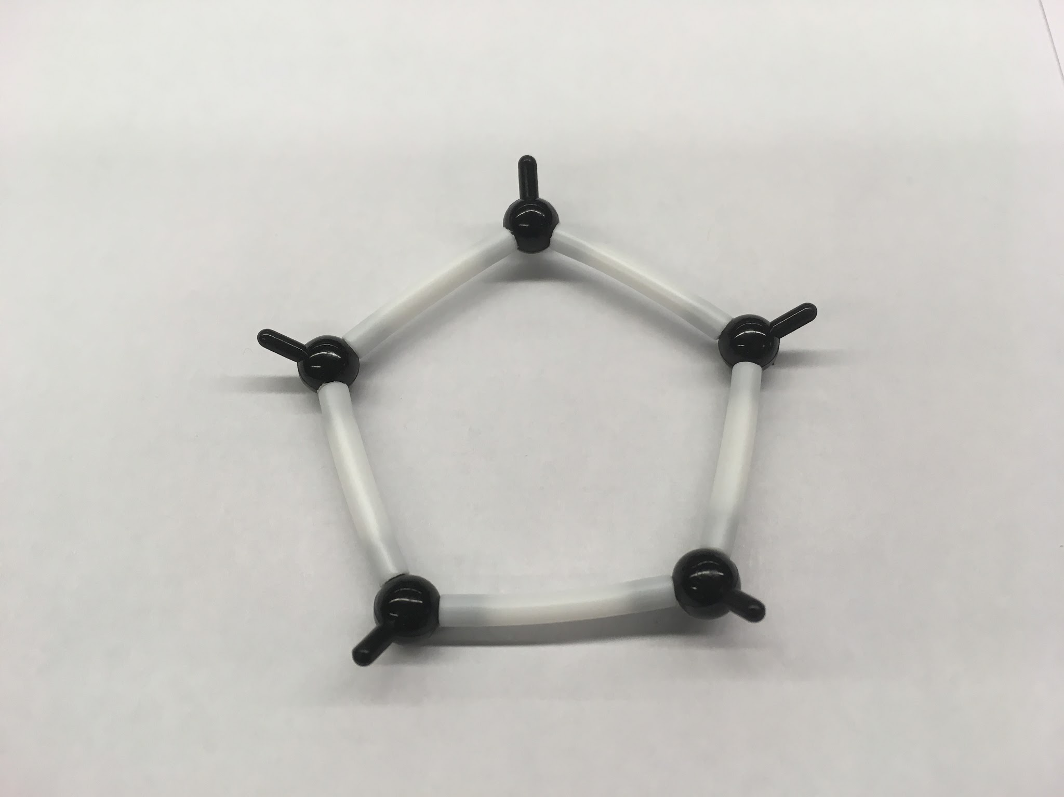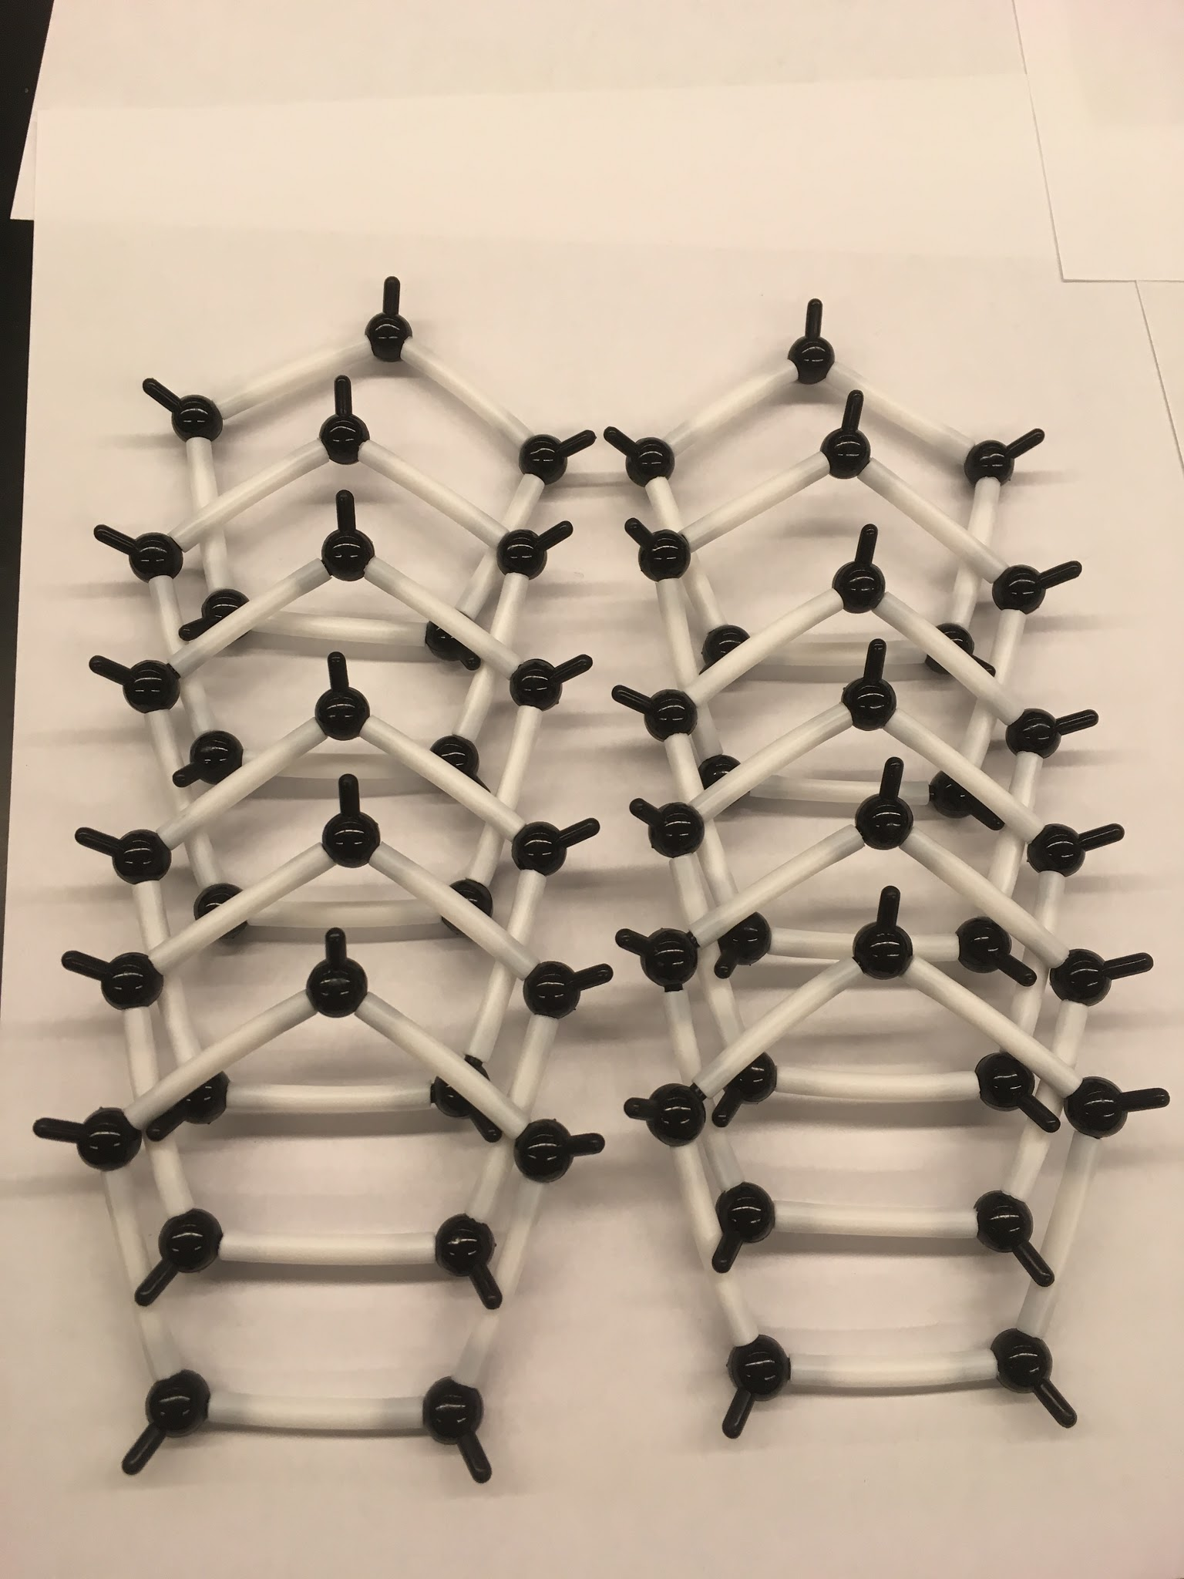

1 Pentagon 12 Pentagons

1. Connect five pentagons to a central pentagon like a snowflake as seen in the picture below. Make sure the tips are all pointed inward.

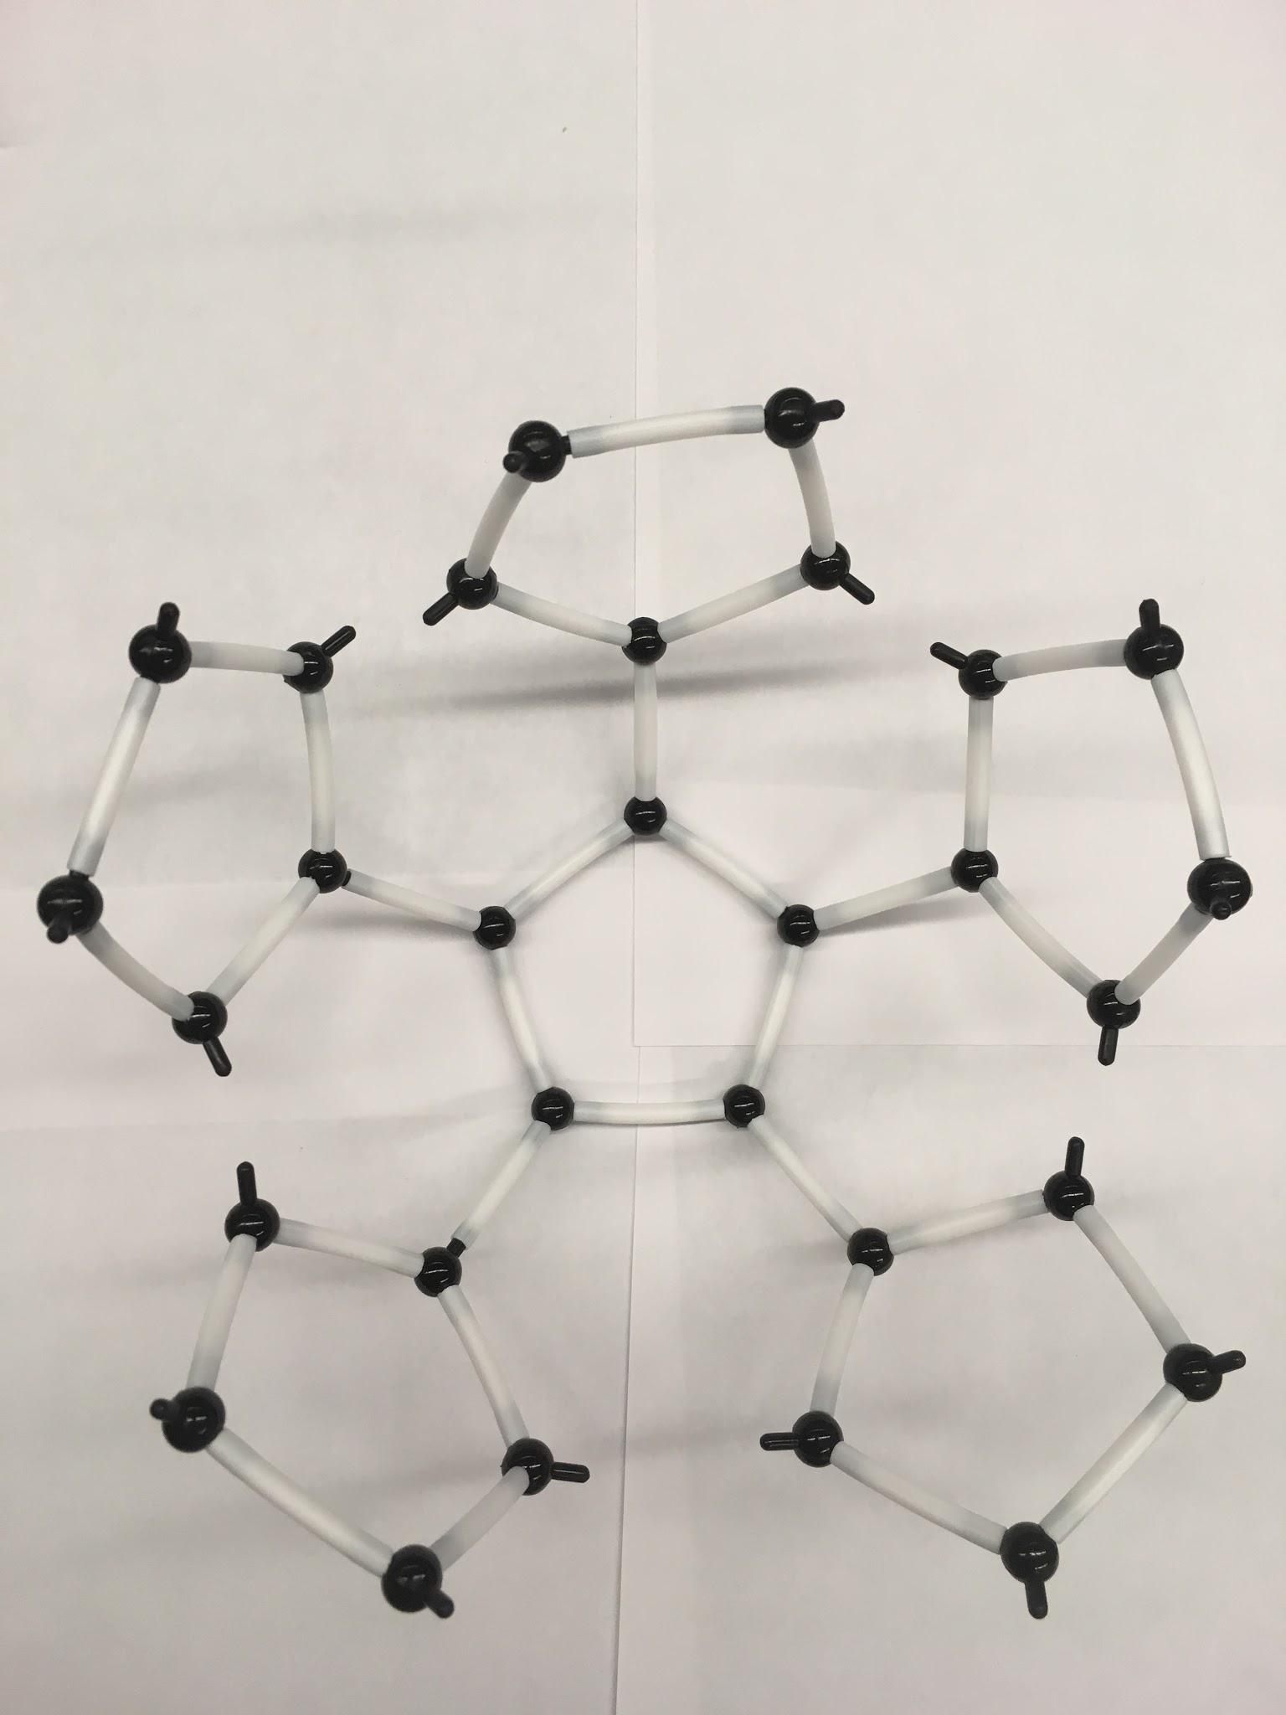

Snowflake Pattern

1. Connect the “arms” of your “snowflake” as shown below to form a “bowl.” Notice how this creates hexagons in the structure.

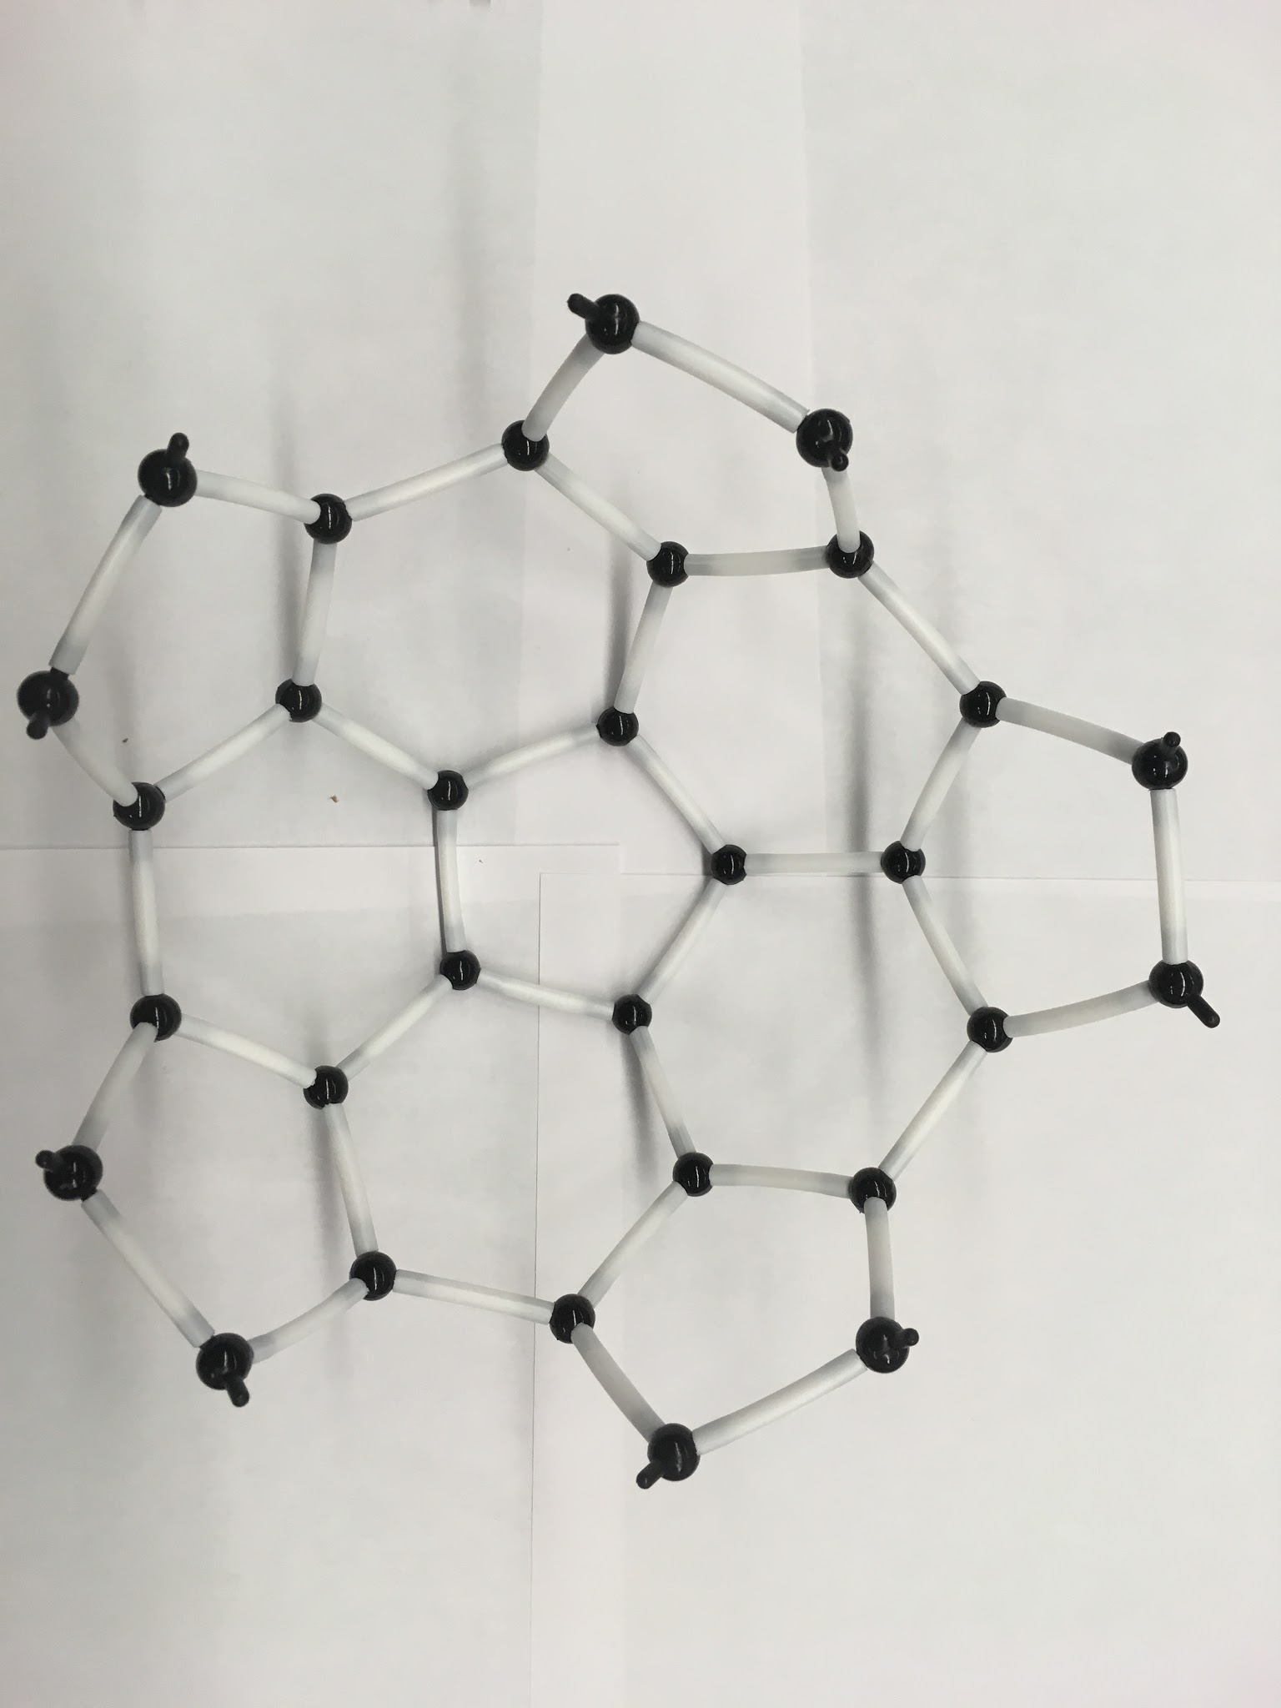

Bowl Structure

1. Repeat steps 2-3 with the other six pentagons
2. Align the two “bowl” So that it looks like they would mesh together like a jigsaw puzzle (see picture).

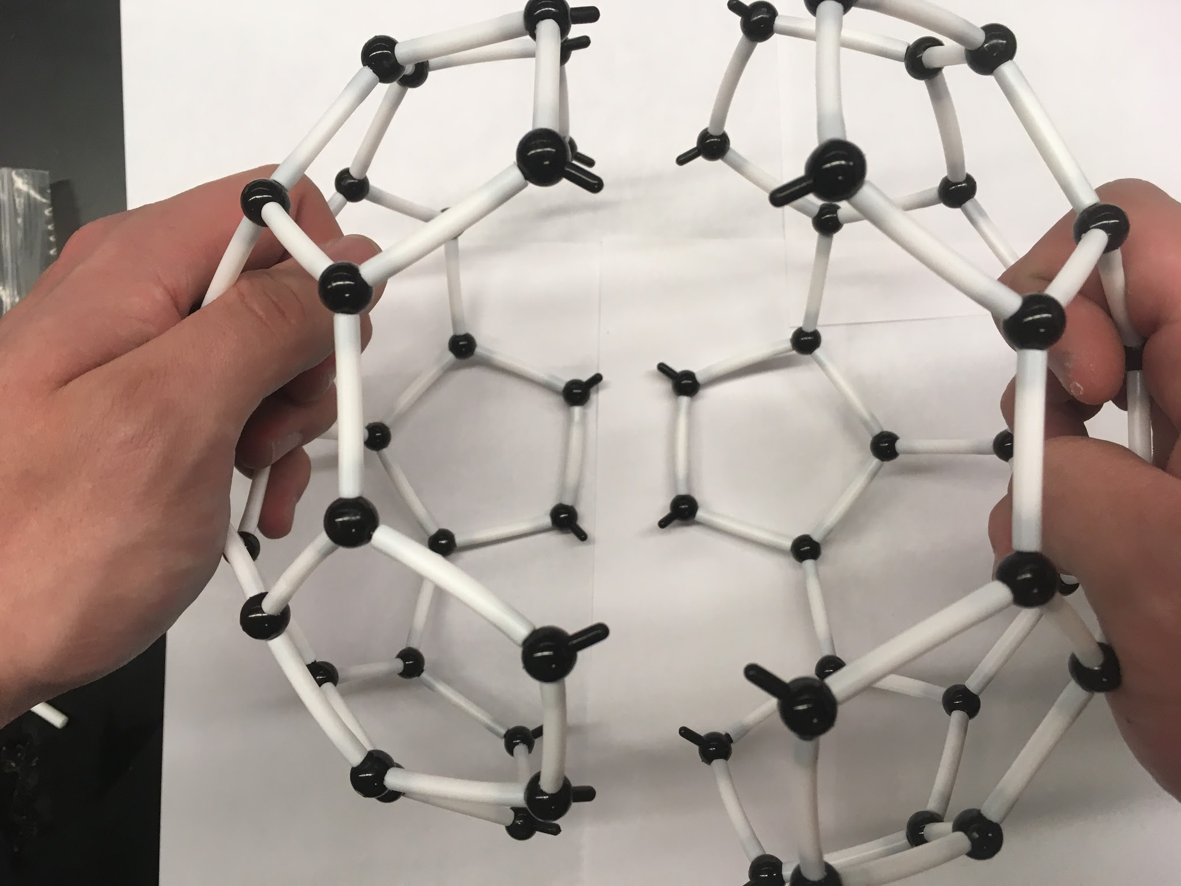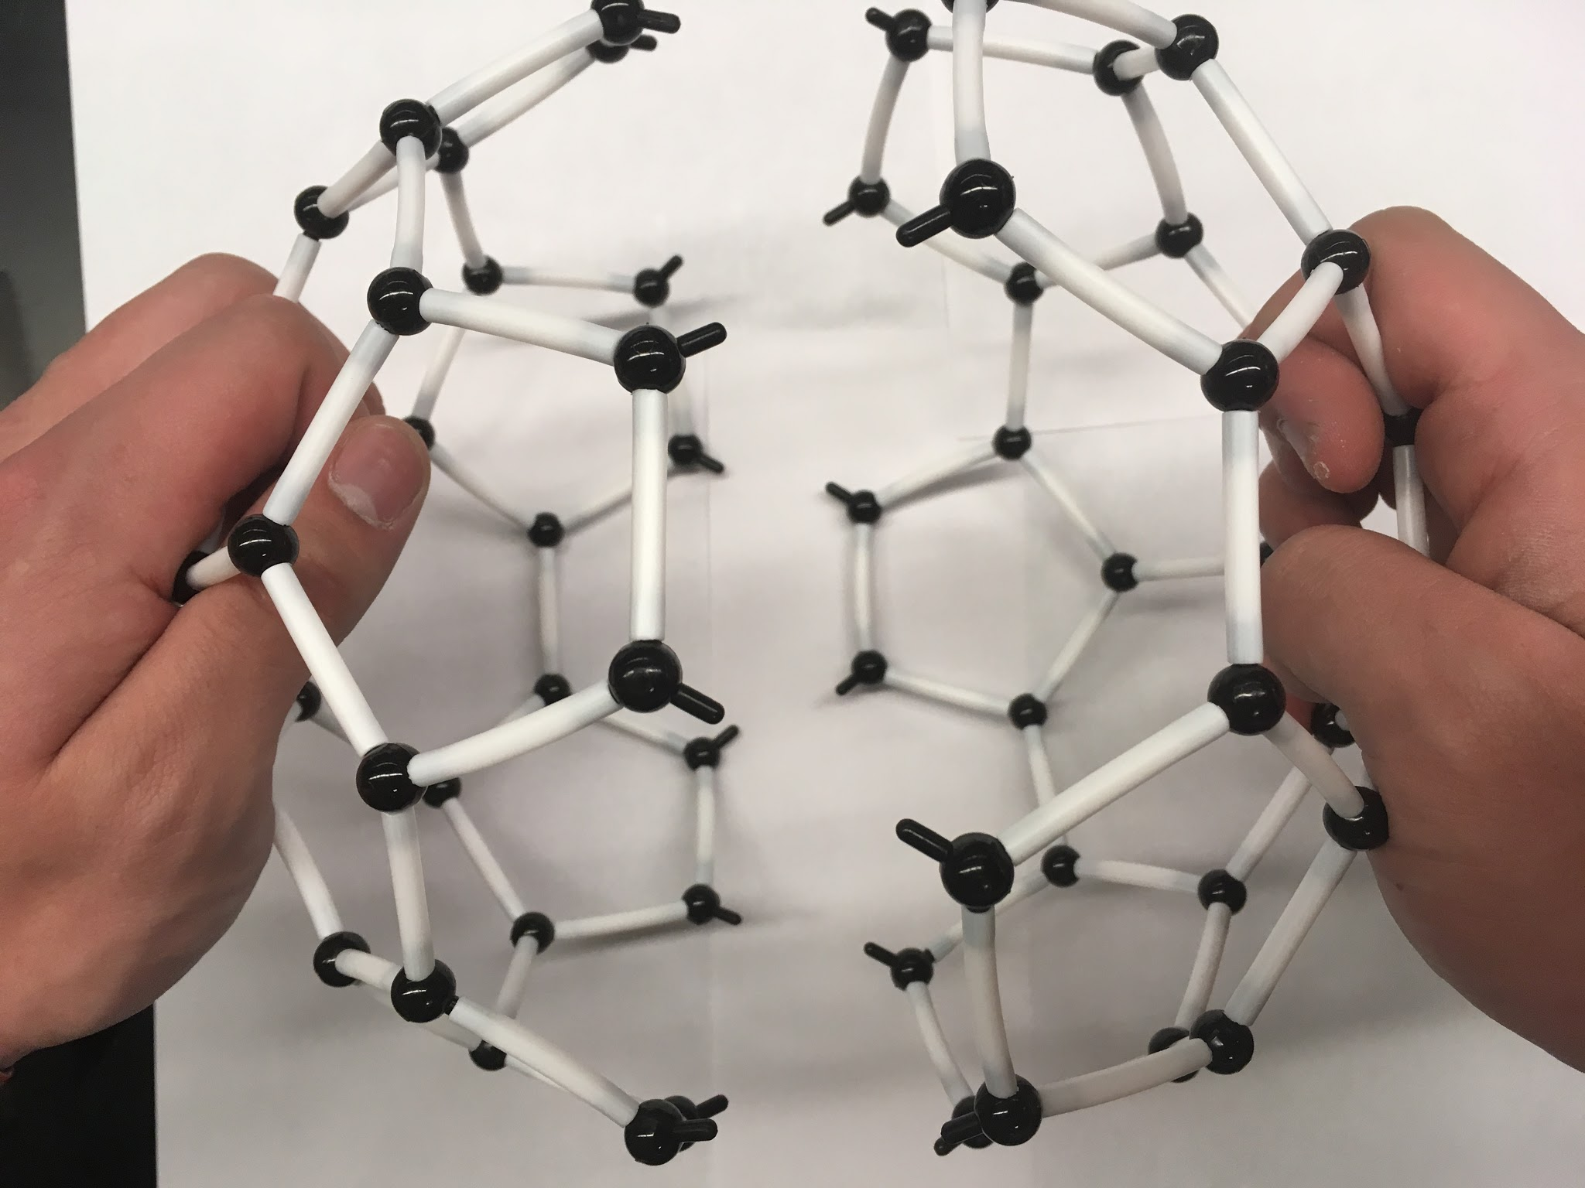

Incorrect Alignment Correct Alignment

1. Join the two bowls together by connecting the bonds that appear to point to each other. Note: This should create hexagons. **If you see a square, you made an error**; backtrack until you have two “bowls” again.

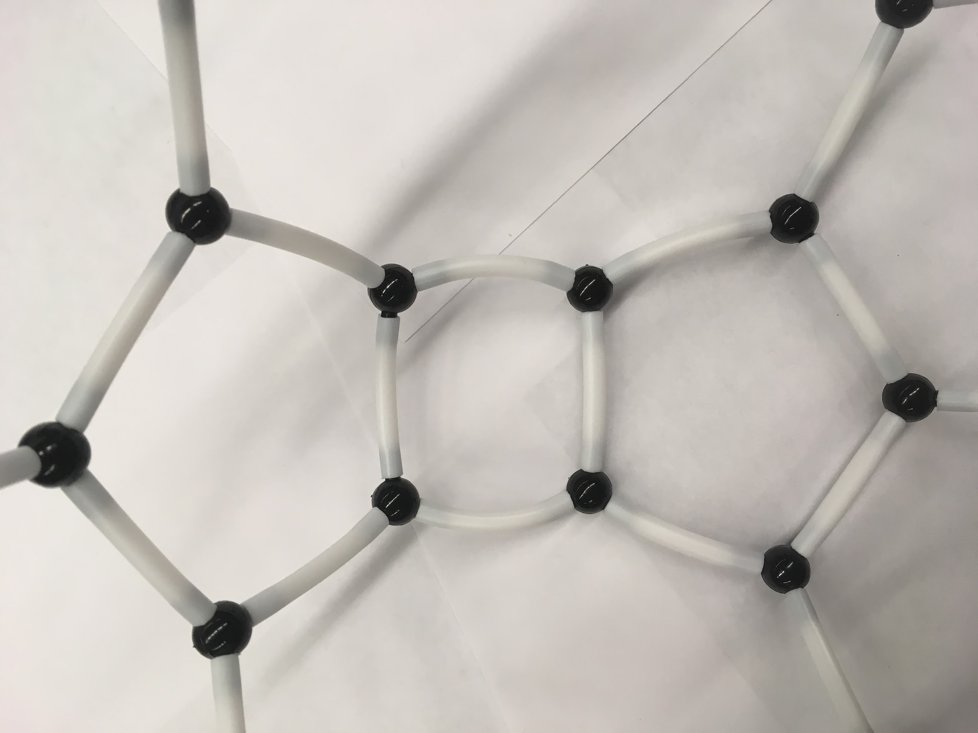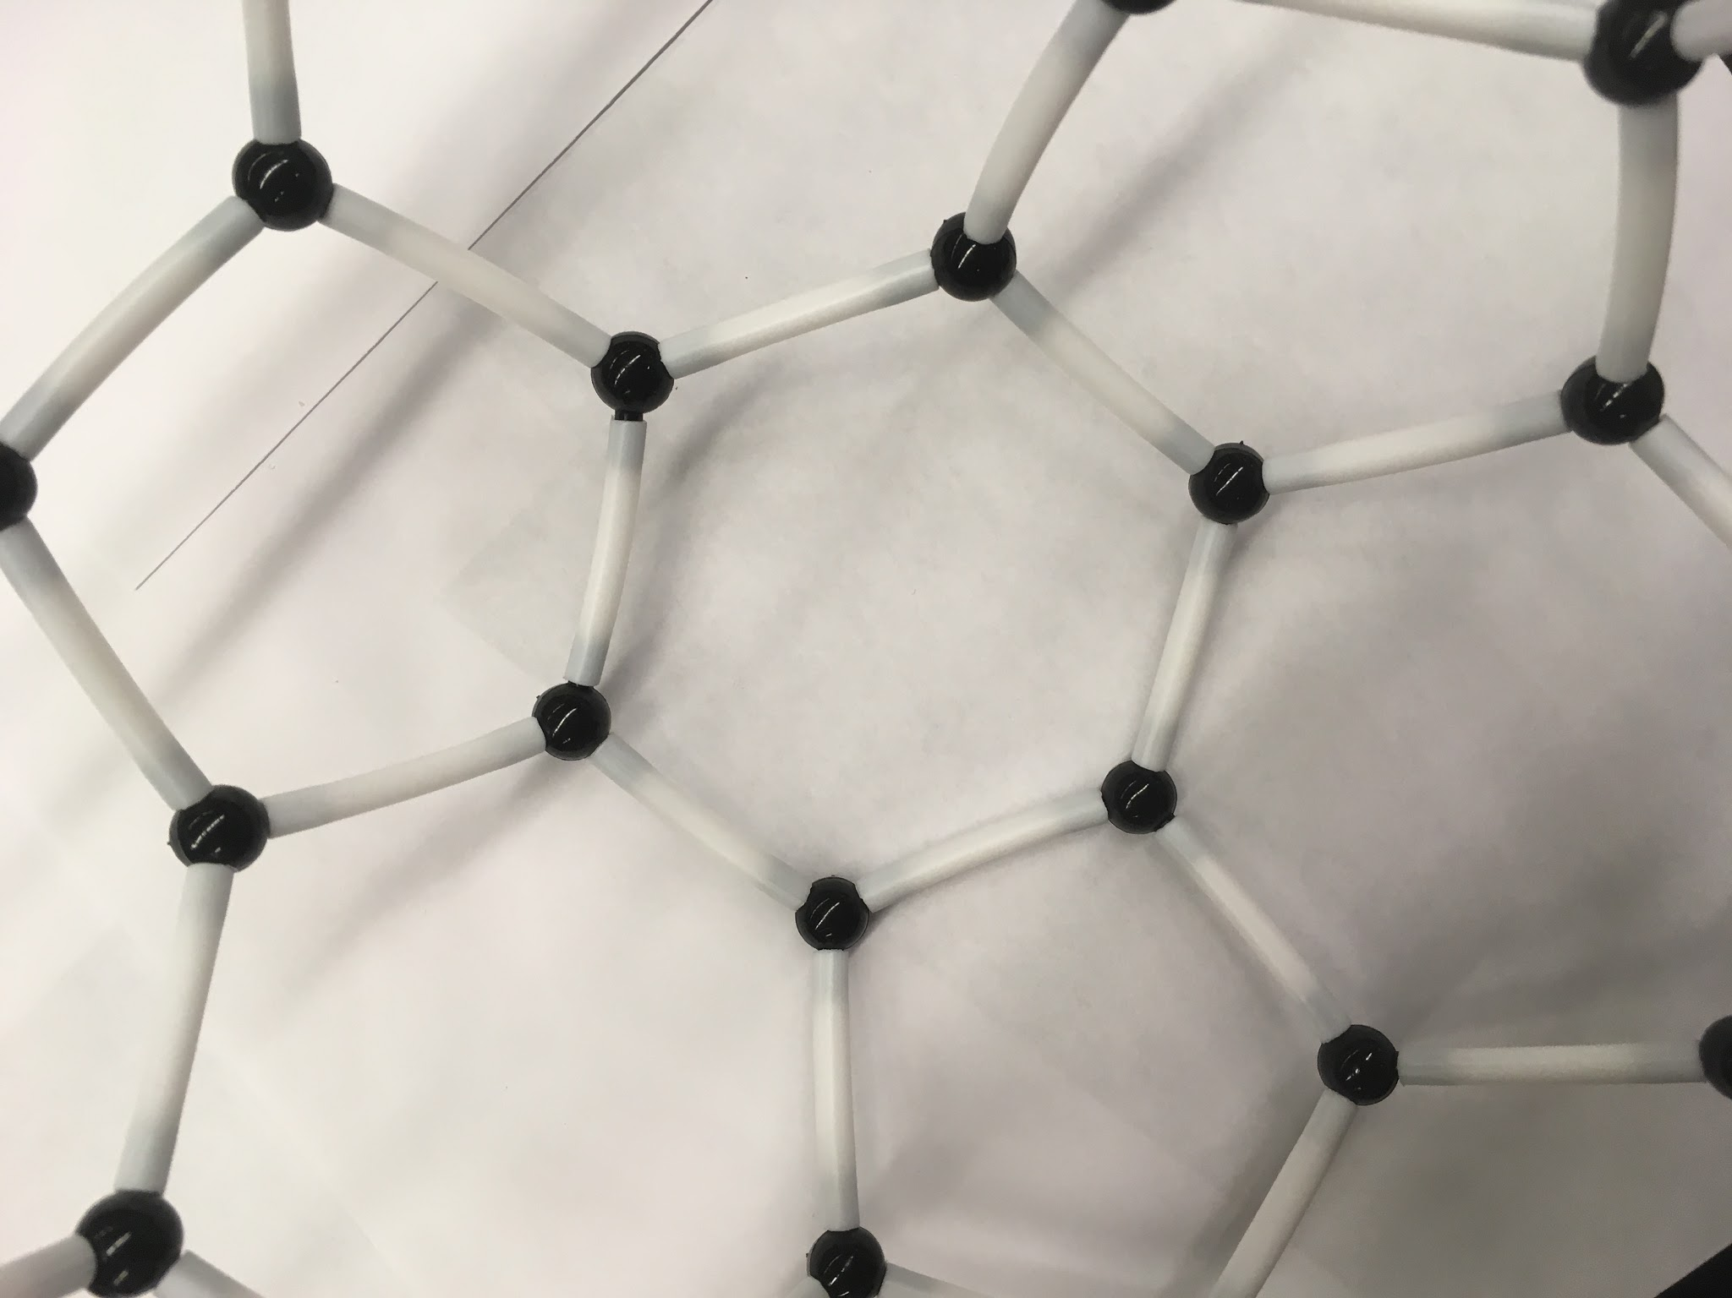

Incorrect Correct

1. Admire your completed buckminsterfullerene (C60) model it should look like the one below.

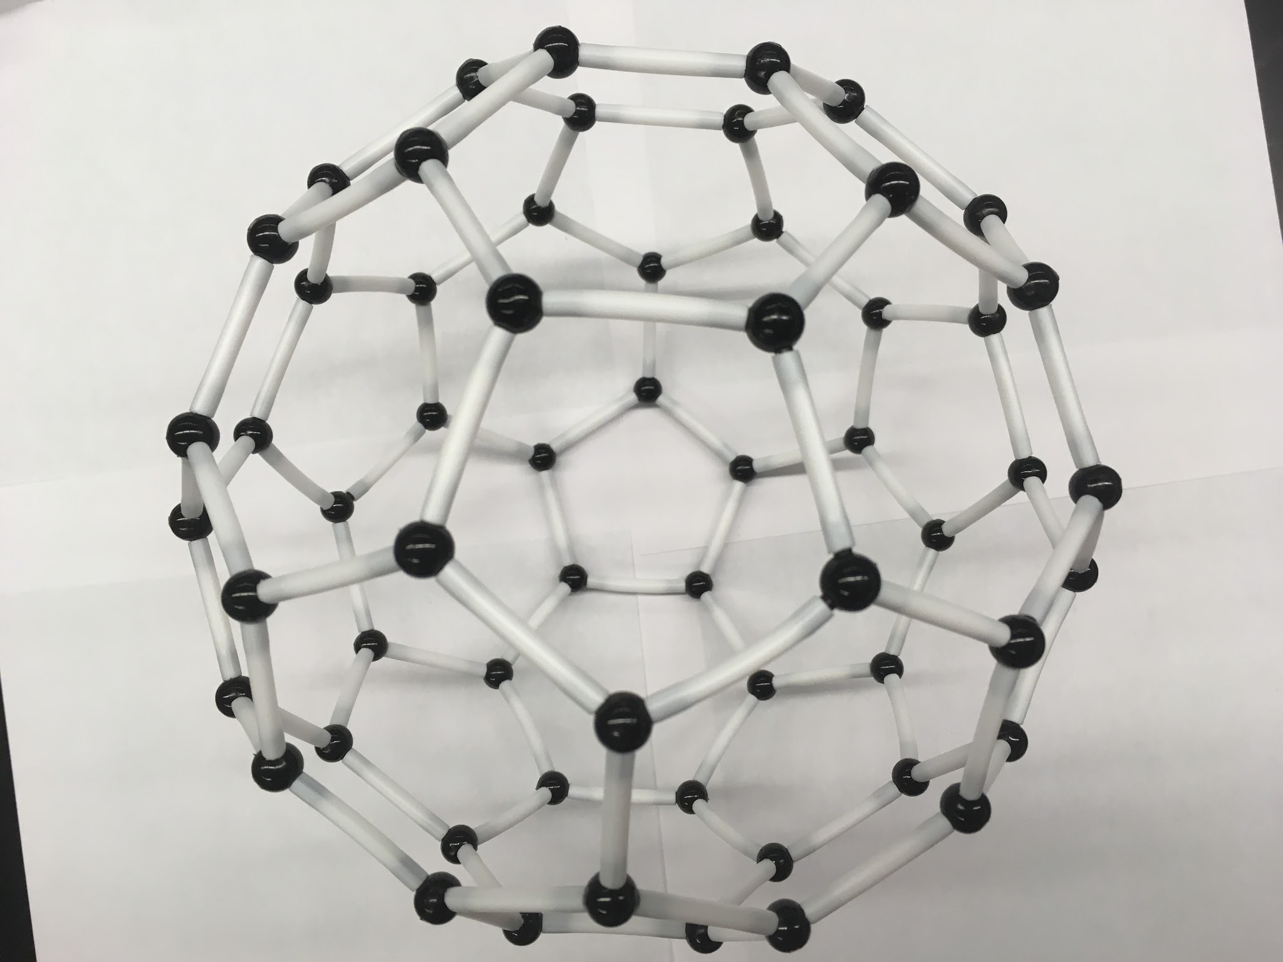

Completed buckminsterfullerene (C60)

**Assessment:**

* Complete student sheet provided.

**Activity Station 3: Nanotube**

**Background Info:**

1. Nanotubes are made out of interlocking hexagons that form a sheet (graphene). When you roll up that sheet into a cylinder, it makes a nanotube. There are three kinds of carbon nanotubes, chiral, zig-zag, and armchair. We will be making the “zig-zag” with this kit.
2. Think of any uses of Carbon Nanotubes? Proceed to complete Student Activity sheet.

**Procedure:**

1. Using a bond, connect two atoms. This simple piece you have just created makes up most of the actual nanotube.
2. Looking at the diagram below, see how the two-atom pieces interlock to create hexagons. Each row of hexagons is staggered, and by connecting the other extrusions with the white bonds, you can see how hexagons are formed.
3. Create four hexagons in a row. Once you have done this, you can curl the sheet of hexagons to make a “ring”. In order to do this, the hexagon must bend. Your hexagons will now be bent to make up two separate planes. This way we will have an 8 sided nanotube. Once one “ring” is complete, continue to build more rings on top of the original. Each kit can make a nanotube four rings high.

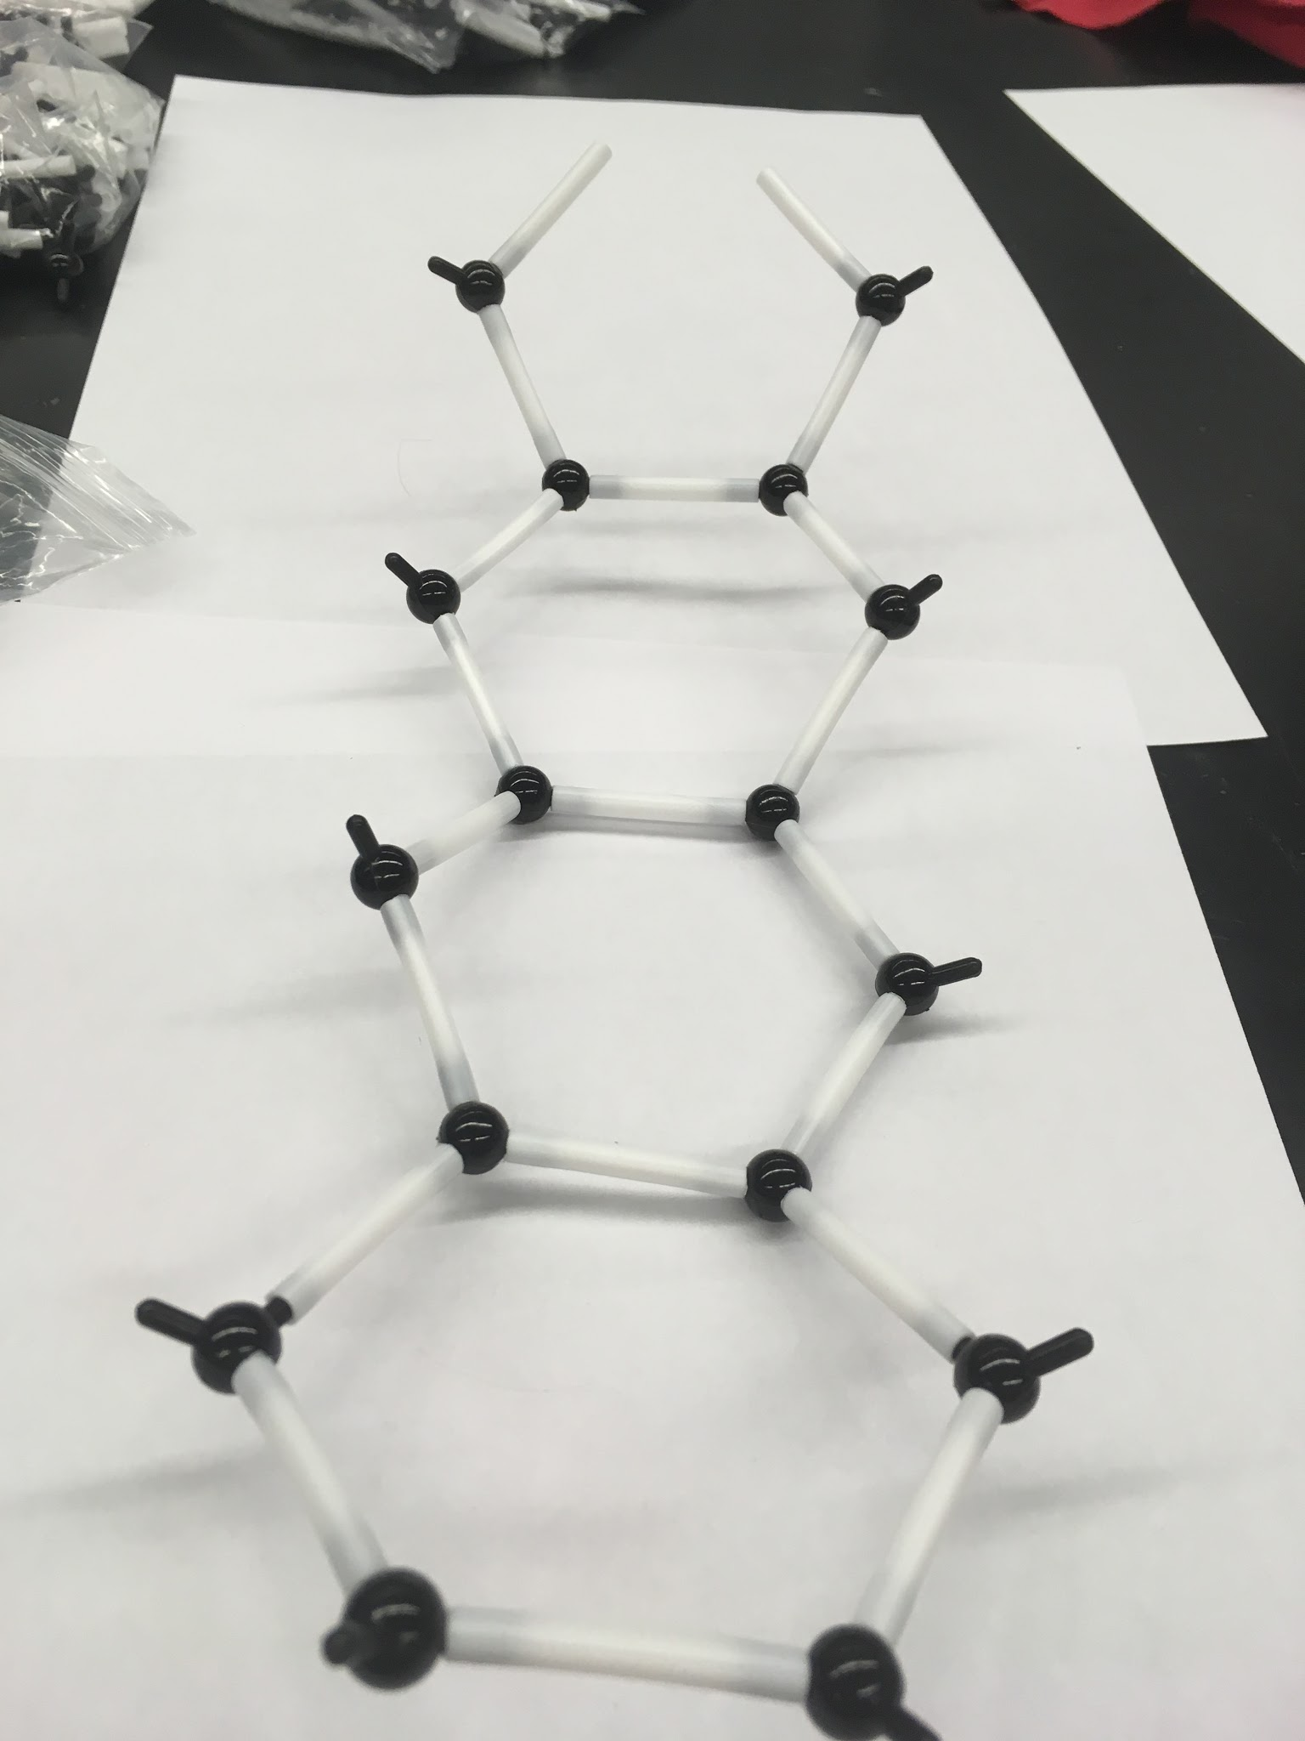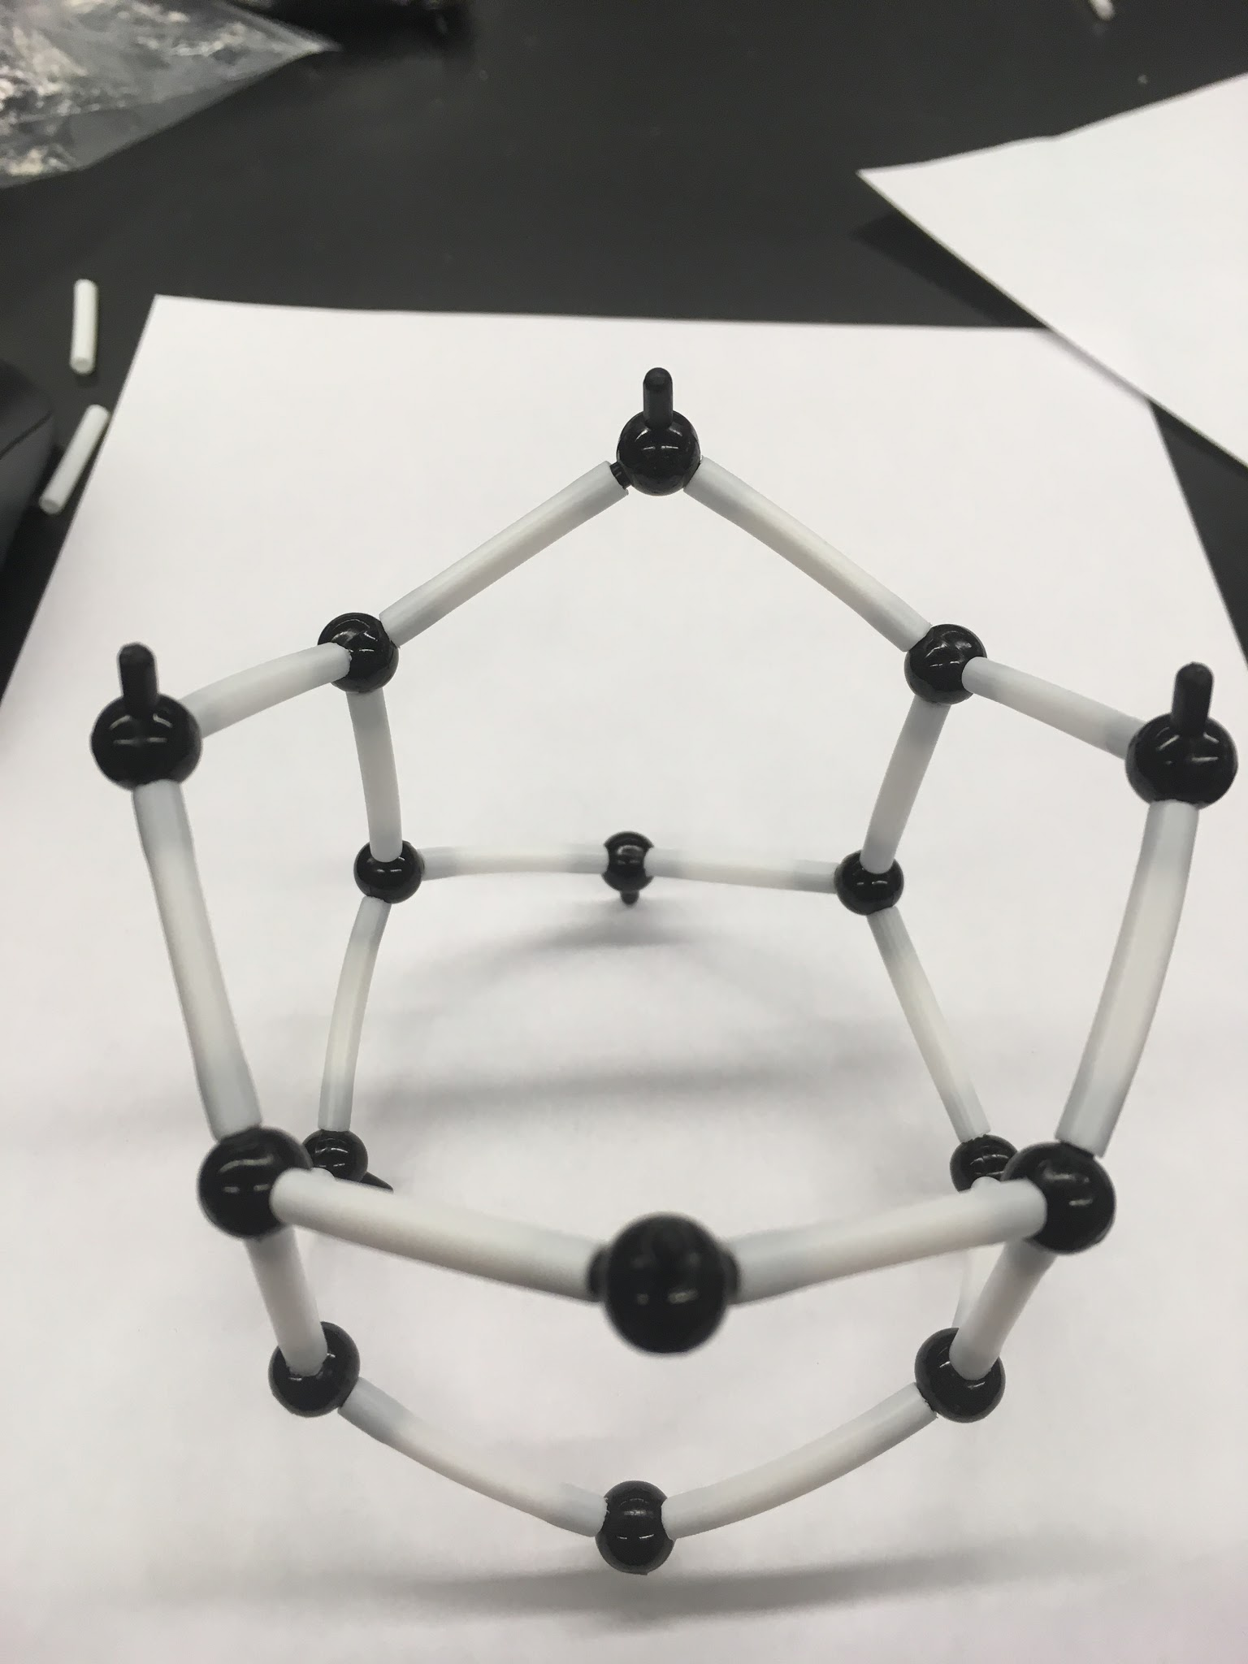

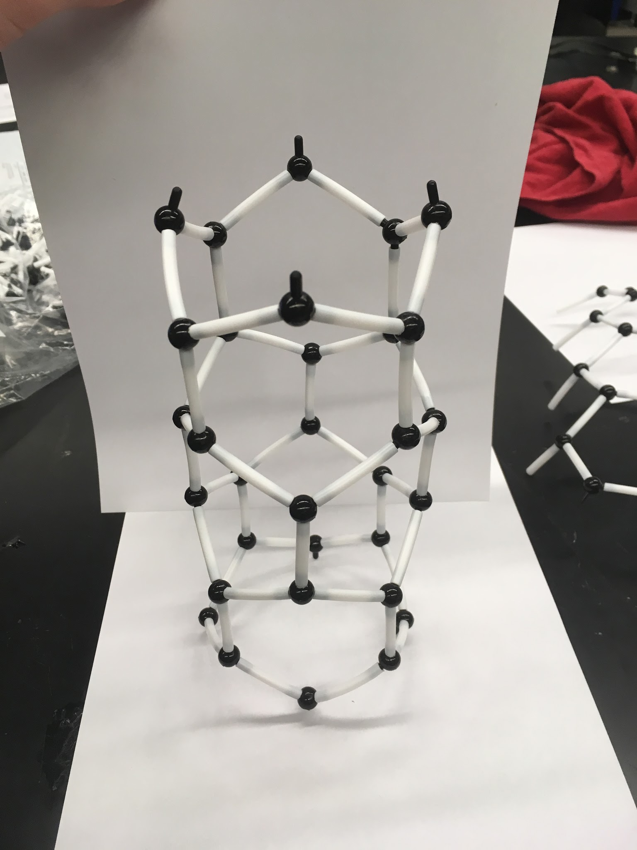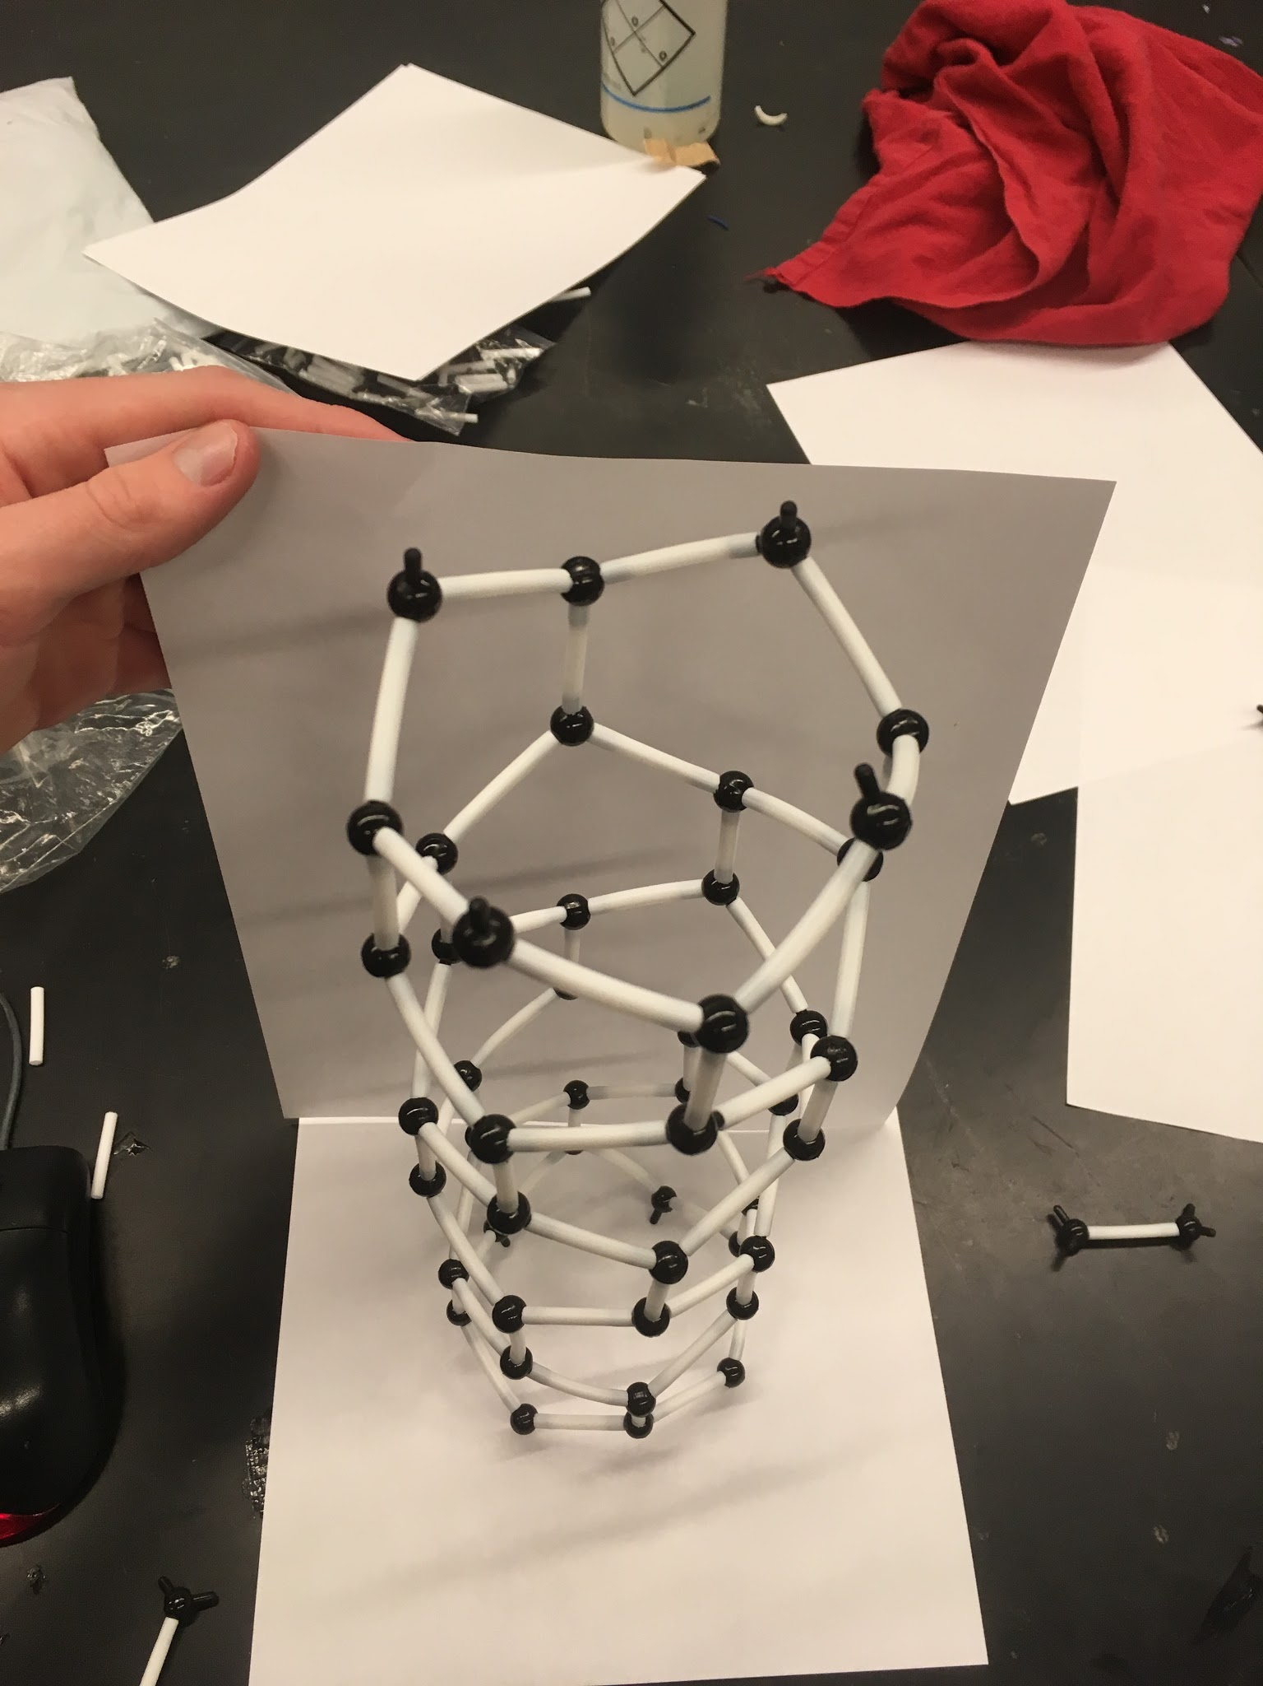

**Assessment:**

* Complete student sheet provided.