Let it snow, let it snow, let it snow!

Tippecanoe County junior high students are wishing it would snow. It’s not that they want to get out of school, but they want to be like the great American photographer Wilson A. Bentley who was the first to capture a snowflake on film.
The students are studying snowflakes and what it takes for a snowflake to form, as well as how no two snowflakes are the same. To many, that seems like an impossible fact. For Bentley, he wanted to find the truth about that fact.
More than 5,000 pictures of snowflakes later, Bentley did prove that no two snowflakes are alike. Bentley, a farmer from Vermont who started school at the age of 14, first made a photograph of a snowflake on Jan. 15, 1885. He took pictures until 1931.
Bentley’s mother gave him a small microscope she had used in her school teaching. From 1880 to 1882, Bentley spent most of his winter’s days in a cold room at the rear of the farmhouse, peering through the microscope at ice crystals collected from passing storms.
In an attempt to capture their beauty and intricacy, Bentley made drawings of the snowflakes. When he discovered cameras – the latest technology at the time – that could take photographs through a microscope, he and his mother persuaded his father to buy a camera and a microscope objective.
Finally after more than a year of experimentation, on Jan. 15, 1885, Bentley obtained the first photomicrograph ever taken of an ice crystal. This discovery was one of the greatest moments of his life.
Bentley kept detailed meteorological records and pondered the meaning of the shapes and sizes of the crystals and why they often varied from one storm to another. He found ice crystals could have different shapes, but snowflakes would always be symmetrical. He never found two identical snowflakes.
According to science teacher Edith Gummer, snow is formed by ice crystals that gather around dust or other particles at below freezing temperatures. When a cloud’s temperature is at freezing or below and the clouds are filled with moisture, snow crystals form. The ice crystals form on dust particles as the water vapor condenses and partially melted crystals cling together to form snowflakes.
John Wilson, a seventh grader at a local junior high school, is so motivated by Bentley’s work he is trying to reproduce his work – except in paper form. “Paper doesn’t melt,” said Wilson. “And it’s not as cold as what Bentley went through.”

The Coolest Snowflake!!!

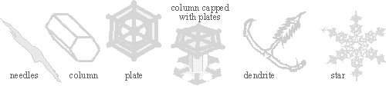

Basically there are 6 different types of snow crystals: needles, columns, plates, columns capped with plates, dendrites and stars. The type of crystals depends on the amount of humidity and temperature present when they are forming. That's why when it's very cold and snowing, the flakes are small, and when it's closer to 32 F. the flakes are larger. The colder the temperature, the ice crystal tips are sharper. At warmer temperatures, the ice crystals grow slower and smoother, resulting in less intricate shapes

      - Snow is formed by ice crystals that gather around dust or other particles below freezing.
      - Snowflakes are made up of many crystals that multiply from one seed crystal.
      - Snowflakes look white because of reflections off the crystals' many faces.
      - Snowflakes have six sides or six points.
      - The six-sided shape of the ice crystal is because of the shape and bonding of the water molecules.
      - Most have symmetry -- vertical, horizontal, or both.
      - No two snowflakes are alike.
      - Only differences in the macroclimate on each side of the ice crystal produces the asymmetrical shapes.

Instructions for Snowflake No. 11 – 8 pointed pattern (3 folds)
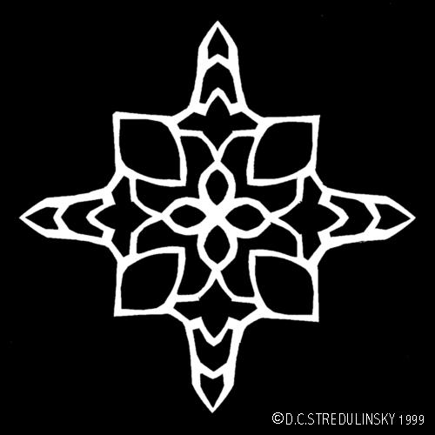
Notes: Attach a loop of black thread through one of the points to hang it on the Christmas tree. Flatten the snowflake by ironing it at low temperature between two sheets of paper. Photocopy the pattern (enlarge or reduce) if you wish to change the snowflake's size.

- Cut out the square below (outer line).
- Fold the square in half along the dashed line labeled FOLD 1. Keep the grey and white triangle (1/8th of snowflake) visible after each step.
- Fold in half again along the line labeled FOLD 2 which extends to the center of the snowflake.
- Fold along the diagonal of the square on the line labeled FOLD 3 so that you are left with a triangle shape of folded paper with the grey snowflake image filling one side.
- With a small pair of sharp scissors cut away all the grey areas so that only the white areas between the grey patches remain. Carefully unfold to reveal your completed snowflake.

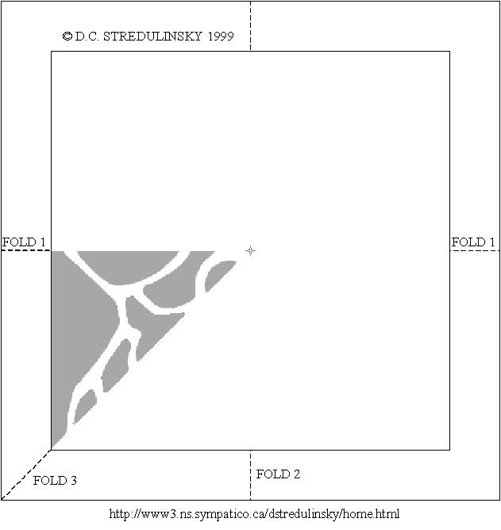

Warm-up Questions

- Who was Wilson A. Bentley?

- How are snowflakes formed?

- How many types of snowflakes are there?

- Are they all symmetrical?

- How many sides does the shape of a snowflake have?

How to make your own snowflakes!

After experimenting with John’s method of doing snowflakes, write him a letter explaining why his snowflake couldn’t possibly be found in nature. With your letter, provide a new set of instructions that he can use to fold and cut out a new paper snowflake that could be found in nature.

