Golfers Swing for Blue Ribbons at '99 Indiana State Fair

INDIANAPOLIS – The PGA was at the 1999 Indiana State Fair, but no one saw Tiger Woods or Sergio Garcia.
That’s because it wasn’t the Professional Golfers’ Association; it was the Professional Greens of Agriculture.
The PGA and its Agricultural Literacy Miniature Golf Course is part of the Indiana Future Farmers of America (FFA) exhibit at the State Fair.
The golf course – which takes up about half of the 25,000 square foot building, plus parts outside of the building – is designed by Indiana FFA chapters and to educate everyone about the importance of agriculture, not only in Indiana, but also in the United States.
This is the third year for miniature golf at the State Fair. “It’s been a hit every year,” said Matt Morris, Indiana FFA northern region vice president from Russiaville. “We constantly have a line at the caddy shack,” said Morris.
During the year, guidelines are sent out that ask chapters to design reinforced holes that will survive over 100,000 people playing a round of golf. Chapters have the option of improving a current hole or of designing a new one. The holes cannot exceed the area of an 10 foot by 20 foot rectangle.
A committee chooses the top 18 designs and then invites the local chapters to build and construct the hole. “The students actually build them,” said Morris.
But after they are built comes the fun part: trying to lay out the golf course to fit within the confines of the building and between all the displays and demonstrations. According to Morris, it took members three days to lay out the exhibit.
But there is more to this exhibit than trying to display one’s athleticism. There’s the agricultural and educational experience.
Before players have the chance to ace, birdie or bogey the hole, participants can test out their agricultural knowledge. A sign holding a multiple choice agriculturally-related question is at the start of each hole. “All of them have an agricultural theme and there’s a question at the beginning of each hole, so it’s like an educational golf course,” said Morris. “People learn something as they go through from hole to hole.”
Morris, who is a 1999 graduate of Clinton Central High School, was involved with FFA while he was in high school. One of those years, the group submitted a design that was selected and is still used today.
For three weeks, Morris worked with an advisor and other FFA members on the project.
“We worked in class and put it together,” said Morris. “It wasn’t a weekend project.”

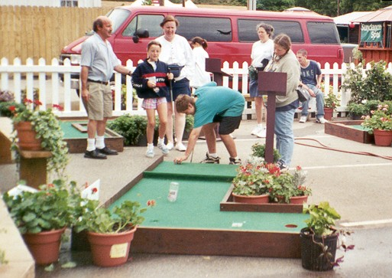
FORE! Indiana State Fair attendees line up to play a round of golf at the FFA Pavilion. The golf course is part of an educational display where fairgoers learn about agriculture and it’s impact on the Indiana economy. FFA groups from across the state prepare designs for an annual contest to have the right to come to Indianapolis and construct their hole, such as the ones above and below.

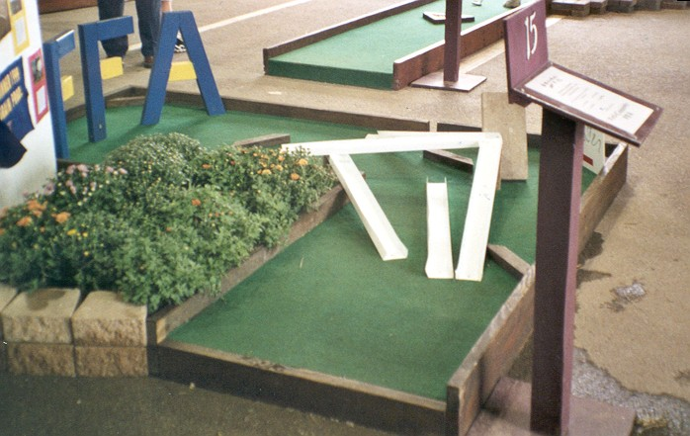

Readiness Questions

- How many holes does the FFA's Miniature Golf Course at the Indiana State Fair include?

- Who designs and constructs the holes around the course?

- What are the maximum dimensions for each hole?

- After the hole designs are chosen, what is done by the coordinators?

The Mini-Golf Activity

Information:
At the Indiana State Fair, the Indiana Future Farmers of America (FFA) designed a miniature golf course called the Agricultural Literacy Miniature Golf Course. After choosing the hole designs, they had to lay out the course to fit within the confines of the building and between the displays and demonstrations. The FFA needed 3 days to lay out their miniature golf course.
After attending the Indiana State Fair and participating in the Agricultural Literacy Miniature Golf Course, Columbus North High School principal David Roland decided to build a miniature golf course as a fund-raiser for his school. After receiving designs for the holes, the Columbus North High School student council members selected the top 18 designs.
Columbus North High School's miniature golf course will be placed in a building that is 56 feet by 65 feet. The end of each miniature golf hole must line up with the beginning of the next hole.

Problem:
The student council needs your help in laying out the miniature golf course. Please write a letter telling the student council how to lay out their miniature golf course.
In your letter, be sure to include a description of how you laid out your golf course, so that it could be used for any other golf course in the future. The shapes and dimensions of the 18 holes are on the next page. The shapes are not drawn to scale.
SHAPES AND DIMENSIONS OF GOLF HOLES

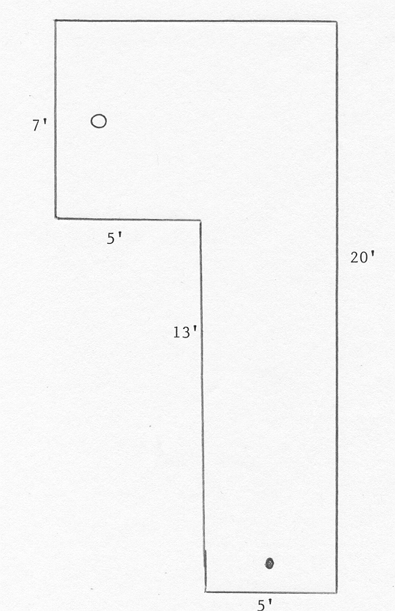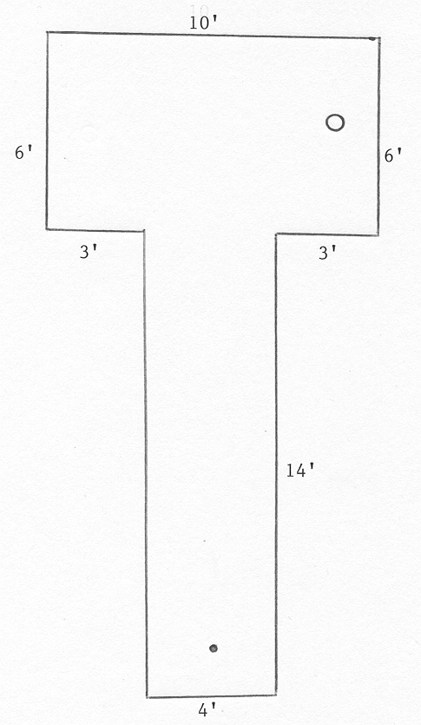
3 holes of this shape 2 holes of this shape

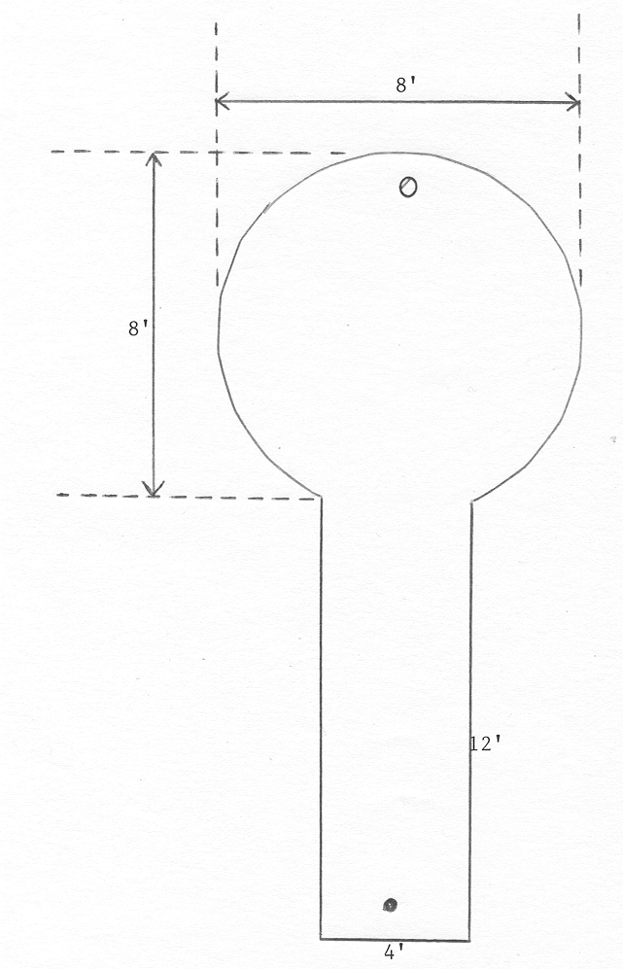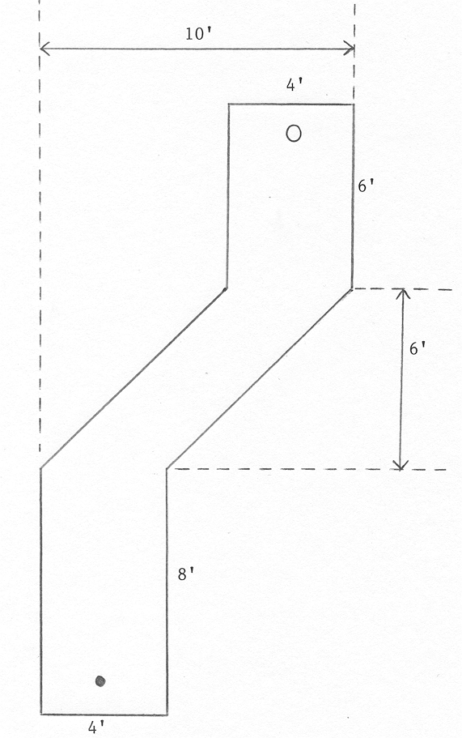
3 holes of this shape 2 holes of this shape

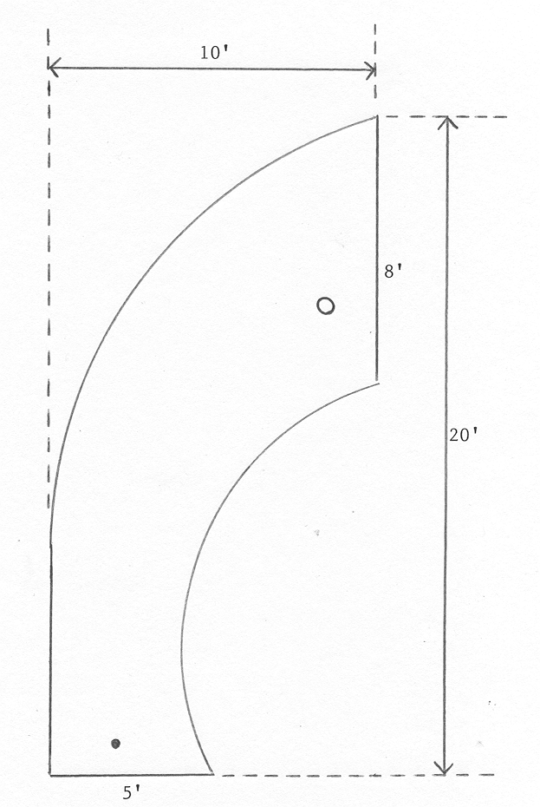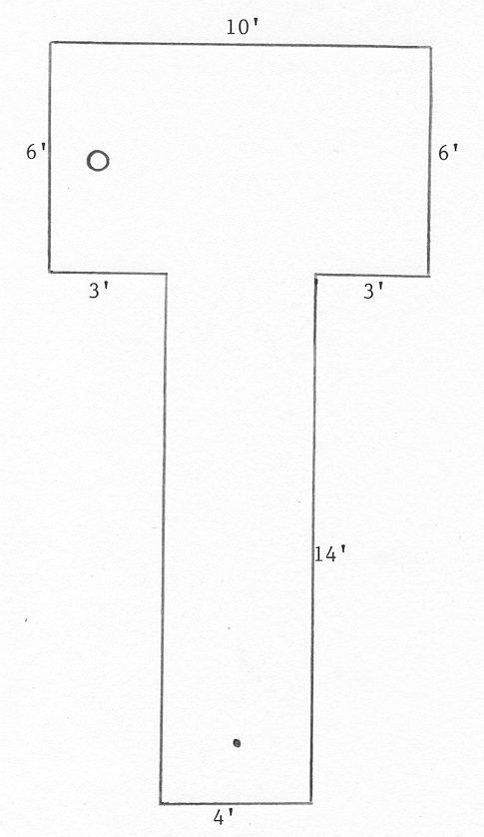
3 holes of this shape 3 holes of this shape

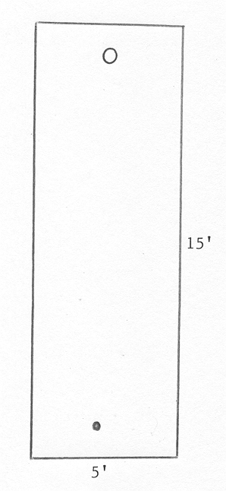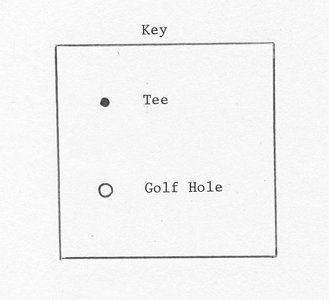
2 holes of this shape

