A World of Fun and Adventure

The dog days of summer have settled in and area residents are finding ways to stay cool.
The town of Smithville is helping people stay cool with special rates for its new tourist attraction.
Since opening on May 26, Adventure World has had approximately 50,000 people pass through its gates.
According to Lupita Carmona, spokeswoman for the park, Adventure World’s turnstiles have been going crazy. “With the warm weather, our affordable prices and our great attractions, it’s no wonder why we’re seeing such huge crowds this early in the season.”
The new park contains 28 rides and attractions in three sections named Challenge Island, Thrill Park and Fantasy World. A wide variety of rides satisfies everyone’s interests.
The main attractions at the park are the two new roller coasters.
One of the most popular rides at the park is The Monster, which is highlighted by a 200 foot, 60 degree drop. The other roller coaster that is turning Central Indiana upside down is The Spiral. On this looping coaster, riders are turned upside down four times.
Long lines have plagued the Monster and the Spiral. Throw in the fact that these two rides are on the opposite sides of the park and you have people running over each other and quite impatient while standing in line.
To help with these long lines, the park has created the Quick Ticket system. With a Quick Ticket, guests are able to avoid long lines by “making reservations” at each ride.
At each Quick Ticket ride there are two separate lines, one for Quick Ticket recipients and the other is the regular entrance for those who did not obtain a Quick Ticket.
A Quick Ticket is very easy to get. At each ride, there is a machine that prints free tickets with times for the riders. By hitting a button, a Quick Ticket is printed with the time the guest should return to the ride, which is normally 30 minutes from the time that the ticket is printed.
Amanda Jennings of Mansfield, Iowa, used the new system to ride the Monster. “When I first walked up to the ride, I noticed that there was a 60 minute wait. I didn’t want to wait in line, so I decided to get a Quick Ticket.”
When she came back, there was only a five-minute wait, said Jennings. “Instead of standing in line for the Monster, I was able to enjoy the rest of the park.”
According to Carmona, the park is one of several in the nation that is using this system. “The system makes sense because people hate standing in line for 45 minutes just to ride a 3 minute ride,” said Carmona.
“We’re very pleased about how the system works and that the customers love it. I’ve had people come up to me and say they were going to come back just because the system made their visit more enjoyable.”

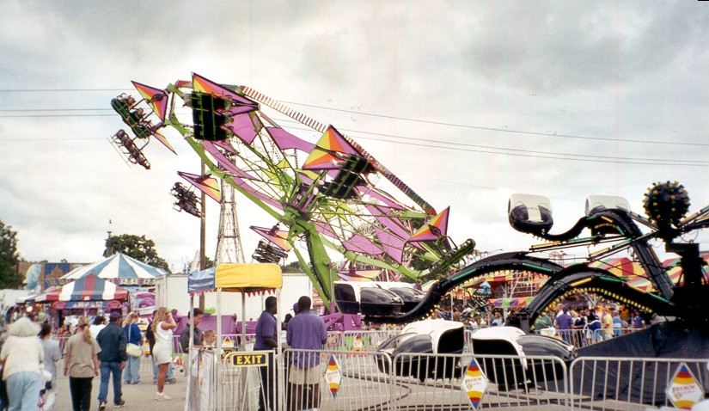

Around and around they go...Visitors to Adventure World theme park can ride numerous rides all day and not have to stand in line with the new Quick Ticket system at the park.

The answer to your long lines: The Quick Ticket has been a hit this year at Adventure World for many thrill-seekers.

ADVENTURE WORLD

Quick Ticket

Valid for June 1, 2000

The Monster
This allows the bearer to use the Quick Ticket entrance to The Monster between 11 a.m. – 12 p.m.

Readiness Questions:

- When did Adventure World Open? How many people have visited Adventure World?

- What is the Quick Ticket system? How does this system compare to waiting in the normal line? Do you have to buy the Quick Tickets?

- How did the Quick Ticket system help Amanda Jennings?

- What rides are the most popular?

- What times of the day are the rides the busiest? How did you come to this conclusion?

- According to the chart listing line wait times at Adventure World, what is listed in a column with a Q? What is listed in a column with an R? What does it mean if a box is gray?

- Which ride has the longest regular wait time? Which ride has the longest Quick Ticket wait time?

- How does the wait time for the Monster change throughout the day?

Amusement Park Problem

Information: Wendy Thompson and her sixth-grade class have been chosen to give a musical performance at Adventure World. When they aren’t performing, they can explore the rides and entertainment at the amusement park. They will be arriving at 8 a.m. and will be leaving at 5:30 p.m. From 12:30 p.m. to 2 p.m., they will be at the Amphitheater in Fantasy World for their performance and eating lunch. From 9:30 a.m. to 10:30 a.m. they are going to watch the movie at the IMAX theatre in Thrill Park. The students and their chaperones have the rest of the day to explore the park’s rides, shops and restaurants.

The Problem:
There are 22 students in her class and four parents to help chaperone. The students need to stay with a chaperone at all times. Wendy wants to group the students in five groups according to their ride preferences. A few weeks ago, she asked each of her students to list their five favorite rides (the list of their favorites is attached) to help her do this.

So each group is sure to get on as many rides as possible, Wendy wants to decide when each group should go on each ride. The park is large and some of the rides are far apart so the schedule needs to be made very carefully in order to allow the groups to ride as many attractions as possible.

Please write a letter to Wendy and her students providing a schedule for each of the five groups’ day at Adventure World and describe the method you used to divide the class into groups and create the schedule so she can share it with other teachers taking students to Adventure World that day for performances.

Line Wait Times at Adventure World

This chart shows how long it takes to wait in line at the different rides at Adventure World. For each time of day, it shows how long you have to wait in a Quick Ticket line and how long you have to wait in a regular line.

Key:

Q = Quick Ticket Line Time in minutes
R = Regular Line Time in minutes
A gray box indicates the Quick Ticket Line is unavailable.
 | Time of Day
 | 8-9 |  | 9-10 |  | 10-11 |  | 11-12 |  | 12-1 |  | 1-2 |  | 2-3 |  | 3-4 |  | 4-5 |  | 5-6
Ride | Q | R | Q | R | Q | R | Q | R | Q | R | Q | R | Q | R | Q | R | Q | R | Q | R
Ball of Fire |  | 5 |  | 7 |  | 12 |  | 12 |  | 8 |  | 10 |  | 10 |  | 12 |  | 15 |  | 15
Boats |  | 5 | 0 | 10 | 0 | 15 | 1 | 25 | 0 | 10 | 0 | 20 | 1 | 25 | 2 | 35 | 1 | 30 | 1 | 30
Cannonball |  | 15 |  | 20 |  | 25 |  | 25 |  | 22 |  | 27 |  | 30 |  | 30 |  | 35 |  | 32
Carousel |  | 3 |  | 3 |  | 5 |  | 7 |  | 4 |  | 5 |  | 5 |  | 7 |  | 7 |  | 6
Cars |  | 0 |  | 0 |  | 5 |  | 5 |  | 0 |  | 5 |  | 7 |  | 10 |  | 10 |  | 5
Chiller |  | 15 | 0 | 25 | 0 | 25 | 0 | 30 | 0 | 25 | 3 | 35 | 5 | 50 | 5 | 50 | 5 | 65 | 5 | 60
Drop Zone |  | 10 |  | 15 |  | 15 |  | 20 |  | 15 |  | 25 |  | 25 |  | 28 |  | 30 |  | 30
Fred’s Flight |  | 5 |  | 5 |  | 7 |  | 10 |  | 5 |  | 10 |  | 10 |  | 12 |  | 10 |  | 10
Fun House |  | 0 |  | 0 |  | 0 |  | 0 |  | 0 |  | 2 |  | 2 |  | 0 |  | 0 |  | 0
Lightening |  | 15 | 0 | 20 | 0 | 27 | 3 | 35 | 0 | 20 | 4 | 46 | 6 | 50 | 6 | 50 | 6 | 50 | 4 | 45
Log Ride |  | 10 |  | 10 |  | 12 |  | 20 |  | 13 |  | 25 |  | 25 |  | 30 |  | 30 |  | 25
Magicoaster |  | 15 | 0 | 17 | 0 | 23 | 2 | 35 | 0 | 17 | 0 | 27 | 2 | 35 | 2 | 35 | 1 | 30 | 1 | 30
Mine Racer |  | 0 |  | 3 |  | 3 |  | 5 |  | 0 |  | 5 |  | 5 |  | 5 |  | 3 |  | 3
Minicoaster |  | 5 |  | 10 |  | 10 |  | 15 |  | 5 |  | 12 |  | 15 |  | 20 |  | 20 |  | 12
Monster |  | 25 | 0 | 30 | 2 | 40 | 3 | 55 | 3 | 55 | 5 | 60 | 5 | 60 | 5 | 70 | 5 | 70 | 5 | 65
Navigator |  | 5 |  | 5 |  | 10 |  | 20 |  | 5 |  | 30 |  | 30 |  | 26 |  | 23 |  | 20
Racer |  | 5 |  | 5 |  | 10 |  | 10 |  | 5 |  | 10 |  | 12 |  | 15 |  | 15 |  | 10
Rocket |  | 5 |  | 5 |  | 7 |  | 10 |  | 5 |  | 5 |  | 10 |  | 10 |  | 10 |  | 15
Rocketrider |  | 12 | 0 | 15 | 0 | 15 | 0 | 15 | 0 | 10 | 0 | 12 | 0 | 12 | 0 | 15 | 0 | 15 | 0 | 13
Slider |  | 20 |  | 20 |  | 25 |  | 30 |  | 30 |  | 35 |  | 40 |  | 40 |  | 45 |  | 50
Snake |  | 5 |  | 5 |  | 10 |  | 10 |  | 7 |  | 10 |  | 10 |  | 15 |  | 15 |  | 10
Spider |  | 0 |  | 0 |  | 3 |  | 5 |  | 2 |  | 3 |  | 3 |  | 3 |  | 5 |  | 2
Spiral |  | 20 | 0 | 30 | 0 | 35 | 2 | 45 | 5 | 50 | 5 | 55 | 5 | 60 | 5 | 60 | 5 | 60 | 5 | 60
Stop & Go |  | 0 |  | 0 |  | 2 |  | 2 |  | 0 |  | 3 |  | 3 |  | 2 |  | 3 |  | 0
Subs |  | 0 |  | 0 |  | 5 |  | 5 |  | 0 |  | 0 |  | 5 |  | 5 |  | 5 |  | 5
Terror Falls |  | 10 | 0 | 17 | 0 | 20 | 0 | 20 | 0 | 22 | 0 | 26 | 0 | 30 | 0 | 30 | 2 | 33 | 0 | 30
Twist & Turn |  | 0 |  | 2 |  | 2 |  | 3 |  | 0 |  | 2 |  | 3 |  | 3 |  | 3 |  | 2
Twister |  | 5 |  | 7 |  | 15 |  | 15 |  | 12 |  | 20 |  | 15 |  | 15 |  | 23 |  | 20

List of Students and Favorite Rides

Name | Favorite Rides
Melissa | Boats | Ball of Fire | Subs | Log Ride | Cars
Debbie | Carousel | Subs | Log Ride | Terror Falls | Cars
Mark | Rocket | Spiral | Monster | Snake | Drop Zone
Crystal | Log Ride | Rocket | Cars | Twist & Turn | Snake
Max | Spiral | Monster | Slider | Racer | Cannonball
John | Spiral | Monster | Cannonball | Twist & Turn | Lightening
Cody | Snake | Monster | Spiral | Subs | Cannonball
Mandy | Log Ride | Cars | Twister | Slider | Subs
Carol | Fun House | Twister | Ball of Fire | Cannonball | Terror Falls
Celia | Twister | Spiral | Monster | Cannonball | Terror Falls
Mary | Magicoaster | Boats | Log Ride | Subs | Carousel
Shawn | Cars | Log Ride | Monster | Spiral | Twist & Turn
Steve | Monster | Spiral | Racer | Slider | Cannonball
LeAnn | Spiral | Racer | Cannonball | Monster | Log Ride
Bill | Twister | Log Ride | Boats | Cars | Subs
Chris | Terror Falls | Boats | Log Ride | Rocket | Snake
Barbara | Lightening | Subs | Spiral | Racer | Log Ride
Stephanie | Magicoaster | Subs | Log Ride | Cars | Boats
Catherine | Terror Falls | Monster | Spiral | Twist & Turn | Ball of Fire
Dan | Lightening | Cannonball | Terror Falls | Cars | Log Ride
Scott | Boats | Magicoaster | Subs | Drop Zone | Ball of Fire
Matt | Snake | Lightening | Log Ride | Terror Falls | Ball of Fire

