Walking Works Wonders

FAIRPORT, NY – This year a group of seniors at East Rochester High School are taking a new approach to their final semester of physical education. The class, which typically focuses on individual physical fitness and nutrition goals, will aim to include students from every grade level and even members of the community.
The idea came from a class discussion on which students were deciding how much time a week should be devoted to exercise. Many students felt that they needed at least two to three hours of exercise weekly, but found it difficult to find that much free time outside of school and other responsibilities. A number of students were also unclear about which kinds of exercise 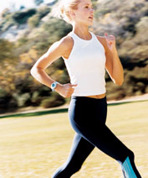were most beneficial.
The discussion then turned to walking as a simple form of exercise that anyone could do at anytime. “People don’t realize that walking can be a good way to stay fit and burn calories,” says Paul Rogers, a physical education instructor at the high school.
Therefore, the students enrolled in the class have decided to organize a school and community wide 5K fun walk to promote fitness and exercise.

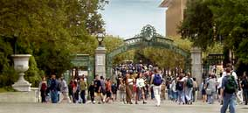

Abby Rowe, a senior, believes that students don’t realize that taking a daily walk is a great way for busy students to get exercise. “A lot of students think they don’t have time to exercise because of homework, clubs or work,” says Rowe. “I think that this is a great way to let them know that just by walking a little bit everyday, they can still get in some exercise.”
Students from every grade level are invited to participate in the Fun Walk as well as family members and anyone else in the community interested in getting involved in promoting physical fitness.
The student organizers hope to achieve this by letting each walker know how long it took them to complete the course as well as how many calories they burned while doing it. “There will be tables set up at the end of the course where students from the class will be calculating each participant’s information,” states Rogers.
The Fun Walk is planned for the end of next month, however, both students and the community will be seeing informational posters appearing soon.
What can you do to prepare for the Walk? “Just start by taking every opportunity to walk,” suggests senior Joe Finch. “Take the stairs instead of the elevator or walk to the grocery store. Make every step count.”

Readiness Questions

Answer these questions after reading the article.

- Why do the students believe that the Fun Walk is a good idea?
- Why might some students feel there is no time for exercise?
- Why is it important both for organizers and walkers to plan ahead for the Fun Walk?
- How do the organizers plan to promote health and fitness to students and the community?
- Do you think a Fun Walk might be successful at your school? Why or why not?
- If you walked for 30 minutes at 3 miles/hour, how far did you walk?
- If you are walking at a speed of 2 miles/hour and you are burning 5 calories/minute, how far have you gone if you burned 225 calories?
Your Mission
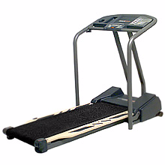
Your class has been asked by a local health club to help solve a problem for Lisa, one of their fitness directors. Lisa has a client that wants to lose some weight by walking on a treadmill. Lisa knows that if her client can walk at a good pace at an incline for 35 min a day several times a week, her client will be happy with the weight loss. Lisa’s client has chosen to walk at a grade of 9%, and wants to know what her cal / min will be for the various speeds that she will be walking (3 to 5 mph). Lisa is using the same graph that you have on the following page. So, Lisa needs to know what the curve will look like for a 9% grade.
Your mission is twofold. First, you are to determine what the curve will look like for Lisa’s client that will be walking at a 9% grade. Second, you are to come up with a general procedure for the health club to use in the future for the clients that choose their % grade. So, your procedure must not be specific to a 9% grade. Make sure the health club can understand your explanation of the procedure well; they plan on using your procedure for future clients’ needs.

