Ancient Crocodile Discovered in Africa

TRENTON, NJ – Dr. William Westmalle, a professor at Rutgers University recently returned from a very exciting trip to Africa. While on an archaeological dig in the Sahara, he uncovered what turned out to be the intact skeleton of a prehistoric crocodile.
“From what we have so far,” says Dr. Westmalle, “this animal was about the size of a school bus and weighed about 1800 pounds.”
It is believed that the giant crocodile, or, Sarcosuchus imperator, lived about 110 million years ago. Preliminary findings suggest that the animal had four foot long jaws and was capable of devouring a 12 foot long fish in a single bite.
There have been bits and pieces of evidence that the massive croc existed. However, scientists were unable to determine the size of the flesh-eating crocodile because they did not have an intact skull.
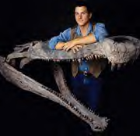
“There is a well documented relationship between the head and body size of crocodiles,” reports Westamalle. “So when we found our skeleton with the skull in excellent condition, we were very excited. We knew we had the missing piece to a very big puzzle.”
What Dr. Westmalle and his team of scientists were able to put together looks very much like a modern day crocodile, only much, much bigger. They believe Sarcosuchus to have been between 37 to 40 feet long. Its head measured at 5 ½ feet long and had 4 foot long jaws. It weighed in at least 17,600 pounds. “That is about as much as one and a half modern day African elephants,” laughs Westmalle.
That is quite a bit different than the crocodiles we see in zoos today. The largest Australian croc is no more than 21 feet long and weighs just a little more than one ton. American alligators, on the other hand, are even smaller, growing to 15 feet long and weighing to 1300 pounds.

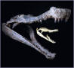
-- The skull of a modern day crocodile inside the 4 foot long jaws of ancient Sarcosuchus imperator

The scientists also believe that the giant crocodiles lived between 50 to 60 years. Modern day crocs can live up to 70 years, and it has been reported that some have lived even longer. While modern day crocodiles grow rather quickly, the ancient crocodile continued to grow throughout its life.
Sarcosuchus lived in a jungle-like area in Africa with lots of trees, rivers and fish. Some of the rivers inhabited by the ancient crocodile were between 200 and 300 feet wide. This made it easy for the giant predator to swim along the river watching for any other animals that would come for a drink. Since its eyes and nostrils were vertically placed on its head, it could keep its body underwater while swimming. The giant croc would be almost unseen before it attacked.

Readiness Questions

- How long was the giant crocodile? How long is a modern day crocodile?
- Have you ever seen a live crocodile? Where were you? Did it seem like a scary animal?
- What do you know about modern day crocodiles? Where do they live? What do they eat?
- How were the scientists able to figure out the size of the ancient crocodile?
- Why do you think the scientists could figure out the size of the ancient crocodile based on the size of its skull?
- Do you think knowing about modern day crocodiles helped the scientists determine the size of the prehistoric one? Why or why not?
- Looking at the pictures below, compare the modern day animals with their prehistoric cousins. How do you think they are different? How are they the same?

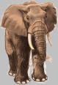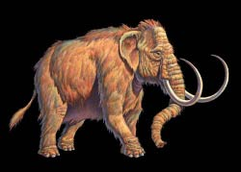
modern elephant prehistoric elephant

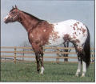 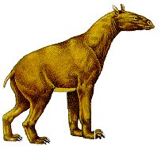
modern horse prehistoric horse
The Problem

Gil Sunderland needs your help. While on a camping trip in Alpena, Michigan, Gil discovered a skull and two giant teeth measuring 10 and 8 1/2 inches long. After doing some research, Gil believes they are very similar to the teeth and skull of a modern day beaver. Gil would like to convince his friend that these are in fact the remains of a giant prehistoric beaver. His friend, however, does not believe that such a creature ever existed.
Your task is to figure out how big the prehistoric beaver was based on the information Gil has given you. You can examine the pictures that Gil has provided of the giant teeth that he found. He has also found out that present day beaver teeth are approximately 3 ½ inches long. He also knows that the length of a modern day beaver is 22-27 inches. The tail can be between 12 inches long and it can weigh anywhere from 35-60 pounds. Gil has also done some research and has discovered that the prehistoric beaver’s tail could reach up to 26 inches in length.
Write a letter to Gil explaining how big you think the ancient beaver was. Also, be sure to explain to Gil how you arrived at your conclusions so that he can convince his friend as well.

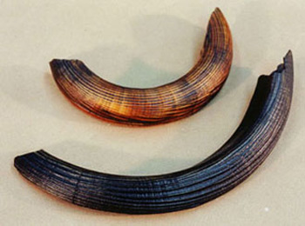
Picture of the two teeth that Gil found while camping

Gil also has a friend that is a taxidermist who buys and sells animal pelts. Now that Gil mal knows more about the size of the giant beaver, he is curious to know two things. He wants to know how big the pelt would be as well as how much money he could get for it according to his friend’s price chart.
When you have decided how big the pelt would be, and how much money it would be worth, write Gil a letter explaining how you arrived at your answer.

Sizing and selling beaver pelts  The size of a beaver pelt is determined by adding together the number of inches across the pelt from top to bottom and from side to side. |  |  | 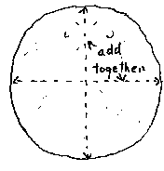
SIZING |  | PRICE LIST
Small | 0-52" | $15.00
Medium | 53-59" | $20.00
Large | 60-64" | $25.00
Blanket | 65-70" | $30.00
Super Blanket | over 70" | $35.00

