Expert Tracker Shares His Experiences

Toms River, NJ- Native son and widely known tracker Tom Brown has had sixteen books published and currently trains others to be trackers at his tracker school. Since 1978, people have come from all over the world to the Tracker School to learn the science and art of tracking from Tom and his highly trained staff.
Tom began his journey as a tracker at a young age. While growing up in the Pine Barrens in eastern New Jersey, he spent many hours exploring the beauty and power of the natural world. It was there he met Rick, who became his best friend and fellow nature explorer. Rick introduced him to his grandfather, Stalking Wolf, an Apache tracker, who became Tom’s mentor. He passed on his knowledge and skills to these two boys for many years.
The hours Tom, Rick, and Stalking Wolf spent in the wilderness taught Tom to understand and respect nature. One thing he learned about himself was his gift for tracking. Tom spent hours tracking a number of animals and learning about them through quiet, detailed observation. These hours spent learning to track gave Tom the ability to observe a track and make predictions about whom or what made it.
As he followed tracks, he would notice the pattern they took and the depth of them. These told a story about the animal’s behavior, for example a track that had a deeper toe indentation told Tom that the animal was running. Other clues that Tom would look for included the toeing marks, sideward ridges on the tracks, the length of the stride, and the size of the track. Being able to read the tracks and know the story they told came after observing the animals in similar situations.
Tom and Rick learned even more about tracks as they observed how weather affected them. They spent many hours watching a track they had made to see the changes that occurred to it as it rained or from freezing and thawing. Different kinds of soil also had an impact on the track.
They became good not only at tracking animal footprints, but car tracks and human footprints also. As young boys, they helped a local search party find a missing five year old in the woods. The hours learning the art of tracking allowed these two boys to do with ease what a group of trained dogs and adults were unable to do.
Tom used this ability many times as an adult also to track down people. The most notable incident for Tom was the time he found a mentally challenged adult who had been missing for a number of days. This time helped Tom to realize that his gift had value for others. In his book, The Tracker, Tom states, “he was there and alive and if my life ended in the next instant, all the years I had spent learning to track had been justified.”

Tracker Readiness Questions

After reviewing the article and the data sheet, please answer the following questions.

1) What clues does Tom Brown look for in a track?
2) How far apart are the Florida Water Rat tracks?
3) Complete the table below using the tracks on the data sheet:

Animal | Length of smallest toe | Width of widest part of print
Sea Otter
Common Snipe
Armadillo
Rock Sandpiper

4). Which animal do you think is the biggest? Why?

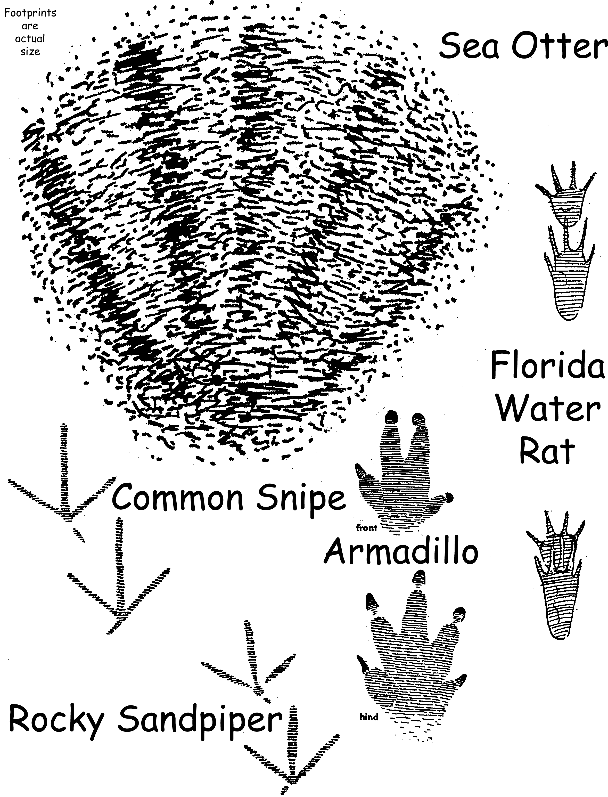

Bigfoot Problem

Early this morning, the police discovered that, sometime late last night; some nice people rebuilt the old brick drinking fountain in the park. The mayor would like to thank the people who did it. However, nobody saw who it was. All the police could find were lots of footprints. One distinctive, very large footprint was found and is shown below. The police feel this is the person they want to find first because whoever made the footprint seems to be very big. To find this person and his friends, it would help if we could figure out how big he/she really is.
Your job is to make a “HOW TO” TOOLKIT, a step by step procedure, the police can use to figure out how big people are by looking at their footprints. Your toolkit should work for footprints like the one that is shown here, but it also should work for other footprints.


