Winter Cycling in Ottawa

Ottawa, Canada – It seems that nearly
everyone in Ottawa loves cycling. Bicycling Magazine has named the city of Ottawa as the 4th best cycling city in North America. There have been an increasing number of people who continue to cycle throughout the winter months as well as the summer months. “I love riding my bike”, says Hayden Peterson, a University of Ottawa graduate student in meteorology and member of the Ottawa Cycling Club. “I commute to the university all year round, this is my fourth winter doing so. I enjoyed it so much, I sold my 4x4 sport utility vehicle last winter because I never used it.”

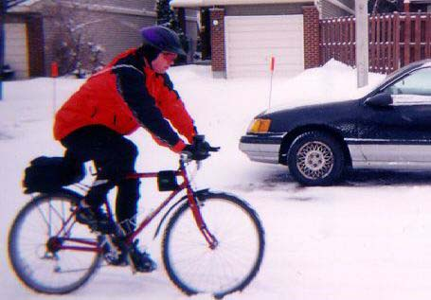

With a growing number of winter bicycle riders, it is important that everyone is aware of the importance of dressing appropriately for the weather. During Ottawa winters, temperatures reaching down to -22 degrees Fahrenheit are not uncommon. “The cold temperatures and wind chill are serious factors that need to be taken into consideration when planning to cycle during the winter”, explains Pam Noonan, a registered nurse and president of the Ottawa Cycling Club. It is important to know that the air temperature has several effects on the human body. The body will always attempt to retain a constant central body core temperature. “In warm weather, this usually results in body sweat to lower body temperature. In cold weather, the body will close down blood flow to prevent excessive cooling. The body acts like a living radiator for temperature control”, explains Noonan. If the core temperature begins to drop, the brain will shut off blood flow to the hands and feet and then arms and legs if cooling continues. This is how frostbite can occur.
Checking the temperature outside may not be enough. The wind chill must be taken into consideration as well. The wind chill temperature is how cold people actually feel when they are outside. “As the wind speed increases, the temperature a person feels gets colder. If the temperature is 0 degrees Fahrenheit and the wind is blowing at 15 mph, the wind chill temperature is a shivering -19 degrees Fahrenheit. At this wind chill temperature, exposed skin can freeze in 30 minutes”, says Peterson.
The Ottawa Cycling Club is doing its part in making riders aware of the potential dangers of winter cycling. “Successful winter cycling is possible when you are able to maintain hydration, minimize sweating, and stay warm and dry”, remarks Noonan. If everyone takes the proper precautions for winter bicycle riding, this winter will prove to be the safest and most fun yet for bicycle traffic in Ottawa.

Readiness Questions

How cold do winters get where you live? How much snow do you get?

Do you enjoy riding a bike? Do you ride all year long?

What things should be taken into consideration when riding a bike on a cold and snowy winter day?

What does the human body do in order to try to keep its central body temperature constant in warm weather? In cold weather?

What is wind chill? How does the speed of the wind effect wind chill?

Arrange the following temperatures ( in degrees Fahrenheit) in order from coldest to warmest: 25, -32, -5, 5, 0

Hayden Peterson is studying meteorology. What is meteorology?

Your Task

Hayden Peterson would like your help. He has a chance to merge his interest in winter bike riding with his studies in meteorology. Hayden is working on a method for predicting the wind chill temperature when the temperature and wind speed are known. The Helena Cycling Club (out of Helena, Montana) wants Hayden to present them with a way to predict the wind chill. Hayden would greatly appreciate it if you could lend him a hand here.
You have been given 4 days of maps for temperature, wind speed, and wind chill temperatures. You are also given a 5th day with maps for temperature and wind speed. Your task is to determine what the map for wind chill temperatures will look like, specifically for the state of Montana. When you have determined what the 5th wind chill map should look like, write a letter to Hayden describing your thought process for determining this 5th map. Make sure your explanation is clear. Not only would Hayden like to present your solution to the Helena Cycling Club, but Hayden would also like to be able to use your reasoning in other prediction processes that he is working on involving temperature, humidity, and heat index.

Day 1
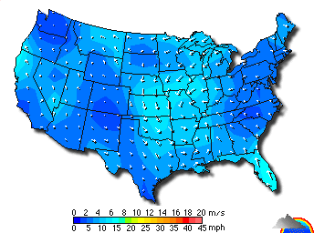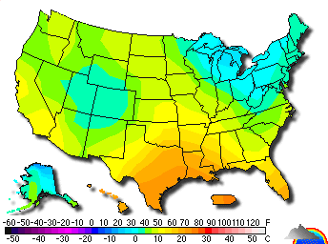
U.S. Map of Wind speeds U.S. Map of Temperatures

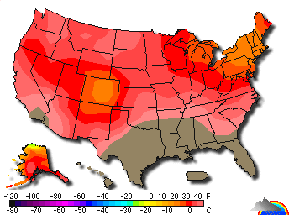

U.S. Map of Wind Chill Temperatures
Day 2
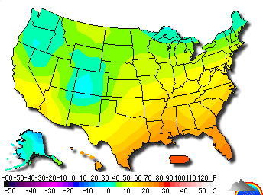

U.S. Map of Wind speeds U.S. Map of Temperatures

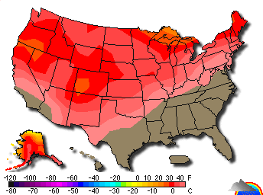

U.S. Map of Wind Chill Temperatures
Day 3
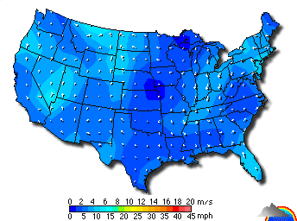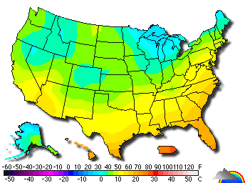

U.S. Map of Wind speeds U.S. Map of Temperatures

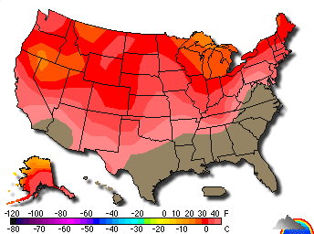

U.S. Map of Wind Chill Temperatures

Day 4

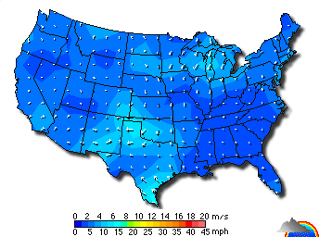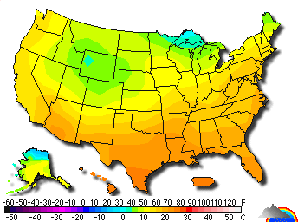

U.S. Map of Wind speeds U.S. Map of Temperatures
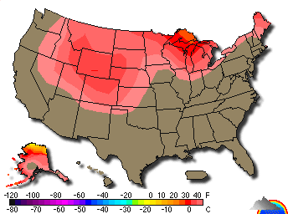
U.S. Map of Wind Chill Temperatures
Day 5
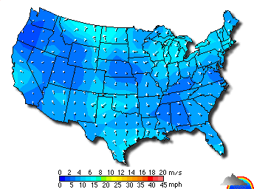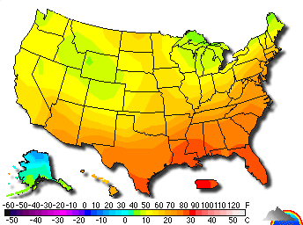

U.S. Map of Wind speeds U.S. Map of Temperatures

Blank Map of the United States for Prediction

