Pre-Reading Activity

Study the map of the Moreno Valley Trash Collection schedule below.

Which areas do you think have a bigger need for trash pick-up?
How many workers do you think are needed to pick up the trash in each district daily?

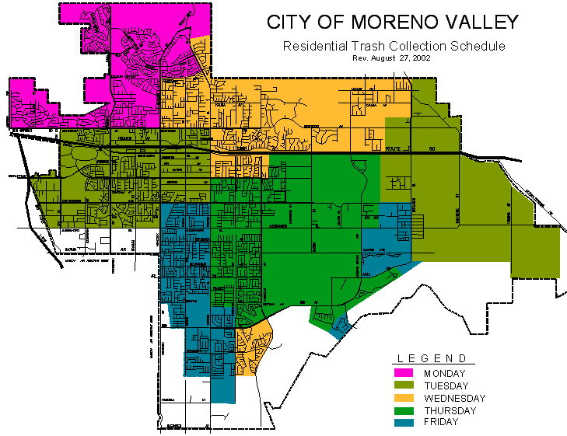
Labor Dispute Gets Messy

Moreno Valley, CA – Meetings between the city of Moreno Valley and the labor union began about a month ago to discuss contract negotiations for the coming year. The hottest topic in this year’s negotiations: an uneven workload for the sanitation workers due to an increase in trash city-wide. The labor union for the sanitation department would like the city to hire more workers. The city of Moreno Valley, however, wishes to investigate the demand for trash removal versus the need for an increase in manpower.
Presently, there is trash pick-up everyday Monday through Saturday. There are 30 sanitation workers under contract with the city. This means that on any given day, 5/6 of the sanitation workers are collecting trash, while the remaining 1/6 are not working. With this schedule, the sanitation department is able to pick up 100,000 pounds of trash a day.
“Basically,” says labor union leader Frank Lafford, “More trash is generated on the weekends. Since we pick up on Saturday morning, there is a backlog of trash from Saturday evening and Sunday.” For the Monday sanitation crew, this translates into more trash than can be collected the first day of the week. This usually balances out by mid-week. “The excess spills over to the Tuesday crew,” explains Lafford, “leaving uneven work schedules for the crews working in the beginning of the week.”
City officials for Moreno Valley say they are listening to the workers’ concerns. “We aren’t saying we’re not willing to change the present system,” says city official Cal Burston. “The city is under very tight fiscal constraints. We need to understand every aspect of this problem before allocating funds for more workers.”
In an effort to negotiate with the union, city officials have presented the following chart to the sanitation workers. It outlines what the typical trash collection for the week should look like in order to keep up with the trash production in the city. “It is a very nice chart,” remarks Lafford. “But, the city isn’t thinking about times of the year, especially holidays, when there are temporary increases in trash.” Lafford also notes that with summer coming, there are more people outdoors having parties and barbecues. The city also hosts many different events throughout the summer months that generate much more trash than normal.
“How can we handle this with 30 workers? Our union requires two full days off for the workers. The city’s present plan doesn’t provide that for us,” argues Lafford. “The city needs a new plan fast. There is lots of talk of a strike.”
Burston, like all city officials share the same concerns as Lafford. “We recognize these issues,” he says. “But this city doesn’t have funds for more workers. It is now a matter of finding a balanced solution.”

Readiness Questions

- Do you know when the trash is picked up in your neighborhood? How many times a week?
- Why is Frank Lafford worried about “uneven” workloads for the sanitation workers? How is this unfair?
- Why can’t the city of Moreno Valley just hire more workers? Is trash pick-up the only job of the Sanitation Department? What are some others?
- What are some of the holidays and other times when there might be more trash than normal? Why do you think this is a problem for the sanitation workers?
- Look at the graph presented to the union by city officials. How might it look different if they included holidays and other times when there is more trash?
- What happens when a group of workers go on strike? What will happen in Moreno Valley if the sanitation workers decide to strike?

Your Task

The sanitation workers in Moreno Valley are threatening to go on strike unless a new schedule is developed.

Your help is needed in restructuring the current work schedule with the 30 employees such that the city doesn’t have to spend additional dollars on hiring more sanitation workers and the trash can be picked up at a rate that meets the trash production of the city. Also, the Sanitation workers’ labor union must be satisfied that your plan has the workers best interests in mind, including giving each employee 5 consecutive work days with two days off as often as your scheduling allows it. When you have determined the new plan for scheduling the workers, write a letter to the city explaining your plan. Make sure your letter clearly explains how your scheduling plan meets their requirements along with how your scheduling plan satisfies the labor union’s concerns.

