Model-Eliciting Activity
Aluminum Crystal Size
(Estimated time: 45 minutes)

1. Individually read the background description on the attached pages.

2. Imagine that the engineering firm you work for is competing for a job for a company that produces aluminum and sells it to manufacturers, such as makers of softball bats. Your potential client (the aluminum producer) wants to improve quality control over their aluminum manufacturing process. To win the job, your engineering firm needs to propose an algorithm for determining the size of aluminum crystals from micrographs.

Your supervisor wants your technical team to develop and articulate a procedure that will determine the average size of crystals for samples of aluminum.

3. Develop a procedure that will win the job. Your team's final solution to this problem should include in a memo to your supervisor:

a. A series of steps that can be used to determine an indicator of average crystal size for samples of aluminum using micrographs.
b. A description of how the procedure would work by applying it to samples A, B, and C shown in Figure 3 in the background description attached.

BACKGROUND: ALUMINUM CRYSTAL SIZE

Batter, Batter, . . . SWING!!

West Lafayette, IN – The Lady Panthers are ready to pounce! Coach Meyers verified today that a new summer league softball team will be forming and joining the league.
“We have been signing up players, and we still have two positions open – third base and center field. So, if you know of anyone that might be interested in playing these positions or even other positions, please have them contact me,” said Meyers. “We are also beginning to make decisions about our uniforms and the pieces of equipment that we need to purchase.”
The Lady Panthers will wear uniforms of yellow and black after their team colors. The new Harry’s Sport Shop on Main Street is designing the uniforms, and the uniforms will be available for purchase by next Friday. Players will be responsible for purchasing their own uniforms, cleats, and mitts.
Since deciding on the team’s colors and the uniforms, Coach Meyer has been investigating the purchase of the necessary equipment for practice and games. Plenty of softballs have been purchased and batting helmets are being priced. Two different helmets are being considered, one for $34.99 and the other for $32.95. “I’ll probably purchase the more expensive helmets because they are of better quality. “When I pick up the helmets I will also purchase the catcher’s mitt and the catcher’s mask.”
The only remaining equipment for the coach to purchase will be the softball bats. The coach is considering three styles of aluminum bats, each of which costs about the same amount. “Since bats are so expensive and last year the bats dented too easily, I want to purchase bats that are more resistant to denting,” commented Coach Meyers.
The first game for the Lady Panthers will occur on June 6 at home. They will be playing the Nappanee Ravens at Strawberry Field. “I’m looking forward to helping the women get ready for our first game. I’ve heard the Nappanee Ravens have some good players, so we’ll need to be ready to go!” explained Coach Meyers.

Background Information: Part I

All metal is composed of crystals, and it is possible to see metal crystals without a microscope. Check out the metal poles supporting a traffic light on a nearby West Lafayette corner. These steel poles are coated with a thin layer of zinc metal that helps prevent rust formation. The zinc metal forms very large crystals that can be readily seen by the eye. The pictures below show the metal pole and a close-up picture of the crystals on the surface of the pole. The letters a, b, and c indicate three crystals that have had a line drawn along the boundaries between the crystals. The arrow on each picture is the scale marker.

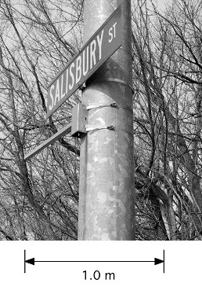 | 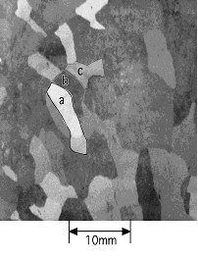
Figure 1. Traffic light pole | Figure 2. Close up of crystals

Background Information: Part II

The size of the crystals in aluminum is often a good indicator of the relative resistance to denting (or strength) of the material. Aluminum consisting of small crystals is stronger than aluminum consisting of large crystals. Figure 3 shows microscopic photographs of crystals for three samples of aluminum metal. They are called ‘micrographs’ because they provide a standard way to compare the size of crystals in aluminum. Materials engineers can chemically treat polished pieces of aluminum to make the boundaries between the crystals more visible. Using a camera attached to a microscope, a picture of the boundaries between the crystals can be obtained, and then the size of the crystals can be estimated.

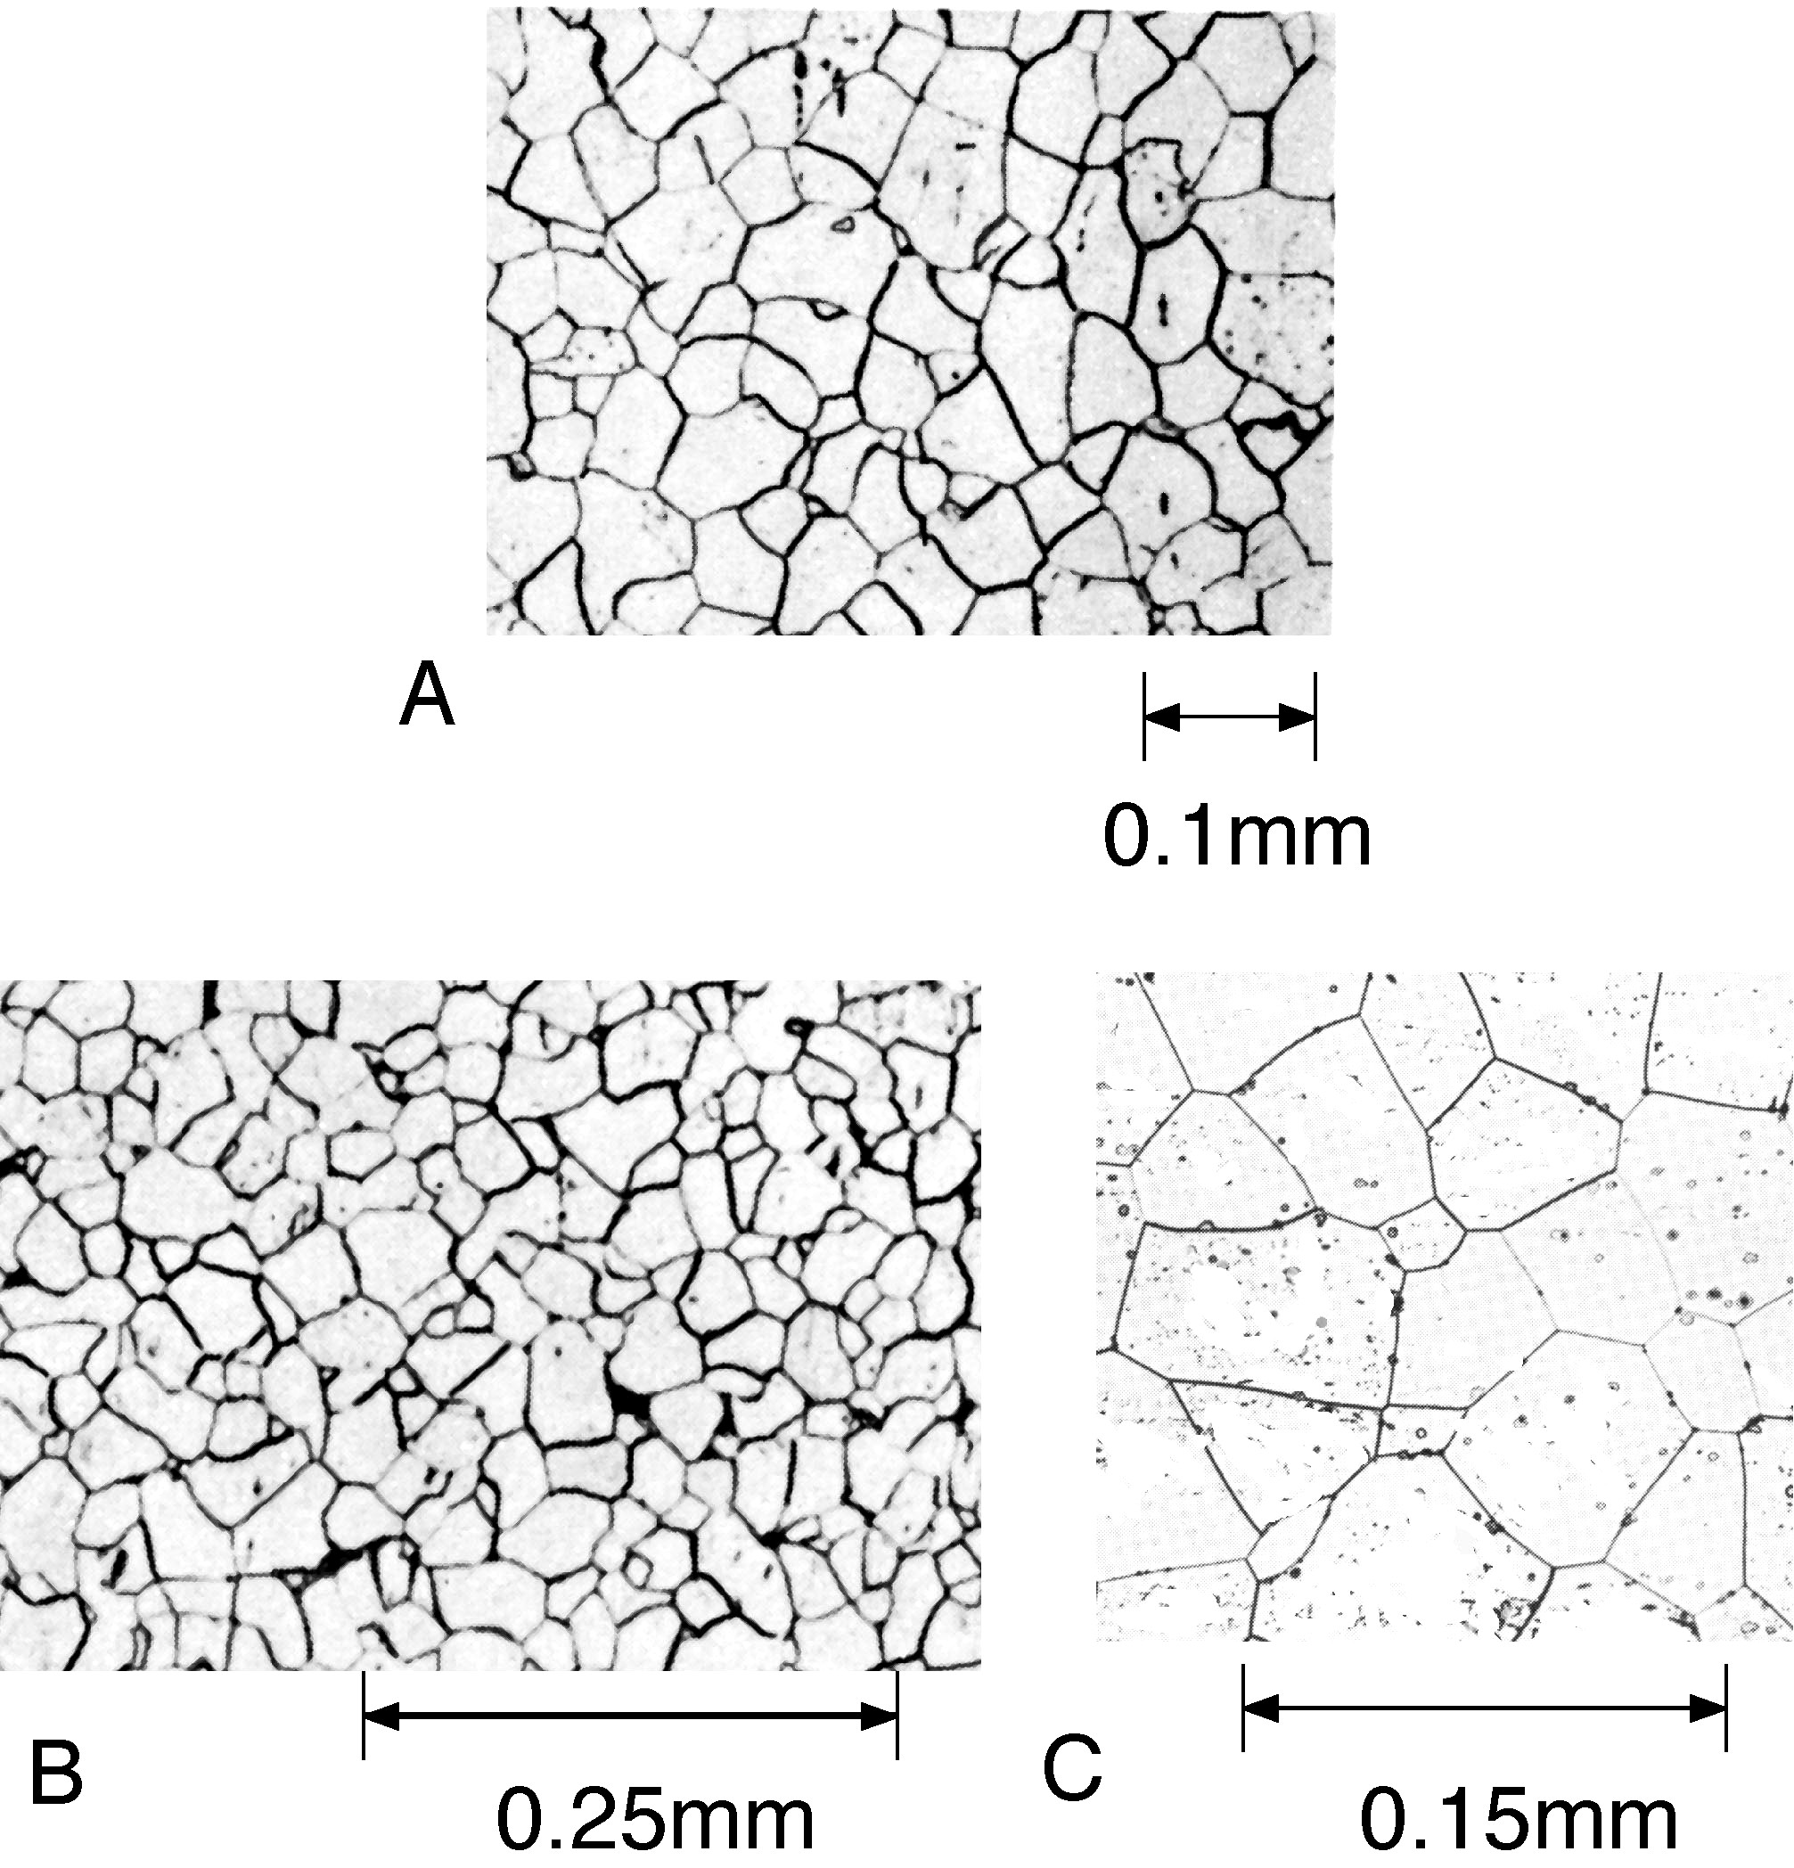

Figure 3. Sample aluminum micrographs.

