Quilters Sew Their Stuff
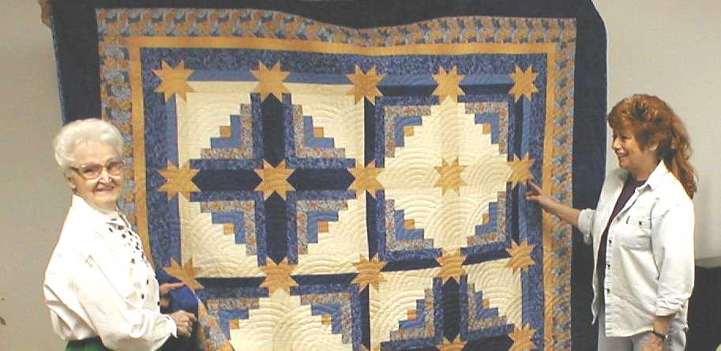

Lafayette, IN- Last weekend, quilters from all over Indiana came to Lafayette to display their best quilts. Quilts of various colors, sizes, and patterns demonstrated the talents and creativity of the quilters. In addition to being used as bed coverings, many quilts are also works of art. Many people will hang a quilt on a wall as they would a painting or photograph.
Many quilters will start with basic patterns, then modify and reorganize them in new ways to create original designs. Piecing together fabric in different ways is one method they use to develop new designs. Changing the colors can also effect how the product looks. Two quilts may use the same shapes in the same configuration, but look very different because of the way the colors were used in the design. This provides the quilter with a great deal of flexibility in their creation.
The quilting process, from pattern to final product, is very complex. Local quilter, Judy Richmond, explained it this way. “I start with the main pattern which gives the quilt a theme. Then I make a layout for my design. I figure out all the measurements for the different parts of the quilt. All of this is done before I start to cut any fabric pieces so I don’t waste any fabric and my pieces fit together very nicely.”
The next step is to make the templates the quilter will use to cut out the pieces. “Each shape in the quilt has its own template. I use the templates as patterns to cut out the pieces for my quilt. The template is the actual size of the piece for the final quilt plus 1/4 inch allowance for the seams. This allows the quilt pieces to fit together snuggly and smoothly,” states Richmond.
Borders are an essential part to the quilt design. Most quilts have two outer borders of different sizes and colors. The outermost border is usually 6 inches and the inner border is 2 inches. Borders also can be use to separate rows and columns of squares. These borders are often the same size as the inner border.
Quilters have to be very careful when making measurements for the layout and when cutting out the pieces from the templates so everything fits together correctly. Sewing the quilt pieces together must be completed in a particular order so the quilt looks right. When done properly, a quilt becomes a work of art that many families keep for many years to come.

Quilt Readiness Questions

After reading the article, answer the following questions.
- How are quilts used?
- What makes quilts of similar design different?
- Why are exact measurements important?

This is the layout for a new quilt Judy Richmond is making. Use it to do the following.

- Make a template for the small triangle.
Each side should be 3 inches plus a 1/4 inch seam allowance.
- Use this template to cut out 3 light and 1 dark colored triangles.
- Fold the triangles along the seam allowances
and put them together according to the layout.
- Make a template for the larger triangle.

Quilt Problem

Mitch would like to make a quilt for his new apartment. The quilt will need to measure 78” by 93” to fit his double bed. He knows the design he would like to use, but first he needs to make the template pieces. Then he can use them to cut the fabric the right size and shape.

Please diagram the layout for the quilt and give the measurements for the different parts using the design above. You will have to decide how many squares you want and how the borders should look. Next, construct a template for each of the pieces in the design.

Mitch is learning how to properly make a quilt, so that he can make a quilt for his sister’s birthday. Her quilt will be a different size and design. He needs you to help him write out the process to determine the correct layout and measurements for the templates. This process needs to work for other designs and sizes of quilts. Be sure to include all the steps and explanations, so Mitch can make a beautiful quilt for his sister.

