Students to fly away with paper airplane contest at Jefferson Middle School

Lafayette, IN – If the Wright Brothers, pilots and engineers can do it surely, then students in Burton Franklin’s eighth grade science class can do it. What can those kids do that a couple of inventors, some of the best pilots in the world and the brightest minds in the world do everyday? Fly!
On Friday, Franklin’s eighth grade science class at Jefferson Middle School will attempt to be like the Wright Brothers and design a plane that will meet today’s standards. They won’t be using aluminum parts or jet engines for these planes. All they need are pieces of paper – and a whole lot of imagination.
Students have the opportunity to design planes that will be able to fly long distances and through a series of obstacles with their annual paper airplane contest. For the contest, each team of students will design a plane to try to win prizes in four categories: Best Floater, Most Accurate, Best Boomerang, and Best Overall.
Some of the rules are that no cuts can be made in the plane’s wings, no parts may be cut off the plane entirely, and the students must build their own planes. They can modify folds in the plane between throws and for different paths.
Each team will get three throwing attempts at three different types of paths. For each throw, the judges will measure the time spent in the air, the length of the throw, and the distance from the target.
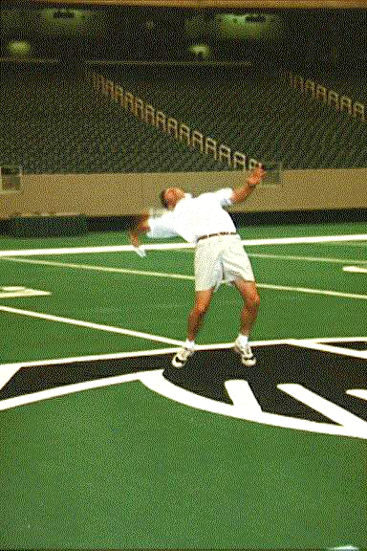

The first throw should travel in a straight path toward a target. The second path will require the plane to take a right turn after traveling around two chairs. It must go through the chairs to qualify for measurement. For the third path, the plane must travel like a boomerang and return to the thrower.
“Some students are really getting into this contest – I’ve heard a couple who said they’re bringing in-flight refreshments,” said Franklin. “It will be interesting.

Reflection questions

- What needs to be done for an airplane to have a successful flight for each path?

- What three measurements are taken for each throw?

- What other kinds of contests measure distance and/or time?

- What other kinds of measurements might be taken in other types of contests that measure distance and time?

- Do you feel the same measuring systems should be used for all airplane contests? Why or why not?

The Greatest Airplane Contest

This year Jefferson Middle School will hold their annual paper airplane contest on May 8th. Each team of students will design one plane to fly in all three different paths shown below. For each path, there is a fixed target point where the plane should land. They get to throw the plane three times for each path.

Paths:
- The first path should be in a straight line.
- The second path should be L-shaped. The plane should turn to the right after flying past two chairs. The chair is 4 meters from the start and 2 meters from the finish.
- The third path is a boomerang so the plane goes out and comes back to the thrower after going around a chair. The chair is 4 meters from the thrower.

Path 1 | Path 2 | Path 3
Finish  Start | Finish  Start | Start & Finish

Problem

In past competitions, the judges have had problems deciding how to select a winner for each of the four awards (Most Accurate, Best Floater, Best Boomerang and Best Overall). They don’t know what to consider from each path to determine who wins each award. Some sample data from last year and a description of how measurements were made have been included.

Write a letter to the judges of the contest. In your letter, explain a method to determine the winner of each award using the data from the contest.

Measurements | Path 1 | Path 2 & 3 – made the turn | Path 2 & 3 – missed the turn
Amount of time in air | Number of seconds from time of throw to landing | Number of seconds from time of throw to landing | Number of seconds from time of throw to landing
Length of throw | Straight-line distance from the start point to the landing point | Distance from starting point to turning point plus distance from turning point to landing point | Distance from starting point to landing point
Distance from target | Straight-line distance from the landing point to the finish point | Distance from landing point to finish point | Distance from landing point to turning point plus distance from turning point to finish point.

Data Table

 |  | Path 1 |  |  | Path 2 |  |  | Path 3
TEAM | Amount of time in air | Length of throw (meters) | Distance from target (meters) | Amount of time in air (seconds) | Length of throw (meters) | Distance from target (meters) | Amount of time in air (seconds) | Length of throw (meters) | Distance from target (meters)
TEAM | (seconds)
Team 1 | 3.1 | 11 | 1.8 | 2.5 | 7.7 | 3.2 | 0.7 | 1.8 | 6.8
Team 1 | 0.1 | 1.5 | 8.7 | 0.9 | 2.9 | 8.6 | 1.2 | 3.7 | 6.7
Team 1 | 2.7 | 7.6 | 4.5 | 0.1 | 1.1 | 2.4 | 2.7 | 8.4 | 4.4
Team 2 | 3.8 | 10.9 | 1.7 | 3.2 | 9.2 | 4.6 | 2.3 | 8.1 | 6.1
Team 2 | 4.2 | 13.1 | 5.4 | 2.3 | 9.4 | 2.9 | 0.2 | 1.6 | 6.9
Team 2 | 1.7 | 3.4 | 8.1 | 1.1 | 2.7 | 8.8 | 2.1 | 6.9 | 5.2
Team 3 | 4.2 | 12.6 | 4.5 | 1.7 | 4 | 5.9 | 2.9 | 8.5 | 5.5
Team 3 | 5.1 | 14.9 | 6.7 | 3 | 10.8 | 3.1 | 2.4 | 7.7 | 8.7
Team 3 | 3.7 | 11.3 | 3.9 | 2 | 6 | 3.2 | 0.2 | 1.9 | 6.7
Team 4 | 2.3 | 7.3 | 3.25 | 1.3 | 4.9 | 4.4 | 1.4 | 4.9 | 4.9
Team 4 | 2.7 | 9.1 | 4.9 | 2.3 | 7.3 | 2.4 | 2.7 | 7.2 | 8.1
Team 4 | 0.2 | 1.6 | 9.1 | 1.4 | 3.7 | 4.1 | 0.2 | 1.1 | 7.3
Team 5 | 4.9 | 7.9 | 2.8 | 2.7 | 10.7 | 1.1 | 2.5 | 7.7 | 5.7
Team 5 | 2.5 | 10.8 | 1.7 | 3.3 | 6.3 | 2.5 | 2.1 | 9.8 | 9.8
Team 5 | 5.1 | 12.8 | 5.7 | 1.3 | 2.6 | 7.2 | 3.2 | 10.4 | 5.8
Team 6 | 0.2 | 1.8 | 8.8 | 1.8 | 3.9 | 4.2 | 0.1 | 1.2 | 8.2
Team 6 | 2.4 | 10.1 | 4.6 | 0.2 | 5.7 | 4.2 | 1.3 | 4.9 | 4.9
Team 6 | 4.7 | 10.3 | 5.4 | 1.6 | 8.5 | 3.4 | 1.8 | 5.5 | 2.7

