Oregon “Rains” Supreme

PORTLAND, OR – There’s no doubt in Ben Woodson’s mind that Oregon would drown out the competition in a precipitation contest between it and Washington State. “Seattle’s reputation is just hype. Olympia’s not even close. No challenge at all,” said Woodson, a 36-year old car salesman from Portland.
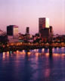
People in the Seattle area like to believe that they have more rainfall, but a few Oregonians would like to disagree. And to prove it, Dale Mead, member of the Portland city council, would like to begin the annual Golden Umbrella competition between the two Pacific Northwest states. “There are so many jokes about the rain,” he says. “Even if you have lived here your whole life, sometimes the rainy days can get you down.”
Mead believes that having this kind of competition would help people get through the rainy times with a positive attitude. “It will make the weather seem a little more interesting,” suggests Mead. “It could even be something to be proud of.”
On average, Washington reports 184 inches of precipitation annually. Meanwhile, Oregon reports up to 204 inches. “Of course it all depends on where you live,” explains Mead. “Places in Oregon like Astoria can get 66 inches per year and Eugene will get about 44 inches.”
This doesn’t necessarily mean that Oregon has this competition won. Cities in Washington like Olympia can receive up to 51 inches of precipitation a year. The town of Quillayute has averaged 104 in the past.
The details are being worked out in the Portland city council as well as in Seattle. Currently, there is some debate on how to measure the total precipitation for each state. “The question right now seems to be when, where and how often to measure the rain fall,” says council member Joann Wallace.
This issue arose when planners realized that the amount of rain falling in the Pendleton area, which is mostly dessert, would not be the same as on the coast. There is also the question of just how many Oregonians are getting rained on. “That should definitely be a factor,” says Wallace. “Obviously, there aren’t as many people being rained on in Barton as there are in Portland. And, isn’t that what makes people claim to be from the rainiest state? Getting rained on?”
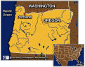
Of course, there are events that can be planned around the competition that will help get the community involved. “We’d like to see schools participate somehow in the competition. One city council member suggested a contest between schools to predict which state will win.”
The most popular idea is a weekend festival to be held in downtown Portland before the winner is announced. Event planners are presently accepting suggestions for activities and soliciting sponsors.

Readiness Questions

- Why does the Portland city council think this competition is a good idea?
- Why do people in Oregon think they could win this kind of competition?
- Do you think this contest will be popular? Why or why not?
- Think about the weather where you live. What is it like? How does it change from season to season?
- Do you think that your state could participate in this kind of competition? Why or why not?
- How do you think the contest officials should measure the rainfall for each state? How many samples should be taken? How often should it be measured?
- How could the different ways of measurement affect the outcomes of the contest?

Your Mission

Ben Woodson from Portland, Oregon needs your help. After all the talk about the Golden Umbrella Competition between Washington and Oregon, Ben’s uncle (the Governor of the state of Virginia) wants to see the state of Virginia get in on the competition. Ben has been talking about how Oregon would beat Washington in the rainfall competition. Ben’s uncle, a long time resident of Norfolk, Virginia believes that on any given day Virginia could beat Oregon in the rainfall competition, despite its size. Ben and his uncle want to be able to propose an idea for a fair and fun competition between the states of Virginia and Oregon. They are unsure of how to determine the best way in deciding which is the wettest state on any given day: Virginia or Oregon. This is where you come in. You are given the following data and information about both states. You are also given a map of both states with precipitation readings on it from a particular day.
You must present a written plan to Ben and his uncle giving your procedure for establishing which state should be named the rainiest state. Developers of rain competitions between other states may use your procedure as well. So make sure your written procedure is clear and understandable.

Oregon
- State Population: 2,853,700
- Land Area: 96, 003 sq. miles
- Highest Point: Mount Hood at 11, 239 feet
- Lowest Point: Pacific Ocean at sea level
- Largest City: Portland

Virginia

- State Population: 6,216,600
- Land Area: 39,598 sq. miles
- Highest Point: Mount Rogers at 5, 729 feet
- Lowest Point: Atlantic Ocean at sea level
- Largest City: Virginia Beach

State Maps With Precipitation Recordings
(Precipitation recordings are noted with red numerals in yellow boxes)

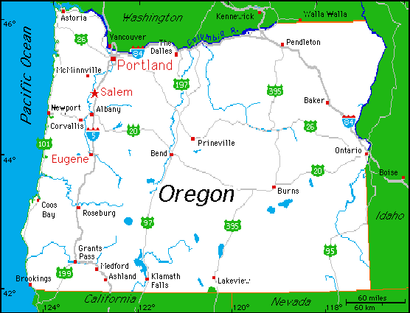
.3”
.36”
.07”
.1”
.05”
.20”
.20”

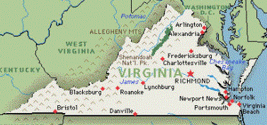
.03”
.22”
.14”
.24”
.21”
.25”
.03”
.01”
.09”
.07”

