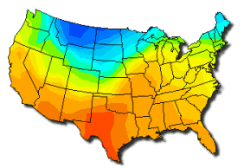
Meteorology Madness

Michigan City, IN-Students at Barker Middle School are experiencing meteorology madness in their science and math classes this quarter. Science teacher Bruce Starek and math teacher Jane Medley are investigating with their students the many weather phenomenon experienced in the Mid-West. These two experienced middle school teachers created this interdisciplinary unit after their students presented them with some good questions. Mr. Starek stated recently, “They asked how the local weather forecasters knew a snowstorm was on the way. As I did more investigating on weather forecasting, I realized it was a natural fit with math.”

Typical weather map of the United Sates
The students have learned a great deal about weather forecasting. They have read a number of books, visited websites, watched the Weather Channel, and interviewed a local meteorologist. Jalica Brown, a sixth grader commented, “It’s so great to be able to learn something in school that is about real life.”
Nicole Brown, a meteorologist from Channel 16 in South Bend, came to the class. She explained what she does to create a forecast. “We read a variety of instruments, look at different weather patterns throughout the country, and use some weather models to create a forecast.” There are five different weather models that are widely accepted and used by meteorologists. Different forecasts can be generated depending on which model is used. It is not an exact science, but an educated guess. Many meteorologists often will use more than one model and then share their different findings as they make their forecasts. “It now makes sense why sometimes the forecaster says that the weather will be one way for one model and another way for a different model,” noted Tanisha Williams.
One of the main points that the students have learned is that even using the right model and having accurate information from the instruments will not always mean the prediction is 100% accurate. Weather is something that can change quickly and unexpectedly.
The students have learned about the wide variety of weather instruments, and what these tell the meteorologist. They have also made these instruments and set up their own weather station at the school. Each day a set of students will read the instruments and check each other’s readings. They then use their readings to create tables, charts, and maps. Students use this information to make weather forecasts, which are broadcast on the local cable channel. They also send their information to the weather team at Channel 16. They will often use this in their nightly reports. In fact, this project has inspired other teachers to do similar units at their schools. Weather stations at local schools are popping up all over northern Indiana.

Meteorology Readiness Questions

Answer these questions after reading the article and studying the typical weather map of the United Sates provided in the article.

- What is meteorology?
- Why is the unit on meteorology a good fit between math and science?
- What do the different colors on the map represent?
- Approximately what temperature is it in the regions that are in the dark blue temperature band (in both Celsius and Fahrenheit)?
- Do the colored bands on the map tell what temperature it is in that region at 9 a.m., 12 p.m., and 5 p.m. that day?
- Is every place of the same color the exact same temperature?
- Approximately how much would the increase or decrease in the temperature be for a region that went from being in the bright yellow band today to being in the bright blue band tomorrow?
- What do you need to do to make a prediction?
- Why are weather predictions not always accurate?
- What things affect weather?

Meteorology Warm – Up Activity

Look at the 4 weather maps on the following page to answer the following question:

Question: Given the four weather maps provided, predict what the fifth day’s weather map will look like?

Weather Maps

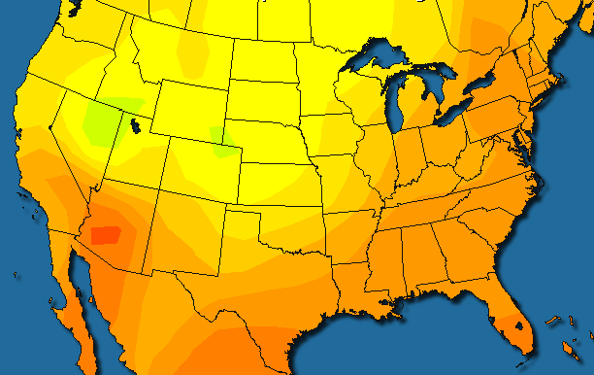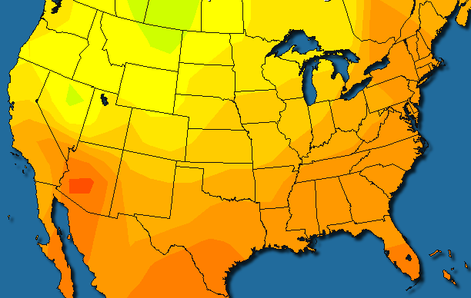

Day 1 Day 2

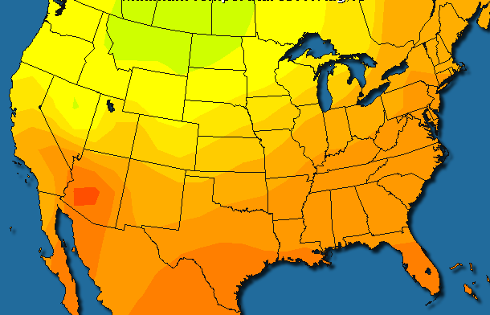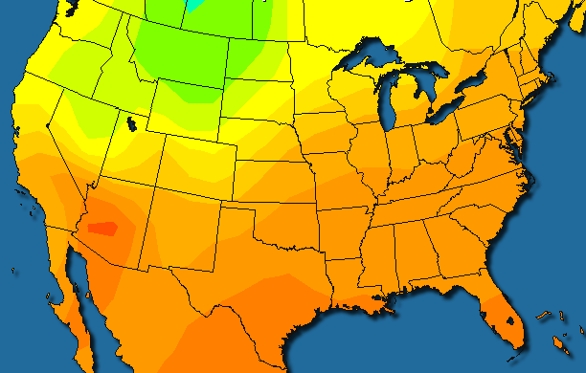

Day 3 Day 4

Weather Map Legend
Blank Map of the United States for Prediction

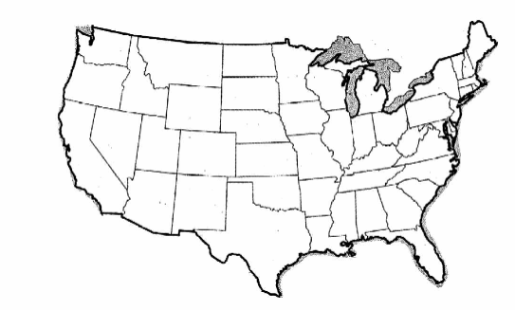

Meteorology Problem

Your class has been asked by a local meteorologist to help with the local weather forecasts. To be sure that you are ready to do this task, the meteorologist has given you a task. Correctly completing the task with a thorough explanation will help the meteorologist know you are able to help in weather forecasting.
Every team of students has been given the four weather maps provided for the warm – up activity. Each team has created a prediction for what the fifth day’s weather map will look like. Now, each team of students is to do three things. First, your team needs to decide which of the mustard yellow temperature bands on the predicted weather maps is the most accurate prediction of the mustard yellow temperature band on the real weather map for the fifth day. Second, determine which predicted weather map, overall, best predicted the real weather map for day 5. Use the prior 4 days’ weather maps to help you make these decisions. Third, you need to write a detailed explanation for why the predicted weather map is the most accurate weather map. The meteorologist will use these explanations to make a decision about which students will help with weather predictions.
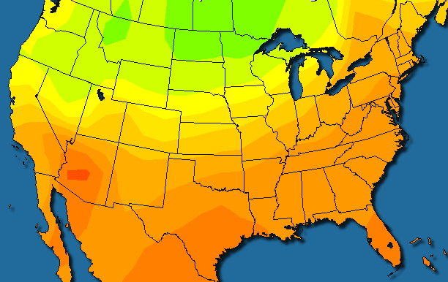

Day 5

