The ‘crack’ of the bat rings throughout Central Indiana town and across fields during summer evenings

GASBURG, Ind. — Summer is underway which means only one thing to the people in the town of Gasburg: softball season has arrived.
For many children in this Central Indiana town, softball is an annual tradition where players learn about competition, friendship and establish many fond memories.
But some parents are trying to make changes to the Gasburg Town Summer League, which has basically remained unchanged since the league was founded in 1946.
The main change that parents want is equal competition between the teams. And they want it now.
This season — like seasons past — one team will most likely run away with the league title. Each year, one coach seems to get the best players in the town to be on the same team, which demolishes the competition.
“Last year the Rib Shack won all of their games. Their closest win was a 10-3 win,” said Kelsey Emonds. Emonds, a four-year veteran outfielder in the league, will compete in her final season before moving on to play softball in high school next year. “It’s kind of sad. One part of me wants to play at this park forever and another part of me wants to move on to high school softball this season because I am tired of the unfair teams."
During her four years in the league, Emonds was on a team that breezed through the competition and then re-assigned the next year to a team that “was the joke of the league,” said Emonds.
“I remember for the first three years, I was on a team with the neighborhood girls and we all played softball competitively,” said Emonds. “Then I was placed on this new team which had players that couldn’t play very well. It was a really bad year.”
The team only won one game all season long in the 25-game season. “I just hope we have a better year. It’s my last year and I want to go out with a better record and have a chance at winning a championship.”
Mike Browning, league president, has expressed a concern about how teams are chosen and is trying to establish a new method of dividing interested players into fair teams.
“Attendance has dropped a lot,” said Browning. “It’s really not asking much to want to see a game in which the two teams are actually competing against one another.”
Some changes might be coming in the way teams are assigned. Every spring, the league holds tryouts and practice games before the season starts. At the tryouts, players are tested in three different events: batting, throwing, and base running.
Each player will get 10 at-bats at the tryouts. Players will be timed running from first base to second base three times and will have five chances to throw from centerfield after catching a ball.
If Browning and other parents have their way, the current system of having coaches pick the players would be abolished and the league would assign the players every year.
“The softball league hasn’t changed much in over 50 years,” said Browning. “If we don’t make changes now, people will be so turned off to softball that we won’t exist in another 10 years.”

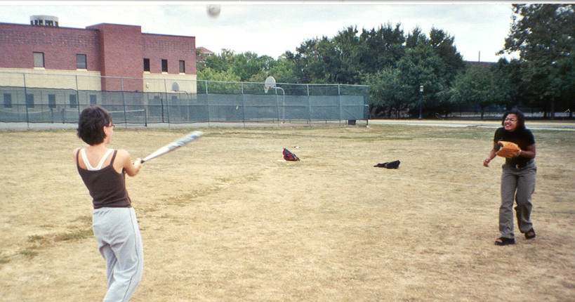
It could be, it might be, it is: Megan Thom (batting) practices her swing against her friend Yves Lynem during practice for the town softball league.

Get into the swing of things this season at Lesh’s Sporting Goods.
The competition won’t like it, but you’ll be glad you did.


Lesh’s Sporting Goods
990 Indiana St. West Lafayette

Warm-up Questions

Answer the following questions after reviewing the article and the data.

- Why are people (parents, coaches, and players) upset with the current system?

- Who is Mike Browning?

- Who threw the farthest of all the participants?

- Who ran the fastest of all the participants?

- Who was the best hitter? Why?

6. Who is the best player? Why?

Comments by coaches:

Tisha: She has great fielding skills. She is very easy to work with.

Kim: Very fast athlete. She can get around the bases quickly and to balls quickly. She has gotten along well with teammates in the past.

Sally: No comments available.

Barb: She has a very strong arm and she is capable of playing several positions in a game.

Melissa: Fields exceptionally well. Her batting was improved near the end of the year.

Charlene: She’s very mature for her age. When her coordination catches up with her age, she could be quite good.

Cynthia: Does many things well.

Rebecca: She knows the most about the game as anyone I’ve coached. Her father played college baseball.

Margaret: She misses practice often. Perhaps her parents made her play this sport and she didn’t want to play.

Beth: She’s a very good offensive weapon and she plays well in the outfield.

Mary Pat: She does many things well.

Kathy: She has a great throwing arm. This was the first year she ever played.

Esther: No Comments available.

Kelly: She helps the other athletes well. She helps the younger athletes.

Picking Softball Teams

Mike Browning, league softball president, is looking for a solution to solve his softball team selection problem. He wants to use the information from the tryouts and scrimmages to divide the players into fair teams.
Use the table and coaches comments to divide the given sample of 15 girls into 3 teams. Mr. Browning expects at least 80 girls to play softball this summer and he needs a system to pick teams fairly. Write a letter explaining your system so that he can use it this summer (and every summer) to divide all of the players into fair teams.

Person | Throw  in ft. |  | Batting |  |  |  | Run in seconds
Tisha | 81  79  69 | 65  61 | Double  Single  Pop-fly | Single  Pop fly  Pop- fly | Single  Pop fly | Pop-fly  Single | 7.2  6.9  6.9
Kim | 67  66  66 | 61  59 | Pop-fly  Pop-fly  Triple | Pop-fly  Pop-fly  Ground out | Pop-fly  Triple | Home run  Double | 5.1  5.3  5.1
Sally | 83  80  80 | 75  82 | Home run  Single  Pop-fly | Ground out  Double  Pop-fly | Pop-fly  Ground-out | Pop-fly  Double | 5.9  6.  6.2
Barb | 97  98  91 | 89  90 | Triple  Ground-out  Single | Ground-out  Ground-out  Pop-fly | Pop-fly  Single | Pop-fly  Pop-fly | 6.4  6.3  6.3
Melissa | 98  90  84 | 88  86 | Pop-fly  Double  Pop-fly | Home run  Ground-out  Pop-fly | Single  Pop-fly | Double  Ground-out | 6.3  6.5  6.7
Charlene | 86  83  65 | 77  80 | Single  Double  Strike-out | Strike out  Ground out  Pop-fly | Pop-fly  Pop-fly | Ground-out  Pop-fly | 6.5  7.1  6.5
Cynthia | 72  72  71 | 72  69 | Strike out  Ground-out  Strike-out | Pop-fly  Strike-out  Pop-fly | Strike-out  Double | Double  Strike-out | 6.9  6.1  6.4
Rebecca | 49  52  56 | 56  54 | Strike-out  Strike-out  Ground-out | Strike-out  Pop-fly  Double | Single  Double | Strike-out  Single | 5.5  5.7  5.6
Beth | 61  61  57 | 54  59 | Single  Double  Strike-out | Pop-fly  Triple  Ground-out | Ground-out  Single | Pop-fly  Home-run | 5.9  6.0  5.9
Mary Pat | 53  57  52 | 50  37 | Strike-out  Pop-fly  Pop-fly | Strike-out  Double  Pop-fly | Pop-fly  Single | Triple  Single | 6.5  6.2  6.4
Kathy | 98  97  99 | 90  92 | Strike-out  Single  Single | Pop-fly  Pop-fly  Pop-fly | Double  Pop-fly | Strike-out  Pop-fly | 5.6  5.9  5.4
Esther | 90  90  86 | 87  85 | Strike-out  Strike-out  Pop-fly | Strike-out  Double  Pop-fly | Single  Single | Pop-fly  Double | 6.1  6.4  6.2
Kelly | 80  79  77 | 80  82 | Home-run  Strike-out  Strike-out | Strike-out  Double  Triple | Home-run  Strike-out | Pop-fly  Pop-fly | 5.2  5.1  4.9

