Webex, Kaltura, Camtasia options for creating and presenting content

Live online teaching, help sessions, or office hours with WebEx Meetings………….2

Live online teaching and lectures with WebEx Training……………………………….5

Recording on campus using Video Express rooms……………………………………….9

Record using PowerPoint…………………………………………………………….9

Record using Kaltura Personal Capture for BoilerCast………………………………….9

Record using Camtasia…………………………………………………………………..12

Uploading a Video to Mediaspace……………………………………………..……..12

Publishing your recording in Blackboard……………………………………………..13

Adjusting Windows Audio Settings……………………………………………………14

Suggested Webcam………………………...………………………………………15

Note Taking app for tablets……………………………………………...…………15

Assistance with Brightspace……………………………………………...…………15

Purdue’s Teaching Remotely Resources

<https://www.purdue.edu/innovativelearning/teaching-remotely/>

Live online teaching, help sessions, or office hours with WebEx Meetings

Schedule your meeting

* Navigate to <https://purdue.webex.com>
* Click Log In at the upper right. Log in with BoilerKey
* If the menu at the top collapses, click on the ^ in the top center of the screen.
* Click the Webex meetings tab.
* Meetings have a limit of 1000 people when hosted by faculty or staff.
* If you are a TA and need more than 8 people to attend your Webex, request additional licenses at: <https://purdue.ca1.qualtrics.com/jfe/form/SV_0VqgWMFG08Pmy5n>

Image_8

* You can click the “My Personal Room” tab on the left to start a meeting that will always be available at the URL <https://purdue.webex.com/join/YOUR_USERNAME>. Anytime you join, this meeting will become active for others.

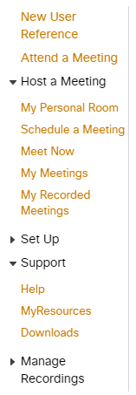

* Alternately, you can schedule a meeting by clicking the Schedule a meeting link and filling out the required information. We recommend setting a meeting password that is easier to type than the one generated by the system.

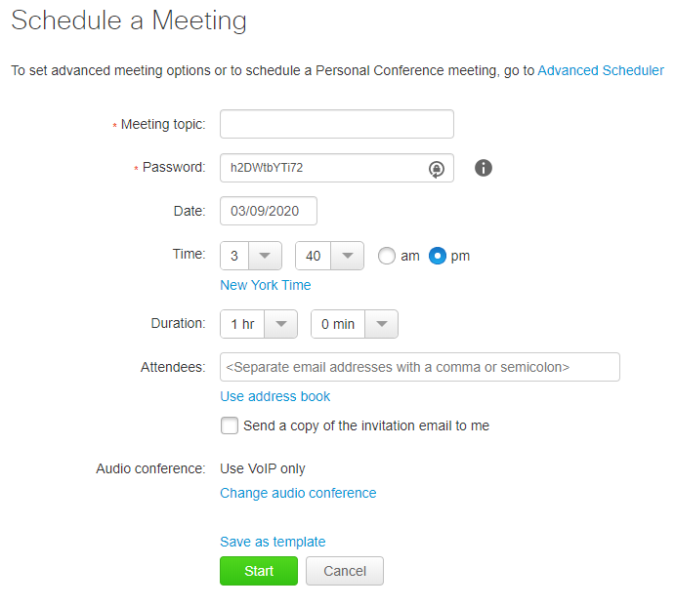

* The meeting will automatically start 5 minutes before the scheduled time.
* Once your meeting is scheduled, you will receive a confirmation email and an invite you can forward along to your class.

Join your meeting

* At the appropriate time, log in at <https://purdue.webex.com> and click the my meetings tab. Click the start or join button for the appropriate meeting.

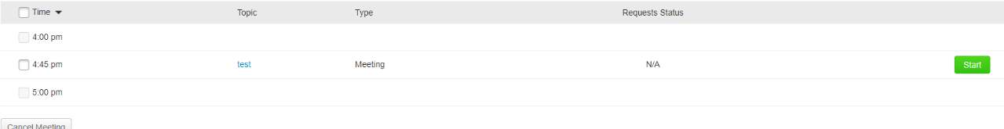

* Connect to audio and video. We suggest using your computer for the call, but a phone can be used if you have issues.

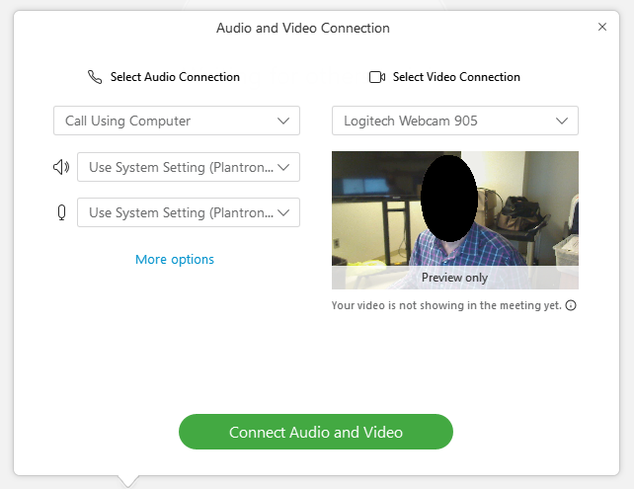

* *Recording your meeting* To start recording your presentation, click the record button located in the toolbar at the bottom of the screen.



* To share content, click the sharing icon at the bottom of the screen and share the appropriate screen. Note that Mac users may need to authorize screen recording within settings in order for screen sharing to work.

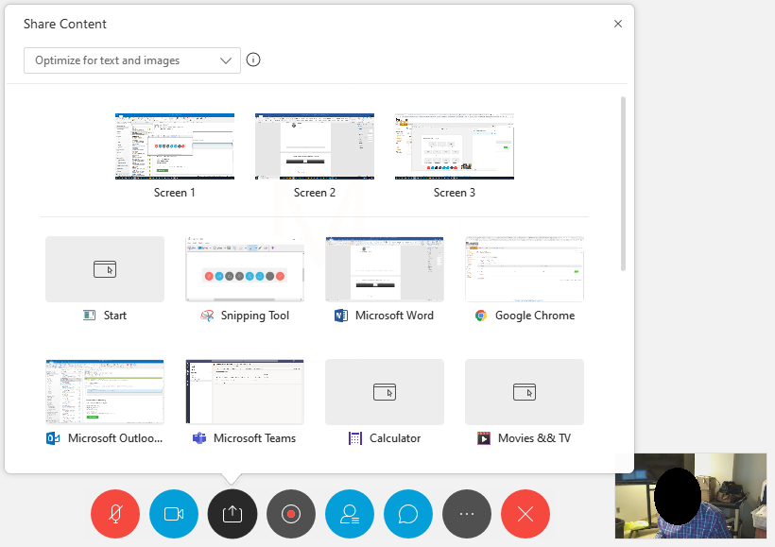

* If your lecture content requires whiteboard functionality, you can join with a separate device such as an iPad Pro or Surface tablet and use the whiteboard features built into Webex. You could also aim your webcam at a sheet of paper.

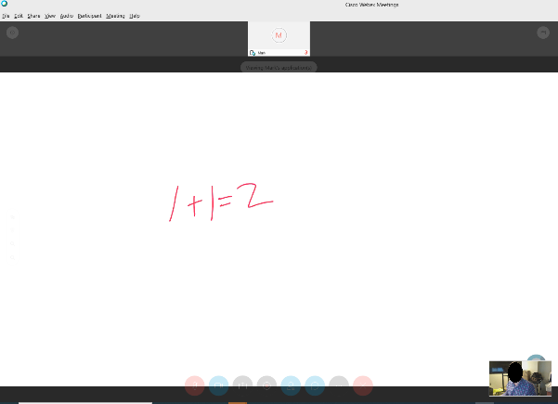

* When you’re done with your lecture, stop the recording, then leave the meeting. Your recording will be available in a few hours at <https://mediaspace.itap.purdue.edu>. It will also be available under your [media in Blackboard](#id.1ksv4uv).

Live online teaching and lectures with WebEx Training

* Webex Training is also available, and includes additional features like breakout sessions. Once you’ve logged into Webex, click Webex Training in the menu.

Image_24

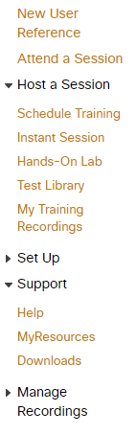

* You can start an instant session using the following instructions, or schedule a one-time or recurring session.

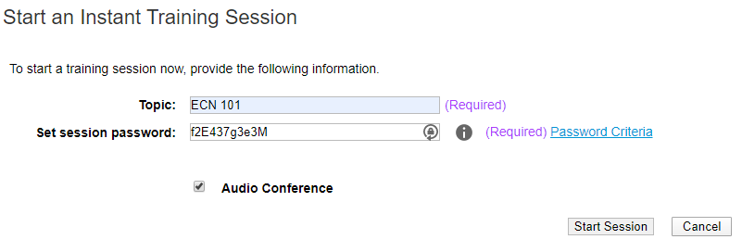

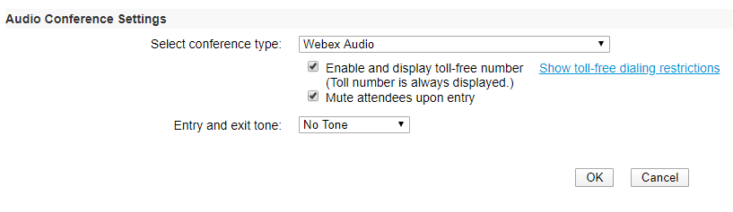

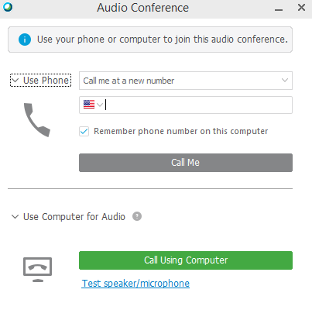

* In an instant session, click Invite and Remind to get the meeting URL.

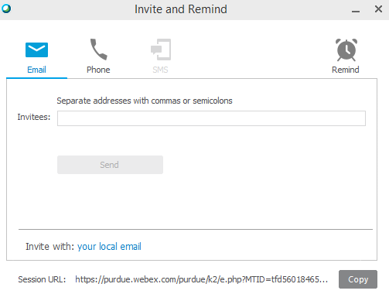

* Or, click on Session Info to find the training session number to share with the class.

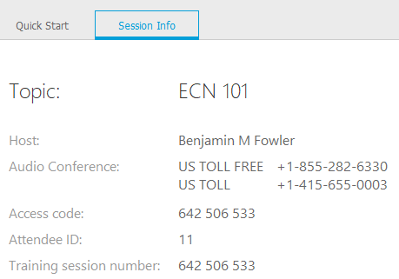

Join your meeting

* Students can join by logging into Webex, clicking Webex Training, and entering the session number that you provide to the class:

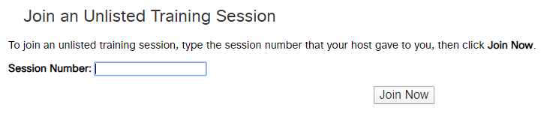

Pre-recording Lectures

Recording on campus using Video Express rooms

An overview of Purdue’s Video Express rooms along with scheduling information can be found at the video express website.

<https://videoexpress.purdue.edu/Portal/Login>

Record using PowerPoint

* Open your lecture slides and save them with a new name indicating that they have audio on them. Mycourse\_courseDate\_Audio.pptx. .  **IF YOU ARE USING A POWERPOINT FILE THAT IS OLDER AND WAS ORIGINALLY SAVED WITH THE .PPT EXTENSION, YOU MUST RE-SAVE THE FILE IN THE NEWER .PPTX FORMAT OR YOU WILL RISK LOSING YOUR AUDIO.**
* Make a quick test recording by selecting your first slide, clicking the slideshow tab, then click the dropdown under record slideshow and select to start recording from the beginning.
* Note: If Camtasia (see Page 7) is installed it can also be used to record audio to be used in Powerpoint.
* **TEST FIRST** on two or 3 slides. PowerPoint creates an audio file for each slide and puts a fade in between, so you will want to finish speaking about slide 1, change to slide 2, then start speaking about slide 2.
* Hit escape to stop your recording, move back to the first slide, turn up the volume on your computer, and click the slideshow button. You should hear your audio playing back. If you don’t, you may need to [adjust your audio settings](#id.2jxsxqh).
* When you’re ready to record, move back to the first slide and click the record slideshow button again. Record your lecture. If you make a mistake, you can press escape, move to the slide where you want to start recording, then click the dropdown to start recording from the current slide.
* Once you’re done recording, save your PowerPoint document.
* Click file>export then select “create a video”
* Select the internet quality option then click create video and save your video to your computer.
* Check your video, then [upload it to Mediaspace](#id.lnxbz9).

Record using Kaltura Personal Capture for BoilerCast

* Open a web browser and navigate to <https://mediaspace.itap.purdue.edu>
* In the upper right, click the icon where it says guest and select login from the dropdown. Image_16
* Once you’re logged in, click Image_20 and select Kaltura Capture. If Kaltura Capture is installed, you will be prompted to launch it. If it is not installed, you can download and install it from the links listed on the web page.
* Follow the installation instructions. Mac users note that upon first launch, you will need to open system preferences and give Kaltura Capture permission to record your screen.

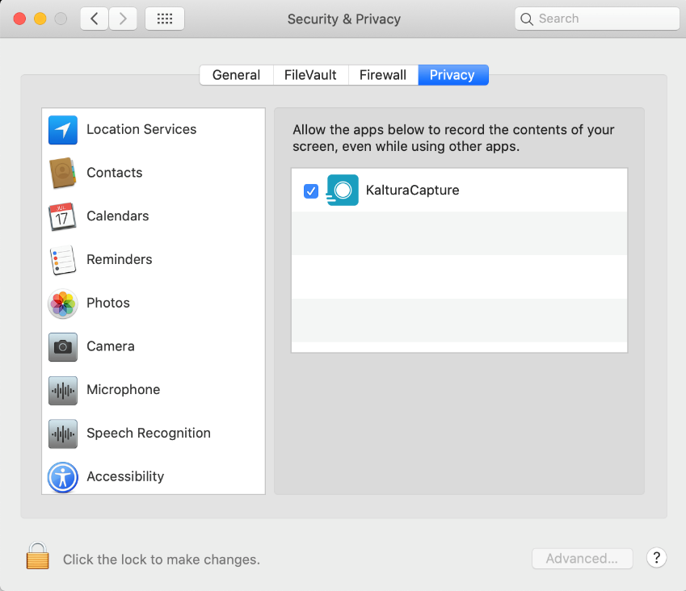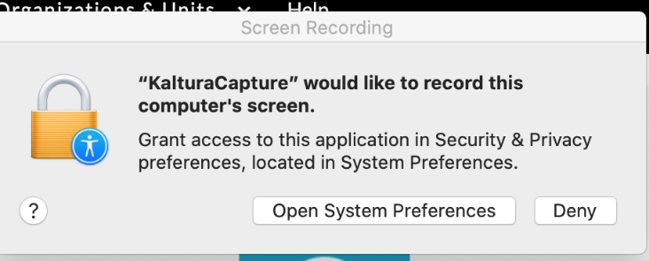

* Once Kaltura Capture is installed, click the Add New button again and select Kaltura Capture
* Select the sources you would like to record with Kaltura Capture. By default it will record webcam, desktop, and microphone. Click the record button to start recording.

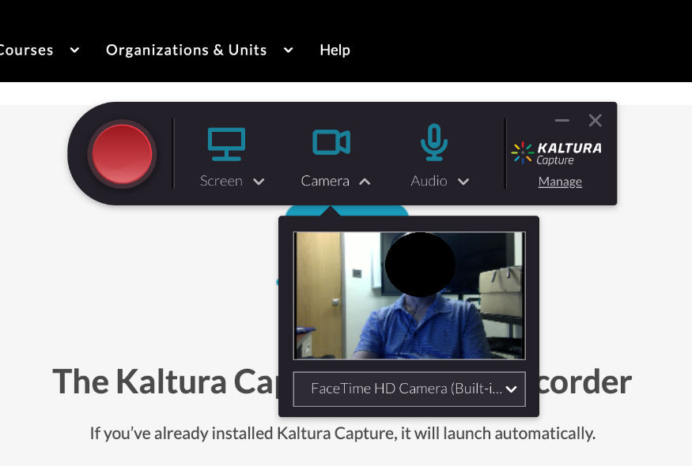

* Use the on screen controls to start, stop, and pause recording.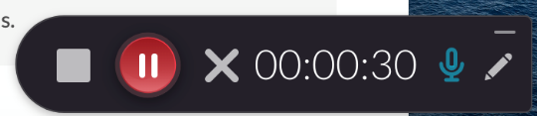
* Once you’re done recording, click the stop button, then title your recording and click the save and upload button to upload to MediaSpace. The new recording will show up under “My Media” in mediaspace.

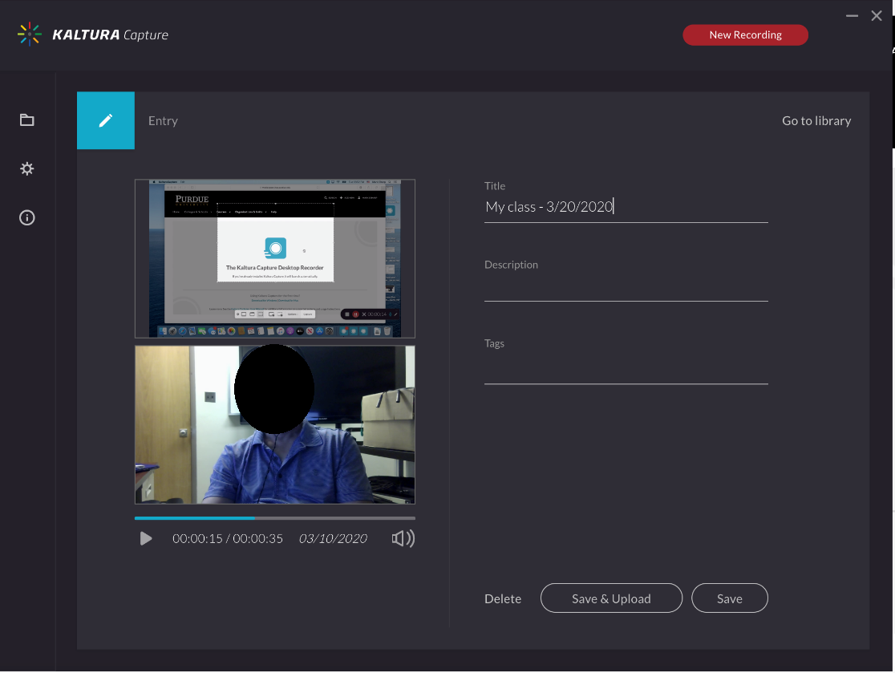

Record using Camtasia

Camtasia is screen recording and editing software available to Purdue faculty and staff. It is more full-featured than Kaltura Personal Capture, but is less integrated with Blackboard and BoilerCast. Once you have completed a recording with Camtasia, you will need to export it for the web, then upload it to MediaSpace. Basic through advanced tutorials are available on the Camtasia website at <https://www.techsmith.com/tutorial-camtasia.html>

Uploading your video to MediaSpace

MediaSpace is Purdue’s online video service. Videos uploaded to MediaSpace can be made available directly within BlackBoard.

*Logging in*

* Log in to MediaSpace at <https://mediaspace.itap.purdue.edu>. Click the Image_25 button in the upper right and select log in from the dropdown

*Uploading a video*

* Click the Image_26 button and select media upload from the dropdown.
* Drag the file you want to upload into the window.

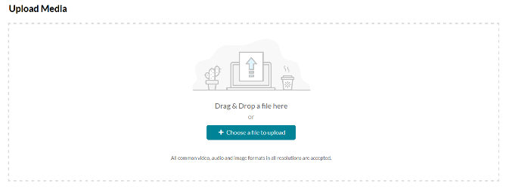

* Once your video has uploaded, it will take a little time for it to process into a video for online use. This amount of time will vary depending on the length of your video. You will see the gear icons while the video is processing.

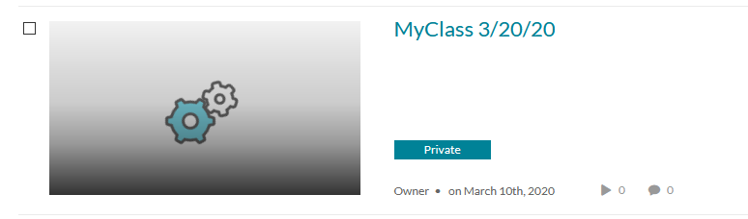

* Once the video is done processing, it will become available in the “My Media” section. To access “My Media”, click your name at the upper right and select “My Media”.

Publishing your recording in Blackboard

* Log into your course in Blackboard
* Click course content then click the Build Content dropdown and select Kaltura Media
* Select your recording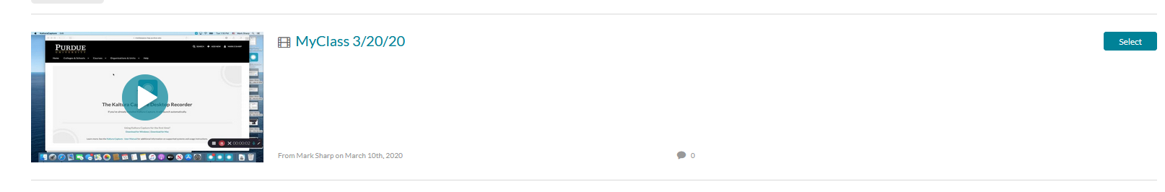
* Complete the required fields and click submit. Your new video will show up in your course content.

Adjusting your computer’s audio settings

Windows users:

Once your microphone (or webcam with microphone) is connected, go into control panel and select the hardware and sound option. The screenshot below is for Windows 10. If you’re using windows 7, you just need to go into control panel then select sound.

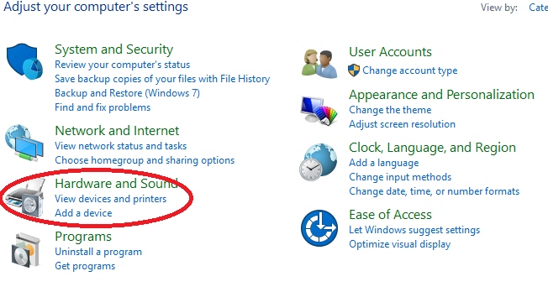

Within hardware and sound, click the option to manage your audio devices.

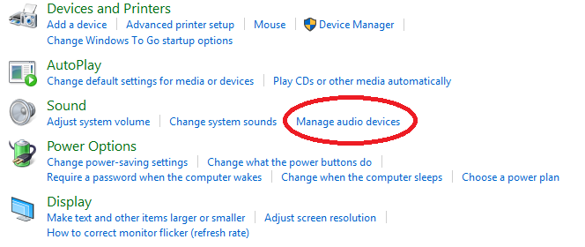

Look for the recording tab click on the microphone and make sure it is set to default device by clicking the set default button. If there is a green check mark over the microphone icon, it is already the default device.  When you talk into it, you should see the meter move.  The meter should respond each time you talk and should be peaking at about a mid-level. If it is pegged at the top or way down at the bottom, you’ll need to adjust your levels.  To adjust levels, click properties then click the levels tab and move the slider up or down.

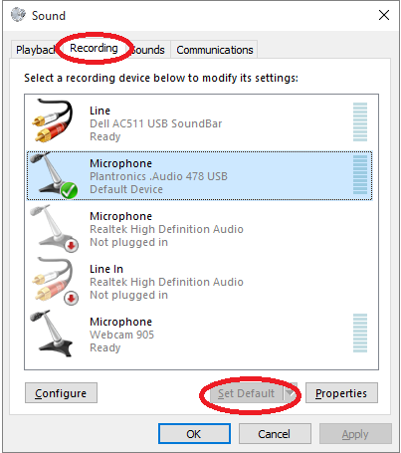

Suggested Webcam

Several options exist for recording audio as well as video. A webcam typically contains both a microphone and video camera. A headset with a built in microphone is also a great option. We recommend the following logitech webcam for your convenience.

Logitech c920s HD Pro - govconnection.com $65

Note taking app for tablets

Nebo is a note taking app for IOS, Android and Windows tablets that allows one to write and capture content on from touch screen input devices. <https://www.nebo.app/>

Assistance with Brightspace

ECN will be able to provide limited assistance with setting up a course in brightspace starting March 18th. TLT group that is part of the Purdue Learning Team should be your primary resource.