Group Overview

Zhejiang Geely Holding Group (ZGH), is a global automotive group based in the city of Hangzhou in south-east China’s Zhejiang Province. The group was established in 1986 and launched its automotive business in 1997.
ZGH consists of many well-known international automotive brands including Geely Auto, Lynk & Co, Volvo Cars, Polestar, PROTON, Lotus, London Electric Vehicle Company, Yuan Cheng Auto, and Terrafugia with global operations spanning the automotive value chain, from research, development and design to production, sales and servicing.
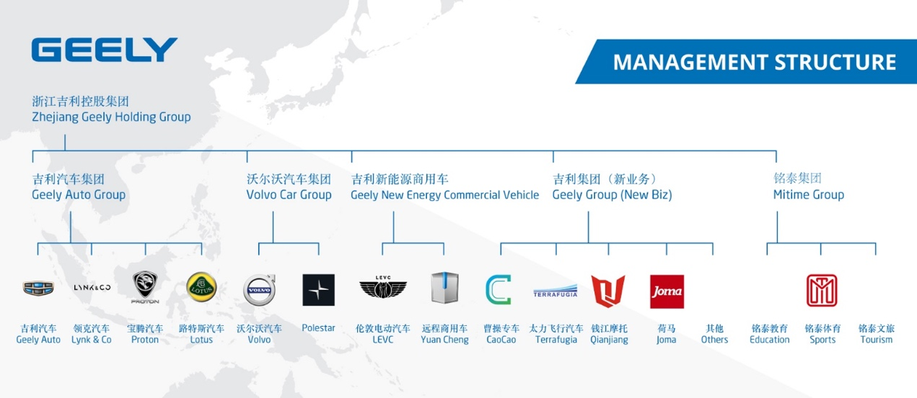
Zhejiang Geely Holding Group is devoted to becoming one of the top 10 world-leading automotive groups through “creating safe, environmentally-friendly and energy efficient automobiles.” Geely Holding Group shoulders the responsibility for setting the benchmark in China’s automotive industry, promoting a corporate culture of entrepreneurship, and showing others the value of scientific research and development. Geely Holding Group is committed to vigorously pushing the development of world-renowned automobile brands and providing high-quality products for multiple market segments in order to meet different levels of consumer demands.
The Group has over 80,000 employees, including 50,000 at Geely Auto, 31,000 at Volvo Cars, and 1,000 at the London Taxi Company. With total assets of over RMB100 billion, the company has been a member of the Fortune Global 500 for seven consecutive years.

Who are we looking for?

Year 2019 Graduates with Bachelor, Master, Doctor or above Degrees
Domestic Graduates from January, 2019 to December, 2019
Oversea Graduates from July, 2018 to December 2019

Recruitment Procedures

1.Online Application
2.Online Assessment
3.Career Talk
4.Interview
5.Offer
6.Induction

Positions

- 整车研发序列（R&D Category）

整车研发序列（Vehicle R&D）
动力研发序列（Dynamic R&D）
造型研发序列 （Auto Styling R&D）
商用车研发序列（Commercial Vehicle R&D）
零部件研发 （Auto Parts R&D）

专业 （Major）
Vehicle Engineering
Mechanical and Electrical Engineering
Engine
Electrical Engineering and Automation
New Energy
Mechanics
Optics
Material Formation and Control Engineering
Mold
Industrial Design
Sculpture
Artistic Design
Computer Science and etc.

- 生产制造类（Manufacture）

整车四大工艺制造序列 （Vehicle Manufacture Category）
动力及产业化制造序列 （Dynamic System Manufacture Category）

专业（Major）
Vehicle Engineering
Mechanical and Electrical Engineering
Engine
Metallic Materials Engineering
Electrical Engineering and Automation
Civil Engineering
Electrical Engineering
Chemistry
Environmental Engineering
Electronic and Information Engineering
Information Management
Computer Science
Industrial Engineering
Logistics Management
The measurement and control technology and instrument and etc.

- 职能服务类（Corporate Service Category）

HR and Administration Category (人力行政序列)
Finance and Legal Category （财务与法务序列）

专业 (Major)
Human Resource Management, Psychology, News Media, Communication, Financial Management, Accounting, Finance, Statistics, Law, Information Science and Technology and etc.

- 营销服务类（Marketing Category）

营销销售服务序列（Marketing and Sales Category）

专业（Major）
Marketing, Business Management, International Trade, Business Administration, Advertising, E-Commerce, News, Communication, Public Relations and etc.

- IT互联网类 （IT Category）
IT与互联网开发序列 （IT and Internet Development Category）

专业 （Major）

Computer Science and Technology，Software Engineering, Network Engineering, Statistical Analysis and etc.

- 供应链类 （Supply Chain Category）

Quality Control, Purchase and Supply Chain Category

专业 （Major）

Telecommunications, Electronics, Mechanics，Mathematics, Physics, Materials, Photoelectricity, Logistics Management，Industrial Engineering, Management science and Engineering and etc.

Career Fair in Purdue

Time: 14:00, Oct. 19th, 2018
Location: LWSN (Lawson Computer Science Building) B155

Interviews

Time: 4:00PM, Oct. 19th, 2018

Check-in Location : WALC (Wilmeth Active Learning Center )

