is the leading national on-demand car repair service

Top-rated expert mechanics perform car repair, maintenance, and diagnostics

Services at car owners’ homes and ofices 7 days a week

600+ services available,
7 days a week

Services backed by a 12-month / 12,000-mile warranty
Fast, free quotes available online or from the YourMechanic iPhone app
Nationwide network of top-tier parts suppliers provide high-quality parts

Available in the top 50+ U.S. metro areas
Launching new cities regularly
YourMechanic is funded by SoftBank Capital, Andreessen Horowitz,
Y Combinator, Ashton Kutcher, and others.

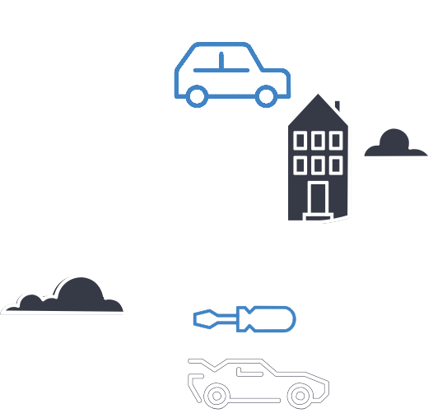Hundreds of mechanics nationwide
Tens of thousands of monthly customers

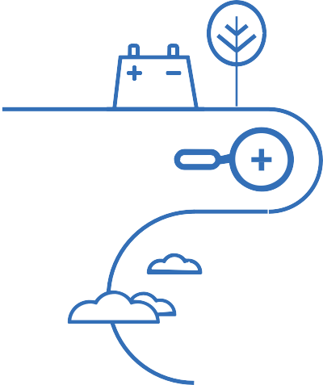Diagnostics:
Car won't start, squeaky brakes,
diffi steering, A/C isn't cold
Repairs &
Maintenance:
Oil changes, brake pads, belts, fluids, sensors, filters, heating & A/C
Support:
Pre-purchase car inspections

Headquarters:
Mountain View, California
Founded: 2012
Startup with $32 million in funding to date. Raised
$24 million series B in March 2016
Anthony Rodio
President & CEO
How to book services:
Download our iPhone app, request an estimate on our website, or call 1-800-701-6230
Media contact:
Lee Florida, Public Relations Manager at lflorida@yourmechanic.com or (650) 265-7138
Winner of
TechCrunch SF Disrupt 2012
Better Business
Bureau (BBB) A+ Rating
1,000+ Yelp
reviews (average rating of 4.2)
YourMechanic NPS
score: 87.9, from
20,000+ customer reviews (average auto service industry NPS score: 20)

Best-of-industry mechanics undergo extensive screening:
Rigorous interviews, background checks, hands-on evaluation of technical and customer service skills
Average 10+ years professional experience and Automotive Service Excellence (ASE) certification

