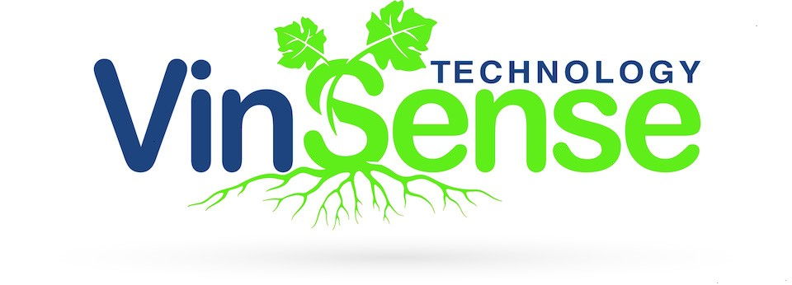

Seeking Software Engineer
VinSense is an agricultural technology start up that launched in 2015 from Purdue University. We are a software company and data integrator for the winegrape and perennial agriculture industry. We provide decision support to interactively visualize in-field data for vineyards through the eyes of our industry experts. Our product is an interactive cloud-based visual analysis interface dashboard that is based on proprietary analytics and functional soil mapping. Our technology empowers growers to improve their crop and wine quality, crop load and sustainability. We are seeking a motivated Software Engineer to work with our CTO and third party software development company to expand our web-based interface for our clients and improve our current code. This position will be a part-time and will grow to full time as the company expands. Creativity and the ability to create concise visualization of data are important, as well as an understanding or a willingness to learn about perennial agriculture.
This position will report to the CTO. If interested, please send resume to Dr. David Ebert at david.ebert@vinsense.net.

Software Engineer Responsibilities:

- Work with CTO, software development company, and the viticulture, enology and soil teams to improve and expand our web-based interface.

Software Engineer Requirements:
- Based in the California North Bay area or Indianapolis or West Lafayette, IN.
- Required skills:

Full stack .NET developer
  - ASP.NET MVC
  - ASP.Net Web API
  - LINQ
  - Database (SQL Server)
  - HTML, CSS, JavaScript, Razor
  - AngularJS
  - Bootstrap
- Desired skills
  - Responsive interface web development
  - Google maps API, OpenLayers
  - D3
  - GIS experience
  - IoT data integration
  - python
  - Materialize

VinSense, LLC
1281 Win Hentschel Blvd. West Lafayette, IN 47906 www.vinsense.net

