President Harry S. Truman Fellowship in National Security Science and Engineering

Seeking Applicants!
Sandia National Laboratories is seeking applicants for the President Harry S. Truman Fellowship (in National Security Science and Engineering). Candidates for this position are expected to have solved a major scientific or engineering problem in their thesis work or have provided a new approach or insight to a major problem, as evidenced by a recognized impact in their field.

The Fellowship provides the opportunity for new Ph.D. scientists and engineers to pursue independent research of their own choosing that supports Sandia’s national security mission. The appointee is expected to foster creativity and to stimulate exploration of forefront science and technology and high-risk, potentially high-value research and development.

Sandia’s research focus areas are: bioscience, computing and information science, engineering science, materials science, nanodevices and microsystems, radiation effects and high energy density physics, and geosciences. To learn more about additional R&D programs that support Sandia’s mission areas, please visit: sandia.gov/missions

The Truman Fellowship is a three-year appointment. The salary is $111,200 plus benefits and additional funding for the chosen proposal. The deadline is November 1 of each year and normally begins on October 1 the following year.

Requirements:

Candidates must meet the following requirements:

- Ability to obtain a DOE “Q” clearance

- Ph.D. (3.5 undergraduate and 3.7 graduate GPA preferred) awarded within the past three years at the time of application or completed Ph.D. requirements by commencement of appointment.
- Candidates must be seeking their first national laboratory appointment (no previous postdoctoral appointments at a national laboratory).
For more information, visit:

http://sandia.gov/careers/students_postdocs/fellowships/truman_fellowship.html
VISION
On behalf of our nation, we anticipate and solve the most challenging problems that threaten security in the 21st century.

MISSION
The synergy and interdependence between our nuclear deterrence mission and broader national security missions forge a robust capability base and empower us to solve complex national security problems.

VALUES
Sandia’s five core values inform our daily decisions, shape our performance, and enable us to achieve success as one lab.

We serve the nation

- We team to deliver with excellence
- We respect each other

- We act with integrity

- We live safe and healthy lives

Apply online: sandia.gov/careers Click on “View all Jobs”
Search “Truman Fellowship” or Job ID: 653576

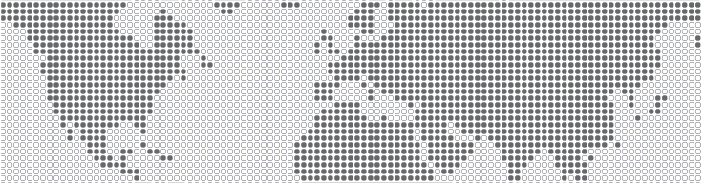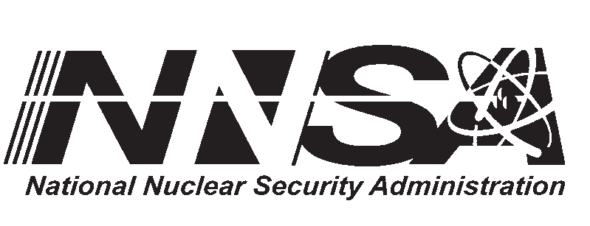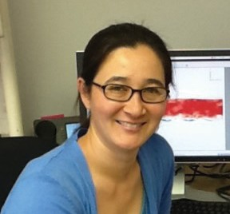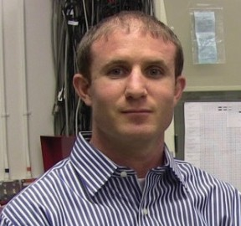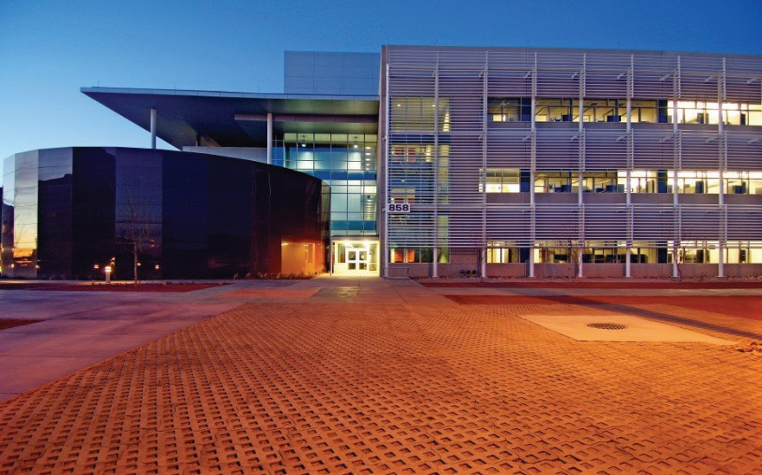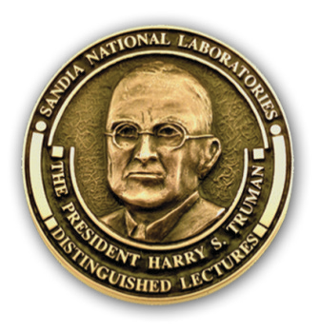

Equal opportunity employer/Disability/Vet/GLBT 05/2016
Sandia National Laboratories is a multiple-program laboratory managed and operated by Sandia Corporation, a wholly owned subsidiary of Lockheed Martin Corporation for the U.S. Department of Energy’s National Security Administration under contract DE-AC04-94AL85000. SAND2015-4263M

