L I B R A R I E S

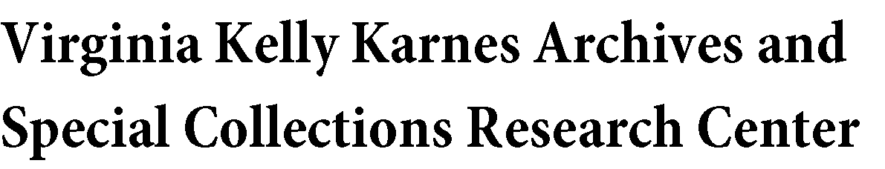

Position Announcement: Digital Archivist Graduate Assistant, Purdue University Archives and Special Collections

About the Position: Purdue University Archives and Special Collections (ASC) and Purdue University Libraries seek a half-time administrative/professional graduate assistant (50.00 CUL) to aid in improvements to collection organization, description, and access. The graduate assistant will be work with the digital archivist to migrate descriptive information to a new content management system, ArchivesSpace. Under the direction of the digital archivist, migration activities will include data clean up, documentation, and coordination of data entry processes. This position will concurrently organize and restructure digitized and born-digital collection materials as needed (80%). In addition, the graduate assistant will be responsible for creation of content for social media platforms (20%).

Responsibilities: Adhering to ASC policies and procedures, the graduate assistant will be trained to arrange, preserve, and describe archival materials in all formats. In addition, the successful candidate will be trained to utilize best archival practices for digital preservation and will create corresponding metadata to provide effective content description, interoperability, sustainability, and access. The digital archivist graduate assistant will document local best practices for use of ArchivesSpace (www.archivesspace.org) moving forward. The position will also include planning content for online posting on the Archives Twitter (@purduearchives) and Instagram (@purduearchives) accounts in accordance with the ASC social media strategic plan.

Qualifications: Interest in working with library and archival materials; interest in data description and preservation tools; knowledge of SQL and database management; demonstrated ability to understand and learn programming languages; experience using Microsoft Word and Excel; demonstrated ability to communicate effectively, both orally and in writing; excellent organizational skills; commitment to accuracy and attention to detail; desire to provide quality customer service; ability to work independently as well as collaboratively; ability to work efficiently to meet project goals and deadlines; ability to lift material which may weigh up to 40 pounds.
To apply, please submit a cover letter and resume by August 17th, 2015 to: Neal Harmeyer, Digital Archivist
Purdue Archives and Special Collections 504 West State Street
West Lafayette, IN 47906

Email (preferred): harmeyna@purdue.edu

Campus mail: Department: SPEC, Building: STEW

Purdue University Libraries SPEC • 504 W. State Street • West Lafayette, IN 47907-2058 Phone: 765-494-2839 • Fax: 765-494-2810 • spcoll@purdue.edu

