How to Apply

APPLY FOR AN ON-CAMPUS INTERVIEW
Please visit your Career Center’s online recruiting system AND the Laboratory’s website: www.ll.mit.edu/college/oncampus.html
Follow us on Facebook, LinkedIn, and Twitter

SEARCH JOB LISTINGS
http://www.ll.mit.edu/employment/

Due to the unique nature of our work, we require U.S. citizenship.
MIT Lincoln Laboratory’s fundamental mission is to apply science and advanced technology to critical problems of national security. MIT Lincoln Laboratory is an Equal Opportunity Employer and does not discriminate on the basis of race, color, religion, sex, national origin, veteran status, or disability.

MIT Lincoln Laboratory

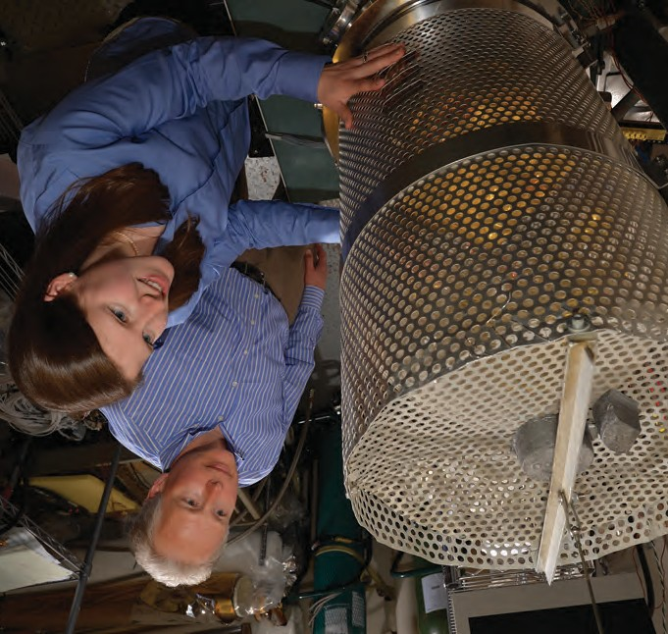

This work is sponsored by the Air Force under Air Force Contract FA8721-05-C-0002. Opinions, interpretations, conclusions, and recommendations are those of the author and are not necessarily endorsed by the United States Government.

ABOUT THE
Technical Seminars Available to University Groups

LABORATORY

MIT Lincoln Laboratory applies advanced technology to problems critical to national secu- rity. Behind the solutions are researchers with exceptional technical abilities and creativity working in cross- disciplinary collabora- tions to develop systems from the initial concept, through research and analysis, to design and prototyping, and finally to real-world applications.

Lincoln Laboratory is distinguished by its capabilities in rapid prototyping, supported by unique facilities such as its state-of-the-art, 70,000 sq ft semicon- ductor research and fabrication laboratory.
Members of the technical staff at MIT Lincoln Laboratory are pleased to present these technical seminars to interested college and university groups. Costs related to the staff member’s visit for these seminars will be assumed by Lincoln Laboratory.

AIR TRAFFIC CONTROL
■■ Experiences from Modeling and Exploiting Data in Air Traffic Control
■■ Integrating Unmanned Aircraft Systems Safely into the National Airspace System
■■ Radar Detection of Aviation Weather Hazards
■■ System Design in an Uncertain World: Decision Support for Mitigating Thunderstorm Impacts on Air Traffic Control

COMMUNICATION SYSTEMS
■■ Building a High-Capability Internet Protocol Airborne Backbone with Disparate Radio Technologies
■■ Cooperative Communication in Heterogeneous Wireless Networks
■■ Diversity in Air-to-Ground Lasercom: The Focal Demonstration
■■ Dynamic Link Adaptation for Satellite Communications
■■ Future Directions in Communication Systems
■■ High-Rate Laser Communications to the Moon and Back
■■ Implementation Considerations for Wideband Wireless Communications
■■ Providing Information Security with Quantum Physics— A Practical Engineering Perspective
■■ Real-Time Modeling of Wireless Networks Through Emulation

Seminar abstracts and instructions for arranging a seminar can be found online at www.ll.mit.edu/college/techseminars.html

CYBER SECURITY
■■ Addressing the Challenges of Big Data Through Innovative Technologies
■■ Content-Centric Networking for Mobile Devices
■■ Cross-Language Illness Tracking via Tweets
■■ Cyber Security Metrics
■■ Developing and Evaluating Link-Prediction Algorithms for Speaker Content Graphs
■■ Efficient, Privacy-Preserving Data Sharing
■■ EMBER: A Global Perspective on Extreme Malicious Behavior
■■ Evaluating Cyber Moving Target Techniques
■■ Experiences in Cyber Security Education: The MIT Lincoln Laboratory Capture-the-Flag Exercise
■■ Multicore Programming in pMatlab ® Using Distributed Arrays
■■ Natural Language Learning Research and Development
■■ New Approaches for Automatic Speaker Recognition and Forensic Considerations
■■ Securing Data at Rest with Optical Physically Unclonable Functions
■■ Signal Processing for the Measurement of Characteristic Voice Quality
■■ The Probabilistic Provenance Graph

■■ Robust Multi-user Wireless Communications

SOLID-STATE DEVICES, MATERIALS, AND PROCESSES

QUICK FACTS

MIT Lincoln Laboratory is a Department of Defense federally funded research and development center, established in 1951.

■■ Waveform Design for Airborne Networks
■■ Worth a Thousand Bits: Visualization of Communication Network Data

HOMELAND PROTECTION
■■ Disease Modeling to Assess Outbreak Detection and Response

OPTICAL PROPAGATION AND TECHNOLOGY

■■ Chemical Aerosol Characterization by Single-Particle Infrared Elastic Scattering
■■ Dynamic Photoacoustic Spectroscopy for Trace Gas Detection
■■ Fully Depleted Silicon-on-Insulator Process Technology for Subthreshold-Operation Ultra-Low-Power Electronics
■■ Geiger-Mode Avalanche Photodiode Arrays for Imaging and Sensing

■■ Mechanical Systems Engineering of Optical Sensors
■■ Hardware Phenomenological Effects on Co-Channel Full-
Duplex MIMO Relay Performance

PERSONNEL
3,685; approximately
1,721 are professional technical staff

FACILITY PROFILE
■■ 28 buildings and structures—
a total area of
2.1 million sq ft
■■ Located on 3 Massachusetts sites—main facility in Lexington; flight and antenna test facility on Hanscom Air Force Base in Bedford; Millstone Hill radar complex in Westford
■■ 3 field sites world- wide and 8 field offices nationwide

RADAR AND SIGNAL PROCESSING
■■ Adaptive Array Detection
■■ Adaptive Array Estimation
■■ Bioinspired Resource Management for Multiple-Sensor Target Tracking Systems
■■ Parameter Bounds Under Misspecified Models
■■ Polynomial Rooting Techniques for Adaptive Array Direction Finding
■■ Radar Signal Distortion and Compensation with Transionospheric Propagation Paths
■■ Synthetic Aperture Radar

SPACE CONTROL TECHNOLOGY
■■ New Techniques for High-Resolution Atmospheric Sounding
■■ Predicting and Avoiding Close Approaches and Potential Collisions in Geosynchronous Orbits

SYSTEMS AND ARCHITECTURES
■■ Choices, Choices, Choices (Decisions, Decisions, Decisions)
■■ Integrated Optics in Silicon
■■ Metamaterials and Plasmonics Research at MIT Lincoln Laboratory
■■ Microfluidics at MIT Lincoln Laboratory
■■ Optical Sampling for High-Speed, High-Resolution Analog-to-Digital Conversion
■■ Pan-STARRS: Gigapixel Astronomy with Atmospheric Distortion Correction
■■ Quantum Information Science with Superconducting Artificial Atoms
■■ Slab-Coupled Optical Waveguide Devices and Their Applications
■■ Submicrosecond to Subnanosecond Snapshot Imaging Technology
■■ Subthreshold Design of FPGAs for Minimum-Energy Operation
■■ Three-Dimensional Integration Technology for Advanced Focal Planes and Integrated Circuits
■■ Toward Large-Scale Trapped-Ion Quantum Processing
■■ Ultrasensitive Mass Spectrometry Development at MIT Lincoln Laboratory

