INTERNSHIP CATEGORIES

INL internships, like its research, span a wide range of science, technology, engineering and math (STEM) fields and other important disciplines. INL is currently looking for exceptional interns in the following areas

ADVANCED MANUFACTURING TECHNOLOGY
Applicable areas of study: Systems Engineering, Materials Engineering, Biology, Chemical Engineering, Analytical Chemistry, Mechanical Engineering, Electrical Engineering

ADVANCED TRANSPORTATION TECHNOLOGY
Applicable areas of study: Electrical Engineering, Mechanical Engineering,
Chemistry, Biology, Chemical Engi- neering, Energy Engineering

BUSINESS, OPERATIONS AND ADMINISTRATION FUNCTIONS*
Applicable areas of study: Accounting, Finance, HR, Law, Audit, Business Management, Information Technol- ogy, Communications, Liberal Arts

CLEAN ENERGY TECHNOLOGY, INTEGRATION AND ENVIRONMENTAL SUSTAINABILITY
Applicable areas of study: Nuclear Engineering, Renewable Energy, Intelligent Systems Engineering, Hybrid Energy, Economic Analysis, Geology, Environmental Engineering, Anthropology, Ecology, Earth and Life
Sciences, Materials Science, Chemistry, Biology, Industrial/Systems Engineering, Manufacturing Engineering, Mechanical Engineering, Electrical Engineering

CRITICAL INFRASTRUCTURE PROTECTION (ELECTRICAL GRID AND WIRELESS TECHNOLOGIES)
Applicable areas of study: Physical and Cyber Security, Electrical Engi- neering, Mechanical Engineering, Computer Science for Resilience, Industrial Control Systems, Critical Infrastructure, Cryptography, Signal Propagation, Vulnerabilities

CYBER SECURITY*
Applicable areas of study: Electrical Engineering, Computer Science for

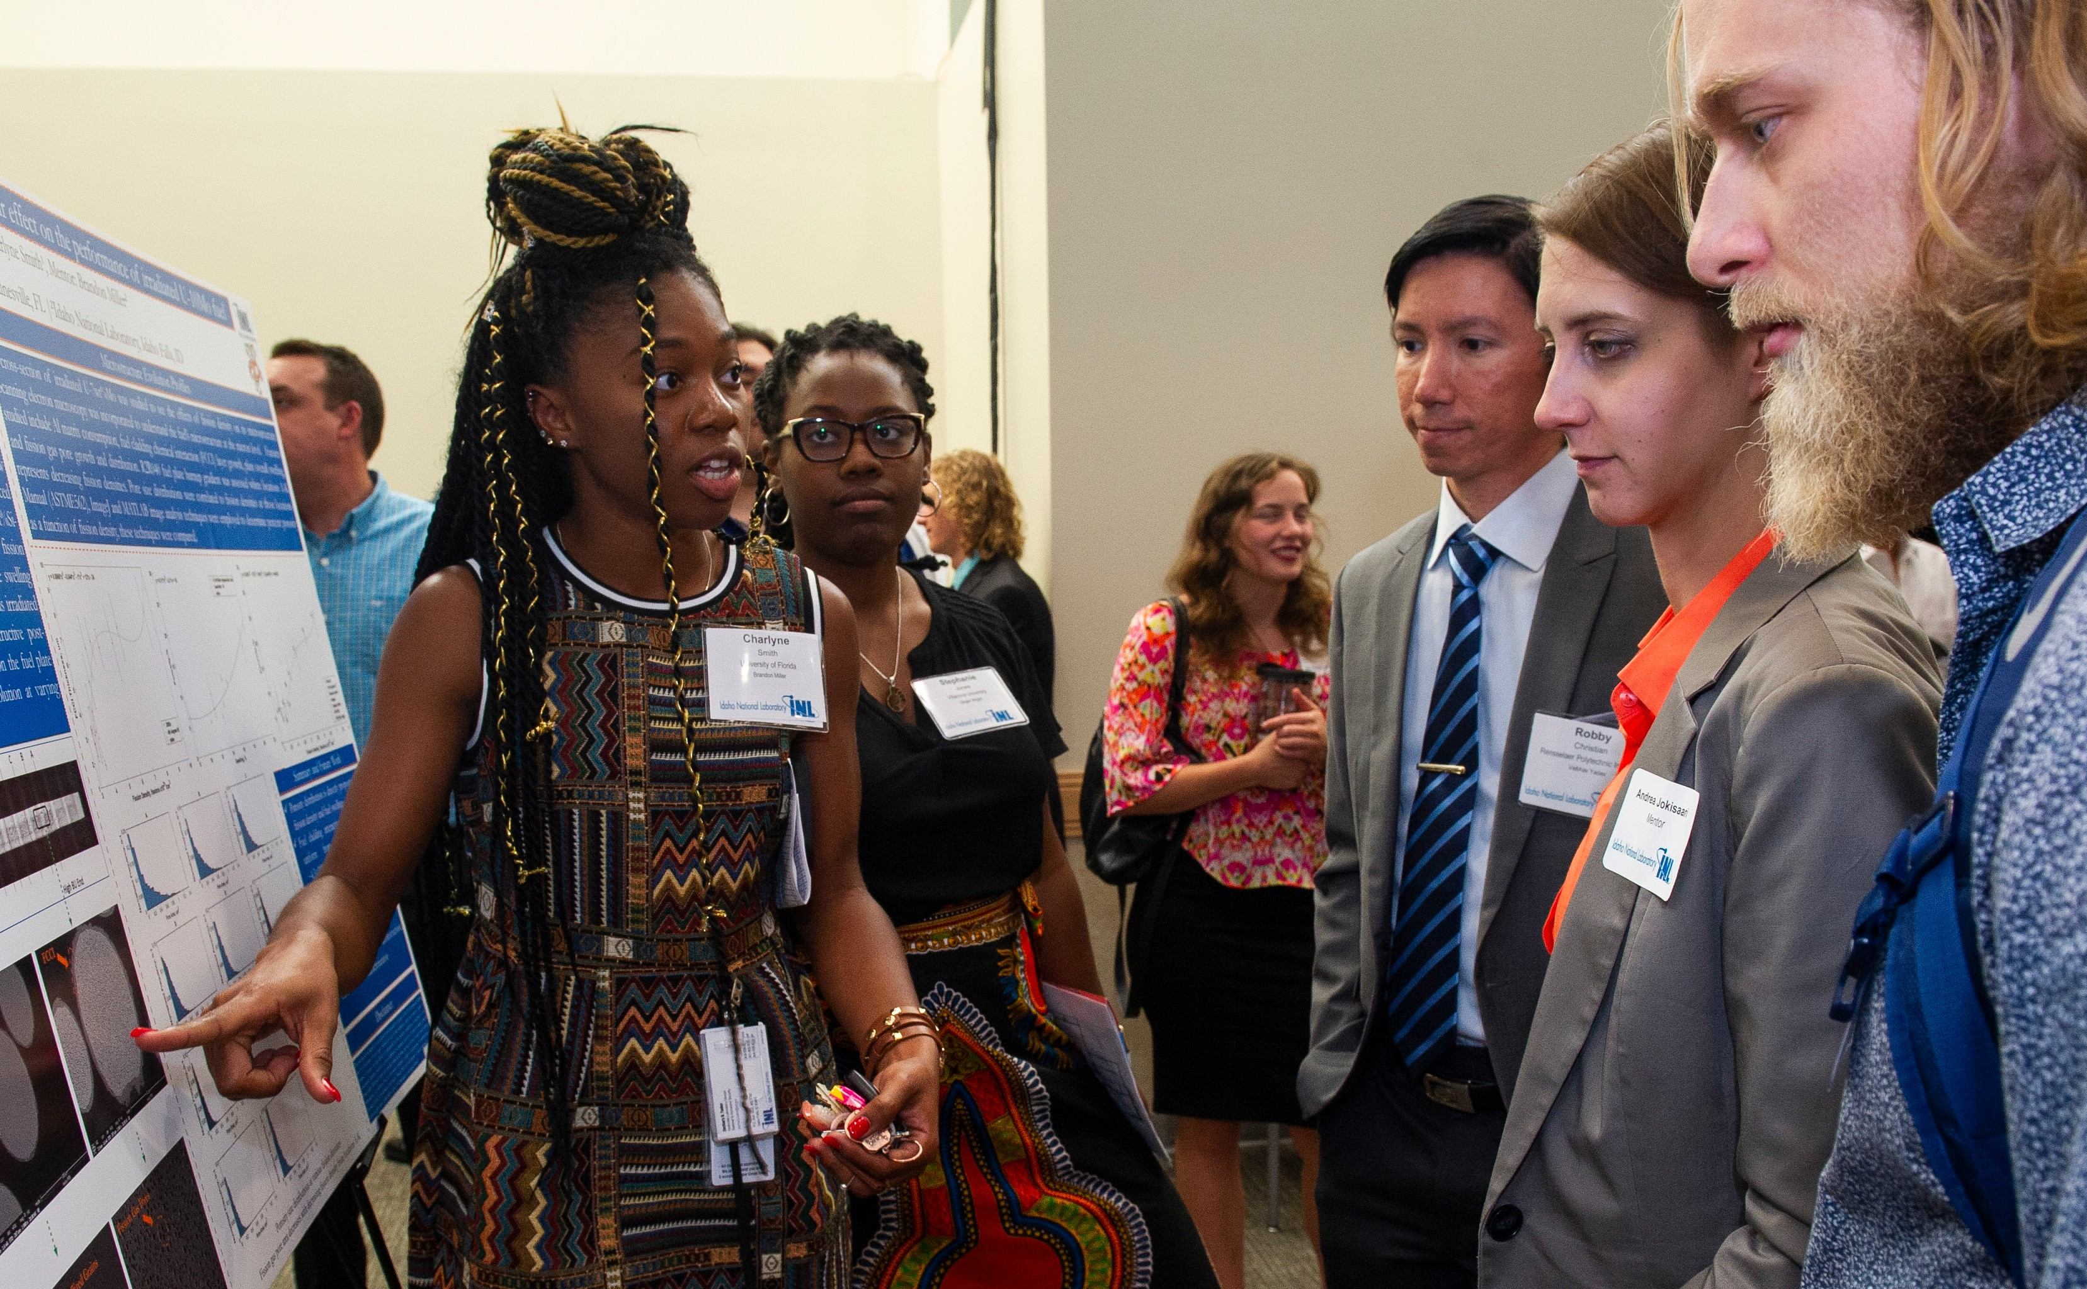

Network Security, Digital Manufactur- ing, Embedded Control Systems, Threat Analysis, Intelligent Control Systems

ENVIRONMENTAL SAFETY, HEALTH AND QUALITY
Applicable areas of study: Environ- mental Engineering, Safety Engi- neering, Fire Protection Engineering, Quality Engineering, Industrial Engineering, Health Physics

HIGH PERFORMANCE COMPUTING
Applicable areas of study: Computa- tional Sciences for Materials, Structural Engineering, Seismic Engineering, Chemical Engineering, Fluid Dynam- ics, Nuclear Engineering, Physics, Engineering, Energy Technology, Vehicle Technology, Energy Storage

NATIONAL HOMELAND SECURITY PROGRAMS SUPPORT*
Applicable areas of study: Communi- cations, Public/International Policy, International Security, Cybersecurity, Business, Computer Science, Geology, GIS, Emergency Preparedness, Home- land Security and Technical Writing

NUCLEAR FUELS AND MATERIALS
Applicable areas of study: Nuclear Engineering, Metallurgical Engi- neering, Materials Science and Engineering, Mechanical Engineering, Civil/Structural Engineering, Physics, Chemistry, Chemical Engineering

NUCLEAR FUEL MANAGEMENT, RECYCLING AND DISPOSAL
Applicable areas of study: Chemical Engineering, Chemistry, Radiochemis- try, Analytical Chemistry, Metallurgical Engineering, Materials Engineering, Geology

NUCLEAR NONPROLIFERATION*
Applicable areas of study: Nuclear Engineering, Analytical Chemistry, Materials Science and Engineering, Chemical Engineering, Forensics, Public/International Policy, Geology

NUCLEAR POWER PLANT SAFETY SYSTEMS
Applicable areas of study: Electrical Engineering, Human Factors, Statis- tics, Computer Engineering, Nuclear Engineering, Mechanical Engineering, Psychology

NUCLEAR REACTOR DESIGNS
Applicable areas of study: Physics, Nuclear Engineering, Mechanical Engineering, Electrical Engineering, Modular Reactors, Life Extension of Current Plants, Future Reactor Design and Construction, Space Technology

RESEARCH FACILITIES, MAINTENANCE AND OPERATIONS ENGINEERING SERVICES
Applicable areas of study: Manu- facturing, Industrial Engineering, Mechanical Engineering, Electrical Engineering, Weld Engineering for Prototype Shop, Fabrication and Welding, Drafting, Project/Construc- tion Engineering, Environmental Engineering, Safety Engineering, Facility Engineering
* Based on the nature of these intern- ships, U.S. citizenship is required.

INTERNSHIP CONTACTS
internships@inl.gov

www.inl.gov/careers

SUPPORTING THE NEXT GENERATION OF SCIENTISTS AND
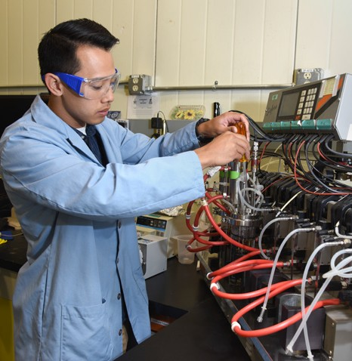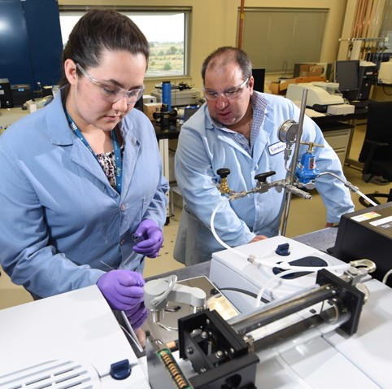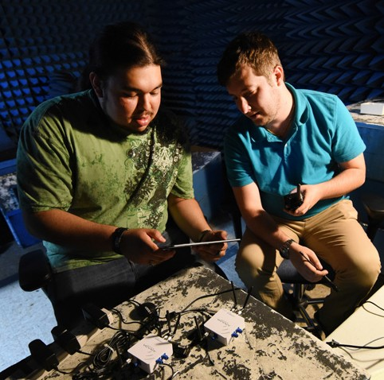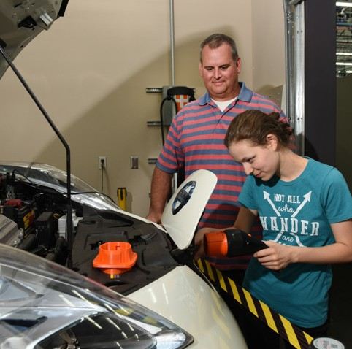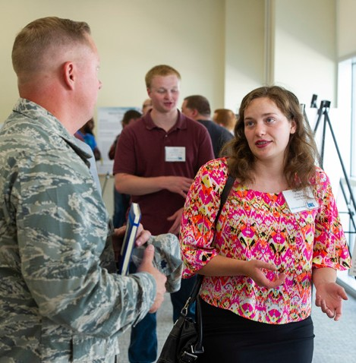ENGINEERS

ExpTeHrEieF UnT cU ReE

16-50126-R2

