HOWARD HUGHES MEDICAL INSTITUTE

INTERNATIONAL STUDENT RESEARCH FELLOWSHIPS
PROGRAM ANNOUNCEMENT 2015

Institutional nomination deadline: November 18, 2014
Application deadline: February 12, 2015 Award notification: June 2015 Fellowships begin: September 1, 2015



……………………………………………………………………

HOWARD HUGHES MEDICAL INSTITUTE
www.hhmi.org

The Howard Hughes Medical Institute is a medical research organization that plays a powerful role in advancing scientific research and education in the United States. Its scientists, located across the country and around the world, have made important discoveries that advance both human health and our fundamental understanding of biology. The Institute also aims to transform science education into a creative, interdisciplinary endeavor that reflects the excitement of real research.

HHMI INTERNATIONAL STUDENT RESEARCH FELLOWSHIPS
Fellowship Term

Evaluation and Selection

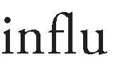Stipends and Allowances

nominate

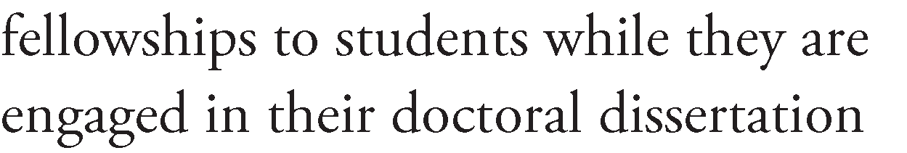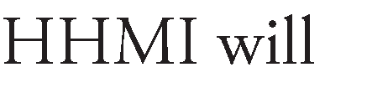•
Conditions of Appointment
•

•

•

5.

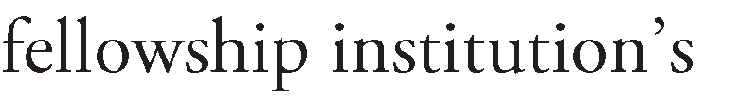6.

7.

Application Process

8.

9.

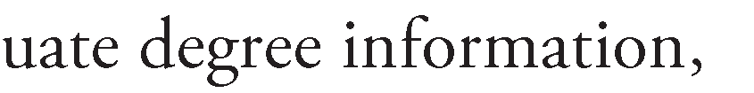1.

2.

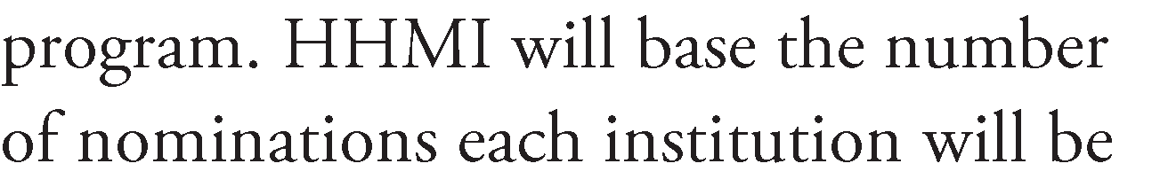Nomination Process
3.
Important Deadlines/Dates



4.

Contacting Program Staff

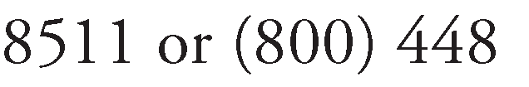HOWARD HUGHES MEDICAL INSTITUTE

INTERNATIONAL STUDENT RESEARCH FELLOWSHIPS PROGRAM ANNOUNCEMENT 2015

http://www.hhmi.org/programs/international-student-research-fellowships

Institutional nomination deadline: November 18, 2014

Application deadline: February 12, 2015

Award notification: June 2015

Fellowships begin: September 1, 2015

Undergraduate and Graduate Programs 4000 Jones Bridge Road
Chevy Chase, MD 20815-6789

www.hhmi.org

