IMPACT OF THE GK-12 PROGRAM:

Interested?

If you are interested in learning more about this program or have additional questions, please email Faith Weeks (fweeks@purdue.edu) for more information.

NEXT STEP
Teacher: “I am certainly not the same teacher that I was before this experience… (this has) changed the way that I approach the education of my students”

Ph.D. Student: “participating in GK12 was the single best decision I have made in my professional life and it will forever influence my career path in the future”

PFF/PFP GK-12
Program

Teachers and Graduate Students Working Together to Enhance Education

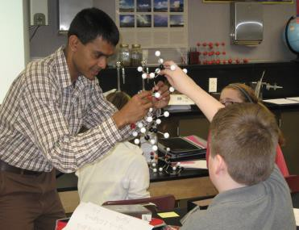If you would like to participate in this volunteer program all you need to do is send your CV (including on campus contact information) and a one page, informal biography of yourself, including why you want to be a part of this program, and a simple explanation of your research to Faith Weeks at fweeks@purdue.edu. This information will be used to match you with a middle school teacher for the Fall 2014 semester.

Part ici pat ing Mi ddle Sc hoo l:

Tecumseh Jr. High School 2101 S. 18th St.
Lafayette, IN 47905

Purdue University

Graduate School

PFF/PFP GK-12
Program

PROG RAM OV ERV IEW ROLE S & RE SPO NSIB ILI TIE S
PROG RAM TI MEL INE* *

- Open to graduate students in any department at Purdue *
- Graduate students volunteer to serve as “visiting scholars” in local middle school classrooms
- Teachers and graduate students work together to integrate research and new approaches into classrooms
- Graduate students observe the classroom first, then gradually assist teachers – working up to teaching a lesson as the primary teacher

PROG RAM GO ALS

- Provide training, mentoring, and experiences for graduate students to develop their abilities as potential future faculty and professionals
- Enhance quality of education in middle schools
- Provide professional opportunities and content support for middle school teachers
- 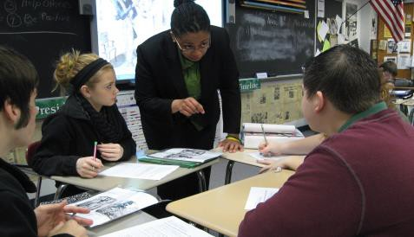Foster partnerships between the university and local schools
- Attend training and check in meetings
- Commit to being in the classroom for 1 day per week (roughly 7 hours)
  - Can split up the time; schedule is up to you
  - Initially assist with lessons led by the
teacher, later develop your own lesson plan
- Submit a short weekly reflective journal on your experiences in the classroom
- Create an inquiry-based lesson plan that relates to your research theme and implement it
- Obtain a service learning grant from Purdue University to support any classroom costs
- Submit final lesson plan, all associated materials, and a final reflective essay about your lesson plan

PROG RAM OU TC OMES

Graduate Students:
New way to apply their research Improved teaching abilities & knowledge Better understanding of K-12 education Enhanced communication and time-
management skills

Teachers:
Enhance lesson plans and teaching Add new lessons based on research Content matter support
Increased understanding of “research”

Middle School Students:
Exciting new curriculum additions
New role models in the classroom

September 4th
  - Deadline to Sign Up to Participate

September 5th
  - Participant Training Workshop
  - 4pm–8pm, Hampton Hall Room 2201

September 10th
  - Teacher/Participant Meet & Greet
  - 4:00pm-4:45pm at Tecumseh

September 15th – November 21st
  - Participants in the Classroom

September 26th
  - Checkup Meeting #1
  - 4pm-8pm, Hampton Hall Room 2201

October 17th
  - Checkup Meeting #2
  - 4pm–8pm, Hampton Hall Room 2201

October 24th
  - Checkup Meeting #3
  - 4pm-8pm, Hampton Hall Room 2201

December 12th
  - Final Participant Group Meeting
  - 4pm-7pm, Hampton Hall Room 2201
  - Final reflective essay and lesson plan materials due

* this is not a funded graduate assistantship; optional 2 credits course (GRAD 590 – Graduate Student Engagement in K-12 Education)
**Dates/times are subject to change.

