Study Abroad with Georgia Tech (GT) – Shenzhen

2014-11

- 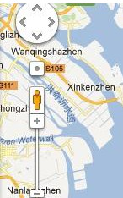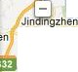l

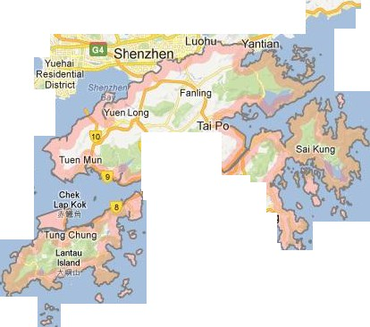(Shaji d'. \
ngzi
\ Pinghu

Longga.n..g..

Ke zhe-n
.J- ,

•

Fu. #
den

Shiyanzhen
rn'iTI'I"'

-ar1
Resi
t
tial
l!Iii[i] '

yong.
- 01 ·t

Restdenttal l s nc
Distnct Longhuazhen
Tleg Henggangzhen
R so l' -
1\\17 Bujizhen
•Xixiangzhen

Bao'an
.' ..,-
Dapeng
Reside-ntial District
MirsBay
Da

Dachan
Island
Nan·aozhen

;1;:11' q 0

Mawan Bay

DaluBay
,
Xi)t9ng Efay

Jinxing Bay

Tangjiazhe-n

Xiangzhou

Zhu}lang RIVer Estuaty
Neilingding 1slahd I"!!WIT!\\

l

n; I 2
:;.)uwun Tong

1zhen
I
Bay

Zhuhai

Macau

Sanjiao
MOuntain ISland
=.ltuJ.J.1\\

Niutou
Island
'I?';sA

Guishan

4 - ,,.,.....-.¥
\ - - ChaiWan
A A{ 0
m_!, •Stf!qJeyJ
lslaOO U
ciM'!& 0 I

.I.

Coloane Datu Island
-1 r:.:r. a
Island
I!ill!\\ Dadong Bay Map data ®2013 AutoNavi.Google, MapKing. Ret

Shenzhen, China

China’s most livable city = Shenzhen

- Bordering Hong Kong; 1-hour ferry from Macau

- Population: 15 million; average age below 30

- Highest GDP per capita among medium & large Chinese cities

- 4th largest container port in the world

- Video: http://youtu.be/u0mjOYoYOd8



Shenzhen – A High Tech City

Shenzhen has headquarters of

  - Huawei: largest telecommunications equipment maker in the world

  - ZTE: 5th largest telecommunications equipment maker in the world

  - Tencent: largest internet company in China

  - Mindray: largest medical equipment maker in China

  - BYD Auto: largest selling Chinese brand

  - …

Location of the GT-Shenzhen Program: Shenzhen Virtual University Park (SZVUP)

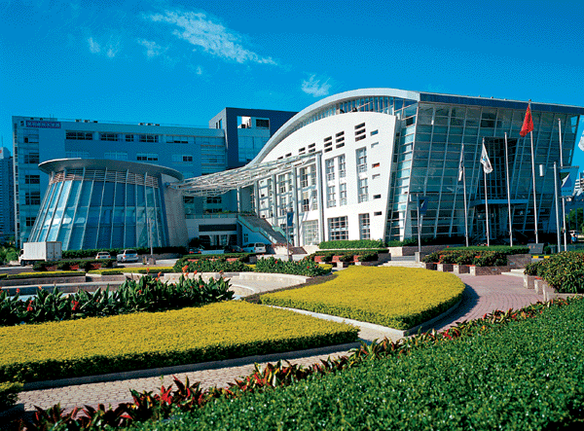

GT-Shenzhen MS ECE Program

GT MS ECE (Electrical & Computer Engineering)
  - Same degree / diploma / transcript as GT-Atlanta
  - 30 credit hours = 10 courses to complete
  - Textbooks, syllabi, teaching methodology identical to GT-
Atlanta
  - All-English instructions
  - GT-Shenzhen students are GT students with GTID, GT email, GT web space, access to GT library online resources …

A small number of non-ECE courses are available as well, mostly in MATH & ISYE



International Student Body:

Our first group of students come from the USA, Indonesia, Taiwan, and Mainland China. Long term goal is to have 50% international students on the program.

International Student Body

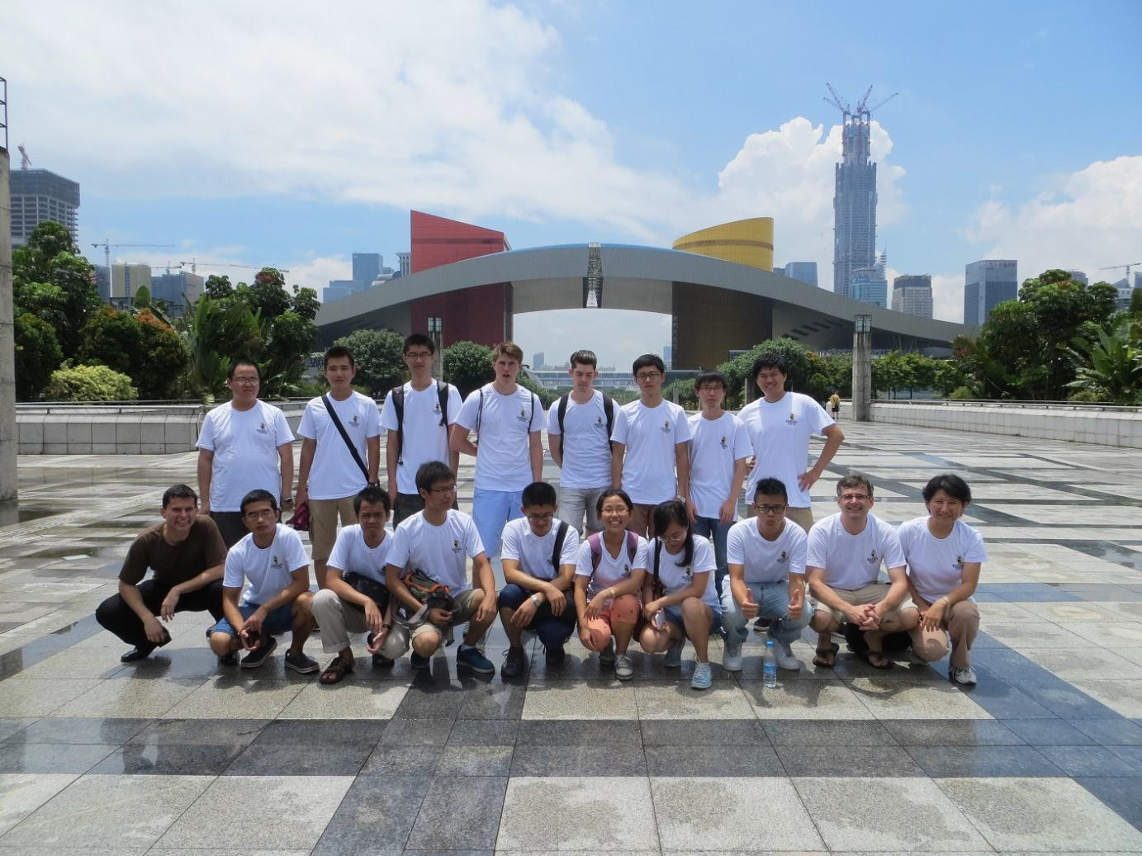

Organized Program Activities



Organized Program Activities



Organized Program Activities

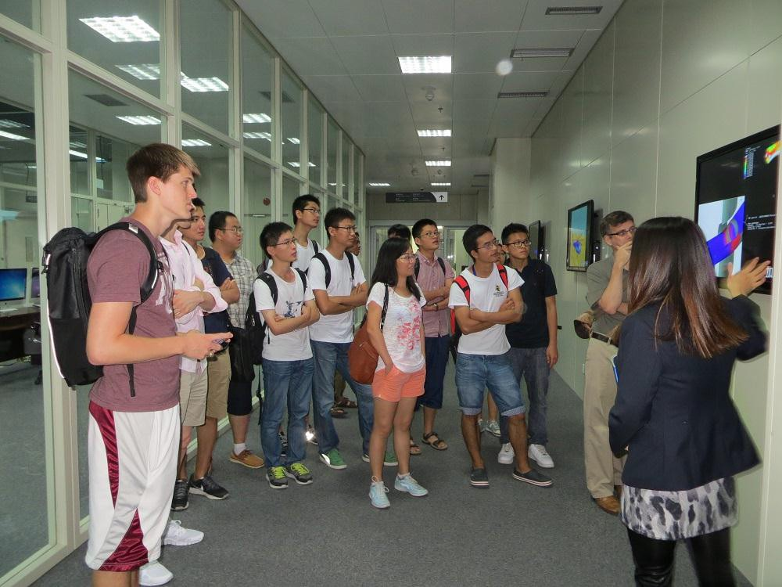

Field Trip to Super Computing Center



Weekly Tea Time



Day Trip to Macau



Biking around Shenzhen Bay

GT-Shenzhen Calendar

Courses are taught in Shenzhen 3 semesters / year

    - Fall: mid August ~ early November (with one week off for Chinese National Day holiday)

    - Spring: early January ~ end of March (with one week off for Chinese New Year)

    - Summer: mid May ~ early August

- New students are accepted each semester

- Most suitable for graduate students and senior undergraduate students

Tuition & Fees

Currently $7,343 per semester, including
  - GT-Shenzhen Tuition
  - GT-Shenzhen Program Fee
  - GT Technology Fee
  - GT Special Institutional Fee

Compare with GT-Atlanta tuition and fees of
$15,349 per semester
  - Approximately half price as compared to GT-Atlanta

Chinese Language Immersion

Non-credit, Beginner Chinese classes offered
to program participants

- Perfect Attendance Scholarships – the Beginner Chinese classes are free as long as you are committed to a perfect attendance record for the classes

Transient Students

Degree seeking student at another US institution can apply to become transient student at GT-Shenzhen for one semester.

- Take GT classes and transfer course credits back to
home institution.

- Student will receive degree from home institution.

- Transient arrangement restricted to US citizen and
permanent resident students.

Transient Students

- Transient students enjoy the same benefits as GT
students while studying aboard at GT-Shenzhen

- Same GT course transcript; issued from Atlanta

- Same low tuition & fees apply to transient students

- Travel the world without delaying progress towards the degree!

- Transient students are accepted any semester (fall, spring, summer) of the year. Need to apply at least 3 months before the start of the semester.

Contact Us

- Official GT-Shenzhen website：www.shenzhen.gatech.edu
- Mr. Wang at GT-Shenzhen Office： 186-6459-4112
tu.gt.shenzhen@gmail.com

- Ms. Zhu at GT-Atlanta Office: +1 (404) 385-1341 Skype ID: gtshenzhen
- Email：gtshenzhen@ece.gatech.edu

- Location: 19 Gaoxin South 4th Street

Room B208, Shenzhen Virtual University Park Shenzhen High Tech Industry Park South

