GE GLOBAL RESEARCH CENTER
EDISON ENGINEERING DEVELOPMENT PROGRAM (EEDP)

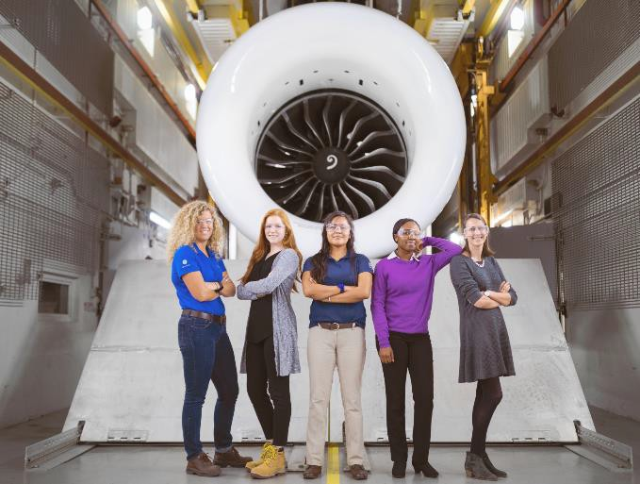
GE Global Research Center
At Global Research, scientists, engineers, and technicians work together to provide GE’s businesses and strategic partners with technical innovations for their future generation products, processes and services.
Finding solutions in energy, healthcare, and transportation. Building, powering, moving and curing the world.
GE's Global Research Center in Niskayuna, NY is currently recruiting for our Edison Program.

MS in Computer Science, Applied Math, Data Science, Electrical Engineering, Mechanical Engineering, or Materials Science/Engineering.

The Edison Engineering Development Program is a technical career accelerator program for people who have a passion for technology, are committed to technical excellence, and share in GE's core values.

GRC Edisons are uniquely positioned to explore new technologies and find their passion. Edisons rotate through multiple engineering projects driven by GE business priorities in aviation, healthcare, transportation, power generation, oil & gas, lighting, and renewable energy.

GRC Edisons grow their skills by collaborating with diverse project teams, building mentor relationships with world-class technologists, and learning from challenging work assignments and advanced engineering coursework.
Apply online
www.ge.com/careers
Job # 2969089
GE offers a great work environment and challenging careers. GE is an Equal Opportunity Employer for all, including minorities, women, protected veterans, and disabled.

